**Title:** Genetic variation in a foundation tree species drives the network structure of a dependent community.

**Authors:** Matthew K. Lau, Louis J. Lamit, Rikke R. Naesborg, Thomas G. Whitham

Summary:

* Intro
  + Understanding the influence of genetic variation on the interactions of associated community members
  + Interaction network modeling can be used to understand complex relationships among species, building on the co-occurrence literature
  + Two scales of co-occurrence, stand = sorting (patterns among trees) and tree = interactions (patterns within a tree)
  + Three sources of variation (age, microsite, phenotype)
  + Epiphytic lichen are an ideal model system
  + Previous work has shown compositional affects of plant genotype
  + Two main questions:

1. Do lichen show significant patterns co-occurrence network structure?
2. How does tree genetics influence the network structure?
   1. Substrate age
   2. Microsite (spatial autocorrelation)
   3. Genetically based traits

* Methods
  + Site Description
  + Garden Description
  + Co-occurrence sampling
  + Lichen identification
  + Tree age, microsite, tree traits
  + Network and co-occurrence modeling
  + SEM
  + Statistical analyses
* Results
  + The wild and garden stands showed significant co-occurrence network structure that was highly correlated.
  + In the wild, roughness was the primary driver of network structure, age indirectly influenced network structure through roughness and microsite did not contribute to network structure
  + In the garden, tree genotype was the main driver of network structure.
* Discussion
  + Hypothesis of genetics supported
  + Network patterns
  + Community assembly
  + Genetics of interaction networks
  + Implications and Future Research

**Abstract**

* Understanding the community level impacts of intraspecific trait variation is integral to understanding community dynamics
* Previous studies have shown that genetically based intraspecific variation can influence the interactions among species; however, no studies have been done that holistically examine these genetic effects on the networks of interacting species
* Here, we use null modeling and network based methods in a model system of epiphytic lichen to examine the effect of phenotypic variation in a foundation tree species (*Populus angustifolia*) on a network of interacting species
* Three main results emerged:

1. Species tended to cluster together at the scale of both the stand (SES = -20.51, P < 0.001) and individual tree (Mean = -4.25, SE = 0.96) suggesting that ….
2. As a potential mechanism that is likely to account for the patterns of species clustering, co-occurrence patterns were strongly related to bark roughness (R2 = 0.42, P = 0.0127),
3. A Structural Equation Model (SEM) showed that bark roughness affected lichen co-occurrence patterns and was twice the indirect effect of tree age (R2 = 0.42, χ2 = 0.38, P = 0.539).

* These results suggest that tree trait variation can contribute significantly to the co-occurrence patterns and potentially the network of interactions among species in tree dependent organisms. Given that this trait has an underlying genetic basis, these results further suggest that evolutionary dynamics play a significant role in determining the interactions among species in complex communities

**Introduction**

* A holistic approach is needed in addition to reduced perspective given the properties of networks
* Trait variation is important in structuring communities
  + Antonovics
  + Wimp 2005
  + Agrawal 20??
  + Lanchau and Strauss
* Cottonwood bark lichen as a model system and previous work on co-occurrence patterns in lichen
  + Ellison 2005
* Hypotheses and possible outcome

1. Lichen community will show significant co-occurrence network structure
2. Tree variation will drive co-occurrence patterns, through three possible mechanisms (G, E and GxE):
   1. Local environmental conditions
   2. Tree age
   3. Substrate suitability (roughness)

**Materials and Methods**

* Study site
  + Uintah, UT
  + Weber River
  + Natural, multi-age stand of cottonwoods (*Populus angustifolia*, *P. fremontii* and hybrids)
  + Only *P. angustiolia* or highly advanced back crosses were sampled
  + Sampled August 2012
* Cottonwood bark lichen system
  + Diverse community of 15 species representing both crustose and foliose species
  + *Xanthomendoza galericulata, X. montana, Caloplaca holocarpa, Candelariella subdeflexa, Rinodina glauca, Lecanora sp., Phyciella melanchra, Physcia adscendens, Physcia undulate, Lecanora hagenii, Phaeophyscia orbicularis (darker stuff), Phaeophyscia ciliata (grey-black-cupped-foliose), Melanelia subolivacea, Meanelia elegantula*
  + Representative samples of each species were taken from a each tree and identified by R. R. Naesborg
* Data collection
  + Trees were chosen haphazardly, spread throughout a 0.10 km2 area
  + 100 cm2 quadrats
  + 10cm by 10 cm grid
  + 1 cm2 cells sampled in a checkerboard pattern
  + Mean thallus size ~1 cm2
  + Sampled at two heights spaced 25 cm apart
  + Quadrat height did not affect lichen composition, so data from two heights were used together for each tree
  + Roughness was assessed as a percentage of cells with bark showing texture resulting from mechanical disruption
  + Canopy cover was accessed using a spherical densitometer (Forrestry Suppliers, Inc.)
* Data imputation
  + One tree was unable to be aged directly, so a regression was used to predict its age using tree size
* Network modeling
  + Co-occurrence network models were generated using the methods of Araujo et al. 2011
* Co-occurrence analyses
  + Co-occurrence patterns at the stand and tree scale were tested using permutation based null model methods (Oskanen 2012, Gotelli 2002)
* Statistical analyses
  + Regressions
  + SEM
  + All analyses were done in R (R Development Core Team 2013)

**Results**

* General lichen community and sampling
  + A total of 14 trees were sampled varying in height from 3 to 8.3 meters tall and 5.5 to 31.3 cm DBH (i.e. diameter at breast height).
* Stand level network and co-occurrence analysis
  + Significant network structure (Fig. 1)
  + Centrality is not related to abundance (P = 0.795) (Fig. 2)
* Co-occurrence patterns varied among trees, but were generally aggregative (Table 1 and Fig. 3)
* Lichen community co-occurrence patterns were significantly correlated with bark roughness (R2 = 0.42, P = 0.0127) (Fig. 4)
* SEM showed good fit (R2 = 0.42, χ2 = 0.38, P = 0.539) with the direct effect of roughness (-0.65) being twice that of the indirect effect of tree age (0.54) (Fig 5).
* Lichen ~ microsite
  + Waiting for data from Lamit

**Discussion**

* The lichen community showed significant co-occurrence patterns and network structure.
  + Centrality was not correlated with abundance
* The hypotheses that bark roughness influences co-occurrence patterns was well supported.
* Age had a smaller indirect effect on lichen co-occurrence patterns
* Bark roughness patterns have a genetic basis and its evolution could have significant effects on the network of interactions among bark lichen
  + Lamit et al. 2011
* These patterns can be generalized to other taxa with strong spatial dependency on foundation trees

**References**

Check formatting guidelines on journal page.

Tables

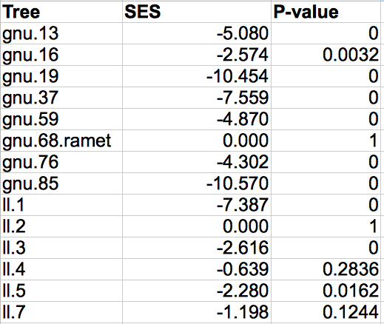

Table 1. Table of the Standardized Effect Sizes (SES) and associated left tail P-values for the surveyed trees.

Figures

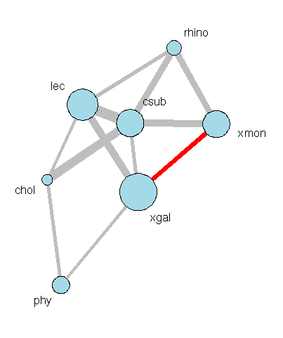

Figure 1. Network showing the co-occurrence patterns for the epiphytic lichen community at the scale of the stand. Nodes show each species and lines show significant spatial dependencies scaled by the total abundance of each species (on a log scale) and the magnitude of the species’ dependencies. Edges are colored grey if aggregative and red if dispersive.

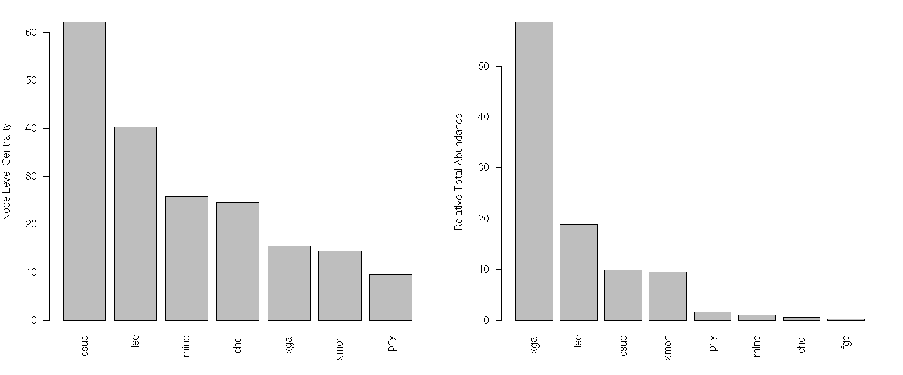

Figure 2. Barplots of the node level centrality (left) and relative abundance (right) in rank order showing that the more centrally connected species in the network are not necessarily the most abundant species in the community.

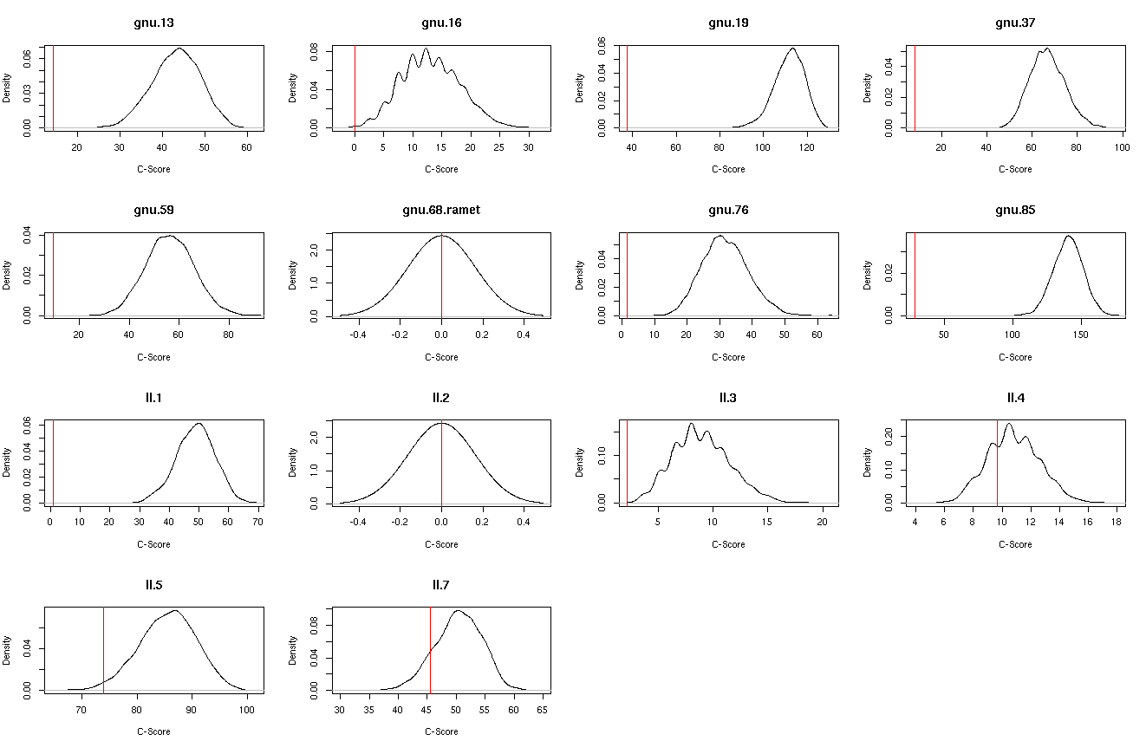

Figure 3. Array of the density plot for the null simulated c-scores used to calculate the Standardized Effect Sizes for the community on each tree.

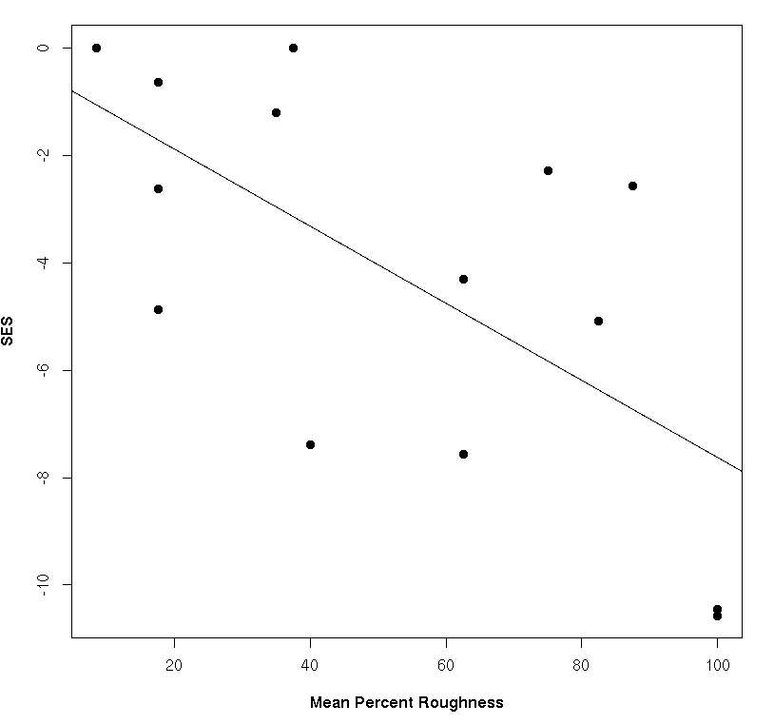

Figure 4. Plot showing the significant effect of bark roughness on the co-occurrence patterns (SES) of lichen communities on each tree.

Macintosh HD:Users:Aeolus:projects:dissertation:projects:lichen_coo:results:sem_coo.png

Figure 5. Path diagram showing the Structural Equation Model (SEM) in which the indirect effect of tree age is compared to the direct effect of bark roughness on lichen co-occurrence patterns (SES).