**Genotypic variation in foundation tree generates ecological network structure**

Biological evolution is argued to occur in the context of complex networks of interacting species in which natural selection defines the structure of ecological networks1,2,3. However, fundamental to this evolutionary process is the discovery of a genetic basis to ecological network structure, which remains unknown. Here, we use both a long-term experimental common garden4 with genotyped individuals and a natural riparian forest of the foundation tree species5 *Populus angustifolia*, to test how genetic variation contributes to the interaction network structure of a model community comprised of epiphytic lichens. We found three main results: 1) lichen communities showed significant unipartite (i.e., one mode) network structure that was similar between the common garden and a natural stand, 2) individual tree genotype significantly influenced lichen species interactions, which was strongly correlated with bark roughness, a genetically based trait known to influence epiphytic lichen6, and 3) bipartite (two mode) genotype-species networks, comprised of the foundation species and its associated lichen community, showed significant modular structure in both the common garden and natural stand. These results demonstrate strong support for a genetic basis to ecological network structure and the potential for selection to act in complex ecosystems. This work sets the stage for studies that address greater complexity in the evolution of biological systems and provides a framework for the discovery of evolutionarily dynamic compartments in ecosystems.

Evolution occurs in the context of complex networks of interacting species. In ecological communities, community dynamics depend on key interactions7 that occur in species interaction networks, such as: trophic8 and mutualistic9 interaction networks. Phylogenetic patterns in ecological networks support the importance of evolutionary processes in shaping species interactions1,10. Community genetics studies11 have shown that genetic variation in foundation species5 (species, such as trees, that largely define the composition of communities by creating locally stabile conditions and modulating resources; contributes to variation in interactions with dependent communities in both terrestrial and aquatic ecosystems12. More specifically, genetic variation affects diverse chemical, phenological, morphological and other traits producing a multivariate phenotype13 that makes each individual unique so that different communities assemble on different genotypes resulting in different species interaction14,15. Although, some empirical studies have shown that genetic variation in a single species can impact a tri-trophic interaction16; currently no studies have yet investigated the impact of intraspecific genotypic variation on network structure, which is integral to the process of evolution by natural selection.

Here, we investigate how genetic variation in a foundation tree species determines the structure of a network of interactions among species. Using a long-term (20 years+), common garden experiment with replicated individuals of known genetic identity and a naturally established stand of *P. angustifolia.* We focused on a model community of 9 epiphytic lichens species, as previous research has demonstrated significant compositional responses of epiphytes to genotypic variation6,17. In addition, the ecology of lichen, with local interactions and slow population turnover rates, allowed us to assess interactions among lichen species rapidly on individual trees. In both the experimental garden and the natural stand, we discovered that genotypic variation in a *P. angustifolia* predictably influenced the structure of the lichen species interaction network and contributed to the formation of evolutionary modules comprised of tree genotypes and the lichen community.

We observed significant unipartite (one-mode) network structure18 in the lichen species interaction networks that was similar between the experimental garden and the natural stand (Fig. 1a and 1b; Garden: z = -6.31, p = 0.0002; Natural: z = -3.15, p = 0.002). The two networks displayed high multivariate structural similarity (Mantel R = 0.51, p = 0.029). Node level eigen-centrality19, a measure of species importance that integrates indirect connections, showed strong correlation between the two stands (Fig. 1c; r = 0.7, t = 2.6135, df = 7, p = 0.035). Centrality was also highly correlated with total abundance in both networks (Fig. 1d; Garden: r = 0.77, t = 3.2427, df = 7, p = 0.014; Natural: r = 0.86, t = 4.43, df = 7, p = 0.003). In combination, the similarity of both the whole and node level network structure between the common garden and the wild indicates that the common garden environment captures much of the natural variation that exists in nature and accurately reflects natural processes.

In the common garden, where the effect of environmental variation was controlled, genotype was an important factor contributing to network structure. Genotype was a significant predictor of interactions on individual trees (Fig. 2a; F = 3.4213, num df = 12.000, denom df = 14.668, p-value = 0.01426). Similar to the effect of a genetically controlled trait (bark roughness) on a dominant lichen5, we found that individual tree genotypes with similar levels of bark roughness had similar levels of lichen interactions (Fig. 2a; Mantel R = 0.08, p = 0.013), which was similar to the correlation observed between bark roughness and lichen interactions in the natural stands (Fig 2b: r = -0.53, p = 0.050).

We also examined how *P. angustifolia* genotypic differentiation contributes to the formation of groups of tree genotypes and lichen species and found significant modular structure. Using a bipartite (two-mode) network approach in which genotype-species networks were modeled using the species maximum relativized values of each lichen species across all *P. angustifolia* genotypes, we found significant modularity in the common garden stand (Fig. 3a; z = 9.64, p < 0.001). When using the same analyses on individual trees in the natural stand, we also found significant modularity (Fig. 3b; z = 7.42, p < 0.001). Furthermore, nestedness of both of these networks was significantly lower than expected under a null model (Garden: z = -2.30, p < 0.001; Natural Stand: z = -2.84, p < 0.001), most likely as a result of module formation.

These findings support the hypothesis that genotypic variation in a foundation species can contribute to the structure of a network of interacting species. Several lines of evidence support this conclusion. First, the wild stand showed significant interaction network structure (Fig. 1a and b); and both tree genotype and the genetically based tree trait, bark roughness, was a strong predictor of co-occurrence patterns (Fig. 2a). Second, the common garden network (Fig. 1b) structure showed a high degree of similarity to the wild stand network structure (Fig. 1c and d). Third, tree genotype was a significant predictor of SES values (Fig. 2a), displaying significant correlation with a genetically linked trait, bark roughness, both in the common garden (Fig. 2a) and in a naturally established stand of trees (Fig. 2b). Last, both of the bipartite genotype-species networks in the common garden and natural stand displayed significant modularity, suggesting that genotypic variation is leading to the formation of evolutionarily dynamic compartments within the community. Thus, just as numerous studies have shown that plant genotype can affect species richness, abundance, diversity, and composition and previous work has demonstrated that evolutionary processes shape ecological networks3,2, this study includes genetics in an empirical investigation that combines both experimental common garden findings along with studies in the wild that are in close agreement. These results point to the importance of understanding the community level effects of genetic variation and corroborate previous findings of the importance of plant genetics in shaping ecosystems10.

This study highlights the potential for indirect effects of genetic variation to propagate through networks of interacting species and trophic levels. Altering the structure of interaction networks presents a means for genetic effects to be magnified within the system of interacting species. At the scale of ecosystems, trophic networks or food webs direct and control the rates of energy and nutrient flux20. One important example16, showed that the interactions among species across three trophic levels depended on cottonwood (*Populus* spp.) genotype. Although our study was conducted with a community of lichens, these results should be generalized to other groups of diverse organisms around the world that also exhibit significant genetic signals at the community level21,14, although spatial scale of interactions should be considered22. As heritable variation is the raw material for natural selection to act upon, a genetic basis for interaction network structure indicates evolutionary dynamics should be considered at the community level and that conserving genetic variation is important to consider in efforts to restore or preserve complex species interactions and the associated ecosystem functions23 that they provide.

**Methods Summary**

**Field observations in common garden and natural riparian forest stands.**

The study was conducted along the Weber River, UT (USA), which is a cottonwood (*Populus* spp.) dominated riparian ecosystem. Although two native species, *Populus angustifolia* (James) and *Populus fremontii* (S. Watson), occur here and are known to hybridize, only pure or highly advanced backcrosses of *P.* *angustifolia* were sampled in order to avoid the effect of the hybridization between these two species. A common garden setting was used to isolate the effect of tree genotype from the effect of the localized microenvironment associated with each individual and spatial autocorrelation. Asexually propagated clones of genotyped *P. angustifolia* individuals4 were obtained from wild collections and planted randomly in a single field (0.025 km2) at the Ogden Nature Center, Ogden, UT in 1992. A total of thirteen genotypes replicated between 3 and 8 times each, were chosen for sampling. Genotype names were previously published5. The natural stand of *P. angustifolia* near the city of Uintah, UT (GPS: N41.13903, W110.94400) was used for the wild stand survey. A total of 14 trees were chosen randomly over a 0.10 km2 area with a minimal distance of 5.56 m between trees across a range of tree core based ages from 15 to 60 years. Observations were made in the common garden in October 2010 and May 2011 and the wild stand in May 2012.

The bark lichen community in this system is comprised of fourteen species; however, only 9 species were observed within our study quadrats. The lichen community included (abbreviations are given for species present in study): **Xg** = *Xanthomendoza galericulata,* **Xm** = *X. montana,* **Ch** = *Caloplaca holocarpa,* **Cs** = *Candelariella subdeflexa,* **Rg** = *Rinodina glauca,* **Lh** = *Lecanora hagenii,* **Ls** = *Lecanora* (unknown species)*,* **Pm** = *Phyciella melanchra,* **Pa** = *Physcia adscendens,* **Pu** = *Physcia undulata, Phaeophyscia orbicularis, Phaeophyscia ciliata, Melanelia subolivacea, Meanelia elegantula*, including both crustose and foliose lichen species that exhibit low inter-annual variation5. We were able to rapidly assess lichen interactions by quantifying thalli in closed contact as assessed using 1cm2 cells. Species accumulation curves showed that communities in the wild and the common garden were thoroughly sampled and with very similar species richness (Supplementary Materials). On each tree, presence or absence of each lichen species was assessed in 50 total 1 cm2 cells arrayed in a checkerboard pattern. Two adjacent 10 cm2 quadrats centered at 50 cm and 85 cm from ground level were sampled. The checkerboard sampling pattern was chosen to isolate each cell based on an average thallus size of 1 cm2. Samples were restricted to the northern aspect of the trunk to maximize the abundance of lichen and control for the effect of aspect. The thalli in each cell are expected to be spatially independent of the other cells in the quadrat, but exposed to similar micro-environmental conditions. Bark roughness was measured on each tree following6.

**Network modeling and structural and statistical analyses.**

We used the observations of lichen in the 1cm2 cells on individual trees of *P. angustifolia*both in the common garden and the natural stand. Uni-partite networks were generated using an analytical procedure that removes non-significant interactions between species18. We used a null model based approach for all other analyses of network structure. A conservative null model that constrained both the row and column marginal totals was used in order to account for the effects of variation in species’ total abundances24. From a total of 5000 null matrices, a standardized score was calculated for each statistic (*z* = $\frac{x_{obs }- {\overline{x}}_{sim}}{{sd}_{sim }}$), including the C-score25, nestedness26 and modularity27. Here, we follow the convention of the co-occurrence literature and refer to the standardized C-Score as the Standardized Effect Size (SES)28.

A correlation test with Pearson’s *r* was used to test for the correlation between the wild and common garden networks. A Welch Analysis of Variance (ANOVA), which relaxes the assumption of homogeneity of variance, was used to test for the effects of genotype on tree scale SES values. A permutation based Mantel Test was used to test for the effect of bark roughness on SES values in the common garden. All analyses were conducted using the programming language R version 3.0.2 (R Development Core Team 2014).

**References**

1. Rezende, E. L., Lavabre, J. E., Guimarães, P. R., Jordano, P. & Bascompte, J. Non-random coextinctions in phylogenetically structured mutualistic networks. Nature 448, 925–8 (2007).

2. Guimarães, P. R., Jordano, P. & Thompson, J. N. Evolution and coevolution in mutualistic networks. Ecol. Lett. 14, 877–85 (2011).

3. Moya-Laraño, J. Genetic variation, predator-prey interactions and food web structure. Philos. Trans. R. Soc. Lond. B. Biol. Sci. 366, 1425–37 (2011).

4. Martinsen, G. D., T. G. Whitham; R. J. Turek, P. K. Hybrid populations selectively filter gene introgression between species. Evolution (N. Y). 55, 1325–1335 (2001).

5. Ellison, A. M. et al. Loss of foundation species: consequences for the structure and dynamics of forested ecosystems. Front. Ecol. Environ. 3, 479–486 (2005).

6. Lamit, L. J. et al. Genetically-based trait variation within a foundation tree species influences a dominant bark lichen. Fungal Ecol. 4, 103–109 (2011).

7. Winfree, R., Gross, B. J. & Kremen, C. Valuing pollination services to agriculture. Ecol. Econ. 71, 80–88 (2011).

8. Fontaine, C. et al. The ecological and evolutionary implications of merging different types of networks. Ecol. Lett. 14, 1170–81 (2011).

9. Bascompte, J., Jordano, P. & Olesen, J. M. Asymmetric Coevolutionary Networks Facilitate Biodiversity Maintenance. Science 312, 431–433 (2006).

10. Rafferty, N. E. & Ives, A. R. Phylogenetic trait-based analyses of ecological networks. Ecology 94, 2321–33 (2013).

11. Whitham, T. G. et al. A framework for community and ecosystem genetics: from genes to ecosystems. Nat. Rev. Genet. 7, 510–523 (2006).

12. Bailey, J. K. et al. From genes to ecosystems: a synthesis of the effects of plant genetic factors across levels of organization. Philos. Trans. R. Soc. Lond. B. Biol. Sci. 364, 1607–16 (2009).

13. Holeski, L. M., Hillstrom, M. L., Whitham, T. G. & Lindroth, R. L. Relative importance of genetic, ontogenetic, induction, and seasonal variation in producing a multivariate defense phenotype in a foundation tree species. Oecologia 170, 695–707 (2012).

14. Whitham, T. G. et al. Community specificity: Life and afterlife effects of genes. Trends Plant Sci. 17, 271–281 (2012).

15. Burkle, L. A., Souza, L., Genung, M. A. & Crutsinger, G. M. Plant genotype, nutrients, and G × E interactions structure floral visitor communities. Ecosphere 4, art113 (2013).

16. Smith, D. S., Bailey, J. K., Shuster, S. M. & Whitham, T. G. A geographic mosaic of trophic interactions and selection: trees, aphids and birds. J. Evol. Biol. 24, 422–9 (2011).

17. Zytynska, S. E., Fay, M. F., Penney, D. & Preziosi, R. F. Genetic variation in a tropical tree species influences the associated epiphytic plant and invertebrate communities in a complex forest ecosystem. Philos. Trans. R. Soc. Lond. B. Biol. Sci. 366, 1329–1336 (2011).

18. Araújo, M. B., Rozenfeld, A., Rahbek, C. & Marquet, P. A. Using species co-occurrence networks to assess the impacts of climate change. Ecography (Cop.). 34, 897–908 (2011).

19. Borgatti, S. P. & Everett, M. G. A Graph-theoretic perspective on centrality. Soc. Networks 28, 466–484 (2006).

20. DeAngelis, D. L., Bartell, S. M. & Brenkert, A. L. Effects of Nutrient Recycling and Food-Chain Length on Resilience. Am. Nat. 134, 778 (1989).

21. Rowntree, J. K., Shuker, D. M. & Preziosi, R. F. Forward from the crossroads of ecology and evolution. Philos. Trans. R. Soc. Lond. B. Biol. Sci. 366, 1322–8 (2011).

22. Zook, A. E., Eklof, A., Jacob, U. & Allesina, S. Food webs: Ordering species according to body size yields high degree of intervality. J. Theor. Biol. 271, 106–113 (2010).

23. Evans, D. M., Pocock, M. J. O. & Memmott, J. The robustness of a network of ecological networks to habitat loss. Ecol. Lett. 16, 844–52 (2013).

24. Blüthgen, N. Why network analysis is often disconnected from community ecology: A critique and an ecologist’s guide. Basic Appl. Ecol. 11, 185–195 (2010).

25. Stone, L. & Roberts, A. The checkerboard score and species distributions. Oecologia 85, 74–79 (1990).

26. Atmar, W. & Patterson, B. D. The measure of order and disorder in the distribution of species in fragmented habitat. Oecologia 96, 373–382 (1993).

27. Newman, M. E. J. Modularity and community structure in networks. Proc. Natl. Acad. Sci. U. S. A. 103, 8577–82 (2006).

28. Gotelli, N. J. Research frontiers in null model analysis. Glob. Ecol. Biogeogr. 10, 337–343 (2001).

Supplementary Information line (see attached)

Acknowledgments**.** This work was supported by the National Science Foundation grant (DEB-0425908) and Integrative Graduate Research Traineeship (IGERT) fellowships for MKL and ARK.

Author Contributions. MKL and LJL conceived the study, MKL and LJL conducted the field work, RRN assisted in lichen identifications, MKL wrote the first draft of the manuscript, SRB and TGW contributed substantively to the conceptual development, TGW established the common garden. All authors contributed to revisions of the manuscript.

Author Information (containing data deposition statement, competing interest declaration and corresponding author line)

Matthew K. Lau1, Louis J. Lamit1, Rikke R. Naesbourg1, Stuart R. Borrett2, and Thomas G. Whitham1

1Department of Biological Sciences and Merriam-Powell Center for Environmental Research, Northern Arizona University, Flagstaff, AZ 86011-5640, USA. 2Department of Biology and Marine Biology, University of North Carolina Wilmington, 601 South College Road, Wilmington, NC, 28403-5915, USA.

Corresponding Author: Matthew K. Lau, Harvard Forest, 324 N Main St, Petersham, MA 01366, Email: mkl48@nau.edu, Phone: 928-523-9138

**Tables**

None.

**Figure Legends**

Figure 1. Significant unipartite network structure was observed for epiphytic lichens on trees of known genotype in a common garden (ONC = Ogden Nature Center, Utah, USA) (**A**) and individual trees in a natural stand (Uintah, Utah, USA) (**B**) of the foundation species, *Populus angustifolia*. Both networks are shown here with lichen species as nodes (see Methods for species names) scaled by the log of their total abundances and significant co-occurrence patterns between species shown as edges scaled by their log frequencies. The bivariate plot (**C**) shows the significant correlation in Eigen Centrality between the two networks. (**D**) The total abundance of lichen species was a significant driver of network structure for both networks.

Figure 2. Tree genotype influenced lichen co-occurrence patterns in the common garden and the natural stand through a genetically controlled tree trait. The lichen co-occurrence patterns were highly correlated with the genetically based phenotypic trait; bark roughness (i.e., the percentage of textured bark), in both the common garden and natural stand. The scatterplot (**A**) shows the mean (± 1SE) percent rough bark (broadsense heritability, H2 = 0.36,***Χ***2=9.214, p = 0.0024) and SES for each genotype for trees in the common garden with SES values becoming more negative (i.e., species interactions increased), indicating stronger co-occurrence patterns, as bark roughness increases. The lichen communities on individual trees in the Unitah natural stand (**B**) displayed a similar pattern with the SES values becoming increasingly more negative on trees with more rough bark.

Figure 3. Bipartite networks displayed significant modularity with modules comprised of both genotypes and species. The left most set of nodes shows tree genotypes (see Methods for genotype names) for the common garden (**A**) or individuals in the natural stand (**B**) connected to lichen species on the right. Both sets of nodes are scaled by their marginal totals (i.e., total observed individuals for tree nodes and total abundance for lichen species) and arranged by ascending totals from bottom to top. Node color shows the significant module membership for both trees and lichen species with module color having no direct relationship between the two networks, as modules were determined for each network independently.

**Figure 1**.

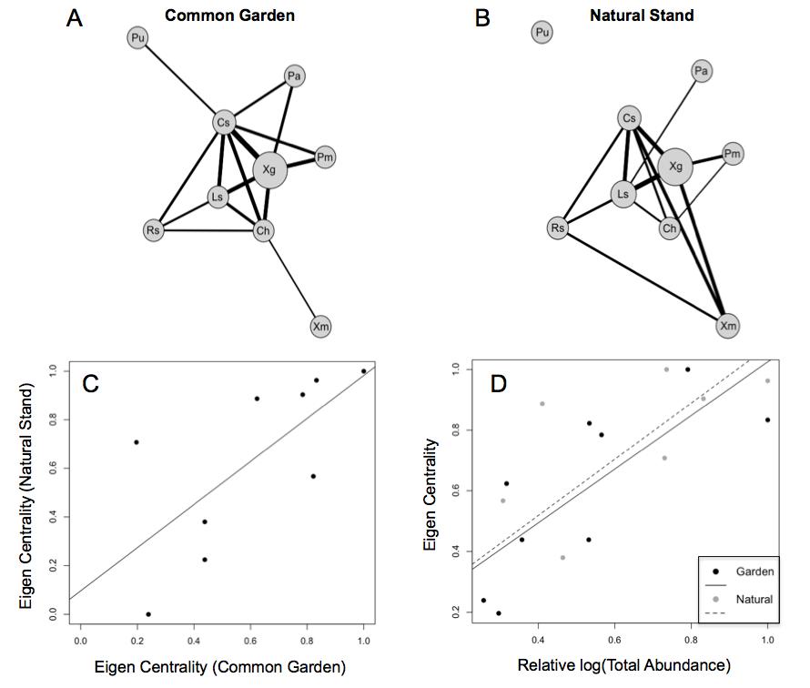

**Figure 2.**

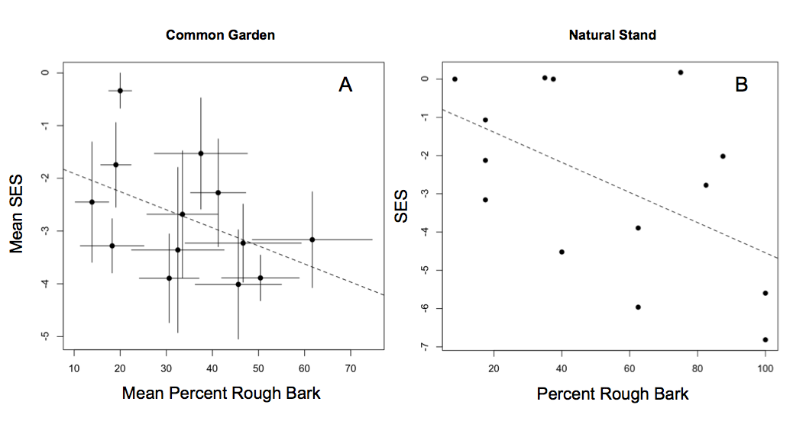

**Figure 3.**

