**Title:** Genotypic variation in a foundation tree species drives the ecological network structure of a dependent community

**Authors:** Matthew K. Lau, Louis J. Lamit, Rikke R. Naesborg, Thomas G. Whitham

**Target:** Ecology Letters

**Abstract**

* Although studies have shown that genetic variation in foundation species can have impacts on the composition and stability of associated species, little is known about how the effects of genetic variation might affect whole networks of interacting species.
* Here, we use ecological network modeling and null-model based co-occurrence analyses to examine the impact of genetic variation in a foundation tree species (*Populus angustifolia*) on the network of interactions among associated epiphytic lichen species.
* Spatial patterns of lichen occurrences both within and among tree species were assessed at a 1 cm2 resolution on trees both in a wild stand and a common garden of known genotypes of *P. angustifolia.* Species dependency network models were constructed and we examined the mechanisms that contribute to this structure.
* The three main results from this study were: 1) the wild stand and common garden networks showed significant dependency network structure that was highly correlated; 2) in the wild stand, bark roughness showed a significant relationship with co-occurrence patterns, while tree age and geographic distance between trees? did not; and 3) in the common garden, genotype significantly affected co-occurrence patterns, which were also strongly related to community composition. What about bark, age, and distance in the garden?
* These results strongly suggest that ecological network structure of dependent species can be determined in part by genetic variation in a foundation species. Given that interaction network structure can have a genetic basis, future work should investigate the potential for selection to act on networks of interacting species.

**Introduction**

As future ecosystems are predicted to undergo major shifts in response to climate change, it is imperative to resolve the evolutionary dynamics of species interactions in the context of complex networks. In ecological communities, plant population dynamics depend on animal herbivore, pollinator, and seed disperser interaction networks (Jordano et al. 2006, Schupp and Fuentes 1995, Fontaine et al. 2011). At the scale of ecosystems, trophic networks or food webs direct and control the rates of energy and nutrient flux (DeAngelis et al. 1989).

Recent work has shown genetic variation in foundation plant species (i.e. dominant species that create locally stable conditions, Ellison et al. 2005) contributes to variation in interactions with dependent communities. A large body of work on plant associated arthropod communities has shown that genetic variation foundation sp can influence community composition, diversity and stability (e.g., Wimp et al. 2005, Crutsinger et al. 2006, Keith et al. 2010); and of particular relevance to plant-pollinator networks ecology, Burkle et al. (2013) found that floral visitation varied significantly among genotypes of *Solidago altissima.* In addition to arthropods, research in other systems, such as plant-plant (Lamit et al. 2011) and plant-fungal (Barbour et al. 2009, Busby et al. 2013), have also demonstrated community level impacts of genetic variation in dominant plant species.

Although these and other studies have demonstrated the effect of genetic variation on interactions between plants and their associated species, few studies have explored more complex patterns of species interactions. One important example is Bailey et al. (2006), which showed intraspecific variation in the interactions of species across three trophic levels depended on cottonwood (*Populus* spp.) genotype. Briefly, the study found that genotypic variation influences traits that determined resistance to a galling insect (*P. betae*). The shifts in gall abundance were then found to correlate with avian predation on galls. This study highlights the potential for indirect effects of genetic variationthat to propagate through networks of interacting species and trophic levels..

In order to explore how genetic variation can contribute to more complex interactions within an entire community, we used the epiphytic lichen community associated with *Populus angustifolia* (narrowleaf cottonwood), as it is comprised of species that live in close association with an individual tree and can be easily identified in the field. Previous studies in this system have shown that the composition of this community varies in response to tree genetic variation (Lamit et al. 2013). Building on these findings, we set out to determine if genetic variation in a foundation tree species can contribute to predictable variation in the interactions among associated species. To do this, we modeled species dependency networks (Araujo et al. 2011) and quantified the co-occurrence patterns on individual trees of *P. angustifolia*both in a wild stand and a common garden with trees of known genetics. We argue that this is a suitable model for detecting shifts in interactions, as interactions occur locally between individuals, patterns of co-occurrence can be used to measure shifts in the frequency with which species can interact. We hypothesized that stand level network structure can arise from three main sources of variation: 1) substrate (i.e. tree) age, 2) direct and indirect influence of variation among trees and 3) genetically based variation in tree traits. I think you need to justify a bit more why you think these 3 things matter. As heritable variation is the raw material for natural selection, a genetic basis for interaction network structure has implications for the evolution of complex interactions among species.

**Methods**

*Study System and Sampling*

The study was conducted along the Weber River, UT (USA). The Weber River is cottonwood (*Populus* spp.) dominated riparian ecosystem. There are two native species *Populus angustifolia* (James) and *Populus fremontii* (S. Watson), which are both widely distributed throughout western North America and known to hybridize (Eckenwalder 1996). For the purposes of this study, only pure or highly advanced backcrosses of *P.* *angustifolia* were sampled in order to avoid the effect of the hybridization between these two species.

A stand of *P. angustifolia* near the city of Uintah, UT (GPS: N41.13903, W110.94400) was used for the wild stand survey. A total of 14 trees were chosen randomly over a 0.10 km2 area with a minimal distance of 5.56 m between trees. Only trees with *P. angustiolfia* morphology were sampled. All trees were geospatially referenced using an average of 10 points taken with a Garmin (Garmin, Inc.).

A common garden setting was used to isolate the effect of tree genotype from the effect of the localized micro-environment associated with each individual and spatial autocorrelation. Asexually propagated clones of genotyped *P. angustifolia* individuals (Martinsen et al. 2001) were obtained from wild collections and planted randomly in a single field (0.025 km2) at the Ogden Nature Center, Ogden, UT in 1992(?). Although some replanting of replicates occurred, the trees in the garden are either the same age or at most three years younger than the original planting (T.G. Whitham, Personal Communication). A total of thirteen genotypes replicated between 3 and 8 times each, were chosen for sampling.

*Lichen Co-occurrence and Tree Trait Sampling*

To establish co-occurrence patterns among the lichen species, fine scale distribution data were collected for epiphytic lichen associated with *P. angustifolia* in both the wild stand in May 2012 and the common garden in October 2010 and May 2011. Previous work in this system has shown that there is a total of fourteen species, *Xanthomendoza galericulata, X. montana, Caloplaca holocarpa, Candelariella subdeflexa, Rinodina glauca, Lecanora hagenii, Lecanora* (unknown species)*, Phyciella melanchra, Physcia adscendens, Physcia undulata, Phaeophyscia orbicularis, Phaeophyscia ciliata, Melanelia subolivacea, Meanelia elegantula*, including both crustose and foliose lichen species (Lamit et al. 2013). All of these species could be identified in the field with the exception of *Physica* and *Physciella*, due to the often small thallus size. Given this and the general tendency for these species to function similarly, we combined them into a generic category, which we designated Phys. On each tree, presence or absence of each lichen species was assessed in 50 total 1 cm2 cells arrayed in a checkerboard pattern inside each of two adjacent 10 cm by 10 cm quadrats centered at 50 cm and 85 cm from ground level. The checkerboard sampling pattern was chosen to isolate each cell based on an average thallus size of 1 cm2. Samples were restricted to the northern aspect of the trunk to maximize the abundance of lichen and control for the effect of aspect.

As previous studies by Lamit et al. (2011 & 2013) have shown that bark texture or roughness was a good predictor of lichen composition and that it had an underlying genetic basis, we chose to focus on bark roughness as a predictor of co-occurrence patterns. The bark roughness of each tree was observed within the same quadrats used to sample the co-occurrence patterns on each tree in both the wild stand and the common garden. Rough bark was defined as any disruption of the outermost layer of tissue, which in early stages of growth is typically smooth and white (Lamit et al. 2011). The presence of rough bark was visually assessed within every 1 cm2 cell (100 cm2 total). Thus, the percent of rough bark was equal to the total number of cells containing rough bark.

In the wild stand, two additional tree traits were observed: canopy cover and tree age. Percent canopy cover was quantified using a spherical densiometer (Forestry Suppliers, Inc.). Densiometer readings were taken at 1 m distance from the trunk on the northern side of each tree. Tree age data was obtained from Lamit et al. 2013. Briefly, tree cores were taken at a height of 1 m using anan increment borer (Forestry Suppliers, Inc.). Annual growth rings were counted at 200X magnification using a dissection microscope (Zeiss).

*Network and Null-Model Based Co-occurrence Modeling*

Stand-level dependence network models were generated for both the wild stand and the garden using the methods of Araujo et al. (2011). This method uses conditional probability to compare the observed to the expected frequency of co-occurrences between all pairs of species. The method produces a matrix of statistically significant dependency values for each dataset. Here it is important to note that each dependency value is the probability of co-occurrence relative to the probability of occurrence across the entire sample, and therefore, it can produce two different values for each species pair. The result is a matrix that defines a network of significant relationships between species based on the degree to which they occur with or without another species, relative to that species occurring at all.

To explore the tree level patterns that contribute to the stand level network structure, we conducted null-model based co-occurrence analysis. We used Stone and Roberts (1991) C-score (*C-Score* = $\frac{\sum_{i,j}^{n}{(r_{i }-S)(r_{j }-S)}}{2n}$, where *r* is the total number of occurrences for a species and *S* is the number of co-occurrences of species *i* and *j* for all *n* species). A Standardized Effect Size (*SES* = $\frac{{x_{obs }}_{ }- \overline{x_{sim }}}{sd(x_{sim })}$) was then calculated for each tree by standardizing the observed C-score with C-scores for co-occurrence matrices generated by permuting the matrices so that species totals were preserved (Gotelli 2002). Thus, the SES is a measure of the observed co-occurrence patterns relative to co-occurrence patterns due to chance.

*Statistical Analyses and Software*

We used a combination of univariate and multivariate statistical tests. A correlation test with Pearson’s r was used to test for the correlation between the wild and common garden networks. Linear regression and Analysis of Variance (ANOVA) were used to test for the effects of tree age, canopy cover, bark roughness and genotype on SES values. A permutation based Mantel Test was used to test for the effect of spatial distance on SES values (Mantel 1957). A vector analysis was used to assess the relationship between community composition and SES values in the common garden.

All modeling and analyses were conducted using the R statistical programming language (v3.0, R Development Core Team 2013). The methods of Araujo et al. (2011) were implemented *de novo* (see Supplementary Materials) and the *sna* package was used for network analyses and plotting (Butts et al. 2010). The *vegan* package was used for all co-occurrence modeling and multivariate analyses.

**Results**

***Lichen community networks in the wild***

***Lichen community networds in a common garden***

***Genetic basis of bark roughness as a mechanism of tree-lichen interactions***

A total of 7.1 cm2 of tree surface was surveyed across the wild and common garden stands. In the wild stand the most abundant lichen, *X. galericulata*, had an average occurrence of 57%, with the next most abundant species, *C. subdeflexa*, having an average occurrence of 10.5%. All other species in the wild stand occurred at frequencies of 2% or less.

The lichen community exhibited network structure that was similar between the wild stand and the common garden. Significant species dependency network structure was observed for both the wild stand and the common garden (Fig. 1a,b).

Dependency values that were non-zero in either network were highly correlated (r = 0.64, P << 0.0001; Fig. 1c).

The most notable difference between the two networks was the increased chance in the connections of *Lecanora* sp. 1d).

In the wild stand, bark roughness was the primary driver of network structure. First, trees varied in significance and magnitude of their SES values, which were all negative or equal to zero (Supplementary Materials, Table 1). Second, bark roughness had a strong, significant effect on SES magnitude (R2 = 0.29. P = 0.027; Fig. 2). Third, neither tree age nor geographic distance had a significant effect on SES.

In the common garden, where the effect of environmental variation was controlled, genotype was an important factor contributing to network structure. Genotype significantly affected the SES of each tree (R2 = 0.65, P = 0.046, Fig. 3a). The SES value was also highly correlated with community composition (R2 = 0.71, P < 0.001, Fig. 3b).

Present the garden results first, since this is the bulk of the support for your main hypothesis – that genetic variation in a foundation sp can influence network structure (and you present this finding first in discussion)

**Discussion**

*Genetic basis of species networks*

These findings support the hypothesis that genotypic variation in a foundation species can contribute to the structure of a network of interacting species. Several lines of evidence support this conclusion. First, the wild stand showed significant dependency network structure (Fig. 1a); and the genetically based tree trait, bark roughness, was a strong predictor of co-occurrence patterns (Fig. 2), while neither the effects of tree age nor geographic distance were significant. Second, the common garden network (Fig. 1b) structure showed a high degree of similarity to the wild stand network structure (Fig. 1c&d). Third, tree genotype was a significant predictor of SES values (Fig. 3a); and SES value was strongly correlated with community composition (Fig. 3b). Thus, just as numerous studies have shown that plant genotype can affect species richness, abundance, diversity, and composition, for the first time this study shown both observationally and experimentally that species interaction networks also have a genetic component.

* what happened to 1 fig per paragraph? Break these up and discuss their implications. It feels like a rehashing of the results section.
* What does it mean that genotypes have different SES values? Does a bigger negative SES mean that that genotype is better at predicting its community?
* Explain the implications for wild and garden stands having similar networks

It is important to note that although we have not directly quantified interactions between species, the dependency network structure and tree level co-occurrence patterns are good indicators of ecological interactions. Although the co-occurrence literature has a long history of dialogue about inferring interactions from spatial patterns (e.g., Diamond 1972, Connor and Simberloff 1983 and Gotelli 2002), multiple studies have been done developing and evaluating spatial pattern based network modeling methods (e.g., Kissling et al. 2012). Since organisms interact along multiple ecological dimensions; such as resource competition or mutualism, predation, or behavioral interference, and a spatial pattern based perspective departs from direct observation of a mechanism, however it contributes an integrated perspective that can compliment more mechanistic studies. We reiterate that species interactions typically occur in close spatial proximity, and therefore species co-occurrences are an indicator of the frequency of interactions.

Although this study was done with lichen, these results can be generalized to other groups of organisms, although spatial scale of interactions should be considered. First, sessile organisms associated with a host species, such as coral, barnacles, endophytic fungi, epiphytic plants and intestinal endosymbionts to name a few, are communities with high potential to exhibit similar patterns of intra- and inter-host patterns resulting from host genetics (CITE). Second, communities of species with interactions that operate at a larger spatial scale might be expected to have less response to another species’ genetic variation, as diffuse co-evolutionary theory would predict (CITE). However, taking a network perspective, previous studies have shown that weak interactions (CITE) and indirect effects (Patten and Higashi 1995) can have large, surprising effects. Give an example even.

Based on these results

* How would you predict climate change to later these interactions? What type of connections would get stronger or weaker? What about ways to assess negative impact of climate change through network structure? Some sort of network instability measurement..
  + Some sort of weighting factor, if you knew whether the interaction was positive (i.e. facilitation) or negative (i.e. competition), would be really cool.
* What about exotic species? If looking purely from a network perspective, might see more connections to be a good thing, but if it involves an exotic, not necessarily beneficial. Can you compare network structure between presence and absence of exotic species? Might expect that Tamarix, with its extensive impact on many different facets of the surrounding environment, to have a complex network structure when it is present, maybe implying that removal will have a larger effect than if there weren’t as many connections.
* What about promoting the conservation of interactions rather than just species per se?

*Conclusion*

*Evolution of interaction networks and relevance to community assembly*

In this study, we have shown how genetic variation can contribute to the structure of a network of interacting species. This has major implications for understanding how networks of species evolve, since genetic variation is the raw material for evolution. Although this has primarily been from an ecological perspective, network theory provides not only a useful tool for systems level analysis but also a common framework for bridging disciplines. These findings have implications for understanding how other networks that operate entirely or in part under principles similar to biological evolution, such as whole ecosystems.

*Observations in the wild and common garden*

Recent studies have questioned the appropriateness of common gardens to reflect community patterns in the wild (Tack refs). Our findings show that …

*Mechanisms (Bark roughness)*

Other questions:

Do genetically similar trees support more similar networks? Genetic similarity rule

**References**

Robert C. Barbour, Julianne M. O'Reilly-Wapstra, David W. De Little, Gregory J. Jordan, Dorothy A. Steane, Jonathon R. Humphreys, Joseph K. Bailey, Thomas G. Whitham, and Bradley M. Potts A geographic mosaic of genetic variation within a foundation tree species and its community-level consequences Ecology 2009 90:7, 1762-1772

D. L. DeAngelis, P. J. Mulholland, A. V. Palumbo, A. D. Steinman, M. A. Huston and J. W. Elwood *Annual Review of Ecology and Systematics* Vol. 20, (1989), pp. 71-95

Eckenwalder, J.E. (1997) Chapter 1: Systematics and evolution of *Populus*. In Biology of Populus and Its Implication for Management and Conservation. Eds. R.F. Stettler, H.D. Bradshaw, Jr., P.E. Heilman, T.M. Hinckley. NRC Research Press, Ottowa, Ontario, Canada.

Fontaine, C., Guimarães, P. R., Kéfi, S., Loeuille, N., Memmott, J., van der Putten, W. H., van Veen, F. J. F. and Thébault, E. (2011), The ecological and evolutionary implications of merging different types of networks. Ecology Letters, 14: 1170–1181. doi: 10.1111/j.1461-0248.2011.01688.x

Martinsen, G. D.; T. G. Whitham; R. J. Turek and P. Keim (2001) Hybrid populations selectively filter gene introgression between species. *Evolution* 55:1325-1335.

Jordano, P., Bascompte, J. and Olesen, J.M. 2006. The ecological consequences of complex topology and nested structure in pollination webs. In: Waser, N.M. and J. Ollerton (eds.). *Specialization and generalization in plant-pollinator interactions*. University of Chicago Press, EEUU. Pages: 173-199.

Keith, A.R., Bailey, J.K. and T.G. Whitham. **2010**. A genetic basis to community repeatability and stability. *Ecology* 91:3398-3406.

Schupp, E.W., Fuentes M. 1995. Spatial patterns of seed dispersal and the unification of plant population ecology. Ecoscience 2: 267–275.

Wimp, G. M.; G. D. Martinsen; K. D. Floate; R. K. Bangert and T. G. Whitham. **2005**. Plant genetic determinants of arthropod community structure and diversity. *Evolution* 59:61-69.

#citations not uniform

**Tables**

|  |  |  |  |  |  |
| --- | --- | --- | --- | --- | --- |
| Source | Df | SS | MS | F | P-value |
| Bark Roughness | 1 | 76.54 | 76.54 | 8.736 | 0.012 |
| Residuals | 12 | 105.14 | 8.76 |  |  |
| Total | 13 | 181.68 |  |  |  |

**Table 1**. F-table showing the significant effect of Bark Roughness on the epiphytic lichen co-occurrence patterns, which were measured with null-model based Standardized Effect Size (SES).

**Figures**

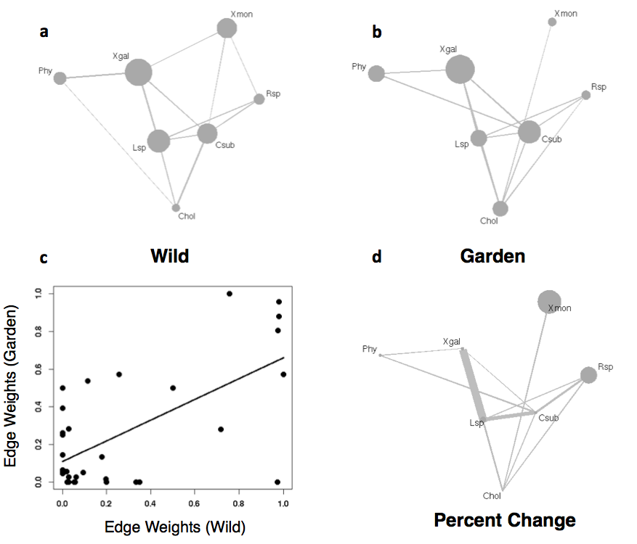

**Figure 1**. Plots showing the significant network patterns for the epiphytic lichen at the scale of the entire stand (**a** and **b**). Species and significant co-occurrence patterns are shown as nodes scaled by log of the relative, total abundance of taxon and lines connecting edges scaled by the dependency value, which is the probability the one species occurs with another species relative to occurring at all. The correlation between the structure of the two stand-level networks (**c**). The network diagram (**d**) shows the percent change (between the wild and garden?) of both the total relative abundances and the edge weights.

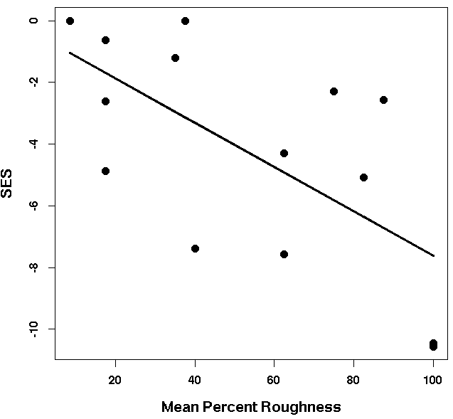

**Figure 2**. Scatterplot showing the significant effect of tree bark roughness and the Standardized Effect Sizes (SES) for individual trees.

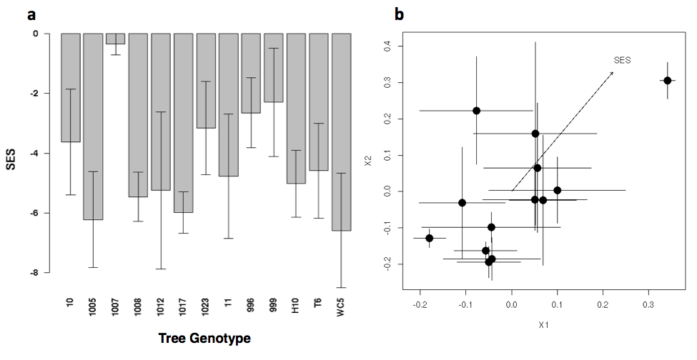

**Figure 3**. The barplot (**a**) shows the mean (±1 S.E.), tree-level standardized effect sizes (SES) on each genotype and the NMDS ordination plot (**b**) shows the ordinated lichen community composition (centroid with bars showing ±1 S.E.) and the multivariate correlation between the ordinated scores and the SES values (arrow scaled by the magnitude of the correlation and oriented in the direction of the correlation).