**Results**

Lichen community communities depended strongly on the phenotypic class of the tree under which they were sampled. The effect of tree phenotype was significant for both species richness and Shannon’s diversity index and marginally significant for total abundance (Table 2). PerMANOVA analysis of the community data, both with and without relativizing by species maxima, also showed a significant effect of tree phenotype on lichen community composition (Table 3, Fig. 2).

As expected, tree phenotype influenced the environmental conditions beneath trees. A PerMANOVA examining the effect of tree phenotypic class on the multivariate set of environmental variables was statistically significant (Table 1). Trees that were from the same phenotypic class tended to be more similar with light availability being the main variable driving this pattern (Fig. 1).

The main tree environmental variables (light and rock availability) both explained variation in lichen communities. The mantel test of the multivariate correlation between environmental and community similarity was significant (P = 0.006, r = 0.229). Thus, trees with more similar environmental variables were more similar to each other in their community composition (Supplemental Materials, Fig. 1).

Structural Equation Modeling supported two indirect mechanistic pathways for the effect of tree phenotype on lichen communities. All of the SEM with tree phenotype as the exogenous variable and hypothesized environmental pathways to lichen abundance, richness and composition were well supported (Fig. 3), although pathway significance varied among these models. For lichen abundance, the only significant pathway was indirect from litter to rock availability to abundance (Fig. 3A). See Supplemental Materials Table 1 for a list of all pathways and their significances.

Outline

*Lichen community varies with tree phenotype*

* GLM table (Table 2)
* Barplots of community summary statistics (Figure 3a-c)
* PerMANOVA (Table 3)
* NMDS of community composition (Figure 3d)
* Indicator species analysis (Table 4)

*Tree phenotype influences local environmental variation*

* PerMANOVA (Table 1)
* NMDS with vectors and points colored by susceptibility (Figure 1)

*Indirect effects of tree phenotype on light and substrate availability determines community composition*

* Mantel
  + r = 0.23 P = 0.005
* Environmental X Community distance plot (Figure 2)
* Path diagram with fit statistics (Figure 4)
* SEM path significances (Appendix 1)

**Tables**

|  |  |  |  |  |  |  |
| --- | --- | --- | --- | --- | --- | --- |
| ENVIRONMENT | |  |  |  |  |  |
| source | Df | SS | MS | F | P-value | R2 |
| Moth | 1 | 0.85818 | 0.85818 | 21.822 | 0.001 | 0.27338 |
| Residuals | 58 | 2.28095 | 0.03933 | 0.72662 |  |  |
| Total | 59 | 3.13913 | 1 |  |  |  |

Table 1. Table for the PerMANOVA test of moth susceptibility on tree environmental variables.

|  |  |  |  |  |
| --- | --- | --- | --- | --- |
| Abundance GLM | |  |  |  |
| Source | Estimate | SE | t | P-value |
| (Intercept) | 0.638827 | 0.117157 | 5.453 | 1.07E-06 |
| Moth:Tree.pairs | 0.018241 | 0.009333 | 1.954 | 0.0555 |
| Richness GLM | |  |  |  |
| Source | Estimate | SE | t | P-value |
| (Intercept) | 1.32339 | 0.08316 | 15.914 | 2.00E-16 |
| Moth:Tree.pairs | 0.02089 | 0.0057 | 3.664 | 0.000248 |
| Diversity GLM | |  |  |  |
| Source | Estimate | SE | t | P-value |
| (Intercept) | 0.7461 | 0.107432 | 6.945 | 3.63E-09 |
| Moth:Tree.pairs | 0.020523 | 0.008558 | 2.398 | 0.0197 |

Table 2. Tables for the effect of moth susceptibility on lichen community abundance, richness and diversity (Shannon’s Index).

|  |  |  |  |  |  |  |
| --- | --- | --- | --- | --- | --- | --- |
| source | Df | SS | MS | F | P-value | R2 |
| env$Moth:env$Tree.pairs | 1 | 0.7518 | 0.75176 | 2.1776 | 0.039 | 0.03654 |
| Residuals | 58 | 20.0227 | 0.34522 |  |  |  |
| Total | 59 | 20.7745 |  |  |  |  |

Table 3. Table for the PerMANOVA test of the effect of tree phenotype on lichen community composition of species maximum relativized data.

|  |  |  |  |
| --- | --- | --- | --- |
| species | cluster | indicator.value | probability |
| Canros | 2 | 0.6397 | 0.006 |
| Acasup | 2 | 0.6295 | 0.002 |
| Acacon | 2 | 0.4769 | 0.001 |
| Acaobp | 2 | 0.4241 | 0.008 |
| Phydub | 2 | 0.4125 | 0.018 |
| Calare | 2 | 0.2966 | 0.036 |

Table 4. Table for the indicator species analysis.

**Figures**

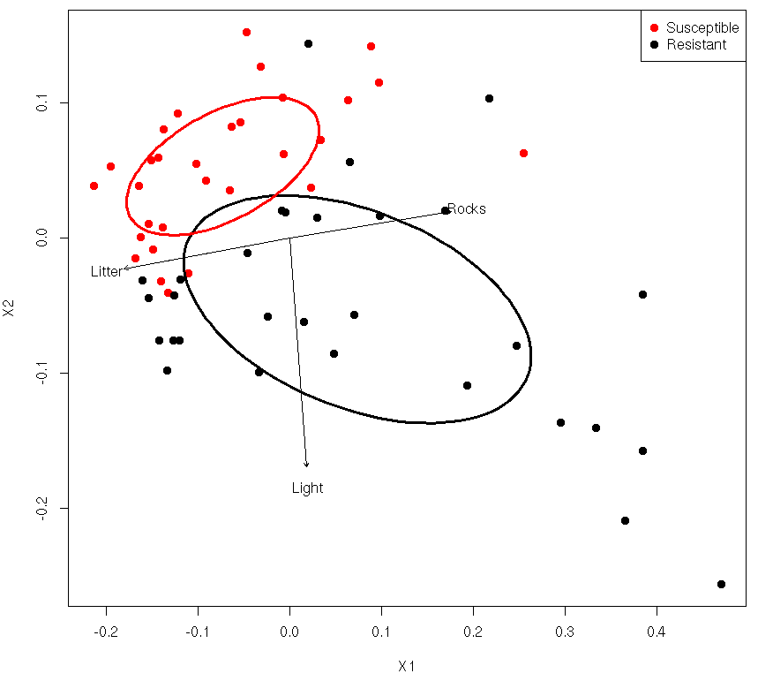

Figure 1. Ordination (NMDS) of individual trees based on their local environmental variables (Black = Resistant, Red = Susceptible). Vectors show the linear correlation of the environmental variables with the ordination axes.

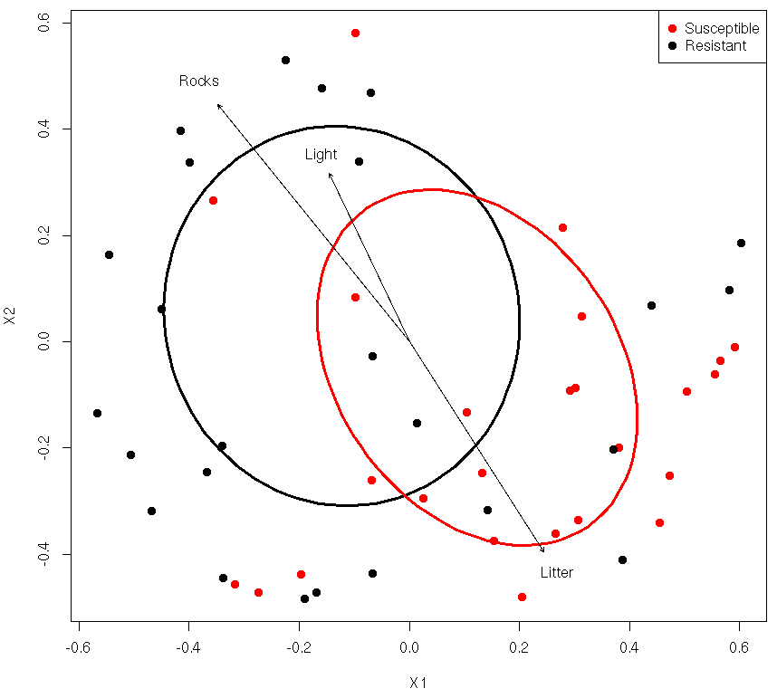

Figure 2. Ordination (NMDS) of individual trees based on their lichen community composition (Black = Resistant, Red = Susceptible). Vectors show the linear correlation of the environmental variables with the ordination axes.

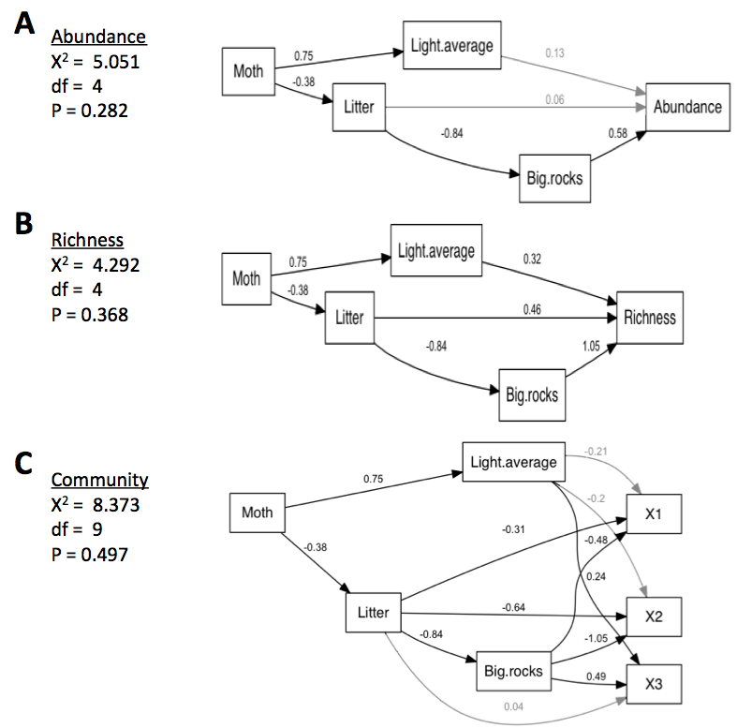

Figure 3. Path diagram showing the standardized path coefficients for the Structural Equation Models (SEM) elucidating causal pathways for Tree Phenotype effects on lichen Abundance, Richness and Community Composition. Non-significant paths (P > 0.05) have been shaded. Community composition was modeled using the axes from a 3 dimensional Non-metric Multidimensional Scaling (NMDS) ordination (X1, X2 and X3).

**Appendix 1**

|  |  |  |  |  |
| --- | --- | --- | --- | --- |
| Appendix SEM path values |  |  |  |  |
| Estimate | From | To | zvalue | Pr(>|z|) |
| g.1.2 | Moth | Light.average | 8.6365177 | 0.00000 |
| g.1.3 | Moth | Litter | -3.1524416 | 0.00162 |
| b.2.5 | Light.average | X1 | -0.9302163 | 0.35226 |
| b.2.6 | Light.average | X2 | -1.0876265 | 0.27676 |
| b.2.7 | Light.average | X3 | 3.326687 | 0.00088 |
| b.3.4 | Litter | Big.rocks | -11.8483246 | 0.00000 |
| b.3.5 | Litter | X1 | 0.1757412 | 0.86050 |
| b.3.6 | Litter | X2 | 0.9444861 | 0.34492 |
| b.3.7 | Litter | X3 | 3.7988627 | 0.00015 |
| b.4.5 | Big.rocks | X1 | -1.5137398 | 0.13009 |
| b.4.6 | Big.rocks | X2 | 0.6063031 | 0.54431 |
| b.4.7 | Big.rocks | X3 | 6.8117662 | 0.00000 |

Table 1. SEM pathway significance values and statistics.

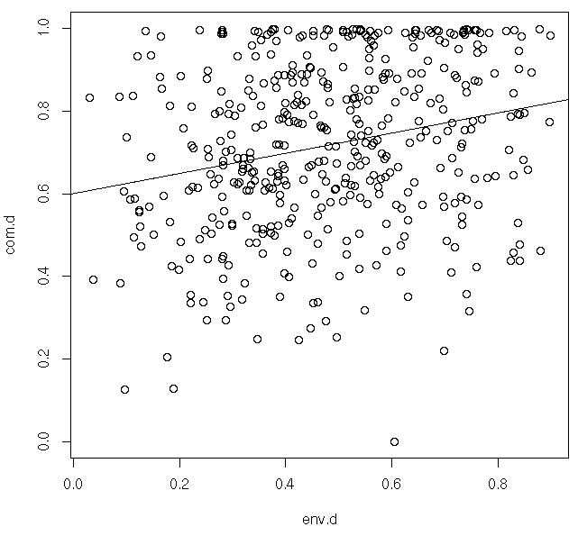

Figure 1. Scatterplot of the correlation between the environmental and lichen community distance values showing that the difference in communities increases with increasing difference in the local environment.