THE GARDEN GROVE ALANO CLUB
CELEBRATES IT’S 30TH ANNIVERSARY

By Bob W.

Garden Grove, CA, February/April 2003—The Alano Club

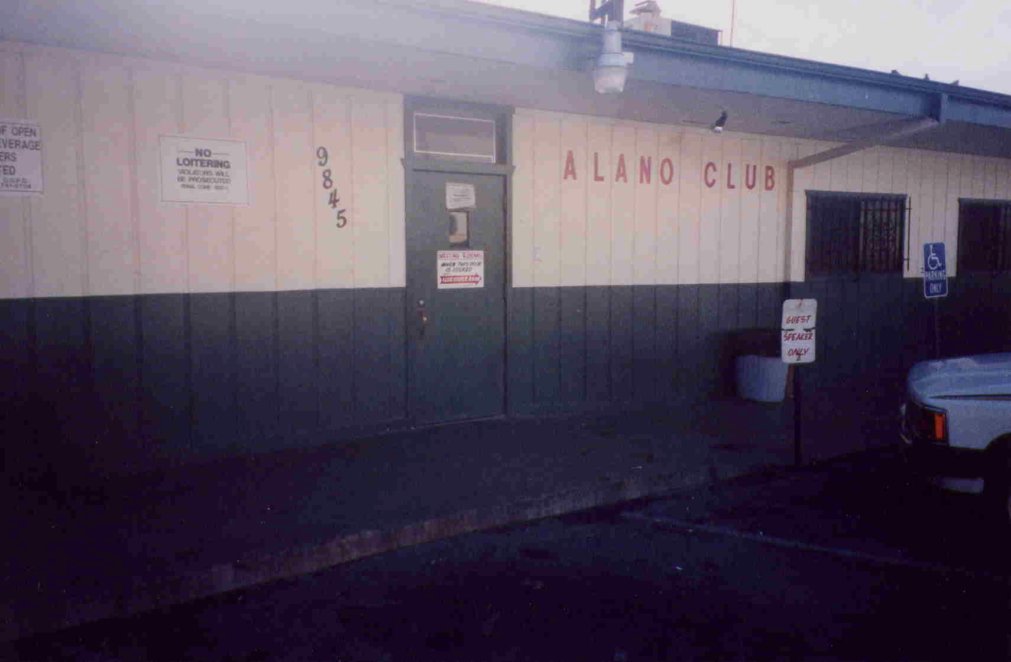
The Garden Grove Alano Club recognized it’s 30 year Anniversary in February with a big celebration at the club. Many old timers were there and shared their stories from the past with those in attendance. The speakers included Ron H, Irene, Vi, Vince, Nancy (Alanon), Herb, Jim, Bob P, Rosemarie, Millie, Michael, Jim, Bettie, Sondra, and many more. A hot turkey dinner was served by the Club for all in attendance. The sobriety countdown started at 57 years. This was the official recognition of the original ratification of the By-Laws marking the Club’s official beginning 30 years ago in 1973.
The GG Alano Club

The origins of this event, however, go back 51 years ago to 1952 when about 6 people were meeting to share their experience, strength and hope to stay sober. The meeting location was the Garden Grove City Chamber of Commerce/Water Dept Building near Garden Grove Boulevard and Main Street. There was no charge for the room. This was the beginning and the focal point of AA in the Orange County area at the time.

To put the time period in perspective, remember that in 1952 WWII had ended just a few years before, the Korean War was under way, the 1st color television was just developed and the Dow Jones Average (DJ) was 250 for most of the year. (Remember Bill W was involved with Wall Street in his early days.) A half-gallon of milk cost about 35¢. AA’s were still using the 1st Edition of the Big Book since publication of the 2nd Edition was still 3 years away in 1955. AA itself had started only 17 years before in 1935 in Akron OH with 2 members. 13 years before, in 1939, there were only 100 members and the 1st Edition of the Big Book had just been released. In 1952, AA in total consisted of less than 150,000 members and 6,000 groups. Hap Adams, alcoholic, and wife Vi, Alanon, were among the original members of the Orange County group.

After meeting in the Garden Grove City Building for a few years, the group had to vacate and Hap found, through an old friend, that the American Legion Hall on Euclid Ave was available. The lease was signed and the group began to meet there. This meeting soon became known as the Saturday Night Speakers Group and numbered about 15 to 20 people. It was “the” place to be on Saturday night for AA’s. Speakers came from all over the Los Angeles and Orange County area to speak at the meeting. The lease was $16 per month and many times Hap and Vi had to make up the difference between the 7th tradition and the lease payment out of their own pocket. But soon the Group grew and the income was sufficient to cover the lease and buy literature and send money to the LA Central Office.

A second group meeting in OC started around 1956 in a small shack at the rear of a gas station on the corner of Garden Grove Blvd and Hope Street. Hap got about 8 AA members to work on the shack and fix it up to be a meeting room. It turned out to be a real comfortable place. It became known as the Tuesday Night Stag Group. This lasted about a year when the property was sold to a car agency and the meeting had to be moved.

Hap had a family friend, Mrs. Eggy, who had built her home on Garden Grove Blvd and he remembered that while she was building it she had lived in a small house on the property which was to be the guest house after the new house was finished. Nothing had been done to the little house for years and, in the meantime, had become a junk collection station. Hap talked to her about the little house and she being sympathetic with AA, let the group use it for the price of the utilities. After being fixed up it was a real beautiful meeting place with plenty of parking, well lighted, landscaped, open fireplace, big kitchen, off the boulevard and quiet. The Wednesday Night Serenity Group started here.

Meanwhile the Legion Hall meeting was still going and the rent had increased to $40 a month and consisted of about 20 members.

In the late 60’s the Legion Hall was going to be torn down so the group had to find a new place. One Sunday about 60 members of AA and Alanon gathered to pledge donations and to volunteer to work on a new building. About 10 people put up $100 each to sign a lease for a new place. Some of the initial members involved were Bob and Millie Cox, Argo, Jim and Laura Gregory, Ron Watson, Hap and Vi Adams.

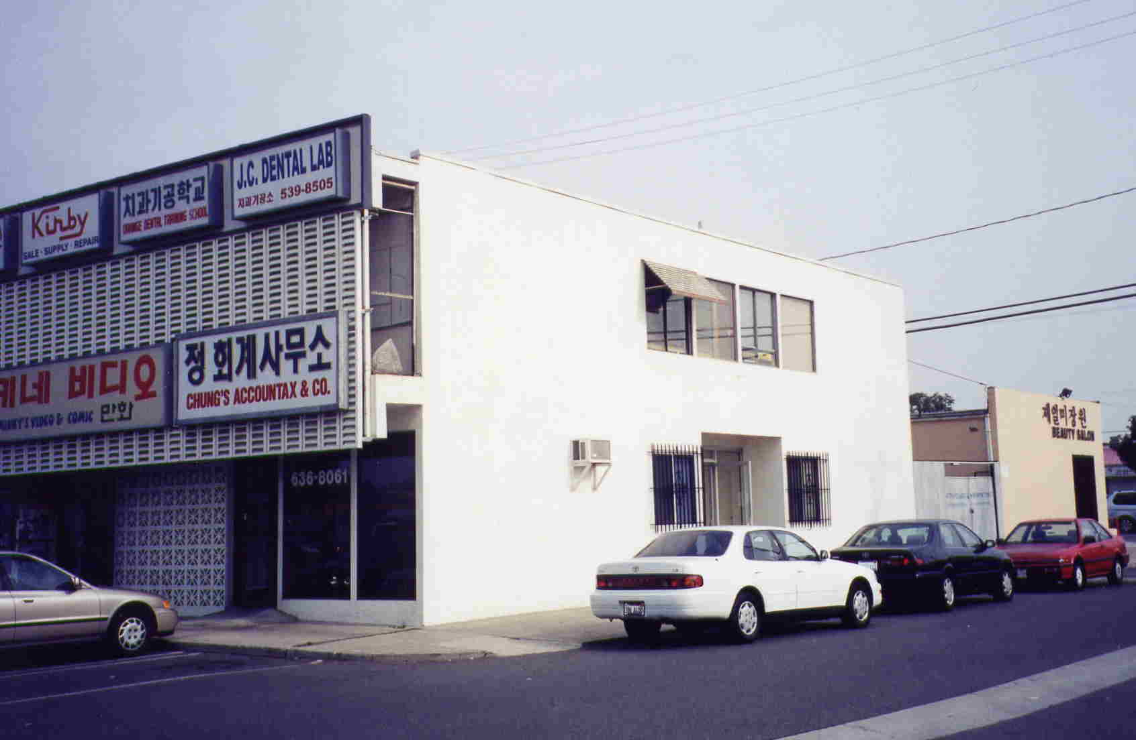
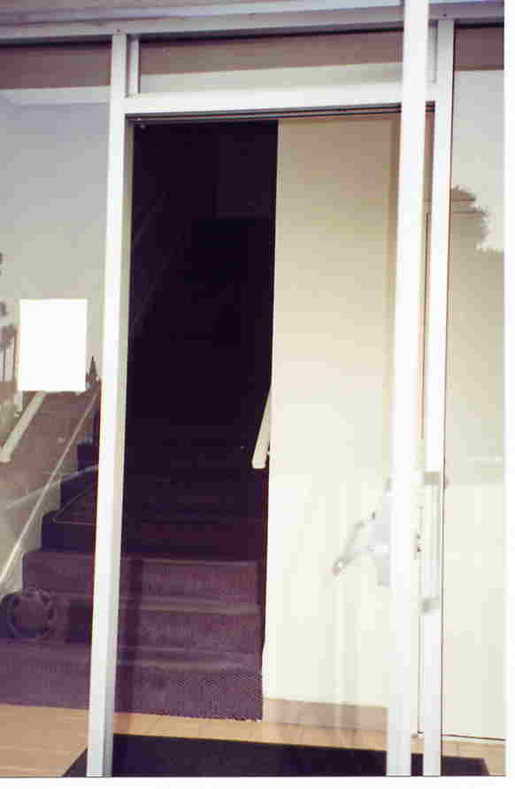
So in 1971 the group moved into the second floor of a 2 story building at 9636 Garden Grove Boulevard just South-West of the intersection of Garden Grove Blvd and Galway close to were the Club is located today. There were 17 steps leading up to the second floor and the meeting rooms symbolizing to many a connection with the 12 Steps of AA.

By this time the DJ was around 900, the Vietnam War was on, Watergate was in the news, OPEC had embargoed oil and that half-gallon of milk now cost about 60¢. There were 4 or 5 groups that agreed to meet in the new location. There were no salaried employees for the first year the club was in operation because there was not enough money. By-Laws were adopted in 1973 whose anniversary is being celebrated at this event today.

By 1976 the Club had 5 paid employees working for a very nominal fee and there were 23 groups meeting there. The employees were either retired drawing social security or had regular employment elsewhere. By 1976 the Club was self-supporting. The facilities consisted of a big room, coffee bar, office room and a second meeting room with a pool table. It was the pool room where the women used to meet. The big room was expanded to accommodate the speaker meetings. There was a room with the number 25 on the door where smaller meetings took place. This became known as Room 25 even after the number was taken off the door. In the beginning there was someone selling alcohol in the building but after a while gave up and AA occupied the whole 2nd floor.

The meetings here were a family affair. Alanon met regularly and events were arranged jointly by both the Alanon and AA members. The place was really kept clean and the 1st Christmas party and New Years dance were held here.

After a while the rent increased and the building was bought by a new owner. Subsequently it became necessary to again look for another place to call home for the AA members.

In 1982 the current location at 9845 Belfast Drive was acquired. Located just south of Garden Grove Boulevard between Galway and Brookhurst Way, the current facility consists of a big room to the right of the main entrance, medium size room to the left, a small room in the back, a patio area outside and a counter area for coffee and snacks.
The Meeting Place in 1971
A private area with a separate entrance for dues-paying members is located on the West end of the building. This area consists of a counter area for coffee and a room with a pool table.
When the current location was first occupied in 1982, the DJ was still in the 900 range, the first Space Shuttle had flown, the Iran hostage crisis was in the news, Reagan had been shot and that half-gallon of milk now cost $1.25. Updated By-Laws adopted at this time stipulated that there would be a 7 member board of Directors and 5 would constitute a quorum, unchanged today.
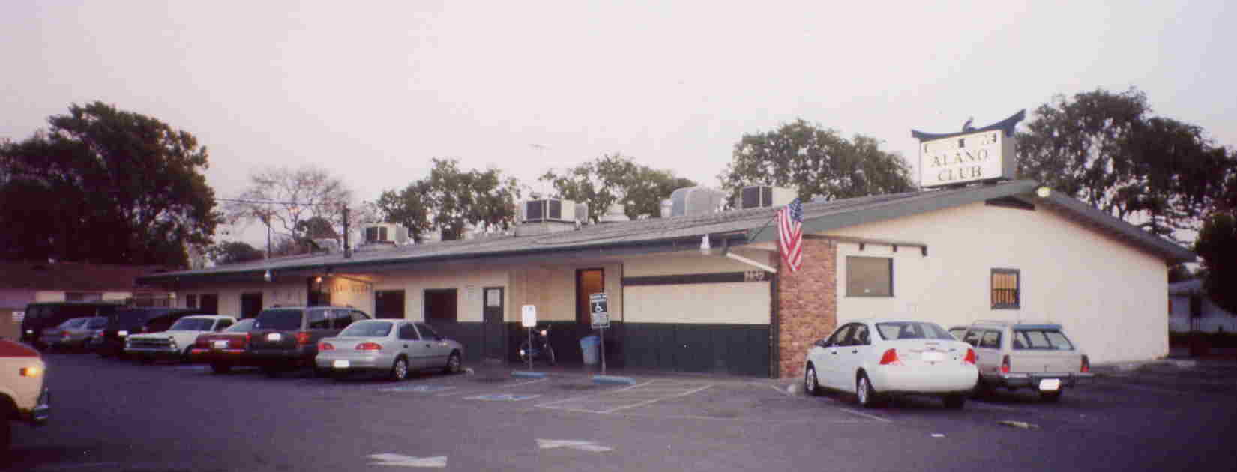

The Club Today

The dues were $5/month or $50/year in 1983 and today this has increased to $8.50/month or $85/year.

Today in 2003 the Club is in full operation with 47 scheduled meetings per week. Some of the current attendees (contributing to this article) are Hope, Millie, Vi, Bob P, Sondra, Pete B, John E and Bob W. Worldwide AA membership stands at over 2 million. The DJ is about 8000 after one of the longest recessions in history, we are

about to go to war a second time with Iraq and that half-gallon of milk now costs $2.35.

But one thing that has not changed is the reason the Club began in 1952. That is that alcoholics and Alanons need support and a place to share the experience, strength and hope of the program. So to all who have contributed to the event celebrated here today –Thank You. And to all of us here today, it is our responsibility to continue the legacy of this Club and help the alcoholic who still suffers, one at a time.

###
.

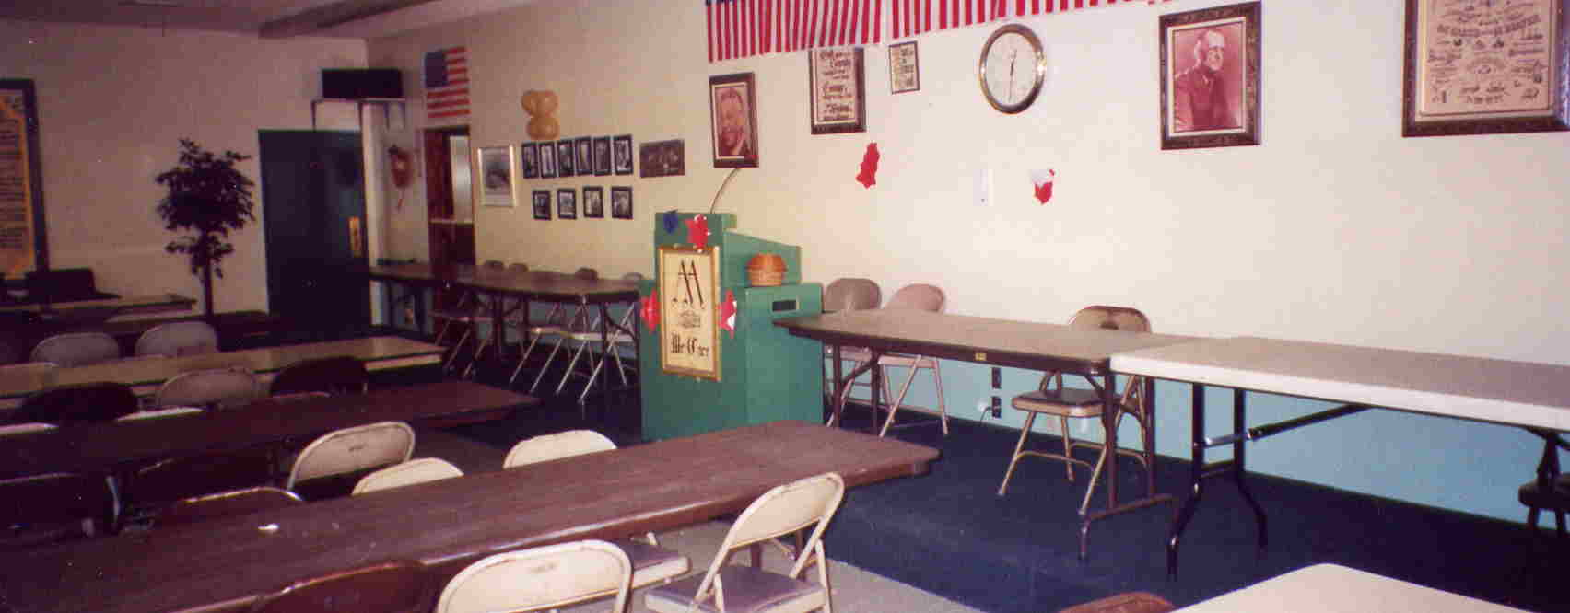
The “Big Room” Where the Celebration was Held

