Empirical Results, Diagnostics, Limitations, and Conclusion
Battery build-out and the shape of California electricity prices
Main finding. After demand, solar, delivered gas cost, calendar effects, and a linear trend are included, the estimated association between battery power capacity and the SP15 evening-minus-midday price spread is close to zero and very imprecise.

Results
The merged file contains all 976 operating dates from 1 May 2023 to 31 December 2025. The adjusted EIA-930 demand and solar fields are blank for all hours on 2 November 2024, so the pre-specified complete-window rule leaves 975 observations. No value was imputed. The mean daily SP15 evening-minus-midday spread was 45.18 USD/MWh (standard deviation 41.48; median 38.56). Its range, from -0.11 to 841.08 USD/MWh, reflects both occasional near-zero spreads and genuine scarcity-price episodes. Operating battery power capacity increased from 4.856 GW to 15.435 GW over the sample.
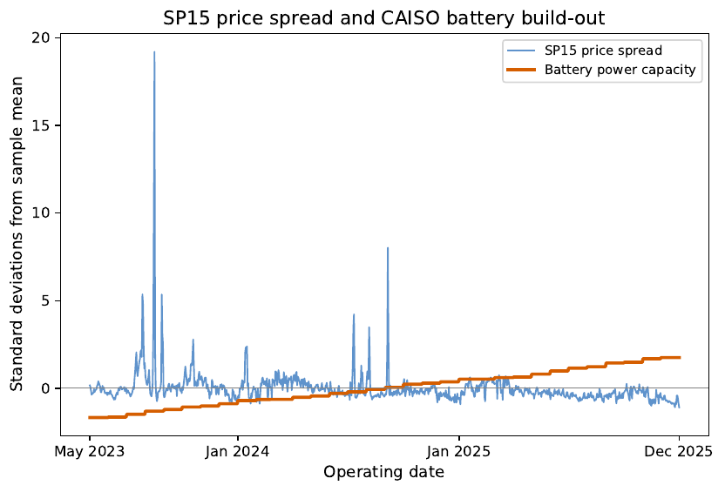
Figure 1. Daily SP15 spread and operating battery power capacity, standardized only for visual comparison. Regressions use original units.
The nested estimates show why the conditional specification matters. With battery capacity as the only regressor, an additional GW is associated with a 3.755 USD/MWh narrower spread (HAC SE 0.805, p < 0.001). Adding the demand gap, solar drop, and gas price yields -2.765 (SE 0.598, p < 0.001). Once weekday and month indicators and the linear trend are added, however, the battery coefficient becomes 0.645 USD/MWh per GW (HAC SE 8.012, p = 0.936), with a 95% confidence interval from -15.059 to 16.349. The baseline R-squared is 0.286. Thus, the full model neither supports a precisely negative association nor rules out economically meaningful effects in either direction. The sign change should not be read as evidence that batteries widen spreads; it shows that the raw negative relationship is largely inseparable from common time movement and calendar/fundamental differences in this short sample.
Regressor | Coefficient | HAC SE | p value | 95% CI
Battery power capacity (GW) | 0.645 | 8.012 | 0.9359 | [-15.059, 16.349]
Evening-minus-midday demand (GW) | 4.449 | 1.244 | <0.001 | [2.012, 6.887]
Midday-minus-evening solar (GW) | 1.571 | 0.621 | 0.0115 | [0.353, 2.788]
FRSCE3 delivered gas cost (USD/MMBtu) | 9.534 | 2.639 | <0.001 | [4.361, 14.707]
Linear trend (years) | -11.539 | 33.068 | 0.7271 | [-76.351, 53.273]
Table 1. Full baseline OLS coefficients with seven-lag Newey-West/HAC standard errors. Weekday and month indicators are included but omitted from the compact display. N = 975.
The fundamentals have economically intuitive conditional associations. A one-GW larger evening-minus-midday demand gap is associated with a 4.449 USD/MWh wider price spread (p < 0.001); a one-GW larger solar drop is associated with a 1.571 USD/MWh wider spread (p = 0.012); and a one-USD/MMBtu higher delivered gas cost is associated with a 9.534 USD/MWh wider spread (p < 0.001). These coefficients are controls within an observational model, not separately identified causal effects.

Diagnostics and focused checks
Serial dependence is substantial. The Durbin-Watson statistic is 0.918, and the seven-lag Breusch-Godfrey F statistic is 63.42 (p < 0.001). The residual autocorrelation is about 0.54 at one day and remains outside the approximate reference bands at several later lags. Seven-lag HAC standard errors are therefore the primary inference. HAC adjusts the estimated covariance matrix; it does not remove omitted dynamics or turn the model into a causal design.
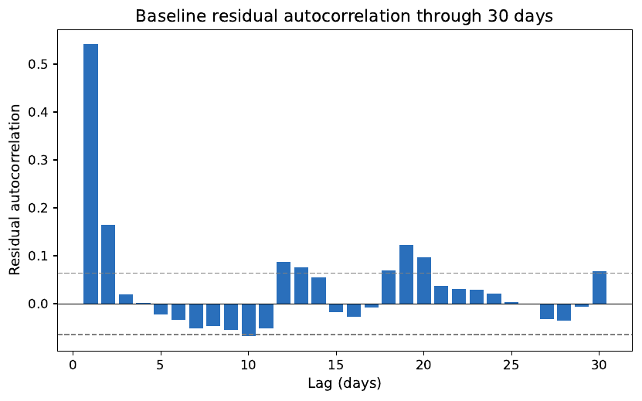
Figure 2. Baseline residual autocorrelation through 30 days. Dashed lines are approximate 95% reference bands.
Battery capacity and the linear trend have a correlation of 0.9975, with VIFs of 391.3 and 387.2. This severe multicollinearity is the central precision problem: the sample contains 975 daily outcomes but only 32 monthly capacity levels, and capacity rises almost monotonically. High VIFs do not bias OLS by themselves, but they greatly widen the separate confidence intervals for capacity and trend. The augmented Dickey-Fuller checks with a constant, trend, and seven lagged differences reject a unit root for each principal series (all p <= 0.0031). Even so, the monthly first-difference estimate is -21.017 (SE 17.094, p = 0.219), so the pre-specified alternative treatment of common trends is also imprecise.
Ten days have absolute externally studentized residuals above three. They cluster around identifiable high-price episodes, including 15-16 August 2023 and 5-6 September 2024, and the source checks provide no evidence that they are transcription errors. Retaining these genuine extremes is appropriate for the primary model. Excluding them changes the battery estimate to -0.787 (SE 4.952, p = 0.874), leaving the substantive conclusion unchanged.
Specification or outcome | Estimate (HAC SE) | p value | 95% CI | N
Full baseline [GW] | 0.645 (8.012) | 0.936 | [-15.059, 16.349] | 975
Additional one-month lag [lagged GW] | 2.271 (6.524) | 0.728 | [-10.515, 15.058] | 944
Exclude |studentized residual| > 3 [GW] | -0.787 (4.952) | 0.874 | [-10.492, 8.918] | 965
Add FRSCE3 tariff-break indicator [GW] | 4.791 (8.226) | 0.560 | [-11.332, 20.915] | 975
Monthly first differences [change in GW] | -21.017 (17.094) | 0.219 | [-54.521, 12.487] | 31
Energy-capacity alternative [GWh] | 1.588 (0.844) | 0.060 | [-0.066, 3.242] | 975
Evening LMP outcome [GW] | 4.010 (8.985) | 0.655 | [-13.599, 21.620] | 975
Midday LMP outcome [GW] | 3.365 (5.256) | 0.522 | [-6.936, 13.667] | 975
Negative-price hours outcome [GW] | -1.403 (0.797) | 0.078 | [-2.965, 0.159] | 975
Table 2. Pre-specified focused checks. Estimates are per unit of the battery measure shown in brackets. The monthly first-difference model has 31 monthly changes.
The additional timing lag uses the preceding monthly exposure and begins in June 2023, leaving 944 complete days. Its coefficient is 2.271 (SE 6.524, p = 0.728), again providing no precise negative association. Adding the FRSCE3 tariff-break indicator, removing extreme-residual days, and replacing power capacity with energy capacity do not generate a robust negative result. The energy-capacity estimate is positive and marginal at the 10% level, but its 95% interval still includes zero and it is exposed to the same common-trend problem. Component regressions are also uninformative: the battery coefficients for evening and midday prices are 4.010 and 3.366, respectively, and neither is significant. For the secondary negative-price-hours outcome, the coefficient is -1.403 hours per GW (p = 0.078; 95% CI -2.965 to 0.159). This is suggestive at most, remains imprecise at the conventional 5% level, and should not displace the pre-specified spread outcome.

Limitations and interpretation
The estimates are conditional historical associations, not causal effects. Expected arbitrage opportunities may encourage storage investment, creating reverse association. Other changes - solar additions, thermal retirements, transmission, hydrology, imports, outages, carbon costs, and market rules - may co-move with capacity and prices. Calendar indicators and a linear trend cannot guarantee that all such factors are removed. The extreme capacity-trend correlation also means that this sample has little independent low-frequency variation with which to separate storage build-out from the passage of time.
Measurement adds further limits. EIA-860M records nameplate utility-scale capacity, not dispatch availability, state of charge, bidding, degradation, duration, or ancillary-service participation, and it excludes sub-1-MW and behind-the-meter resources. CAISO-wide demand and solar controls do not perfectly match the SP15 trading hub. FRSCE3 is a reproducible delivered gas-cost proxy that includes transportation and in-kind reimbursement, not the stand-alone ICE commodity index; the tariff-break check reduces but cannot eliminate this measurement difference. Finally, the May 2023-December 2025 period covers only 32 monthly exposure levels, so the daily observation count overstates the amount of independent capacity variation.

Conclusion
California's battery build-out coincided with a narrower SP15 evening-minus-midday spread in simple specifications, but that negative association disappears after the pre-specified fundamentals, calendar effects, and trend are included. The baseline estimate is 0.645 USD/MWh per GW, with a wide confidence interval spanning economically meaningful negative and positive values. Timing, outlier, tariff, first-difference, energy-capacity, and component-price checks do not overturn this conclusion. The study therefore does not find precise evidence that installed battery capacity independently narrowed the daily SP15 price spread during May 2023-December 2025; equally, it does not establish that batteries had no effect. A more credible causal estimate would require longer exposure variation or plausibly exogenous deployment or operating shocks, ideally combined with direct battery dispatch data.

