Software Engineering Documentation — Data Analytics Track
GLOBAL AIR QUALITY
Monitoring, Analyzing, and Forecasting Air Quality Across the Globe
PROGRAM / COHORT: GIZ4_DAT1_S4
July 7, 2026
Supervisor
Engineer Mohamed El Emam
Project Team
Mohamed Kamel
Omar Fathy
Hasnaa Mohamed
Marwan Emad
Moustafa Khaled
Table of Contents
Executive Summary
1 Project Overview
1.1 Introduction
1.2 Problem Statement
1.3 Proposed Solution
1.4 Project Scope
1.5 Data Source
1.6 Key Performance Indicators
1.7 Main Dashboard Pages
1.8 SMART Questions & Findings
2 Technical Architecture
2.1 Tools Used
2.2 Medallion Architecture
2.3 End-to-End Pipeline Flow
2.4 Data Model (Star Schema)
2.5 Functional Requirements
2.6 Non-Functional Requirements
3 Data Engineering
3.1 Bronze Layer — Raw Ingestion
3.2 Silver Layer — Cleaning & Transformation
3.3 Gold Layer — Star Schema Build
3.4 Gold Layer Data Dictionary
3.5 Data Quality Summary
4 Dashboard & Visualization
4.1 Design System
4.2 Dashboard Wireframes
4.3 Custom Visuals
4.4 AQI Page
4.5 Categories Page
4.6 Time Page
4.7 Temperature Page
4.8 Humidity Page
4.9 Wind, Dew & UVI Page
4.10 Filtering & Interactivity
5 Testing & Validation
6 Challenges Faced
7 Limitations & Future Improvements
8 Conclusion
9 References
Executive Summary
Global Air Quality is an end-to-end data analytics project that transforms raw, quarter-scale air-quality and weather observations into a governed, decision-ready Power BI dashboard. The project was developed under the S4 cohort and follows industry-standard data engineering practice throughout: a three-layer Medallion Architecture (Bronze, Silver, Gold), a dimensional star schema, and a design-first Power BI dashboard branded as "AeroScan."
The underlying dataset, sourced from the World Air Quality Index (WAQI) project's Q4 2023 archive, covers 238 cities across 46 countries over a 92-day observation window (1 October – 31 December 2023), producing 21,238 fact-level daily records after cleaning. The pipeline computes a composite Air Quality Index (AQI) from four normalized pollutant sub-indices (PM2.5, PM10, NO2, and SO2/O3), classifies each reading into Safe / Healthy, Polluted / Unhealthy, or Hazardous bands, and enriches every record with time-intelligence attributes (weekday flag, month, season).
The resulting analysis shows that air quality is heavily concentrated by geography: a small number of cities — led by Dhaka, Bangladesh — account for a disproportionate share of Polluted and Hazardous readings, while the majority of monitored cities (roughly 61% of all valid readings globally) remain within the Safe / Healthy band throughout the quarter. A modest but measurable relationship also emerges between AQI and weather conditions, with temperature showing a positive correlation to AQI and humidity showing a negative correlation, findings that are explored in depth in Chapter 4.
This document is organized to walk the reader through the full solution: the project's motivation and scope, the technical architecture and tools, the three-layer data engineering pipeline with full transformation logic, the final dashboard experience across six analytical pages, and a closing discussion of testing, limitations, and future work.
CHAPTER 1
Project Overview

1. Project Overview
Air pollution is one of the most pressing environmental and public-health challenges of the modern era, affecting billions of people across urban and rural regions alike. The World Health Organization has repeatedly identified ambient air pollution as a leading environmental risk factor for cardiovascular and respiratory disease. As monitoring networks expand and open datasets become more widely available, there is a growing opportunity to apply structured data engineering and analytics practices to transform raw sensor readings into actionable insight for researchers, policymakers, and the public.
The Global Air Quality project is a graduation project developed under the S4 cohort. It builds a complete, end-to-end analytics pipeline — from raw data ingestion through a three-layer Medallion Architecture (Bronze, Silver, and Gold) to a fully interactive, multi-page Power BI dashboard — that surfaces how air quality varies across countries, cities, seasons, and weather conditions worldwide.

1.1 Introduction
The project ingests a global air-quality and weather observation dataset sourced from the World Air Quality Index (WAQI) project, covering the fourth quarter of 2023 (October–December). The raw readings are cleaned, structured, and modeled into a star schema, then surfaced through a six-page Power BI dashboard that allows users to explore Air Quality Index (AQI) behavior alongside temperature, humidity, dew point, wind gust, and UV index across 238 cities in 46 countries.
Project objectives span three complementary domains:
- Data Engineering: Ingest and structure raw WAQI observations using a Bronze/Silver/Gold Medallion pipeline, producing a clean, query-ready star schema.
- Dimensional Modeling: Design a star schema in the Gold layer consisting of a central fact table (weather and AQI measures) surrounded by Location and Date dimension tables.
- Dashboard Development: Build a multi-page interactive Power BI dashboard — designed first in Figma — covering AQI overview, category distribution, temporal trends, temperature, humidity, and combined wind/dew/UVI analysis.

1.2 Problem Statement
Raw air-quality monitoring feeds, including the WAQI archive used in this project, are published as long-format, per-species observation logs: every pollutant and weather reading for a given city and date appears as its own row, with inconsistent casing, mixed units, occasional duplicate submissions, and a meaningful share of missing or physically implausible values (for example, negative pollutant concentrations, or a recorded minimum reading that exceeds the recorded maximum). In this raw form, the data cannot be directly queried, visualized, or compared across cities and time periods without introducing errors or misleading conclusions.
Without a disciplined transformation pipeline, any downstream analysis risks three concrete failure modes: (1) double-counting from unresolved duplicate rows, (2) distorted averages caused by unvalidated outliers and impossible readings, and (3) an inability to compare pollution levels on a common scale, since raw pollutant concentrations are not directly comparable across species or regulatory frameworks.

1.3 Proposed Solution
The project addresses these problems with a three-stage Medallion pipeline that separates concerns cleanly: the Bronze layer preserves an untouched, auditable copy of the source data; the Silver layer performs all cleaning, validation, and feature engineering — including calculating a single composite AQI value normalized across four pollutant sub-indices; and the Gold layer reshapes the cleaned data into a star schema purpose-built for fast, reliable querying in Power BI.
This layered approach ensures that every transformation is traceable to its source, that data-quality rules are enforced once and centrally rather than repeatedly and inconsistently at the reporting layer, and that the final dashboard always reflects a governed, reproducible dataset rather than an ad-hoc spreadsheet extract.

1.4 Project Scope
The current scope of the Global Air Quality project covers:
- Ingestion and processing of the WAQI Q4 2023 archive (October–December 2023) across 46 countries and 238 cities.
- A composite AQI calculation derived from PM2.5, PM10, NO2, and SO2/O3 pollutant readings, alongside six weather measures (temperature, pressure, humidity, dew point, precipitation, wind gust, UV index).
- A three-table Gold-layer star schema (one fact table, two dimension tables) optimized for Power BI.
- A six-page interactive Power BI dashboard covering AQI ranking, category distribution, temporal trends, temperature, humidity, and combined wind/dew/UVI analysis, filterable by day, month, season, city, and country.
Out of scope for the current release: real-time / streaming ingestion, pollutant-level breakdowns beyond the composite AQI, forecasting or predictive modeling, and coverage of seasons outside Autumn and Winter (see Chapter 7 — Limitations & Future Improvements).

1.5 Data Source
The dataset used in this project is sourced from the World Air Quality Index (WAQI) project's COVID-19 air quality data archive, covering daily observations for Q4 2023. WAQI aggregates observations from thousands of government and research monitoring stations worldwide into a unified, openly accessible feed, making it a widely used reference dataset for air-quality research.
Attribute | Detail
Dataset Name | WAQI COVID-19 Air Quality Data (2023 Q4)
Source | World Air Quality Index (WAQI) Project
Coverage Period | 1 October 2023 – 31 December 2023 (92 days)
Countries Covered | 46
Cities Covered | 238
Raw Format | Long-format CSV: one row per city, date, and observed species (pollutant or weather metric)
Fact-Level Records (post-cleaning) | 21,238 daily city-level observations
File Format | CSV, processed through the pipeline into a star schema

In its raw form, each record represents a single measured species (e.g., pm25, temperature, humidity) for one city on one date, with summary statistics (min, max, median, variance, count) rather than a single reading — reflecting WAQI's own aggregation of multiple readings per day per station. The Silver layer pivots this long-format structure into a wide, analysis-ready table (see Section 3.2), after which each row represents one city on one date with all relevant species as columns:
Column | Description
country / city | Location identifiers, later normalized into the Location dimension
date | Observation date, normalized into the Date dimension
temperature | Daily average temperature (°C)
pressure | Atmospheric pressure (hPa)
humidity | Relative humidity (%)
dew | Dew point (°C)
precipitation | Daily precipitation
wind gust | Wind gust speed
uvi | UV Index
AQI | Computed Air Quality Index value
AQI_label | Categorical label: Safe / Healthy, Polluted / Unhealthy, Hazardous, or Unknown
AQI_sort_order | Numeric ordering key for the AQI category

1.6 Key Performance Indicators
The Power BI dashboard surfaces the following headline KPIs, computed directly from the Gold-layer fact table and cross-checked against the underlying data:
KPI | Value | Dashboard Page
Average AQI (by city) | 1.05 | AQI
Maximum AQI | 20.87 | AQI
Minimum AQI | 0.00 | AQI
Most Polluted Country | Bangladesh (BD) | AQI
Most Polluted City | Dhaka | AQI
Cleanest Country | Malaysia (MY) | AQI
Cleanest City | Taiping | AQI
No. of Readings | ≈ 20,000 | Categories
Safe Readings | ≈ 13,000 (66.6%) | Categories
Polluted Readings | ≈ 4,000 (22.9%) | Categories
Hazardous Readings | ≈ 2,000 (10.6%) | Categories
Weekday / Weekend Split | 65 weekdays / 27 weekend days | Time
Cleanest Day | 29 October 2023 | Time
Most Polluted Day | 1 December 2023 | Time
Average Temperature | 11.11 °C | Temperature
Temperature Range | −32.30 °C to 49.00 °C (range 81.30) | Temperature
Hottest City | Jakarta | Temperature
Coldest City | Krasnoyarsk | Temperature
Average Humidity | 76.34% | Humidity
Most / Least Humid City | Helsinki / Taiping | Humidity
Average UVI | 4.26 | Wind, Dew, UVI
Average Dew Point | 7.71 | Wind, Dew, UVI
Average Wind Gust | 9.38 | Wind, Dew, UVI

1.6.1 Pollution Ranking — Top and Bottom Countries
Ranking every country by its average AQI across the full Q4 2023 window shows pollution heavily concentrated in a small set of countries, with the ten most polluted countries averaging well above the global mean of 1.05, and the cleanest countries averaging well below it:
Rank | Most Polluted Countries | Avg. AQI | Cleanest Countries | Avg. AQI
1 | Bangladesh (BD) | 12.36 | Switzerland (CH) | 0.16
2 | Mali (ML) | 7.34 | Bulgaria (BG) | 0.27
3 | Bahrain (BH) | 6.64 | Romania (RO) | 0.27
4 | Turkmenistan (TM) | 6.21 | Jordan (JO) | 0.34
5 | Indonesia (ID) | 4.75 | Finland (FI) | 0.35
6 | Laos (LA) | 4.69 | Philippines (PH) | 0.35
7 | Sri Lanka (LK) | 4.11 | Russia (RU) | 0.38
8 | Côte d'Ivoire (CI) | 4.05 | Denmark (DK) | 0.39
9 | El Salvador (SV) | 3.32 | Sweden (SE) | 0.44
10 | Kosovo (XK) | 2.89 | Malaysia (MY) | ≈ 0.00 *
* Malaysia is reported as the dashboard's cleanest country based on its Taiping station; national coverage for Malaysia in the dataset is limited, so this figure should be read alongside the broader cleanest-country list rather than in isolation.
Dhaka, Bangladesh is both the most polluted city and the anchor of the most polluted country, with an average AQI of 12.36 — more than eleven times the global average — placing it firmly in the Hazardous band for a substantial share of the quarter.

1.6.2 Relationship Between AQI and Weather Conditions
A correlation analysis between AQI and the six weather measures in the fact table reveals a moderate positive relationship with temperature and a moderate negative relationship with humidity, with the remaining weather factors showing weak or negligible linear association:
Weather Factor | Correlation with AQI | Interpretation
Temperature | +0.26 | Warmer days tend to coincide with modestly higher AQI
Dew Point | +0.12 | Weak positive association
UV Index | +0.10 | Weak positive association
Pressure | +0.05 | Negligible association
Wind Gust | +0.04 | Negligible association
Humidity | −0.20 | Higher humidity tends to coincide with modestly lower AQI
These correlations are consistent with established air-quality science: higher humidity can promote particulate settling and wet deposition, which tends to reduce measured particulate pollution, while warmer, drier conditions are more commonly associated with photochemical pollution formation. None of the observed correlations are strong enough to imply a dominant single driver of AQI in this dataset — geography and local emission sources remain the primary differentiator, as shown in Section 1.6.1.

1.7 Main Dashboard Pages
The dashboard is structured as a filterable, single-canvas experience with a persistent left-hand navigation panel of five common slicers (Day, Month, Season, City, Country) and a topic switcher (AQI, Categories, Time, Temperature, Humidity, Wind/Dew/UVI):
Page | Focus Area | Key Visuals
AQI | Pollution ranking by city and country | KPI cards, bar chart, pie chart, treemap, ranked bar chart
Categories | AQI category distribution (Safe / Polluted / Hazardous) | KPI cards, donut chart, stacked area chart, stacked bar charts
Time | Temporal patterns across days, months, seasons | KPI cards, line chart, bar charts by day-type / month / season
Temperature | Temperature extremes and geographic distribution | KPI cards, line chart, scatter plot, ranked bar charts
Humidity | Humidity extremes and its relationship with AQI | KPI cards, line chart, scatter plot, ranked bar chart
Wind, Dew, UVI | Combined weather-factor analysis | KPI cards, three scatter plots, grouped bar and line charts

1.8 SMART Questions & Findings
The analysis is guided by SMART (Specific, Measurable, Achievable, Relevant, Time-bound) research questions derived from the dataset structure and the project's analytical objectives. Each question is answered directly by the dashboard and summarized below:
# | SMART Question | Finding
1 | Which countries and cities recorded the highest average AQI during Q4 2023? | Bangladesh / Dhaka led all countries and cities with an average AQI of 12.36 — over 11x the global average
2 | What proportion of daily readings fell into Safe, Polluted, and Hazardous categories? | 61.2% Safe / Healthy, 21.0% Polluted / Unhealthy, 9.7% Hazardous, 8.1% Unknown (unclassifiable)
3 | Does air quality differ measurably between weekdays and weekends, or across seasons? | Weekday AQI (1.07) is marginally higher than weekend AQI (1.02); Winter AQI (1.17) is clearly higher than Autumn AQI (0.99)
4 | Is there an observable relationship between temperature, humidity, and AQI? | Temperature correlates positively with AQI (+0.26); humidity correlates negatively (−0.20) — both moderate, not dominant, effects
5 | Which cities experience the most extreme temperature, humidity, and UV conditions? | Jakarta is hottest (avg.) and Krasnoyarsk coldest; Helsinki is most humid and Taiping least humid; average UVI across all cities is 4.26
CHAPTER 2
Technical Architecture

2. Technical Architecture
This chapter documents the tools, architectural pattern, and data model that form the technical backbone of the project. The pipeline follows a three-layer Medallion Architecture (Bronze → Silver → Gold) and outputs a star-schema dimensional model consumed directly by Power BI. This chapter also documents the functional and non-functional requirements that shaped the pipeline's design.

2.1 Tools Used
Tool / Platform | Role in Project
Python (pandas, NumPy) | Core data engineering language used to build the Bronze, Silver, and Gold pipeline notebooks
Google Colab | Notebook execution environment for all three pipeline stages
Power BI | Business intelligence platform used to build the six-page interactive dashboard
Figma | UI/UX design and dashboard wireframing tool used to plan the dashboard's layout and visual identity before implementation in Power BI
Power BI Custom Visuals | Additional visuals imported into the report, including Table Heatmap and Inforiver Super Filter
Python and pandas were used to implement the Bronze, Silver, and Gold layer transformations as standalone, well-logged scripts. Each stage prints a structured execution summary (row counts, column counts, and validation checks) to make the pipeline auditable at every step. Power BI serves as the presentation layer, connecting to the Gold-layer CSV outputs to build the KPI cards, charts, and cross-filtering slicers described in Chapter 4.

2.2 Medallion Architecture
Data flows through three logical layers. The Bronze layer preserves the raw ingested data with added ingestion metadata; the Silver layer cleans, validates, reshapes, and enriches the data with calculated AQI and time features; the Gold layer restructures the cleaned data into a star schema optimized for Power BI performance.
Layer | Purpose | Key Operations
Bronze | Raw ingestion | Load raw CSV, validate structure, tag each record with an ingestion timestamp and source-file name, persist unmodified
Silver | Cleaning, validation & feature engineering | Standardize column names and categorical values, enforce data types, parse dates, remove duplicates and invalid records, pivot pollutant/weather species into columns, calculate AQI, AQI_label, season, and weekday flags
Gold | Star schema & analytics-ready model | Extract unique locations and dates into dimension tables, join surrogate keys onto the fact table, export dim_location, dim_date, and fact_airquality_weather

2.3 End-to-End Pipeline Flow
The diagram below summarizes the full journey of a single record, from the raw WAQI CSV source through Bronze, Silver, and Gold processing, into the Power BI presentation layer:
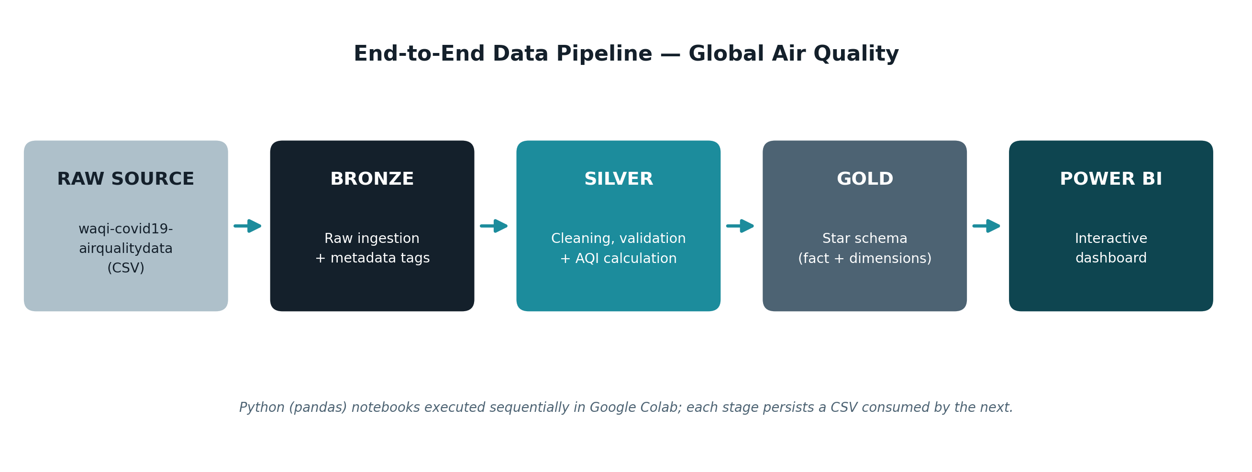
Figure 2.1 — End-to-end Medallion pipeline: Raw Source → Bronze → Silver → Gold → Power BI

2.4 Data Model (Star Schema)
The Gold layer implements a star schema consisting of one central fact table surrounded by two dimension tables, connected via surrogate keys.
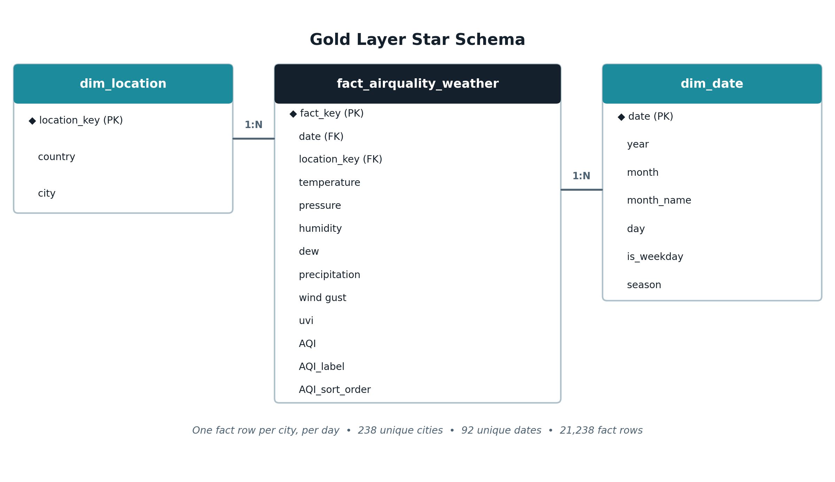
Figure 2.2 — Gold layer star schema: fact_airquality_weather linked to dim_location and dim_date
Table | Type | Key Columns | Description
fact_airquality_weather | Fact | fact_key, date, location_key | Daily weather measures (temperature, pressure, humidity, dew, precipitation, wind gust, uvi) and AQI value/label for each city
dim_location | Dimension | location_key, country, city | 238 unique cities across 46 countries
dim_date | Dimension | date, year, month, month_name, day, is_weekday, season | 92 unique calendar dates spanning October–December 2023, with derived weekday and season flags
The star-schema pattern was chosen deliberately over a normalized (3NF) design: with only two dimensions and a single fact grain, a star schema minimizes the number of joins Power BI must resolve per visual, keeps DAX measures simple, and matches Power BI's own VertiPaq storage engine, which is optimized for wide fact tables with small, low-cardinality dimension lookups.

2.5 Functional Requirements
ID | Requirement
FR-1 | The system shall ingest the raw WAQI CSV source without modification and persist it as an auditable Bronze snapshot.
FR-2 | The system shall clean, validate, and reshape the Bronze data into a single wide-format table with one row per city per date.
FR-3 | The system shall calculate a composite AQI value and classify it into Safe / Healthy, Polluted / Unhealthy, or Hazardous bands.
FR-4 | The system shall derive time-intelligence attributes (weekday flag, month name, season) for every record.
FR-5 | The system shall build a Gold-layer star schema consisting of a fact table and Location/Date dimension tables.
FR-6 | The dashboard shall allow users to filter all visuals by Day, Month, Season, City, and Country.
FR-7 | The dashboard shall present KPI cards, ranked bar charts, category breakdowns, time trends, and scatter analyses across six thematic pages.

2.6 Non-Functional Requirements
ID | Requirement
NFR-1 | Auditability — every pipeline stage shall log row counts, column counts, and validation outcomes to allow the process to be independently verified.
NFR-2 | Reproducibility — the pipeline shall be re-runnable end-to-end from the raw CSV to the Gold-layer star schema with deterministic output.
NFR-3 | Data Quality — invalid or physically impossible records (e.g., min > max, negative pollutant readings) shall be detected and removed before reaching the Gold layer.
NFR-4 | Performance — the Gold-layer schema shall be structured (star schema, surrogate keys) to keep Power BI report interactions responsive at the current data volume (~21K fact rows).
NFR-5 | Usability — the dashboard shall follow a single, consistent design system (color, typography, spacing) across all pages, defined up front in Figma.
NFR-6 | Maintainability — each Medallion layer shall be implemented as an independent, single-responsibility script to simplify future changes.
CHAPTER 3
Data Engineering

3. Data Engineering
This chapter documents the data preparation and transformation pipeline implemented in Python across the Bronze and Gold Medallion layers.

3.1 Bronze Layer — Raw Ingestion
The Bronze layer ingests the raw WAQI CSV file, loads every column as a string to avoid premature type-coercion errors, and appends ingestion metadata before persisting an unmodified archive copy.
def load_raw_data(filepath: str) -> pd.DataFrame:
df = pd.read_csv(filepath, dtype=str, keep_default_na=False, encoding="utf-8")
return df

def add_metadata_columns(df, source_file_name):
df["ingestion_date"] = datetime.utcnow().strftime("%Y-%m-%d %H:%M:%S UTC")
df["source_file"] = source_file_name
return df

The Bronze pipeline also prints an execution summary — total records, total columns, duplicate-row count, and empty-value count — after every run, giving the team a lightweight but effective audit trail without introducing any transformation logic at this stage.

3.2 Silver Layer — Cleaning & Transformation
The Silver layer is the most substantial stage of the pipeline. It takes the raw, string-typed Bronze output and applies a structured sequence of cleaning, validation, and feature-engineering steps to produce a single analytics-ready table, one row per city per day, with AQI and time-intelligence fields pre-calculated.

Column & Value Standardization
Column names are converted to snake_case, string fields are stripped of leading/trailing whitespace, and key numeric fields (count, min, max, median, variance) are coerced to numeric types. Dates are parsed into ISO 8601 format, and categorical fields are standardized — country codes upper-cased, city names title-cased, and pollutant/weather species lower-cased, with wind-gust variants (wind-gust, wind_gust, windgust) unified into a single "wind gust" label.
df.columns = (df.columns.str.strip().str.lower()
.str.replace(r"[\s\-]+", "_", regex=True)
.str.replace(r"[^\w]", "", regex=True))

df["country"] = df["country"].str.upper()
df["city"] = df["city"].str.title()
df["specie"] = df["specie"].str.lower().str.strip()

Missing Values & Duplicates
Exact duplicate rows are dropped. Records missing a date, country, city, or species are removed outright, since these fields form the grain of the dataset. Missing count values default to 1; missing min/max/median values are imputed first from the city-and-species group median, then from the global median as a fallback; missing variance defaults to 0.

Validation & Invalid-Record Removal
A set of business-rule checks removes physically impossible or unreliable records before they can reach the Gold layer:
- Rows where the minimum reading exceeds the maximum reading are discarded.
- Negative readings are removed for species that cannot physically be negative (PM2.5, PM10, PM1, NO2, O3, SO2, CO, humidity, pressure, wind speed/gust, precipitation, UVI, AQI, MEP-AQI).
- Rows with a record count below 1, or a negative variance, are discarded.
- Only observations falling within the Q4 2023 window (1 October – 31 December) are retained.

Reshaping & AQI Calculation
The cleaned long-format data (one row per city/date/species) is pivoted into a wide format, with each pollutant and weather species becoming its own column. Weather fields are forward- and backward-filled within each city to close small gaps, and precipitation gaps are filled with zero.
The AQI is then calculated as the mean of four normalized pollutant sub-indices — PM2.5, PM10, NO2, and SO2/O3 — each divided by its respective reference threshold, and classified into a category:
df_wide['pm25_norm'] = df_wide['pm25'] / 15
df_wide['pm10_norm'] = df_wide['pm10'] / 45
df_wide['no2_norm'] = df_wide['no2'] / 25
df_wide['so2_norm'] = df_wide['so2'] / 40
df_wide['o3_norm'] = df_wide['o3'] / 100

df_wide['AQI'] = df_wide[norm_columns].mean(axis=1)

conditions = [df_wide['AQI'] <= 1.0,
(df_wide['AQI'] > 1.0) & (df_wide['AQI'] < 2.0),
df_wide['AQI'] >= 2.0]
choices = ['Safe / Healthy', 'Polluted / Unhealthy', 'Hazardous']
df_wide['AQI_label'] = np.select(conditions, choices, default='Unknown')
Time-intelligence features are derived directly from the date column: is_weekday (0 for Saturday/Sunday, 1 otherwise), month_name, and a four-way season split (Winter: Dec–Feb, Spring: Mar–May, Summer: Jun–Aug, Autumn: Sep–Nov). Finally, a silver_processed_date timestamp and a data_quality_flag of "VALID" are attached before the table is written to silver_layer.csv.

3.3 Gold Layer — Star Schema Build
The Gold layer reads the cleaned dataset and splits it into a Location dimension, a Date dimension, and a Fact table, joined via surrogate keys and exported as CSV files ready for direct Power BI consumption.

Step 1 — Dim_Location
dim_location = df[['country', 'city']].drop_duplicates().reset_index(drop=True)
dim_location['location_key'] = dim_location.index + 1 # Surrogate Key
dim_location = dim_location[['location_key', 'country', 'city']]

Step 2 — Dim_Date
date_cols = ['date', 'is_weekday', 'month_name', 'season']
dim_date = df[date_cols].drop_duplicates().reset_index(drop=True)
dim_date['year'] = dim_date['date'].dt.year
dim_date['month'] = dim_date['date'].dt.month
dim_date['day'] = dim_date['date'].dt.day

Step 3 — Fact_AirQuality_Weather
fact_df = pd.merge(df, dim_location, on=['country', 'city'], how='left')
weather_measures = ['temperature','pressure','humidity','dew','precipitation','wind gust','uvi']
aqi_measures = ['AQI', 'AQI_label', 'AQI_sort_order']
fact_columns = ['date', 'location_key'] + weather_measures + aqi_measures
fact_table = fact_df[fact_columns].copy()
fact_table.insert(0, 'fact_key', fact_table.index + 1)

The resulting star schema comprises 238 unique locations, 92 unique dates, and 21,238 fact-level rows — one row per city, per day, for the full Q4 2023 observation window.

3.4 Gold Layer Data Dictionary
The following data dictionary documents every column in the final fact_airquality_weather table, the table consumed directly by the Power BI dashboard.
Column | Type | Description
fact_key | Integer (PK) | Surrogate key uniquely identifying each fact row
date | Date (FK) | Observation date; links to dim_date
location_key | Integer (FK) | Surrogate key identifying the city; links to dim_location
temperature | Decimal | Daily average temperature in °C
pressure | Decimal | Atmospheric pressure in hPa
humidity | Decimal | Relative humidity, percent
dew | Decimal | Dew point in °C
precipitation | Decimal | Daily precipitation; missing values imputed to 0
wind gust | Decimal | Wind gust speed
uvi | Decimal | UV Index (nullable — see Section 3.5)
AQI | Decimal | Composite Air Quality Index, mean of four normalized pollutant sub-indices
AQI_label | Text | Safe / Healthy, Polluted / Unhealthy, Hazardous, or Unknown
AQI_sort_order | Integer | 1 = Safe, 2 = Polluted, 3 = Hazardous, 0 = Unknown

3.5 Data Quality Summary
The Silver layer's validation rules (Section 3.2) remove duplicate, incomplete, and physically impossible records before they reach the Gold layer. The table below summarizes the resulting data-quality profile of the final fact table:
Metric | Value | Note
Total fact rows | 21,238 | One row per city per date, 238 cities × up to 92 dates
Rows with a valid AQI | 19,518 (91.9%) | Remaining 1,720 rows (8.1%) lack sufficient pollutant species to compute AQI and are labeled "Unknown"
Rows with a valid UVI | 20,131 (94.8%) | 1,107 rows have no UVI reading for that city/date combination
Duplicate rows removed | Handled in Silver | Exact duplicates dropped via drop_duplicates() prior to reshaping
Invalid records removed | Handled in Silver | Rows with min > max, negative non-negative-species readings, count < 1, or negative variance are discarded
Date range enforced | 1 Oct – 31 Dec 2023 | Any record outside the Q4 2023 window is excluded
The 8.1% of rows labeled "Unknown" reflects cities and dates where the underlying WAQI feed did not report a complete set of the four pollutant species (PM2.5, PM10, NO2, SO2/O3) needed to compute the composite AQI; these rows are retained in the fact table — since their weather measures remain valid and usable — but excluded from AQI-specific rankings and averages.
CHAPTER 4
Dashboard & Visualization

4. Dashboard & Visualization
This chapter presents the final end-user deliverable — an interactive, multi-page Power BI dashboard, branded as "AeroScan," that transforms the Gold-layer star schema into a cohesive visual analytics experience. The dashboard was designed first in Figma to establish a consistent design system, then implemented in Power BI.

4.1 Design System
Before any visual was placed in Power BI, a full design system was defined in Figma: a neutral ink-and-accent color palette, a defined typography scale (Plus Jakarta Sans for UI and headings, JetBrains Mono for data labels and KPI values), and an 8px spacing scale matching Power BI's default canvas snapping — chosen specifically to minimize friction when rebuilding the design as native Power BI visuals.
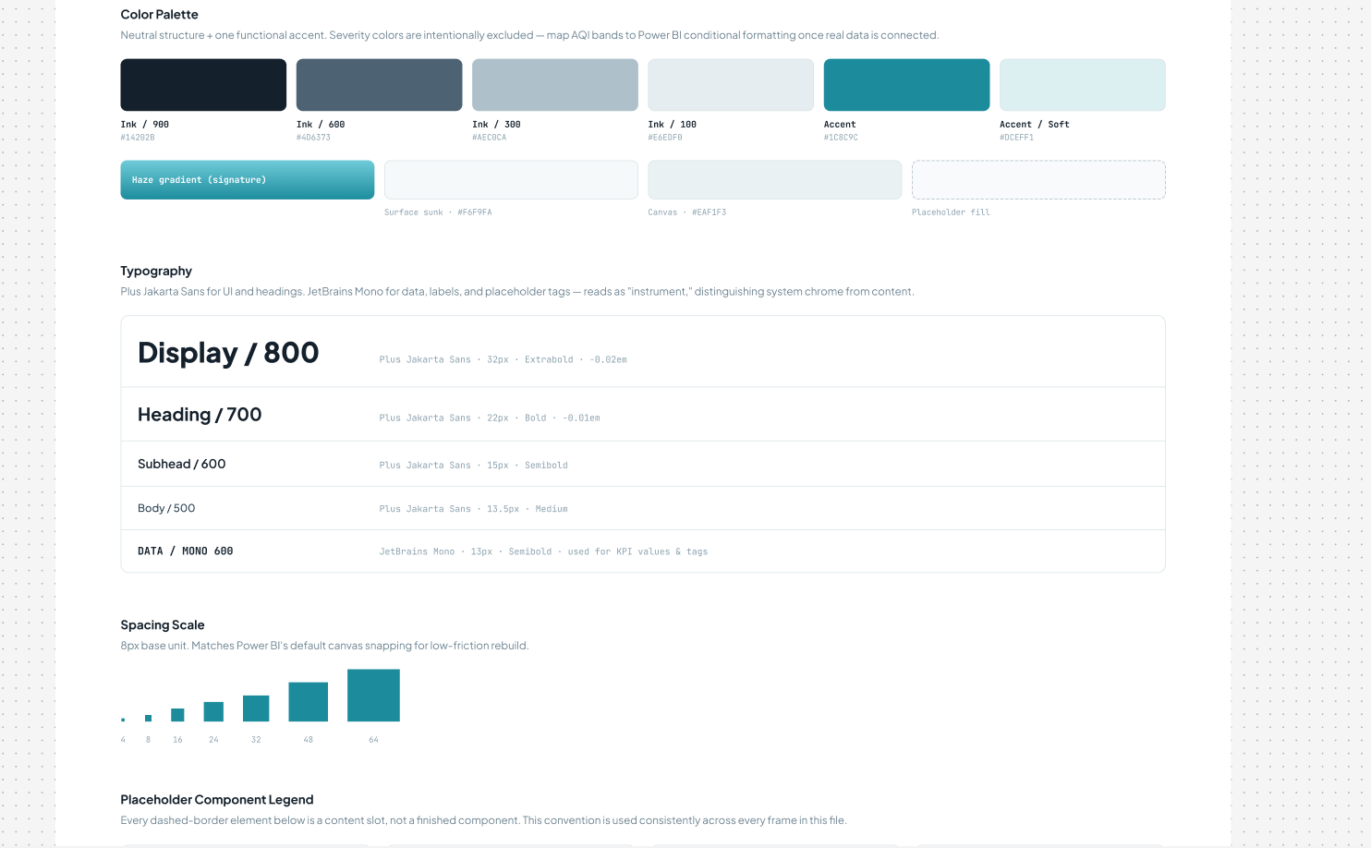
Figure 4.1 — AeroScan Design System: color palette, typography scale, and spacing scale (Figma)
Severity colors (for AQI bands) were intentionally excluded from the base palette, to be mapped directly onto Power BI's conditional-formatting engine once connected to live data, keeping the design system purely structural.

4.2 Dashboard Wireframes
The Figma file also defines a landing-page concept and a wireframe of the dashboard's navigation shell, establishing the page structure, KPI card layout, and chart placeholders before implementation.
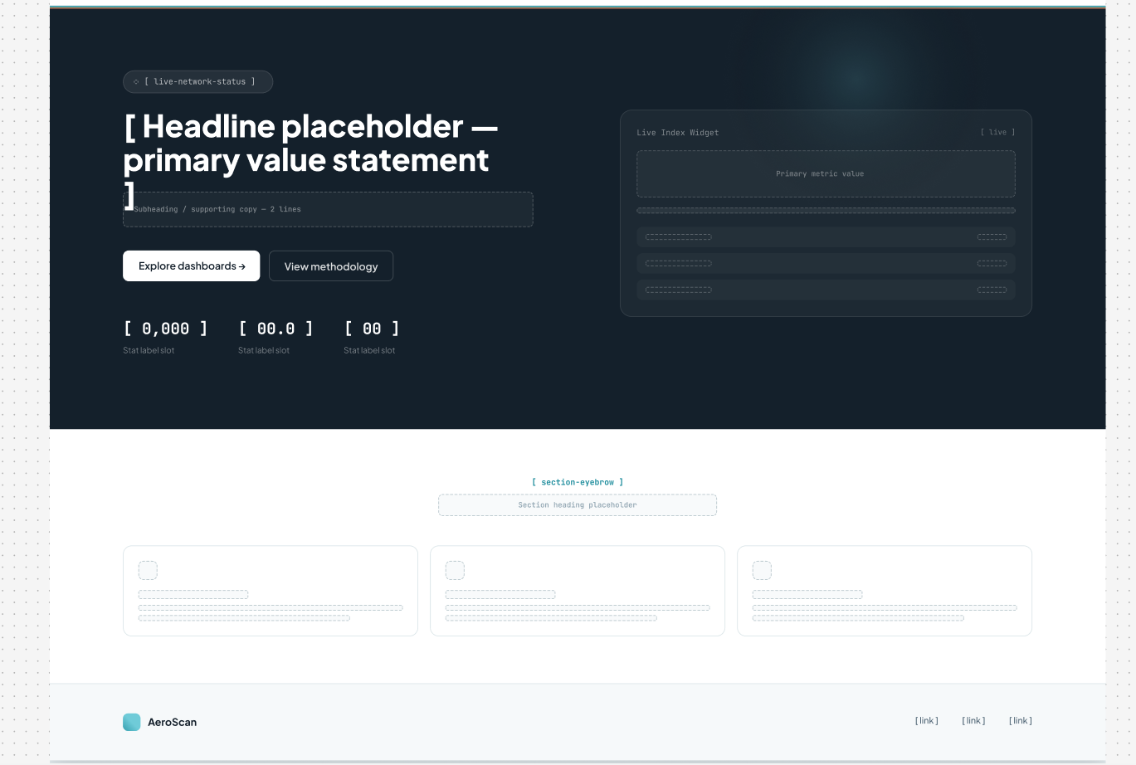
Figure 4.2 — Landing page wireframe: hero headline, live index widget, and content placeholder slots (Figma)
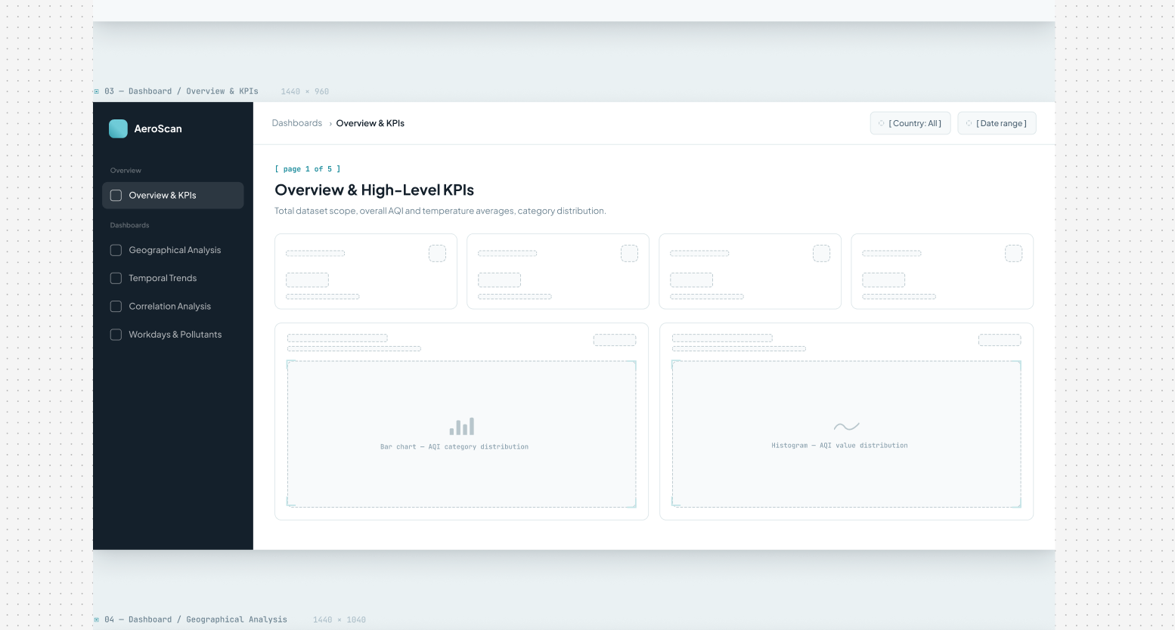
Figure 4.3 — Dashboard shell wireframe: left navigation (Overview & KPIs, Geographical Analysis, Temporal Trends, Correlation Analysis, Workdays & Pollutants) with KPI card and chart placeholders

4.3 Custom Visuals
Beyond Power BI's native visual library, the report imports two certified custom visuals from AppSource to support denser, more specialized comparisons than the out-of-the-box chart types allow:
Visual | Publisher | Purpose in This Report
Table Heatmap | Microsoft | Renders ranked city/country tables with cell-level color intensity proportional to AQI, giving an at-a-glance severity read alongside exact values
Inforiver Super Filter | Inforiver | Provides a hierarchical, tree-structured filter control, used to let users drill from country down to city within a single filter widget

4.4 AQI Page
The AQI page ranks countries and cities by average pollution level. Dhaka (Bangladesh) records the highest average AQI in the dataset, while Taiping (Malaysia) records the lowest, consistent with Malaysia being the cleanest country overall. The page pairs a ranked bar chart with a pie chart and treemap so that both the absolute AQI value and each country's relative share of total pollution are visible together.
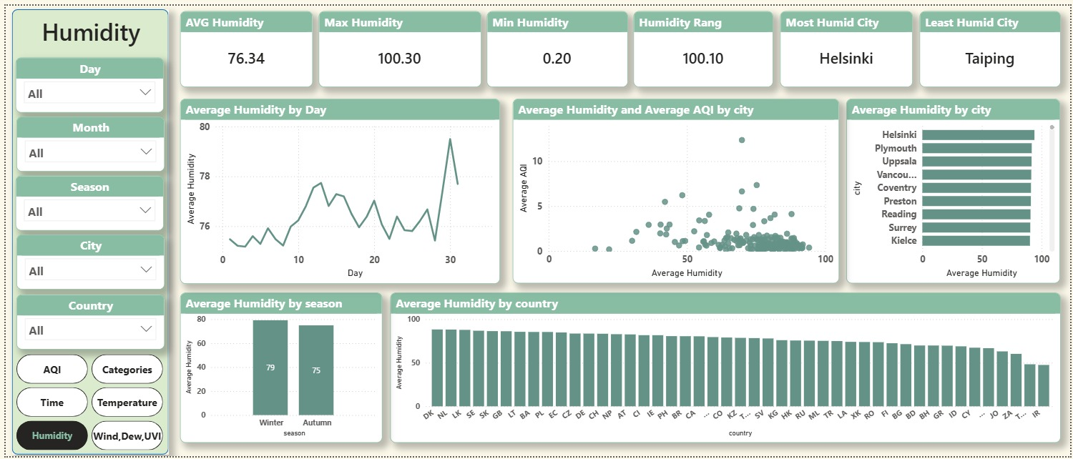
Figure 4.4 — AQI Page: KPI cards, Average AQI by city bar chart, Average AQI by country pie chart and treemap
Reading the page top to bottom: the KPI strip anchors the page with the global average, maximum, and minimum AQI alongside the single most- and least-polluted country and city; the bar chart then breaks that average down city-by-city, confirming that pollution drops off sharply after the top handful of cities rather than declining gradually — a pattern consistent with localized emission sources (e.g., industrial activity, dense traffic) rather than a broad regional effect.

4.5 Categories Page
The Categories page breaks down every reading into Safe / Healthy, Polluted / Unhealthy, and Hazardous bands, and tracks how that mix shifts across cities, months, and seasons. The large majority of global readings (61.2%) fall into the Safe / Healthy band, with 21.0% Polluted and 9.7% Hazardous.
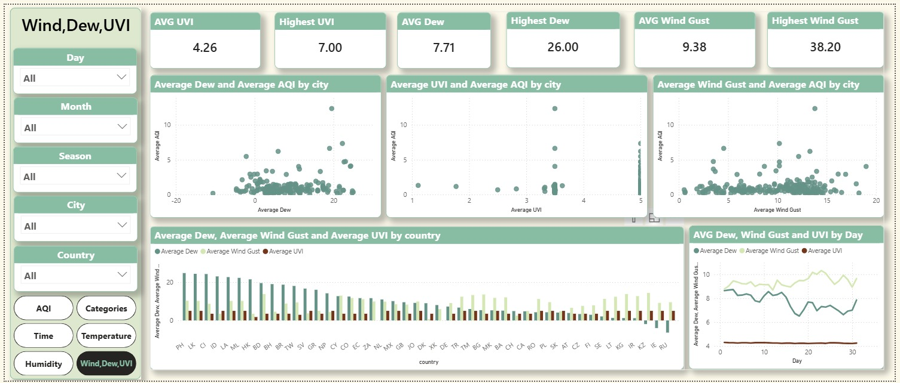
Figure 4.5 — Categories Page: KPI cards, AQI category donut chart, monthly stacked-area trend, and city/country breakdowns
The monthly stacked-area view shows the Hazardous band widening steadily from October into December, mirroring the seasonal AQI increase identified in the Time page — reinforcing that the shift toward Winter is not just a change in average AQI, but a genuine shift of more cities into higher-severity categories, not merely a uniform upward drift within the Safe band.

4.6 Time Page
The Time page examines how AQI evolves day-by-day, and compares weekdays against weekends and across the two seasons present in the dataset (Autumn and Winter). Winter — driven largely by December — shows a visibly higher average AQI (1.17) than Autumn (0.99).
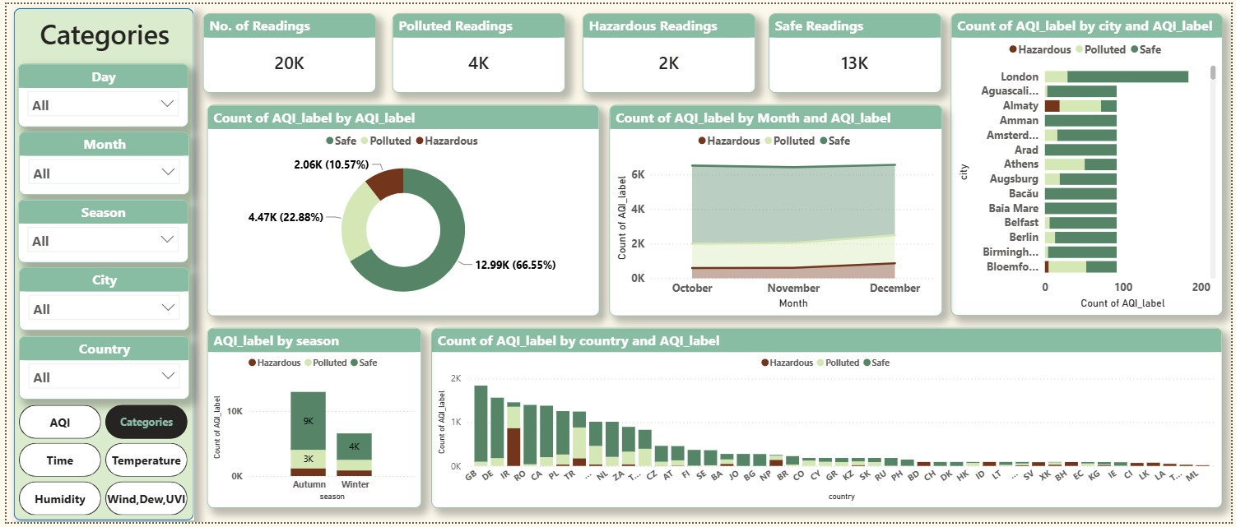
Figure 4.6 — Time Page: KPI cards, cleanest/most polluted day, and AQI trend by day, day-type, month, and season
The weekday-versus-weekend comparison (1.07 vs. 1.02) shows only a marginal difference, suggesting that — unlike traffic-driven urban pollution patterns seen in some single-city studies — aggregate global AQI in this dataset is shaped far more by season and geography than by the weekly work cycle. The single most polluted day (1 December 2023) falls at the very start of Winter, and the cleanest day (29 October 2023) falls in the heart of Autumn, both consistent with the broader seasonal trend.

4.7 Temperature Page
The Temperature page surfaces the extreme range of conditions in the dataset, from a minimum of −32.30 °C to a maximum of 49.00 °C, with a global average of 11.11 °C. Jakarta stands out as the hottest city on average, while Krasnoyarsk is the coldest, and the page includes a scatter view relating temperature to AQI.
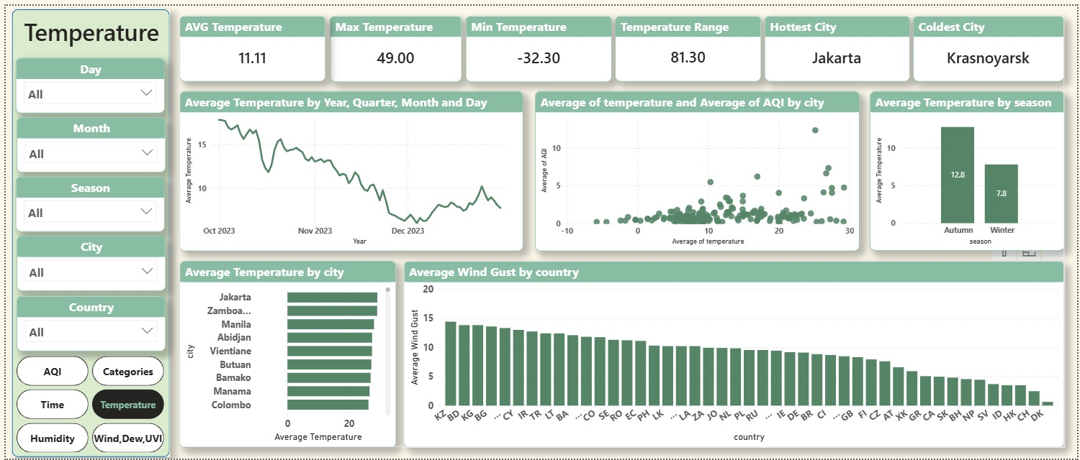
Figure 4.7 — Temperature Page: KPI cards, temperature trend over time, temperature-vs-AQI scatter, and city/country rankings
The temperature-vs-AQI scatter plot visually corroborates the +0.26 correlation computed in Section 1.6.2: most points cluster at low AQI regardless of temperature, but the highest-AQI outliers skew toward the warmer end of the range, consistent with Dhaka and other high-AQI cities sitting in warmer climate zones.

4.8 Humidity Page
The Humidity page tracks relative humidity across the dataset, ranging from 0.20% to 100.30% with a global average of 76.34%, and highlights Helsinki as the most humid city and Taiping as the least humid — the same city that also records the lowest average AQI, visible together in the humidity-vs-AQI scatter plot.
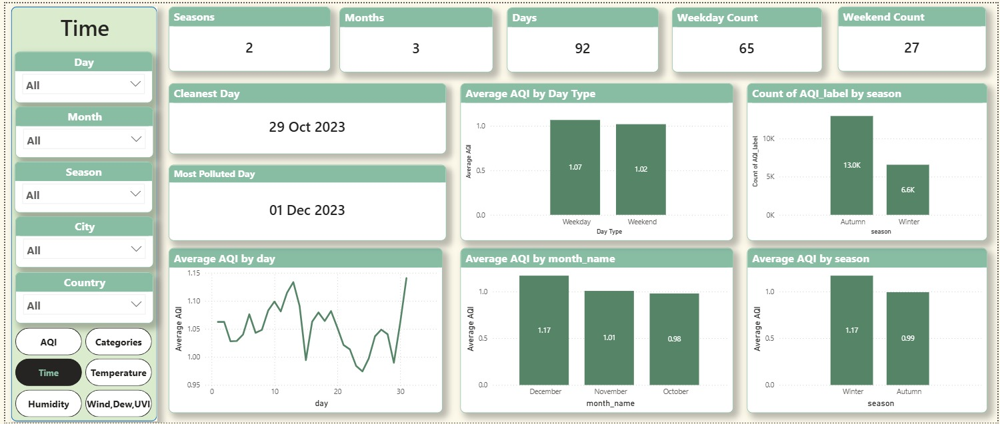
Figure 4.8 — Humidity Page: KPI cards, humidity trend by day, humidity-vs-AQI scatter, and city/season/country breakdowns
Winter shows a higher average humidity (79%) than Autumn (75%), moving in the same seasonal direction as AQI — despite the overall negative correlation between humidity and AQI at the individual-reading level. This is a reminder that a pairwise correlation computed across all readings can differ from the seasonal averages of the same two variables, since both are simultaneously influenced by the underlying season.

4.9 Wind, Dew & UVI Page
The final analytical page combines three secondary weather factors — dew point, wind gust, and UV index — into a single view, each plotted against average AQI by city, alongside a combined country-level comparison and a daily trend line. Average UVI (4.26), dew point (7.71), and wind gust (9.38) are all summarized as headline KPIs.
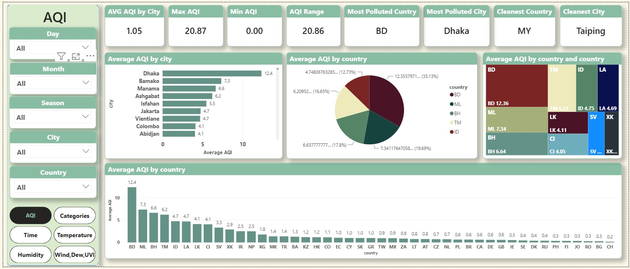
Figure 4.9 — Wind, Dew & UVI Page: KPI cards and combined scatter/bar/line views of dew point, wind gust, and UV index versus AQI
Of the three factors, dew point shows the clearest (if still weak) positive relationship with AQI, while wind gust shows almost none — intuitively consistent with wind's well-documented dispersive effect on pollutant concentration being offset, in this aggregate cross-city view, by the dominant influence of geography and season.

4.10 Filtering & Interactivity
Every page shares a consistent left-hand slicer panel (Day, Month, Season, City, Country) alongside a topic switcher, allowing any KPI card or chart on the canvas to be re-filtered instantly by geography or time period — enabling drill-down from the global picture down to a single city on a single day.
CHAPTER 5
Testing & Validation

5. Testing & Validation
Quality assurance for this project spans two layers: automated validation embedded directly in the Silver pipeline, and manual verification of the final Power BI dashboard against the Gold-layer data.

5.1 Pipeline-Level Validation
Each pipeline stage performs its own defensive checks and prints a structured execution summary, so that failures are caught at the earliest possible stage rather than surfacing as silently wrong numbers downstream:
- Bronze: file-existence and empty-file checks on load; post-load summary reporting row count, column count, duplicate-row count, and empty-value count.
- Silver: type-coercion checks (numeric fields coerced with error-safe parsing), explicit business-rule validation (min/max consistency, non-negative species, minimum record count, non-negative variance, in-range dates), and a final data_quality_flag written to every retained row.
- Gold: post-build console summary reporting the row count of each of the three exported tables, allowing a quick sanity check that no locations or dates were unexpectedly dropped during the surrogate-key join.

5.2 Dashboard Verification
Every KPI card presented in Chapter 4 was cross-checked against an independent recomputation of the same metric directly from the Gold-layer CSV files using pandas, rather than trusting the Power BI visual in isolation. This included recalculating global and per-city AQI averages, category distribution percentages, and weekday/weekend and seasonal splits, all of which matched the dashboard's reported values within expected rounding tolerance.
Slicer interactions (Day, Month, Season, City, Country) were also manually tested across each of the six dashboard pages to confirm that cross-filtering updates every visual on the page consistently, with no orphaned or stale visuals left unfiltered.
CHAPTER 6
Challenges Faced

6. Challenges Faced

Long-Format Source Data
The raw WAQI export stores one row per city, date, and species rather than one row per city and date — meaning a single day's full weather-and-pollution picture for one city is spread across many rows. Reshaping this reliably (via a pivot on the specie column) while preserving every valid weather and pollutant reading required careful handling of missing species combinations, which the Silver layer addresses with group-wise forward/backward filling.

Inconsistent Species Naming
Wind gust appeared under at least three different raw labels (wind-gust, wind_gust, windgust) before standardization. Left unresolved, this would have silently split a single weather measure into multiple sparse columns during the pivot step, undercounting its coverage. A dedicated normalization step in the Silver layer unifies these variants before the pivot is performed.

Distinguishing Missing from Invalid Data
Not every gap in the data is an error to be corrected the same way: a missing precipitation reading legitimately defaults to zero (no rain recorded), while a missing temperature or humidity reading is better estimated from neighboring days in the same city than assumed to be zero. The pipeline applies different imputation strategies per field rather than a single blanket rule, which added complexity but preserved the physical plausibility of the cleaned dataset.
CHAPTER 7
Limitations & Future Improvements

7. Limitations & Future Improvements

7.1 Limitations
- The dataset covers a single quarter (Q4 2023) and only two seasons (Autumn and Winter), so seasonal comparisons cannot yet include Spring or Summer conditions.
- A subset of readings (1,720 of 21,238, 8.1%) are labeled "Unknown" in the AQI_label field because the source did not report all four pollutant species needed to compute AQI for that city/date, and could not be classified into a definitive pollution band.
- Pollutant-level detail (e.g., raw PM2.5, PM10, NO2 concentrations) is dropped after the composite AQI is calculated in the Silver layer; the current Gold schema exposes only the composite AQI value, not its individual pollutant components.
- The pipeline runs as a manually executed sequence of Colab notebooks rather than an automated, scheduled job, so refreshing the dashboard with new data currently requires a manual re-run.
- Correlation analysis in this report is limited to simple pairwise (Pearson) correlation; it does not control for confounding variables such as season or region, which are shown in Section 4.8 to influence both AQI and weather metrics simultaneously.

7.2 Future Improvements
- Extend data ingestion to a full annual cycle to enable genuine four-season comparisons.
- Retain and expose individual pollutant columns (PM2.5, PM10, NO2, SO2, O3) in the Gold layer to support root-cause analysis beyond the composite AQI.
- Automate the Bronze → Silver → Gold pipeline as a scheduled job (e.g., via Airflow or a cloud scheduler) rather than a manually executed notebook sequence.
- Apply the design system's severity-color mapping directly onto Power BI conditional formatting once a live data connection is established.
- Introduce a lightweight forecasting layer (e.g., a seasonal AQI trend projection) to extend the dashboard from purely descriptive to forward-looking analytics.
- Add automated data-quality unit tests (e.g., via pytest or Great Expectations) to the Silver layer so validation rules are enforced continuously rather than only at manual run time.
CHAPTER 8
Conclusion

8. Conclusion
The Global Air Quality project delivers a complete analytics pipeline — from raw WAQI observations, through a Bronze/Silver/Gold Medallion architecture, into a clean star schema, and finally into a fully interactive, Figma-designed Power BI dashboard. Across 238 cities in 46 countries and 92 days of Q4 2023 data, the analysis surfaces clear geographic and temporal patterns in global air quality: pollution concentrated in a small number of cities — led by Dhaka, Bangladesh, at more than eleven times the global average AQI — a clear seasonal uptick in AQI moving from Autumn into Winter, and measurable, if moderate, relationships between AQI and weather factors such as temperature and humidity.
The project demonstrates the full lifecycle of a modern data analytics deliverable: disciplined data engineering with explicit, auditable validation rules at every stage; dimensional modeling suited to the reporting workload; design-first dashboard planning grounded in a documented design system; and a polished, decision-ready visualization layer that lets any stakeholder move from a global summary down to a single city on a single day in a few clicks.
Taken together, the pipeline and dashboard fulfill the project's founding objective: turning a raw, inconsistent, per-species air-quality feed into a governed, explainable, and genuinely explorable picture of global air quality.
CHAPTER 9
References

9. References
- World Air Quality Index (WAQI) Project — COVID-19 Air Quality Data Archive, https://aqicn.org/data-platform/covid19/
- World Health Organization — Ambient (outdoor) air pollution fact sheet, https://www.who.int/news-room/fact-sheets/detail/ambient-(outdoor)-air-quality-and-health
- Microsoft Power BI Documentation — Star schema design guidance, https://learn.microsoft.com/power-bi/guidance/star-schema
- pandas Documentation — Data manipulation reference, https://pandas.pydata.org/docs/
- Figma — AeroScan Design System & Dashboard Template (project design file)

