# Location-Based Attendance Management System

# Introduction:

The **Location-Based Attendance Management System** enables employees to mark their attendance only when they are physically present within the designated **office or campus premises**.

This system uses the **geolocation** of the user's device to validate their proximity to the registered office location. Employees can conveniently use their **own smartphones or devices** to mark their attendance through a secure web or mobile interface.

# Key Highlights:

* Attendance can be marked only within the allowed distance from the office/campus.
* Supports real-time check-in and check-out from personal devices.
* Ensures accurate and secure attendance by confirming the user's location and a unique reference ID assigned to their device.
* Helps organizations maintain accurate, location-verified attendance records.

# Accessing the Application:

* URL:[*dps.adhyayan.online*](https://dps.adhyayan.online)
* **Username**: Employee code (e.g. EMP001, In your case its your employee code)
* **Password**: (Please contact your administrator to obtain the password. You will have the option to change it after logging in.)

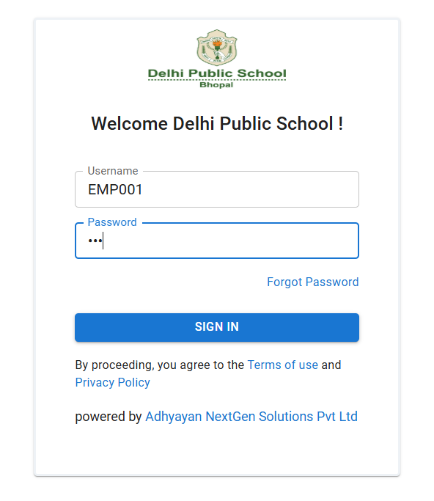

# Steps For Employees-

## 1. Login

* Go to [dps.adhyayan.online](https://dps.adhyayan.online)
* Enter your **User ID** (your employee code) and **Password** (****)
* Click Login

## 2. Mark Attendance

* Click on the Attendance option below the Employee Dashboard.
* You got redirected to Your Attendance List

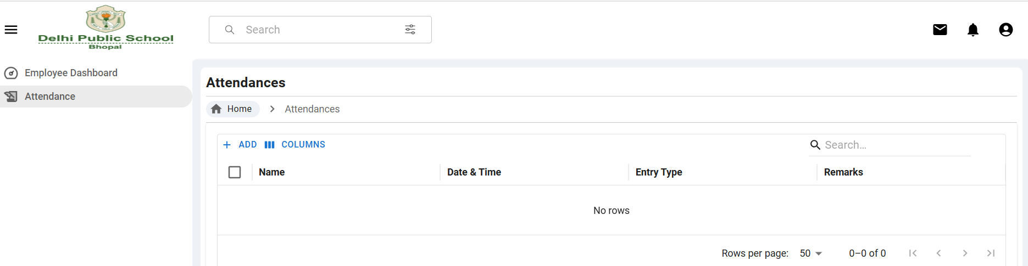

* Now click on +ADD button to mark your attendance
* Select your Entry Type and add Remark then click SUBMIT to mark your Attendance

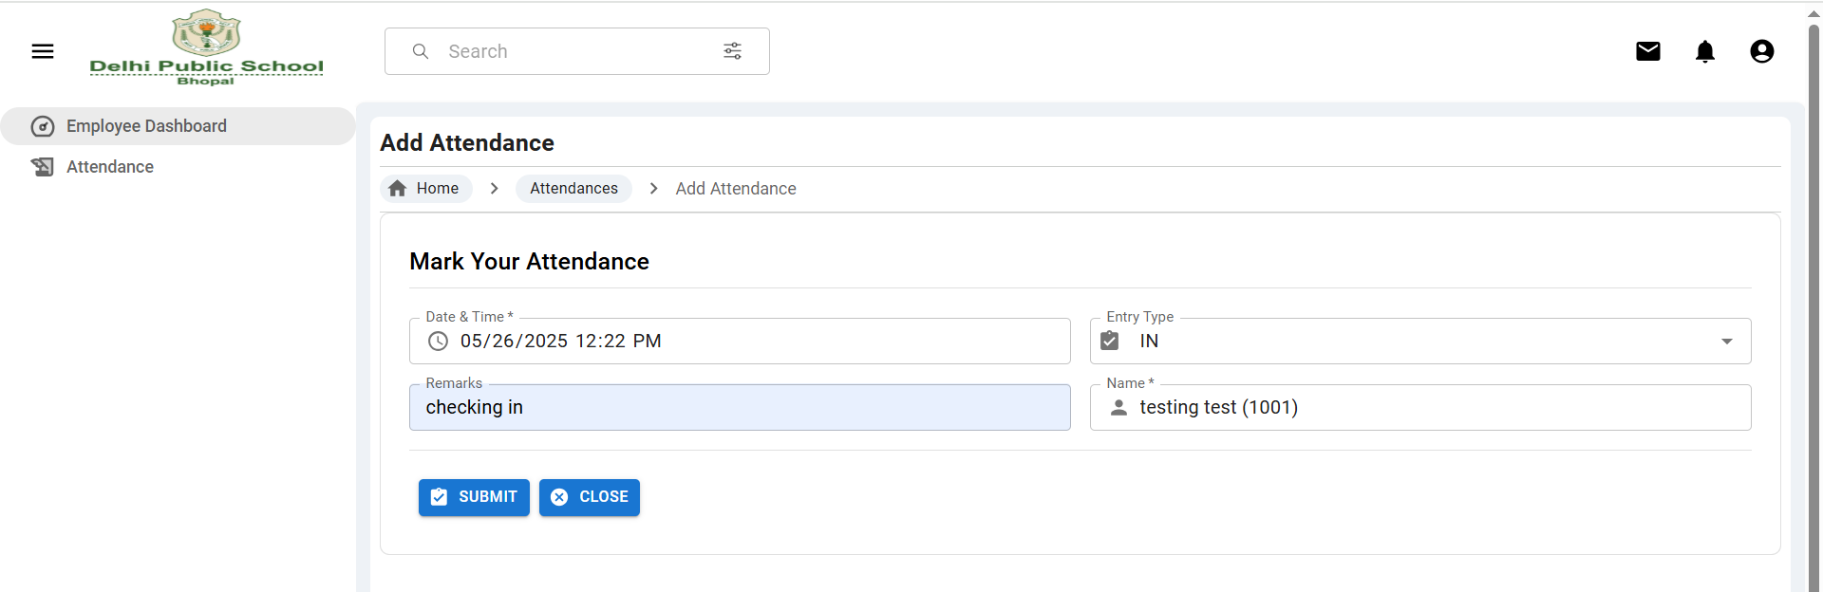

* Your Attendance List will look like this

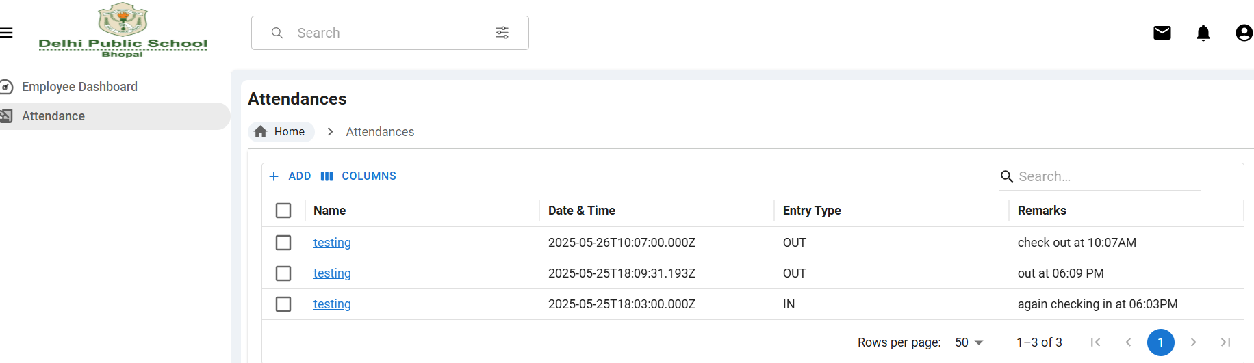

* You can view your specific attendance from List by clicking on Your Name of that specific row

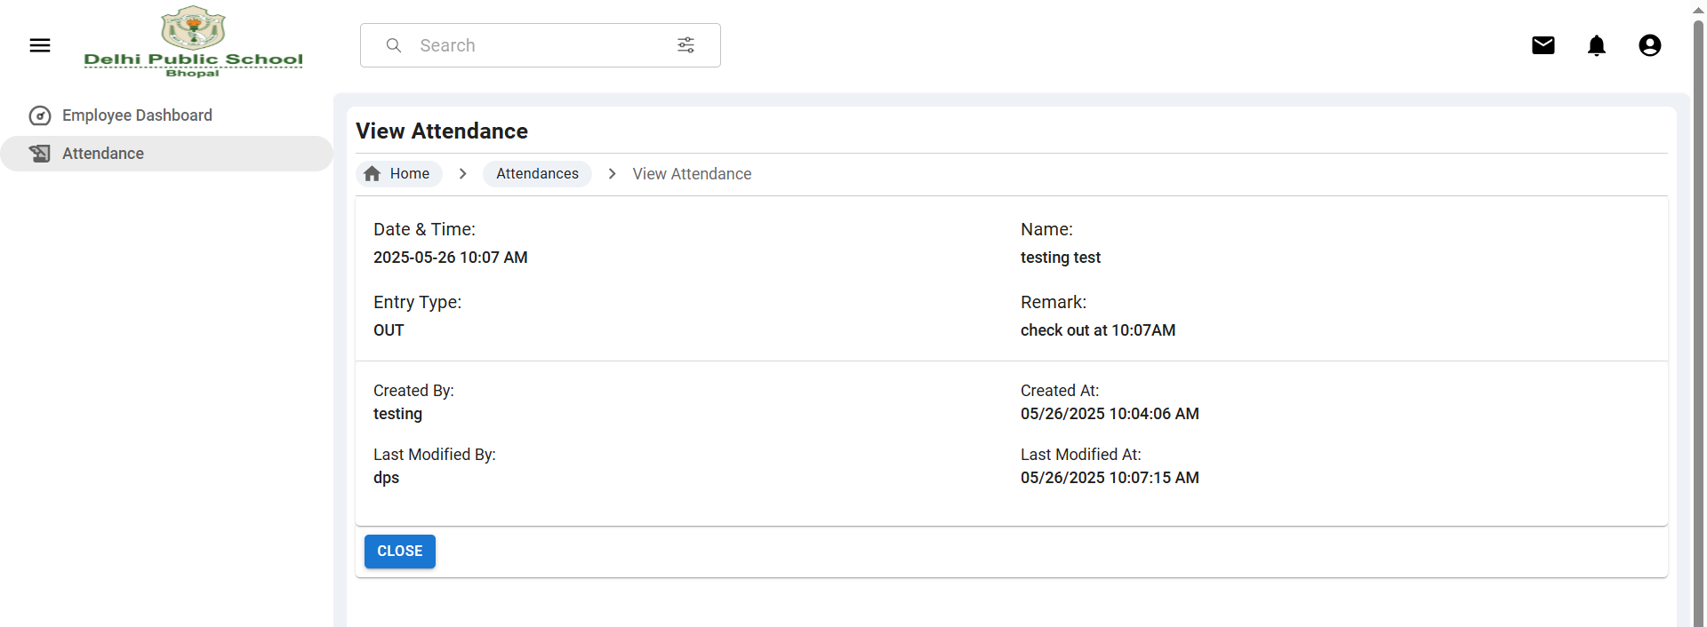

## 3. View/Edit Profile

* After successful login, click on the Profile icon on the top right corner of the Employee dashboard page
* On clicking on Profile, you got redirected to your Profile page
* Review your information
* Click edit if need to update information

## 

* Your Profile Looks like this:

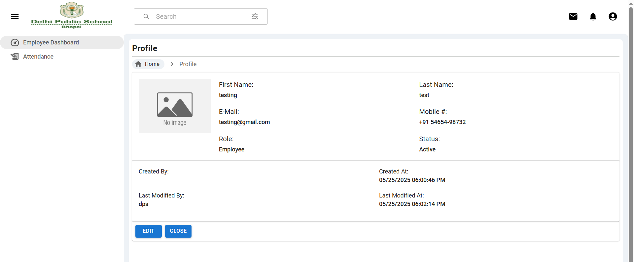

## 4. Change Password

* Click on the Profile icon on the top right corner of the Employee dashboard page, then Change Password
* Enter Your Current Password then Set a New Password
* Confirm and click Save

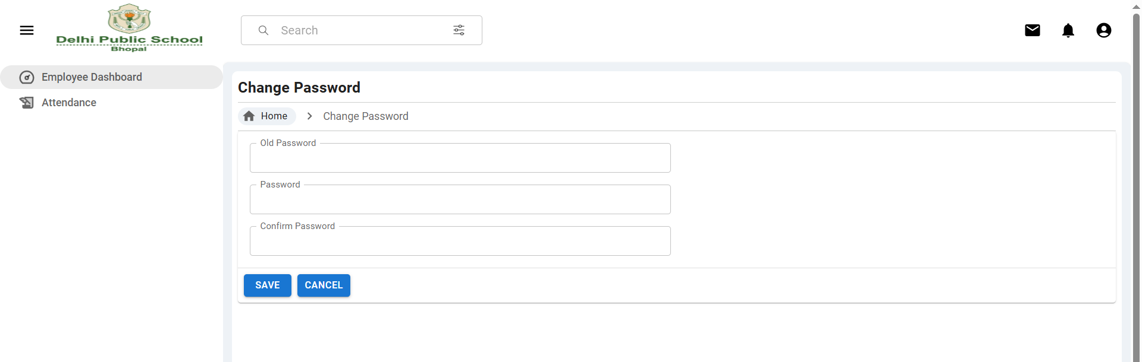

## 5. Logout

* Click on the Profile icon on the top right corner, then click Logout to securely exit

## 6. Forgot Password

* On the login screen, click Forgot Password

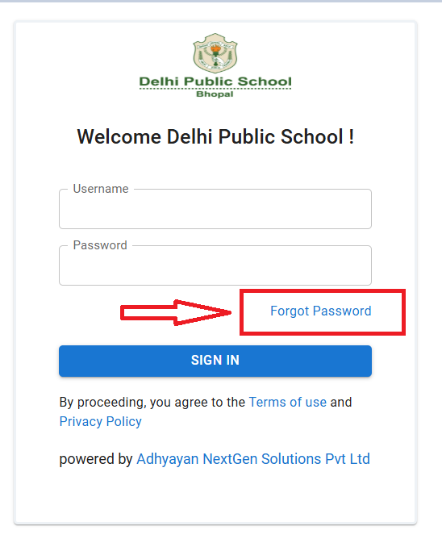

Forgot Password using Email :

## 

* Enter your Email Id/ User Id
* Enter new Password for your login and click submit

Forgot Password using UserName (employee code) :

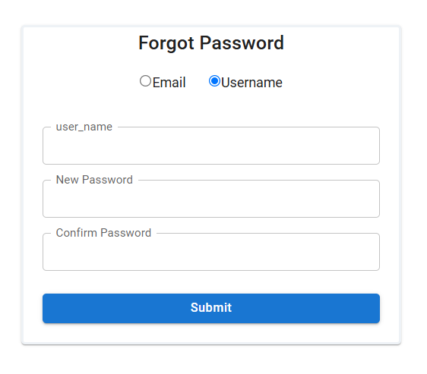

# Steps For Admin User-

## 1. Login

* Go to [dps.adhyayan.online](https://dps.adhyayan.online/)
* Enter your **User ID** (********) and **Password** (*******)
* Click Login

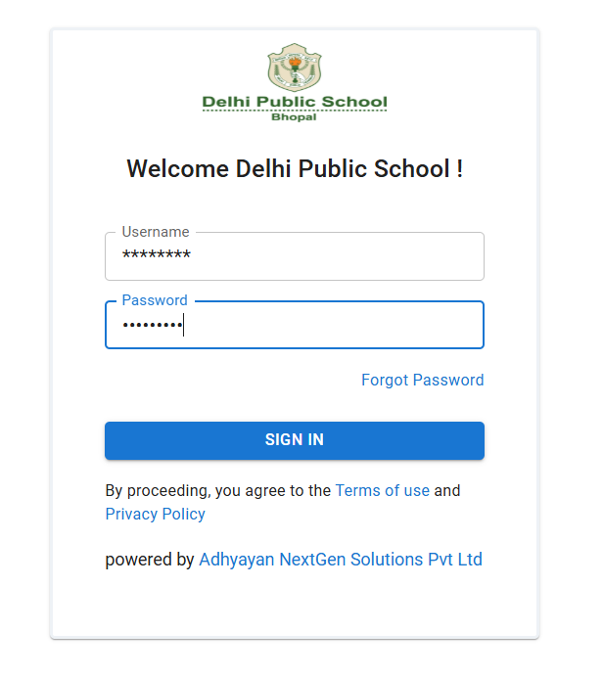

## 2. Role Module

* Click on the Role option below Users.
* You got redirected to Roles List.

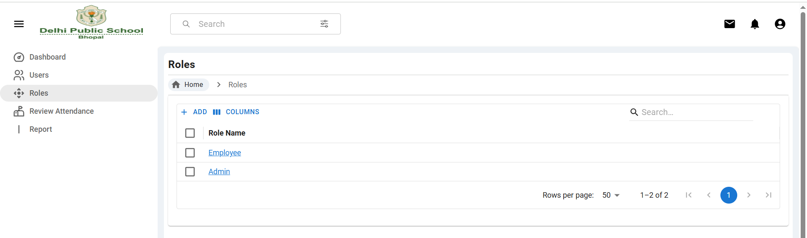

* You can add **Role** by clicking on +ADD button

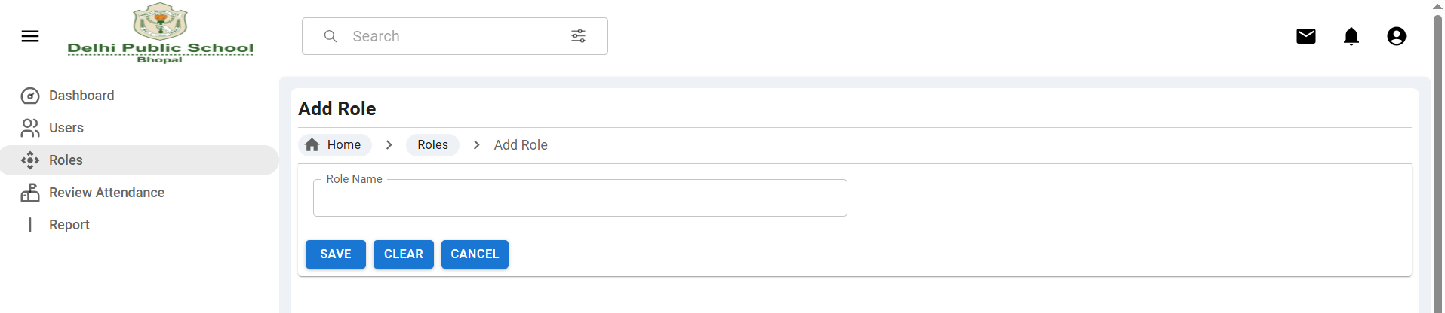

* You can view role by clicking on the role name



* That’s how the role view looks

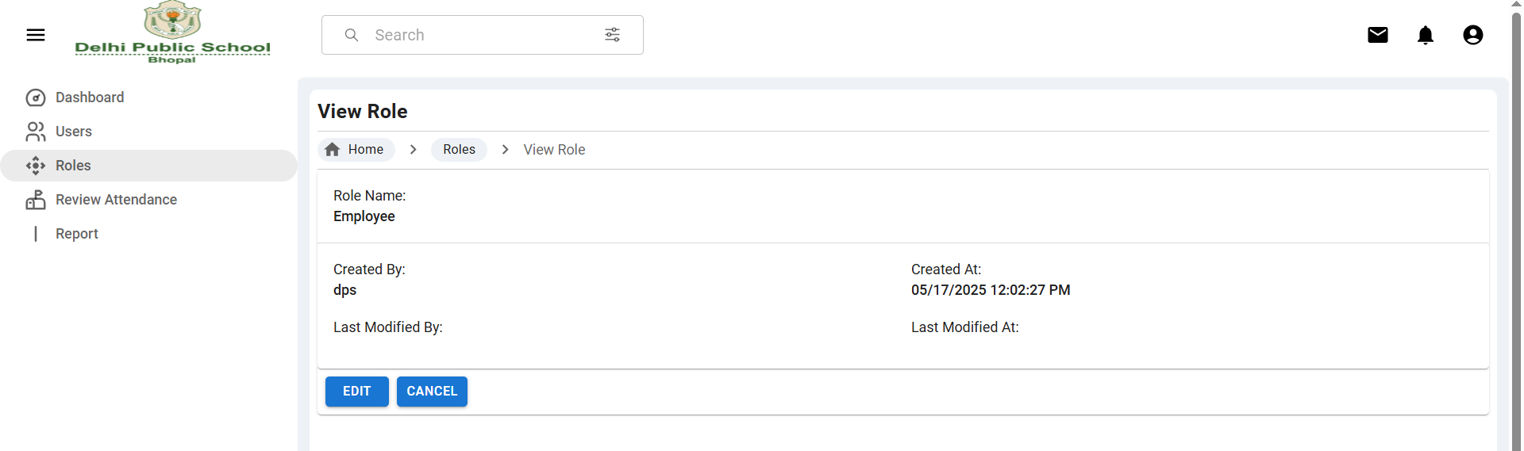

* You can edit the role by clicking on the EDIT button in view role / or by right clicking on the role name from the list / or by double clicking on the role name in the list.

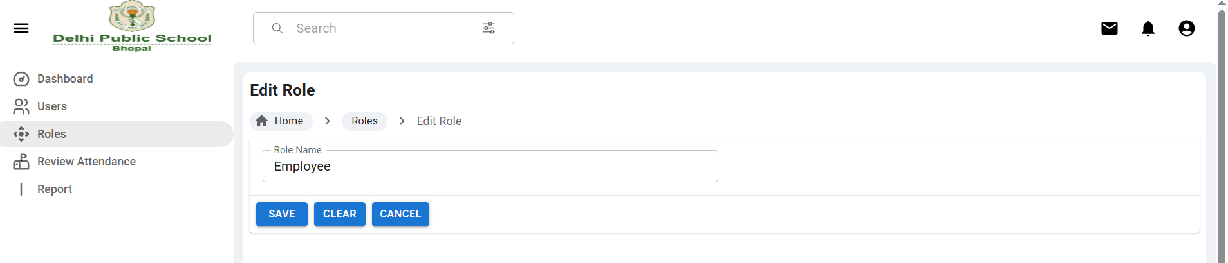

* Admin can delete Role by selecting the row from the list

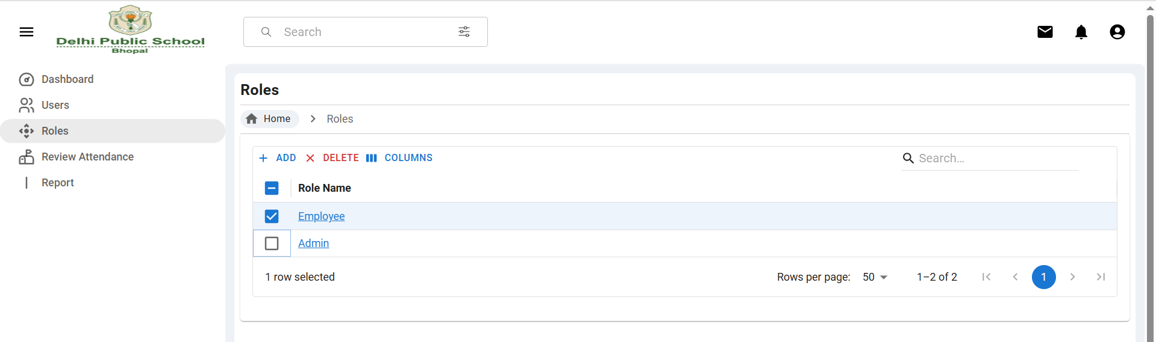

## 3. Users Module

* Admin user can perform all the operation (Add User, View User, Edit User, Delete User) same as admin can perform in **Role module** as mentioned above.

## 4. Review Attendance

* An admin user can review and manage employee attendance in the following ways:
* **View All Records**: Admin can review the complete attendance history of all employees.
* **Filter by Employee:** Admin can select an employee from a dropdown to view their specific attendance records.
* **Filter by Date Range:** Admin can filter attendance data based on selected date ranges.
* **View Specific Records:** Admin can view details of a selected attendance entry (similar to functionality in the Role module).
* **Edit Attendance:** Admin has the ability to edit attendance records if required (same behavior as in the Role module).
* **Delete Attendance:** Admin can delete attendance entries when necessary (similar to the Role module).

## 

## 4. Report Module

* The Admin Attendance Report feature allows administrators to analyze employee attendance data through various filters and views-
* View Complete Attendance Reports: Access attendance reports for all employees across the organization.
* Filter by Employee: Select an employee from a dropdown to view their individual attendance report.
* Filter by Date: View attendance reports based on specific dates or date ranges.
* Check-In / Check-Out Times: View the exact check-in and check-out times recorded for each employee.
* Total Work Duration: Automatically calculate and display the total time between check-in and check-out for each entry.

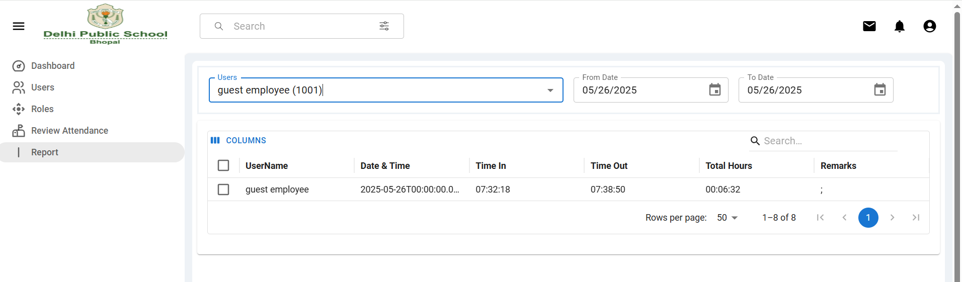

# 6. User Device Mapping Module

* Admin can change the status of users device so that the user can mark their attendance form their new Device.
* Admin User can View or Edit user’s Device status same as admin can perform in **Role module** as mentioned above.

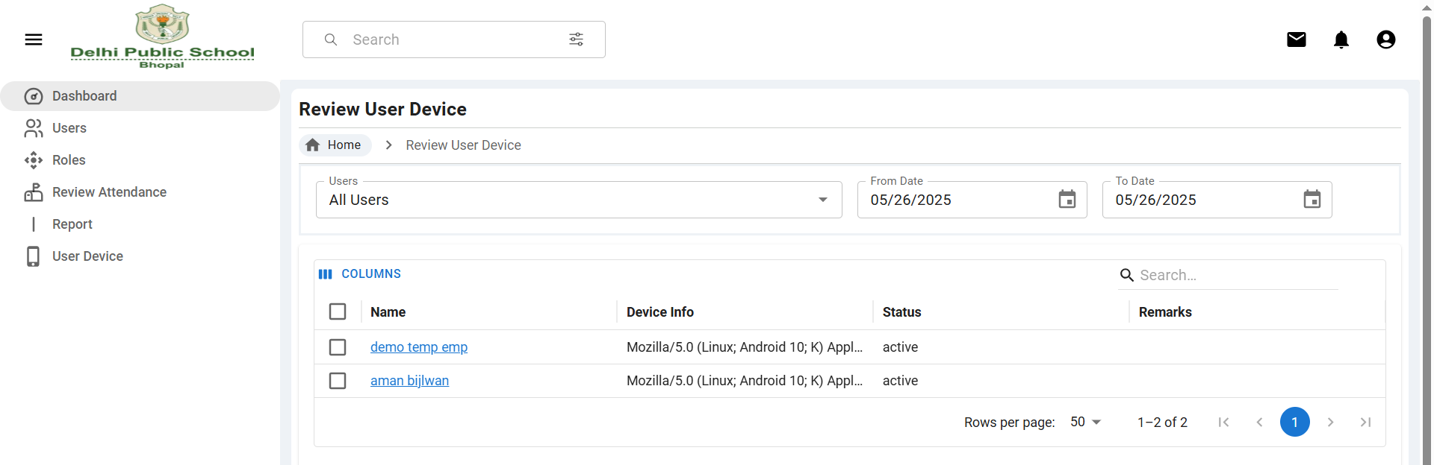

## For Forgot Password, View/Edit Profile, Change Password, Please Refer Steps for Employee.

# 6. Security Recommendations

* Always change the default password on first login.
* Do not share your credentials.
* Admins should periodically review user access and attendance irregularities.

# Need Help?

For any issues or support, contact the IT admin at :

Email : info@adhyayan.online