Name: Khai Cao - 2216586

Group: TXL22S1-B

1. **Expressions and truth table**

* 1. Truth table

We define functions F and G as functions of two variables A and B as follows:

* + - F yields value 1 when A and B have equal values, otherwise 0
    - G yields value 1 when both A and B have value 0, otherwise 0.

Construct truth tables for functions F and G.

|  |  |  |
| --- | --- | --- |
| A | B | F |
| 0 | 0 | 1 |
| 0 | 1 | 0 |
| 1 | 0 | 0 |
| 1 | 1 | 1 |

|  |  |  |
| --- | --- | --- |
| A | B | G |
| 0 | 0 | 1 |
| 0 | 1 | 0 |
| 1 | 0 | 0 |
| 1 | 1 | 0 |

* 1. Truth table and expression from verbal description

Bank vault door is operated by two buttons that must be pressed simultaneously for the vault door to open. However, the vault door does not open if the alarm signal is active.

Button pressed = 1, not pressed = 0.

Alarm active = 1, no alarm = 0

Name signals and construct a **truth table** and an **expression** for the door opening signal.

Door open = 1, door close = 0

|  |  |  |  |
| --- | --- | --- | --- |
| Button 1 | Button 2 | Alarm | Door |
| 0 | 0 | 0 | 0 |
| 0 | 1 | 0 | 0 |
| 1 | 0 | 0 | 0 |
| 1 | 1 | 0 | 1 |
| 0 | 0 | 1 | 0 |
| 0 | 1 | 1 | 0 |
| 1 | 0 | 1 | 0 |
| 1 | 1 | 1 | 0 |

* 1. Evaluate expression

Expressions for functions F and G are given below.

Calculate the values of both functions when A = 0, B = 1 and C = 1.

$$F=\overline{A}∙C+B∙ \overline{C}$$

$$G=(A+B)∙( \overline{B}+\overline{C})$$

Write your answer here!

$$F=\overline{A}∙C+B∙ \overline{C}= \overline{0}∙1+1∙\overline{1}=1∙1+1∙0=1+0=1$$

$$G=\left(A+B\right)∙\left( \overline{B}+\overline{C}\right)= \left(0+1\right)∙\left( \overline{1}+\overline{1}\right)=1∙0=0$$

1.4 Expression from circuit diagram

Construct an expression defining function L(A, B, C, D) represented in the following circuit diagram:

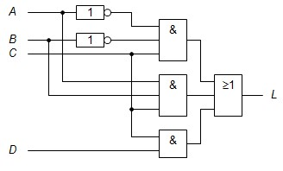

$L=\left(\overline{A}∙\overline{B}∙C\right)+\left(A∙B∙C\right)+(C∙D)$

In the following two exercises you need to use **IEC symbols** for logic gates. IEC symbols are box shaped symbols with operation symbol inside the box. You can set the gate shape in Logisim Evolution in File → Preferences → International → Gate shape.

1.5 Draw circuit diagram

Draw circuit diagrams representing the following functions using the basic logic gates:

$$F=A+\overline{B}∙C+B∙\overline{C}$$

$$G=(A+\overline{B}+C)(A∙\overline{C})(B+\overline{C})$$

Draw one diagram per function. Do not combine functions in the same diagram. Paste image capture from logisim here! Use windows snipping tool to capture the image.

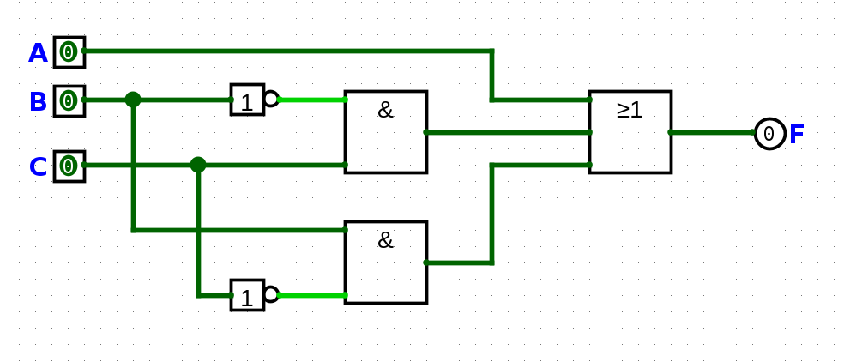

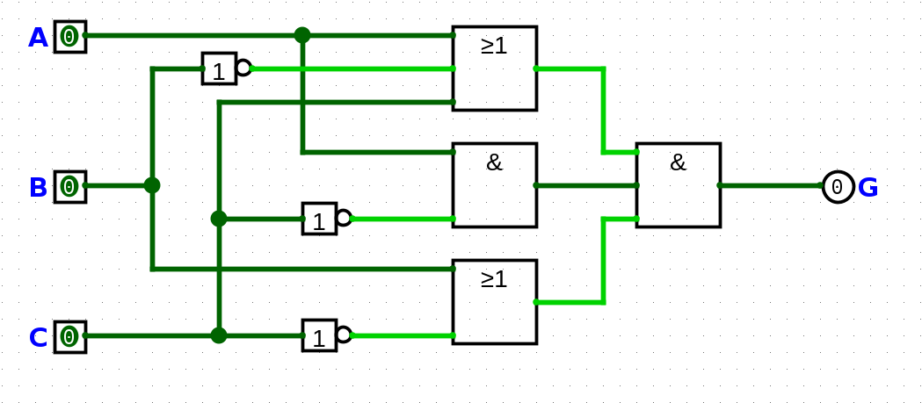

1.6 Design combinatinal circuit

A bus has two doors one at the front of the bus and one at the back of the bus. Each of the doors is equipped with a push button for opening the door. Door opens when the button next to the door is pressed and the bus is not moving. The signal that indicates that the bus is moving is obtained from the speedometer of the bus. Additionally there is a switch for the inspector which can be used to prevent opening the doors during ticket inspection. Design a digital circuit that generates door opening signal.

Name required signals, construct truth table for door opening signal, and draw a circuit diagram containing signals for both doors with Logisim.

Button pressed = 1, not pressed = 0

Bus is moving = 1, not moving = 0

Inspector switch on = 1, off = 0

Door 1 opened = 1, not opened = 0

Door 2 opened = 1, not opened = 0

|  |  |  |  |  |  |
| --- | --- | --- | --- | --- | --- |
| Button 1 | Button 2 | Moving | Switch | Door 1 | Door 2 |
| 0 | 0 | 0 | 0 | 0 | 0 |
| 0 | 0 | 1 | 0 | 0 | 0 |
| 0 | 1 | 0 | 0 | 0 | 1 |
| 0 | 1 | 1 | 0 | 0 | 0 |
| 1 | 0 | 0 | 0 | 1 | 0 |
| 1 | 0 | 1 | 0 | 0 | 0 |
| 1 | 1 | 0 | 0 | 1 | 1 |
| 1 | 1 | 1 | 0 | 0 | 0 |
| 0 | 0 | 0 | 1 | 0 | 0 |
| 0 | 0 | 1 | 1 | 0 | 0 |
| 0 | 1 | 0 | 1 | 0 | 0 |
| 0 | 1 | 1 | 1 | 0 | 0 |
| 1 | 0 | 0 | 1 | 0 | 0 |
| 1 | 0 | 1 | 1 | 0 | 0 |
| 1 | 1 | 0 | 1 | 0 | 0 |
| 1 | 1 | 1 | 1 | 0 | 0 |

