Name: Khai Cao - 2216586

Group: TXL22S1-B

1. **Sequential circuits and ASM method**
   1. Study the following ASM-chart and answer the questions:

* What is the minimum number of flip-flops (state bits) needed for the following ASM-chart?
* k ≥ $$\log_{2}{}s$$ = $$\log_{2}{}14 ≈3.8$$ $$→$$ k = 4
* Minimum number of flip-flops is 4
* How many output signals does the system have?
* Sis, ssis, tul, ul $$→$$ 4 ouput signals
* Is it a Mealy or Moore state machine?
* It’s a Moore machine

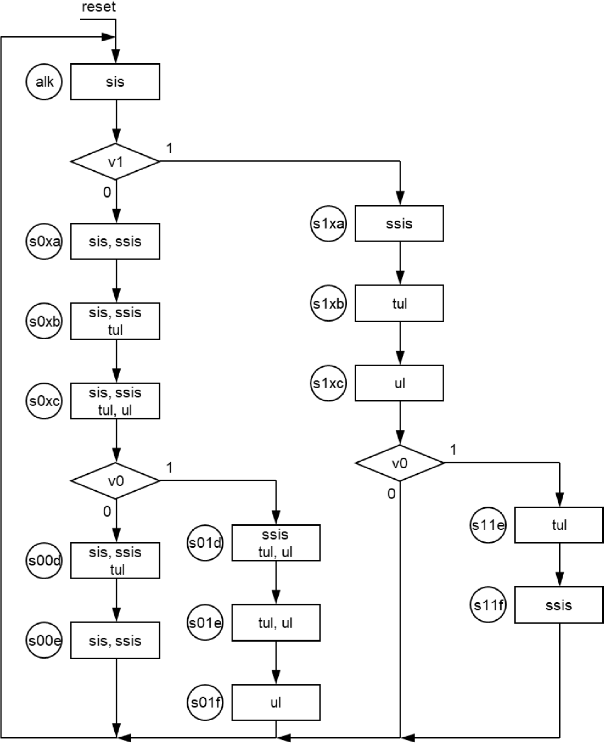

* 1. In the following ASM-chart the clock cycle time is 0.5 s. How many states do you need to add if motor should be started 2 seconds after the button was pressed?

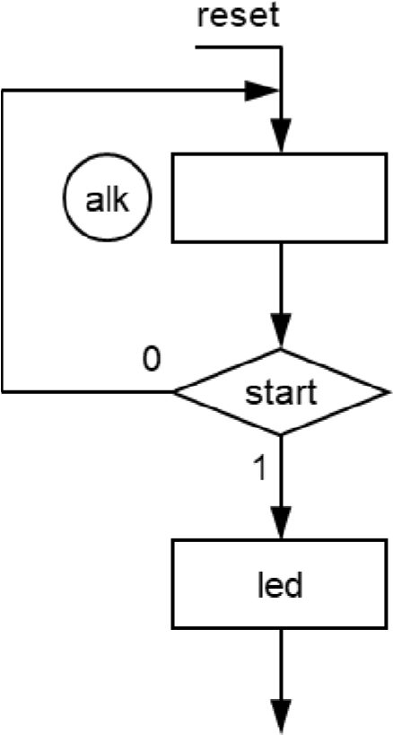

* + 2s / 0.5s = 4 $$→$$ 4 states are needed
  1. A bank vault door is controlled by a sequential circuit. Initially the door is locked. The door can be opened by pressing two opening buttons simultaneously. The buttons are placed at opposite ends leading to the vault. When the buttons are pressed the unlock signal is activated. When the unlock signal is active a yellow warning light flashes. The unlock signal stays active until both buttons are released. When both buttons are released the unlock signal is deactivated, flashing stops, and the circuit returns to the initial state. Name signals and draw an ASM-chart of the door controller