**HEALTH TECH**

**HEART RATE MONITOR DEVICE – SMART RINGS**

**Student: Khai Cao**

**Group: TXL22S1-B**

**Student number: 2216586**

**Teacher: Sakari Lukkarinen**

1. **Device[1]**

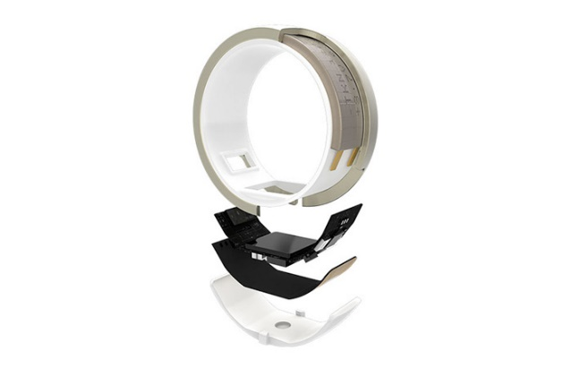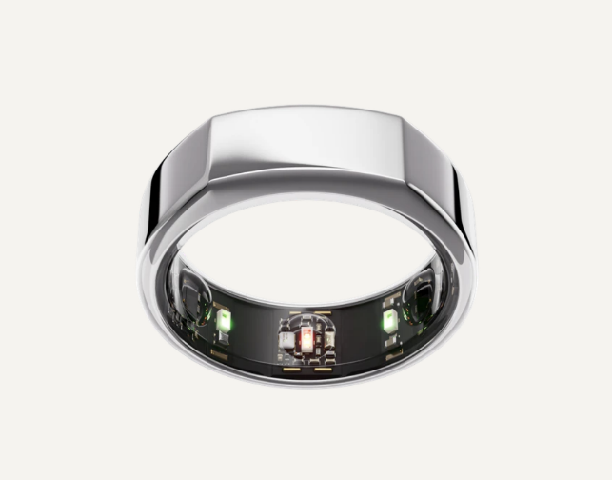A smart ring is a wearable electronics device loaded with mobile components like sensors and NFC chips that are used for a variety of applications, mostly tracking daily activities and as a peripheral tool to support mobile devices. This makes smart rings a nifty alternative to smart watches and fitness bands. But smart ring applications go beyond monitoring steps or as an extension of your smartphones.

Figure 2. An example of a smart ring’s structure [1]

Figure 1. An example image of a smart ring. Source: www.runnersworld.com/uk/gear/a40459007/best-smart-rings

Most smart rings don’t have only one functionality. For instance, one smart ring can track both your sleeping habits and daily activities. Other smart rings can do both on top of other features like contactless payments and online security.

Depends on different smart rings, there can be a lot of technologies inside a ring, for example an NFC chip, sensor, Bluetooth chip, battery, microcontroller, and light indicator.

1. **Use[1]**

Smart ring devices can be used for a range of applications. The most common uses we’ve seen on the market nowadays are in the health and fitness category. But other practical applications include digital payments, online security, and access control.

1. **Heath & wellness management**

Smart rings are capable of tracking health parameters like heart rate, blood oxygen levels (SpO2), blood pressure, and glucose levels, among others.

Meanwhile, some smart rings can be used to measure a user’s stress level through Electrodermal Activity (EDA), the same reference used in lie detector tests to evaluate emotion and cognition through the skin. Moodmetric Ring does precisely that and helps you manage your stress levels.

1. **Sleep monitoring**

Sleep-tracking smart rings keep tabs on sleep patterns, including how much sleep you get, sleep disturbances, and how much time is spent in the different sleep cycles. This allows smart rings to come up with recommendations on how users can regulate their bodies based on their personal circadian rhythm, our natural 24-hour body clock.

Figure 3. Sleep tracking ring

1. **Fitness tracking**

Fitness tracking is a common functionality among smart ring devices. Fitness smart rings can monitor daily activities, including the number of steps taken, distance traveled while walking, and calories burned.

1. 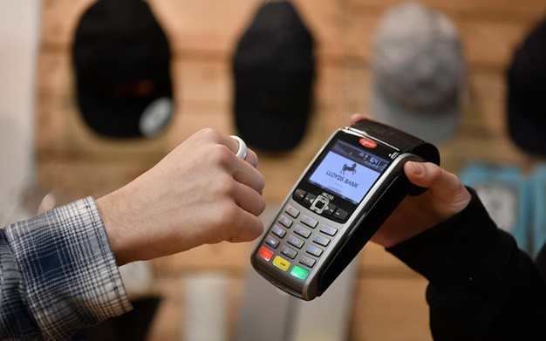**Contactless payments**

Figure 4. Smart ring used in contactless payments

With a contactless payment ring, you can tap-to-pay transactions below the local floor-limit on Visa and MasterCard contactless payment terminals globally.

1. **Online security**

Motiv Ring, for instance, uses two-factor authentication (2FA) for web log-ins with the help of its app and preset gesture control. An up-and-coming online security feature in smart rings is biometric authentication, which provides a more secure way to navigate around the web than passwords and PINs. Motiv is doing a beta test for fingerprint scanning and facial recognition as authentication methods.

In development are biometric authentication based on a user’s electrocardiogram (ECG) and gait, or the manner a person walks. Like face recognition and fingerprint scanning, ECG is far safer and more resilient against hacking, identity theft, phishing, and other malicious attacks.

1. **Remote control**

Most smart rings have capabilities that allow you to control your smartphone and other devices. Whether it’s to set alarms, receive message or call notifications, or control music, smart rings are a great tool to minimize your screen time and increase your productivity.

1. **Smart key**

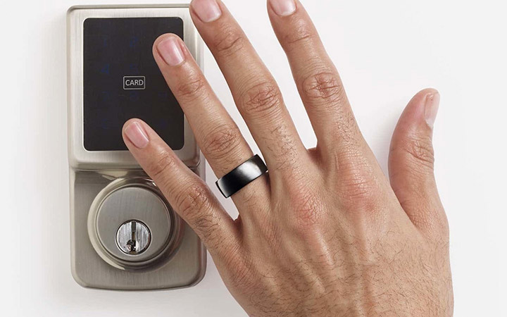Some smart rings that have optical sensor inside them that enables you to open your home, car, or office instead of using a traditional physical key, access card, or badges. Taking the smart ring off your finger locks the door or halts access. This makes for a great security system so no one else can access your home, car, office, gym, or anything that it’s connected to.

Figure 5. Smart ring as a contactless key [1]

1. **Transit pass**

A slew of NFC smart rings can serve as a travel pass or ticket for public transportation with tap-to-pay card reader terminals at transit gates. These smart rings are essentially stored-value cards (SVC), keeping the monetary value of the travel fund readily available without any third-party support of credit or debit accounts or network connection required.

1. **Users**
2. **Sensors**

Several varieties of the sensors used in smart-rings include a heat, heartbeat sensor (infrared or optical type sensor), an accelerometer (3 axis type, for tracking and monitor the movements like walking, running and sleeping, etc.), EDA sensors (for tracking human emotions, feelings, and mental condition also like stress levels), NTC thermistor (for tracking body temperature).[2]

1. **Data collection**

**References**

1. What are smart rings? How do they work? – Link: [www.smartringnews.com/posts/what-are-smart-rings-how-do-they-work](http://www.smartringnews.com/posts/what-are-smart-rings-how-do-they-work)
2. How does Smart Ring work? – Link: [elexexplorer.com/2021/04/17/how-does-smart-ring-work](https://elexexplorer.com/2021/04/17/how-does-smart-ring-work)