Name: Khai Cao - 2216586

Group: TXL22S1-B

1. **Boolean algebra**

* 1. De Morgan’s theorem

Apply De Morgan’s theorems (more than once if needed) and a suitable identity to simplify the following expressions to obtain expressions having no long bars, i.e. bars may remain only over single variables.

* 1. Canonical SOP and POS

Given the truth table below construct canonical SOP and POS representations of the function F.

|  |  |  |
| --- | --- | --- |
| A | B | F |
| 0 | 0 | 1 |
| 0 | 1 | 0 |
| 1 | 0 | 1 |
| 1 | 1 | 0 |

SOP:

POS:

* 1. Truth table from a standard expression

The expressions below are in standard form. Construct the truth tables of functions F and G.

$$F\left(A, B\right)=A\overline{B}+B$$

$$G(A, B)=\left(A+B\right)∙\left(\overline{A}+\overline{B}\right)$$

|  |  |  |  |
| --- | --- | --- | --- |
| A | B | F | G |
| 0 | 0 | 0 | 0 |
| 0 | 1 | 1 | 1 |
| 1 | 0 | 1 | 1 |
| 1 | 1 | 1 | 0 |

* 1. De Morgan’s theorem in programming

Jamie is making a robot vacuum cleaner. The robot has three sensors to detect if the robot is located on the charging station or not. A sensor returns true if the sensor is over the station and false when the sensor is outside the station. Jamie is working on piece of code that is supposed to drive the robot out of the charging station. Jamie has three variables that represent the state of the sensors: L is for the left side of the robot, C is for the center, and R is for the right side of the robot.

Jamie has written an if-statement to run the robot at full speed when it has completely left the charging station:

if not (not L or not C or not R):

full_speed()

Use De Morgan’s theorem to simplify Jamie’s stop condition. Is Jamie’s if-statement correct?

Jamie’s stop condition: $F=\overline{\overline{L}+\overline{R}+\overline{C}}=LRC$

Jamie’s if-statement is incorrect. The full_speed() function should only be executed when all 3 sensors are not detected.

Truth table of the full_speed() function

|  |  |  |  |
| --- | --- | --- | --- |
| L | C | R | F (Full speed) |
| 0 | 0 | 0 | 1 |
| 0 | 0 | 1 | 0 |
| 0 | 1 | 0 | 0 |
| 0 | 1 | 1 | 0 |
| 1 | 0 | 0 | 0 |
| 1 | 0 | 1 | 0 |
| 1 | 1 | 0 | 0 |
| 1 | 1 | 1 | 0 |

* Correct answer: $F=\overline{L}∙\overline{R}∙\overline{C}$
  1. Canonical forms

Jamie’s charging station is designed so that all three sensors return true when the robot is correctly aligned on the station. Jamie has also noticed that when two sensors out of three are on the station rotating the robot will get the robot properly aligned i.e., brings all sensors on the station.

* Construct truth table of the function that tells when Jamie should rotate the robot.
* Construct canonical SOP of the function.
* Implement the SOP with Logisim.

|  |  |  |  |
| --- | --- | --- | --- |
| L | C | R | Rotate |
| 0 | 0 | 0 | 0 |
| 0 | 0 | 1 | 0 |
| 0 | 1 | 0 | 0 |
| 0 | 1 | 1 | 1 |
| 1 | 0 | 0 | 0 |
| 1 | 0 | 1 | 1 |
| 1 | 1 | 0 | 1 |
| 1 | 1 | 1 | 0 |

SOP:

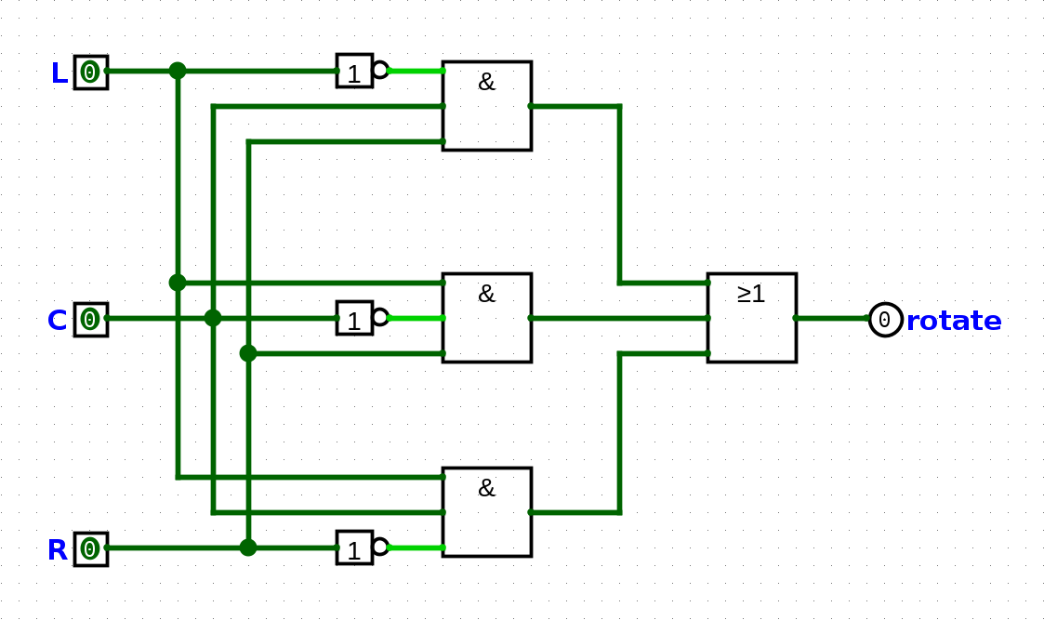

* 1. Draw circuit diagram and simulate

Expressions for functions F and G are given below. Draw circuit diagrams of the functions and simulate the circuits with A = 0, B = 1 and C = 1.

$$F=\overline{A}∙C+B∙\overline{C}$$

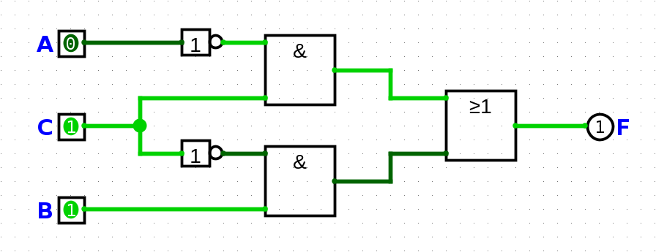

$$G=\left(A+B\right)∙\left(\overline{B}+\overline{C}\right)$$

