Name: Khai Cao - 2216586

Group: TXL22S1-B

1. **ASM method and one hot encoding**
   1. Implement an ASM chart with one hot encoding

The state machine controls lights with a push button. When the button is pressed the light

switches on immediately. The button has to be released before lamp can be switched off.

Then when the button is pressed again the light switches off. The following ASM-chart

specifies the state machine operation. Implement the state machine with one hot encoding.

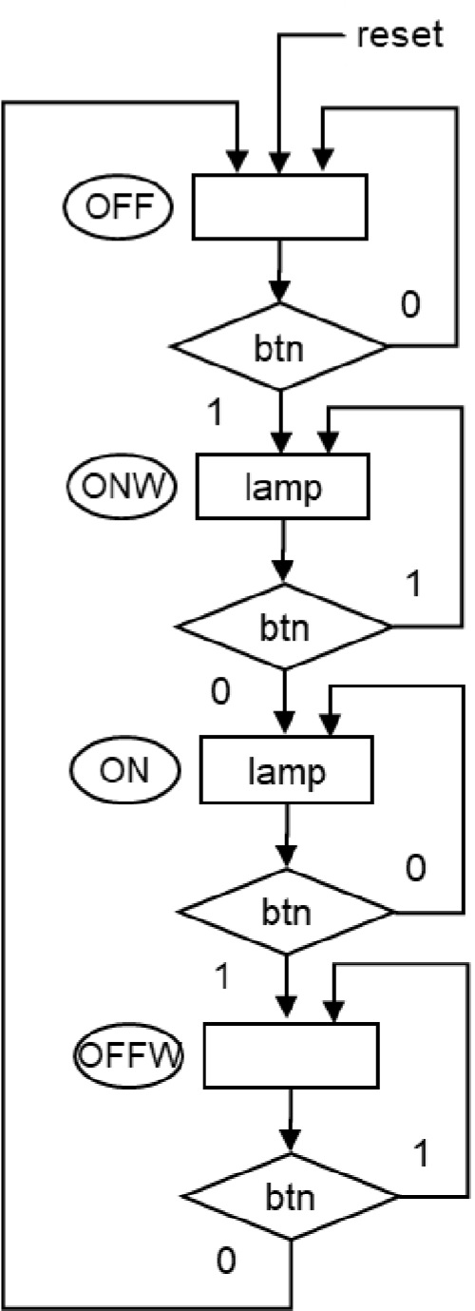

* 1. Design and implement a state machine

An alarm system has two inputs: alarm signal and a button. Alarm signal goes high when

there is an alarm. Button can be pressed to acknowledge the alarm. There are two outputs:

red light and siren.

The alarm system works so that initially both light and siren are off.

* When alarm is activated both lamp and siren go on.
* When the button is pressed the alarm acknowledged. If the alarm is still active when it is acknowledged the siren is switched off and the red light starts to blink. The red light keeps on blinking until the alarm is deactivated.
* If the alarm is deactivated before button has been pressed the siren is switched off and red light stays on until user presses button.

Draw ASM chart of the alarm system and implement it with one hot encoding.

You have following input signals:

* Button (1 = pressed)
* Alarm (1 = alarm is active)

You have following output signals:

* Red lamp (1 = lamp is on)
* Siren (1 = siren is on)