Lancer le script schema-data.sql

Recréer la DB en créant trois scripts : schema, data, constraint.sql

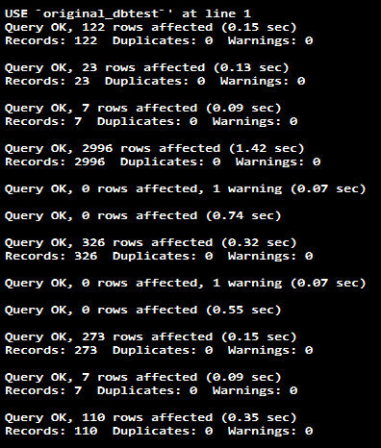

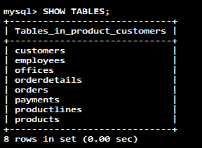

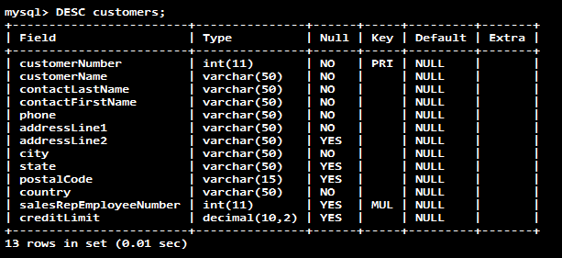

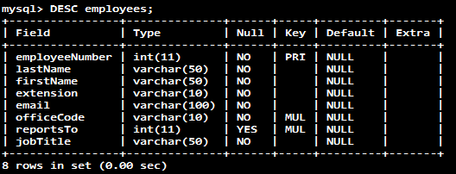

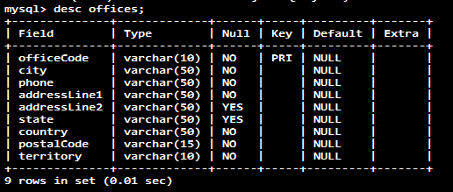

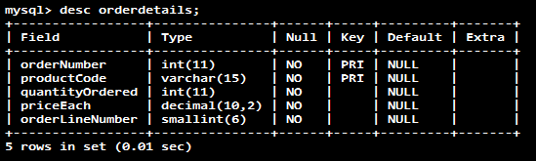

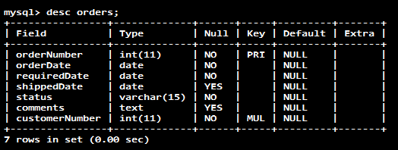

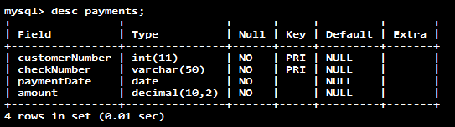

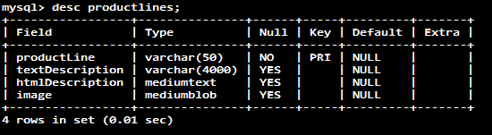

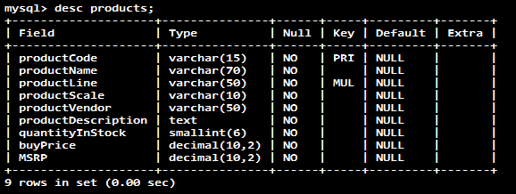

-- select complet

SELECT

column_1, column_2, ...

FROM

table_1

[INNER | LEFT |RIGHT] JOIN table_2 ON conditions

WHERE

conditions

GROUP BY column_1

HAVING group_conditions

ORDER BY column_1

LIMIT offset, length;

-- Qry : SELECT

SELECT lastname, firstname, jobtitle FROM employees ORDER BY lastname ;

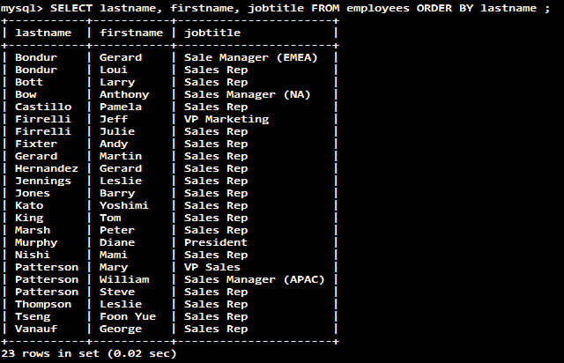

-- Qry : DISTINCT

SELECT lastname FROM employees ORDER BY lastname ;

-- Rq : Certains employés ont leur même nom de famille : Bondur, Firrelli et Patterson !

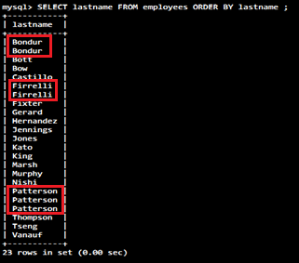

-- Q : Supprimer les doublons !

SELECT DISTINCT lastname FROM employees ORDER BY lastname ;

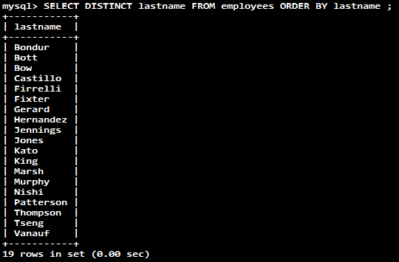

-- Qry : DISTINCT + NULL values

SELECT DISTINCT state FROM customers;

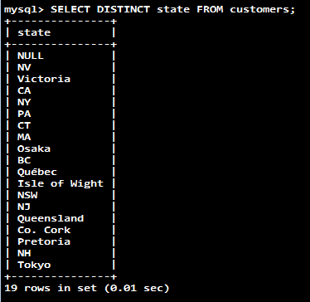

-- Qry : DISTINCT + Multiple Columns

SELECT DISTINCT state, city FROM customers WHERE state IS NOT NULL ORDER BY state , city;

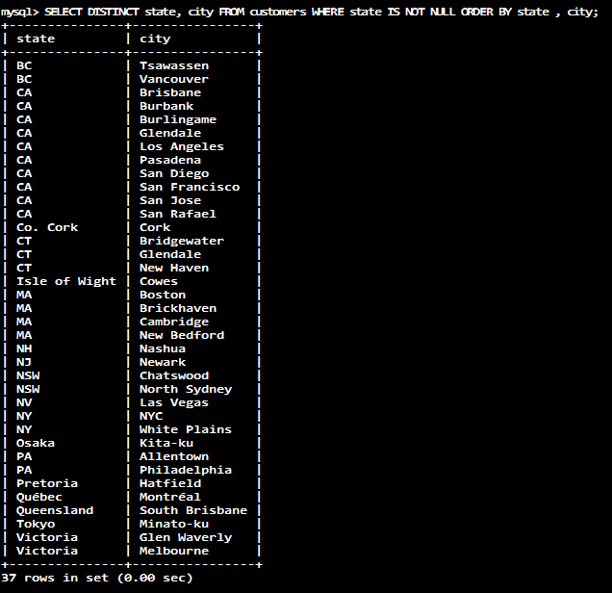

SELECT state, city FROM customers WHERE state IS NOT NULL ORDER BY state , city;

-- CA SAN Francisco se repete 2 fois

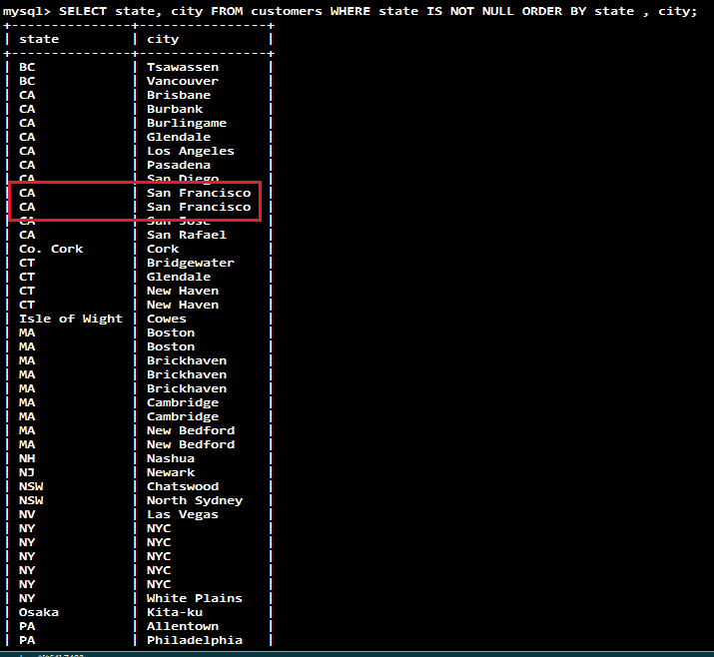

-- Qry DISTINCT Vs. GROUP BY

SELECT state FROM customers GROUP BY state;

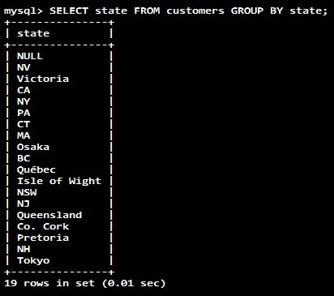

-- GROUP BY retourne des données triés.

-- On n'a pas besoin d'1 ORDER BY avec GROUP BY (sans 1 fonction d'AGGREGATION)

SELECT DISTINCT state FROM customers ORDER BY state;

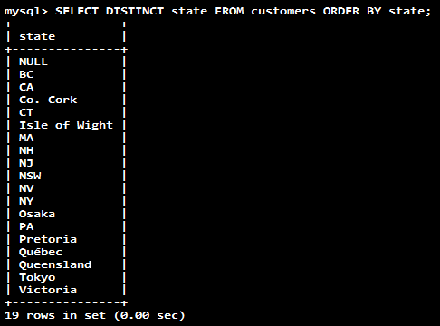

-- DISTINCT ne trie pas les données. Ns sommes obligés d'indiquer ORDER BY.

-- DISTINCT avec 1 fonction d'aggrégation

SELECT COUNT(DISTINCT state) FROM customers WHERE country = 'USA';

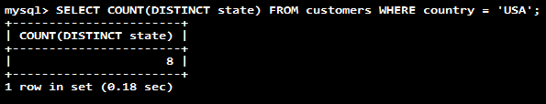

-- Qry : ORDER BY + ALIAS

SELECT ordernumber, orderlinenumber,

quantityOrdered * priceEach AS subtotal

FROM

orderdetails

ORDER BY

ordernumber,

orderLineNumber,

subtotal; -- Je peux utiliser l'ALIAS

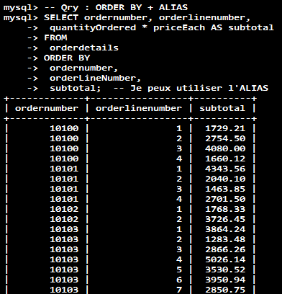

-- Qry : ORDER BY + FIELD

SELECT

orderNumber, status

FROM

orders

ORDER BY FIELD(status,

'In Process',

'On Hold',

'Cancelled',

'Resolved',

'Disputed',

'Shipped');

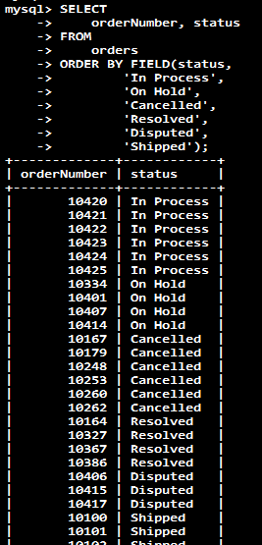

-- Qry : WHERE + FIELD

SELECT

lastname,

firstname,

jobtitle

FROM

employees

WHERE

jobtitle = 'Sales Rep' AND

officeCode = 1;

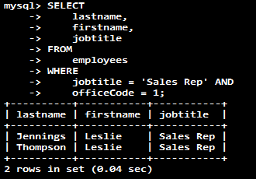

-- Qry : INNER JOIN

SELECT productCode, productName, textDescription FROM

products t1

INNER JOIN

productlines t2 ON t1.productline = t2.productline;

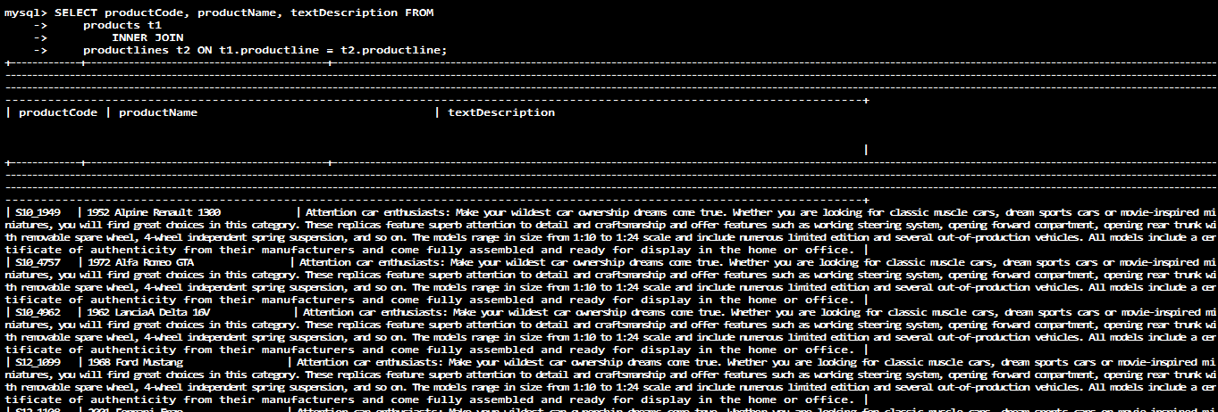

-- Qry : INNER JOIN + GROUP BY

-- Q : Trouver le total des ventes par 'orderNumber' et 'status' ?

SELECT T1.orderNumber, status,

SUM(quantityOrdered * priceEach) total

FROM

orders AS T1

INNER JOIN

orderdetails AS T2 ON T1.orderNumber = T2.orderNumber

GROUP BY orderNumber;

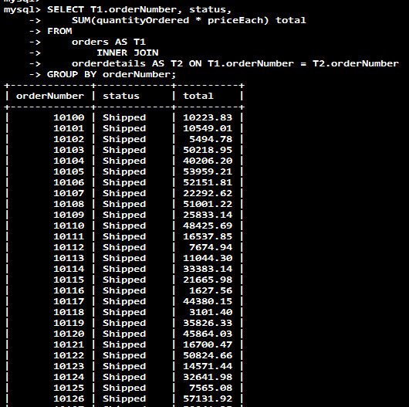

-- Qry : INNER JOIN + GROUP BY + WHERE

-- Q : find sales prices of the product whose code is S10_1678 that are less than the manufacturer’s suggested retail price (MSRP) for that product ?

SELECT orderNumber, productName, msrp, priceEach FROM

products p

INNER JOIN

orderdetails o ON p.productcode = o.productcode

AND p.msrp > o.priceEach

WHERE

p.productcode = 'S10_1678';

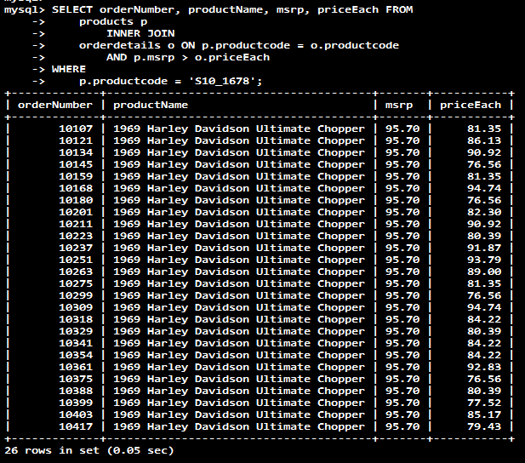

-- Qry : LEFT JOIN

-- Q : find all orders that belong to each customer ?

-- Remember :

-- Each order in the orders table must belong to a customer in the customers table.

-- Each customer in the customers table can have zero or more orders in the orders table.

SELECT c.customerNumber, c.customerName, orderNumber, o.status FROM

customers c

LEFT JOIN orders o ON c.customerNumber = o.customerNumber;

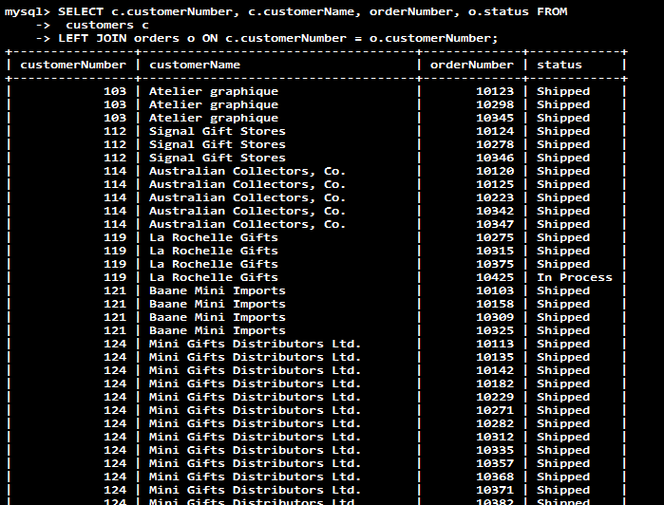

-- Qry : LEFT JOIN + WHERE + IS NULL

-- Q : find all customers who have not placed any order ?

SELECT c.customerNumber, c.customerName, orderNumber, o.status

FROM customers c

LEFT JOIN

orders o ON c.customerNumber = o.customerNumber

WHERE

orderNumber IS NULL;

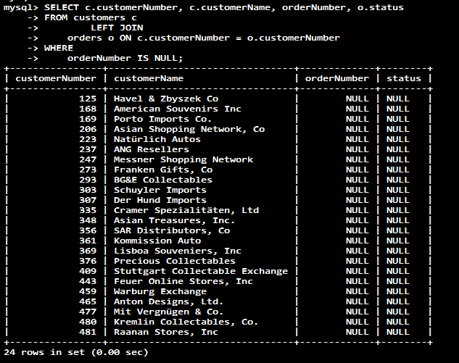

-- Qry : LEFT JOIN + WHERE VS ON

Q : Expliquer ces 2 Qry ?

SELECT o.orderNumber, customerNumber, productCode FROM orders o LEFT JOIN orderDetails USING (orderNumber) WHERE orderNumber = 10123;

R: Cette requête retourne les valeurs (customerNumber, productCode) pour tous les orderNumber 10123 présents dans la table orders.

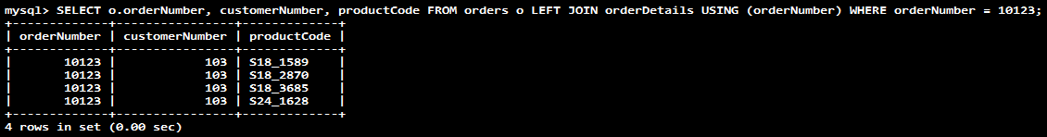

SELECT o.orderNumber, customerNumber, productCode FROM orders o LEFT JOIN orderDetails d ON o.orderNumber = d.orderNumber AND o.orderNumber = 10123;

R: Cette requête retourne tous les orderNumber présents dans la table orders mais ne fournira les valeurs (customerNumber, productCode) que pour les orderNumber 10123, pour les autres orderNumber la valeur sera NULL.

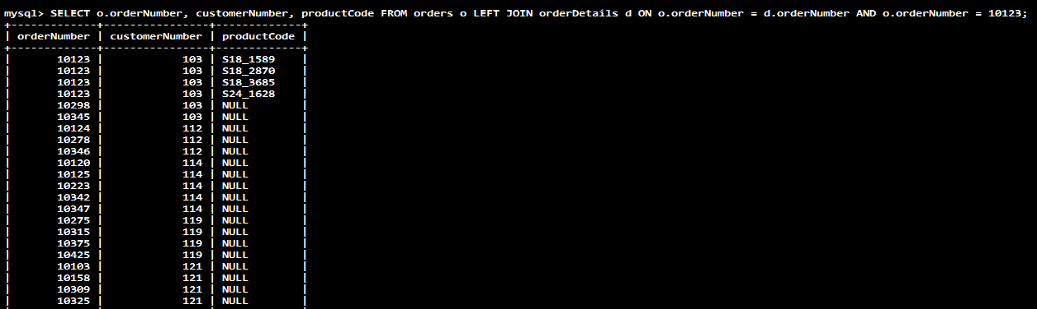

-- Qry : RIGHT JOIN

-- Q : get the sales representatives and their customers ?

SELECT concat(e.firstName,' ', e.lastName) salesman, e.jobTitle, customerName

FROM

employees e

RIGHT JOIN

customers c ON e.employeeNumber = c.salesRepEmployeeNumber

AND e.jobTitle = 'Sales Rep'

ORDER BY customerName;

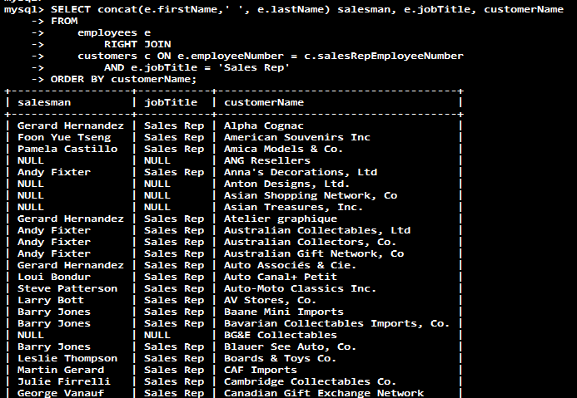

-- Qry : SELF JOIN

-- Q : Display a list of customers who locate in the same city ?

SELECT

c1.city, c1.customerName, c2.customerName

FROM

customers c1

INNER JOIN

customers c2 ON c1.city = c2.city

AND c1.customername > c2.customerName

ORDER BY c1.city;

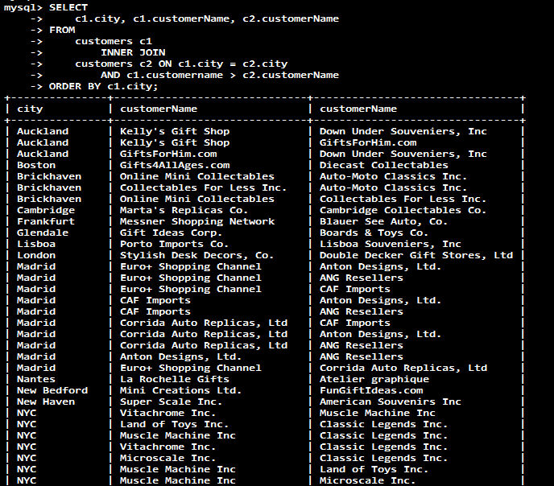

-- Q : get the whole organization structure (organigramme de la société) ?

SELECT

CONCAT(m.lastname, ', ', m.firstname) AS 'Manager',

CONCAT(e.lastname, ', ', e.firstname) AS 'Direct report'

FROM

employees e

INNER JOIN

employees m ON m.employeeNumber = e.reportsto

ORDER BY manager;

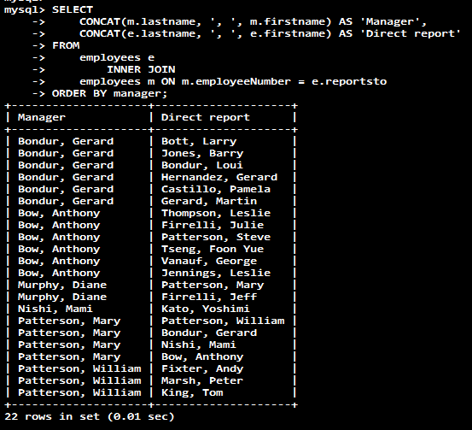

-- Qry : SELF JOIN + IFNULL

-- La dernière Qry fonctionne bien sauf que ns avons juste les noms des fonctionnaires (elle ne retourne pas le nom des managers alorsq ns avons besoin de l'organigramme de la société)

-- R : get the whole organization structure ?

SELECT

IFNULL(CONCAT(m.lastname, ', ', m.firstname), -- retourner le nom du manager

'Top Manager') AS 'Manager',

CONCAT(e.lastname, ', ', e.firstname) AS 'Direct report'

FROM

employees e

LEFT JOIN

employees m ON m.employeeNumber = e.reportsto

ORDER BY manager DESC;

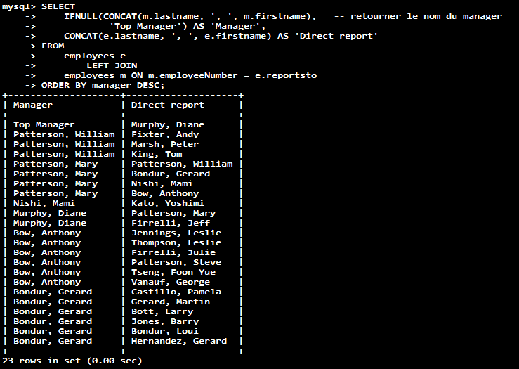

-- Qry : CROSS JOIN

Un exemple :

CREATE TABLE products**_test** (

id INT PRIMARY KEY AUTO_INCREMENT,

product_name VARCHAR(100),

price DECIMAL(13 , 2 )

);

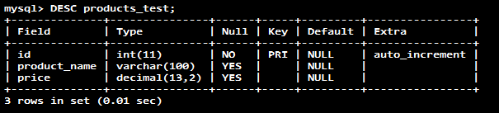

CREATE TABLE stores**_test** (

id INT PRIMARY KEY AUTO_INCREMENT,

store_name VARCHAR(100)

);

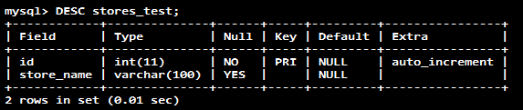

CREATE TABLE sales**_test** (

product_id INT,

store_id INT,

quantity DECIMAL(13 , 2 ) NOT NULL,

sales_date DATE NOT NULL,

PRIMARY KEY (product_id , store_id),

FOREIGN KEY (product_id)

REFERENCES products (id)

ON DELETE CASCADE ON UPDATE CASCADE,

FOREIGN KEY (store_id)

REFERENCES stores (id)

ON DELETE CASCADE ON UPDATE CASCADE

);

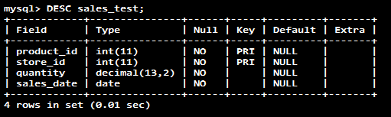

-- Suppose we have three products iPhone, iPad and Macbook Pro which are sold in two stores North and South.

INSERT INTO products(product_name, price)

VALUES('iPhone', 699),

('iPad',599),

('Macbook Pro',1299);

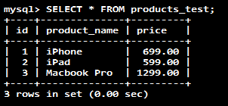

INSERT INTO stores(store_name)

VALUES('North'),

('South');

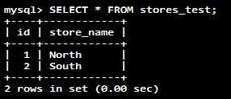

INSERT INTO sales(store_id,product_id,quantity,sales_date)

VALUES(1,1,20,'2017-01-02'),

(1,2,15,'2017-01-05'),

(1,3,25,'2017-01-05'),

(2,1,30,'2017-01-02'),

(2,2,35,'2017-01-05');

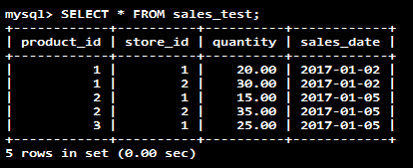

-- Q : get the total sales for each store and for each product, you calculate the sales and group them by store and product as follows ?

SELECT

store_name,

product_name,

SUM(quantity * price) AS revenue

FROM

Sales**_test**

INNER JOIN

Products**_test** ON products**_test**.id = sales**_test**.product_id

INNER JOIN

Stores**_test** ON stores**_test**.id = sales**_test**.store_id

GROUP BY store_name , product_name;

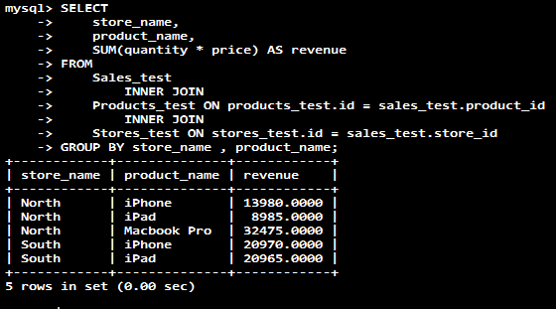

-- Q : you want to know also which store had no sales of a specific product ?

-- First, you use the CROSS JOIN clause to get the combination of all stores and products:

SELECT

store_name, product_name

FROM

stores**_test** AS a

CROSS JOIN

products**_test** AS b;

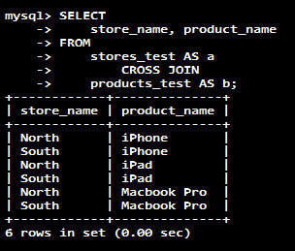

-- Next, you join the result of the query above with the query that returns the total of sales by store and by product. The following query illustrates the idea

SELECT

b.store_name,

a.product_name,

IFNULL(c.revenue, 0) AS revenue

FROM

products**_test** AS a

CROSS JOIN

stores**_test** AS b

LEFT JOIN

(SELECT

stores**_test**.id AS store_id,

products**_test**.id AS product_id,

store_name,

product_name,

ROUND(SUM(quantity * price), 0) AS revenue

FROM

sales**_test**

INNER JOIN products**_test** ON products**_test**.id = sales**_test**.product_id

INNER JOIN stores**_test** ON stores**_test**.id = sales**_test**.store_id

GROUP BY store_name , product_name) AS c ON c.store_id = b.id

AND c.product_id= a.id

ORDER BY b.store_name;

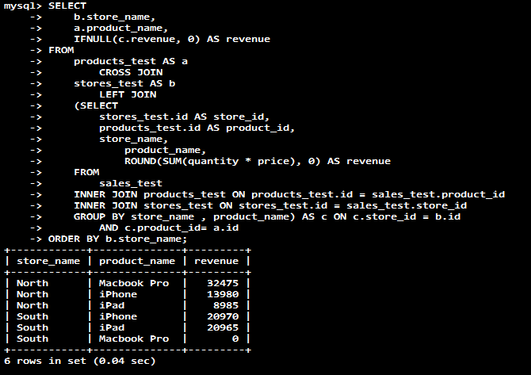

**FIN**