Mahmoud Kahack

11/13/2018

Memo

The project status is almost done, I still have to optimize the code in the sense of cleaning it up more, extracting some classes, decoupling certain classes from others, and making my test suite more presentable. Other done that the project should meet all the requirements specified in the project description, API specification, and test script. One big component that is missing is making the application thread safe. This is important for this application because many people will be accessing at the same time. Other than that it meets all the other requirements.

Statistics about the project

* https://github.com/Makk-Attack/CS445/tree/master/ParkPaySystem
* Lines of code: 916 source lines of code + 690 API lines of code
* Lines of code in unit tests: 976 lines of code
* 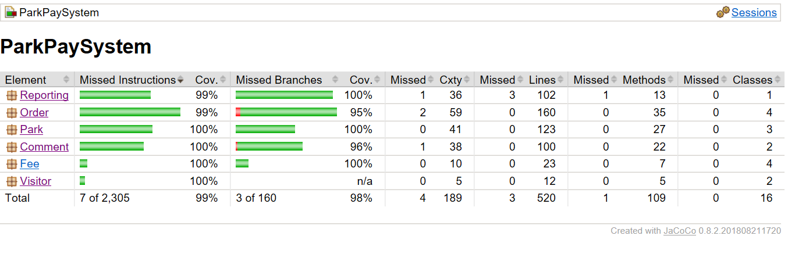Unit test coverage: 99% instructions, 98% branches.
* Cyclomatic complexity for your code. Please don't submit code with cyclomatic complexity higher than 20 because you're just wasting your time.
* The number of hours you needed to get the code working.
* The number of hours you spent preparing your submission.
* A list of challenges you faced while working on this assignment and the solutions you found to those challenges.