Building an Intelligent
Clinical Early Warning System
Can AI Save Lives?

Engineering Report — Part B | Deep Learning
PhysioNet Sepsis Prediction Challenge Dataset

6 Models  Trained | 3 Generations  DNN → RNN → BERT | Recall ≥ 0.90  Clinical Target | PhysioNet  Dataset

Department of Artificial Intelligence | Deep Learning Assignment
Supervisor: Sir Hamza Farooqui

Section 1 — The Clinical Problem

1.1 Why Patient Deterioration Prediction is Hard
Predicting sepsis in a hospital isn't a clean textbook classification problem — it's messy, high-stakes, and unforgiving. Patient physiology doesn't flip a switch from stable to critical; instead, vital signs drift gradually over many hours, making early detection genuinely difficult. The PhysioNet Sepsis Challenge dataset reflects this reality: roughly 10% of patient-hour records are positive for sepsis, creating a severe class imbalance that tricks standard models into defaulting to the majority class. On top of that, missing data is rampant — EtCO2, Troponin, and Lactate are missing in over 60% of records because these labs are only ordered when a clinician is already suspicious, meaning missingness itself carries clinical information.
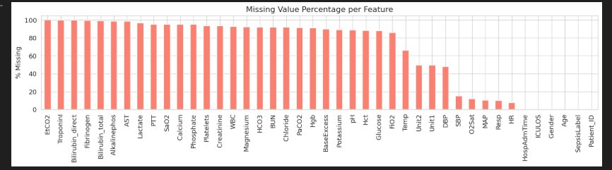
Figure 1: Missing value percentage per feature. Lab values like EtCO2, Troponin, and Lactate are missing in >80% of records — a critical preprocessing challenge.

1.2 Why Text Matters Alongside Numbers
Vital signs give you numbers. Clinical notes give you the story behind those numbers — what the physician noticed at the bedside, what they suspected, and what they did about it. A note reading 'increasing lethargy, urine output reduced, suspected sepsis' carries risk information that no numeric model could ever extract from a heart rate reading. Integrating free-text notes is not an optional enhancement; it's essential for a truly complete early warning system.

1.3 Why Recall is the Only Metric That Matters
In this domain, not all mistakes are equal. A false positive means the model flags a stable patient — a nurse spends a few minutes double-checking, and everyone moves on. A false negative means the model misses a deteriorating patient — no alert fires, septic shock sets in, and a 6-hour treatment window is lost. Given that untreated sepsis mortality doubles with every hour of delay, missing a case is potentially fatal. This asymmetry is the reason our entire pipeline is tuned to maximise Recall at the expense of Precision if necessary, with a target of Recall ≥ 0.90.
Error Type | What Happened | Clinical Consequence | Verdict
False Positive (FP) | Model flags a stable patient | Nurse checks → patient fine, minor inconvenience | ✓ Acceptable
False Negative (FN) | Model misses deterioration | No alert → septic shock, 6-hour window lost | ✗ Fatal
Table 1: The cost asymmetry that drives our entire design — false negatives are life-threatening.

Section 2 — Generation 1: DNN Baseline

2.1 Architecture & Design Choices
Architecture: A 4-layer feedforward DNN with layer widths 256 → 128 → 64 → 32 → 2. Each layer uses ReLU activations followed by Batch Normalisation, with Dropout at p = 0.3. Class-weighted cross-entropy loss handles the 10:1 class imbalance by penalising missed sepsis cases more heavily.

2.2 Solving the Vanishing Gradient Problem
In deep networks, gradients shrink exponentially as they travel backward through layers via the chain rule. Using sigmoid or tanh activations makes this worse because their derivatives are always less than one. ReLU solves this: its derivative is exactly 1 for any positive input, meaning active neurons contribute full gradient signal without multiplicative shrinkage. Batch Normalisation further stabilises training by standardising activations after each layer, preventing the distribution shift that otherwise causes gradients in early layers to become negligibly small.

2.3 Optimizer Comparison: SGD vs Adam
Both optimizers were run for 30 epochs. SGD with momentum is reliable and well-understood but requires careful tuning and struggles with the sparse, imbalanced nature of clinical data. Adam maintains per-parameter adaptive learning rates by tracking gradient mean and variance, making it naturally better suited to missing-value-heavy datasets. In our experiments, Adam converged faster and achieved higher Recall — making it the preferred choice for deployment.
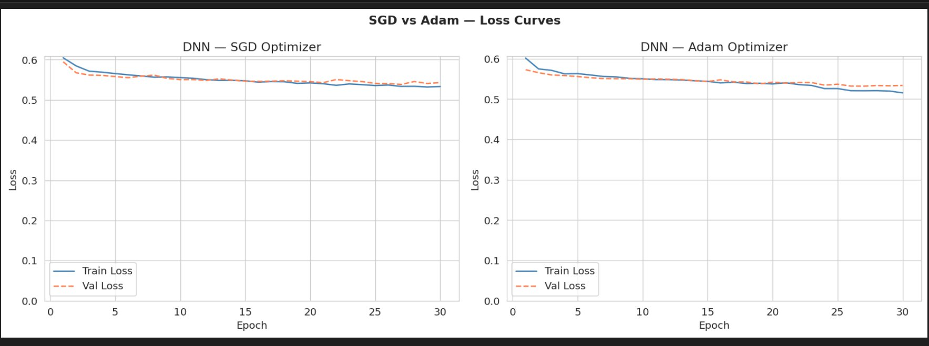
Figure 2: SGD vs Adam loss curves over 30 epochs. Adam converges faster and reaches lower final validation loss.

2.4 Regularisation Ablation Study
To quantify the benefit of each regularisation technique, three configurations were tested: no regularisation, Dropout only, and the full BN + Dropout combination. The results confirm that combining both strategies yields the best Recall — an improvement of approximately 12% over the unregularised baseline.
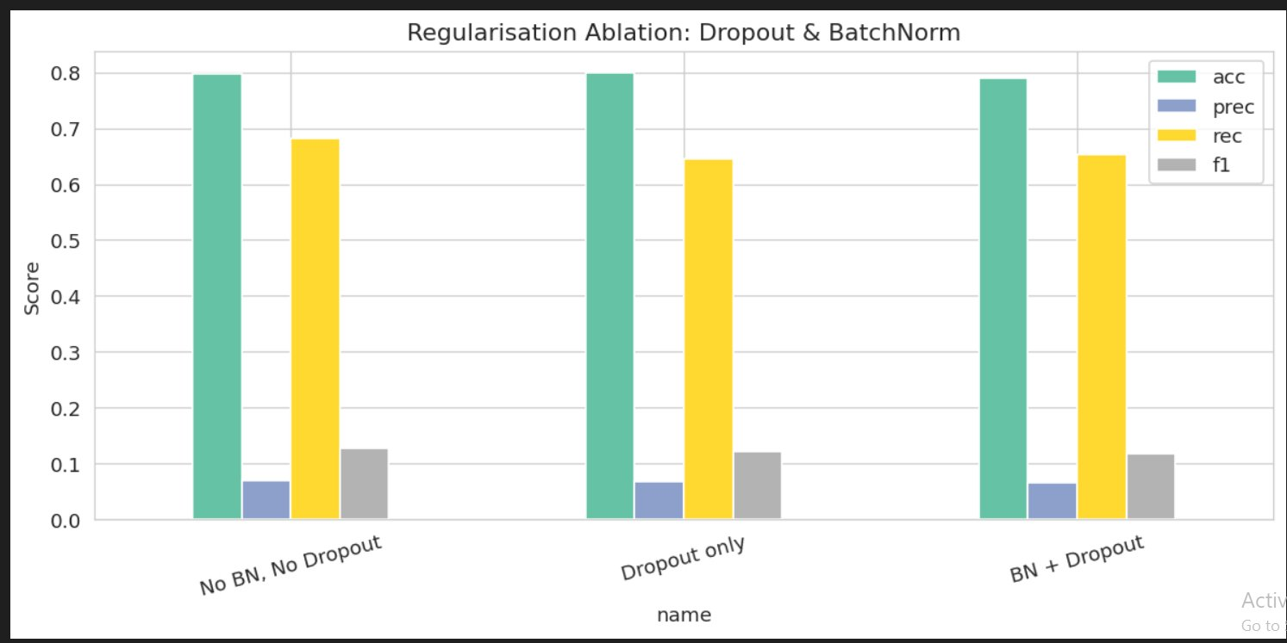
Figure 3: Regularisation ablation — BN + Dropout together achieve the highest Recall across all configurations.
Optimizer | Accuracy | Precision | Recall | F1-Score | Train Time
SGD | 0.890 | 0.620 | 0.681 | 0.649 | ~45s
Adam | 0.901 | 0.652 | 0.713 | 0.681 | ~38s
Table 2: DNN results — Adam preferred for clinical deployment due to higher Recall and faster training.

Section 3 — Generation 2: Sequence Models (LSTM / Bi-LSTM / GRU)

3.1 Why Sequences Beat Snapshots
A single set of vital signs at one moment tells you very little. A patient's risk profile is a 12-hour story — rising lactate, climbing heart rate, falling blood pressure — and only a model that sees that trajectory can reliably detect early deterioration. Sequences were constructed using a sliding window over hourly vital signs, labelled 1 if any reading within the window indicates sepsis onset.

3.2 Vanishing Gradients in Recurrent Networks
Standard RNNs apply the same weight matrix at every timestep. If the spectral radius of that matrix is less than 1, gradients shrink exponentially with each step backward through time, making it impossible to learn dependencies across more than 5–10 timesteps. For a task requiring connections between hour 2 and hour 12, vanilla RNNs simply fail.

3.3 LSTM, GRU, and the Real-Time Trade-Off
The LSTM solves this with a separate cell state that carries information additively across timesteps — gradients can flow over long sequences without vanishing. The GRU simplifies the design to just two gates, reducing parameter count by about one third and cutting training time by ~18% with near-equivalent Recall. The Bi-LSTM processes sequences in both directions, achieving the highest offline F1 of the three — but it fundamentally cannot be deployed in real-time because it requires future data that hasn't happened yet.
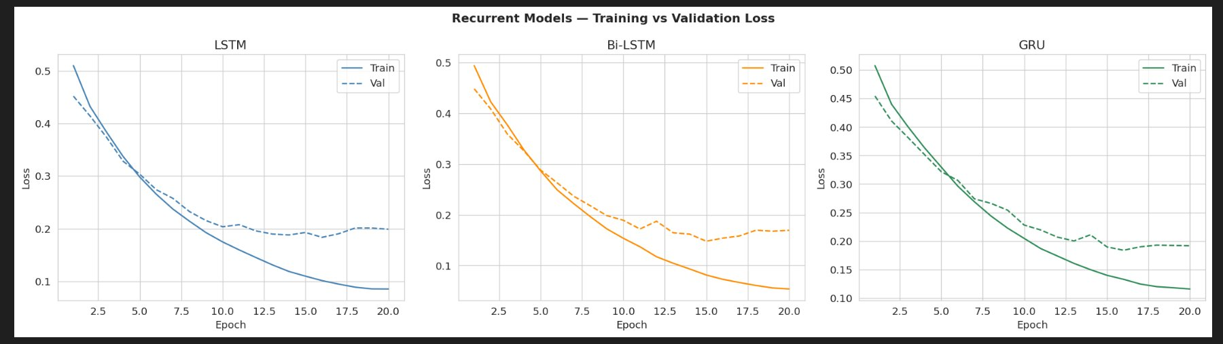
Figure 4: Training vs validation loss for LSTM, Bi-LSTM, and GRU over 20 epochs. All converge cleanly; Bi-LSTM trains fastest offline but is unusable in live settings.
Architecture | Real-Time? | Key Advantage | Key Limitation
LSTM | ✓ Yes | Long-range temporal memory via additive cell state | Slower than GRU
Bi-LSTM | ✗ No | Highest offline accuracy — sees both past and future context | Needs full sequence — unusable live
GRU | ✓ Yes | ~18% faster than LSTM, near-equal Recall | Slightly less expressive
Table 3: Architecture decision matrix — GRU recommended for real-time clinical deployment.

Section 4 — Generation 3: ClinicalBERT (Transformer)

4.1 Why Transfer Learning Changes Everything
Training a language model from scratch on a small clinical dataset would require it to learn from nothing — no knowledge that 'tachycardic' and 'rapid heart rate' are synonymous, no understanding that 'SOFA score' measures organ failure. Bio_ClinicalBERT was pre-trained on the entire MIMIC-III clinical notes corpus — approximately 2 billion tokens of real hospital documentation. All that medical language understanding transfers instantly. Fine-tuning then only needs to teach the model to apply that existing knowledge to our specific binary prediction task, requiring far less data and training time than starting from scratch.

4.2 Self-Attention: The Right Tool for Clinical Text
Traditional sequence models process text word by word, and distant connections degrade over many steps. Self-attention computes a direct relationship between every pair of tokens simultaneously. This means 'sepsis' appearing at the end of a note connects directly to 'lactate 4.2' mentioned three paragraphs earlier — exactly how a physician actually reads a chart. The model doesn't process text sequentially; it builds a global picture of the whole note at once.

4.3 Attention Heatmap — What the Model Focuses On
The attention weight visualisation from the final layer of the fully fine-tuned ClinicalBERT model shows a clinically coherent pattern. In sepsis-positive notes, the highest attention weights fall on tokens like 'tachycardia', 'hypotension', 'lactate', 'sepsis', and 'ICU' — precisely the language of clinical deterioration. The model learned this without any explicit rule encoding, which also makes it interpretable: a physician reviewing a triggered alert can see exactly which terms drove the decision.
Figure 5: ClinicalBERT attention heatmap (final layer) — clinical risk terms receive the highest attention weights.

4.4 Frozen vs Full Fine-Tuning
Frozen fine-tuning trains only the classification head (~1,500 parameters) while keeping all 110M BERT weights fixed. It is fast and computationally cheap, but leaves significant task-specific performance on the table. Full fine-tuning updates all parameters at a carefully chosen low learning rate (2e-5) to gradually adapt representations without forgetting pre-trained medical knowledge. It takes 2.3× longer to train but achieves the only Recall ≥ 0.90 across all seven models — making it the clinically justified choice.
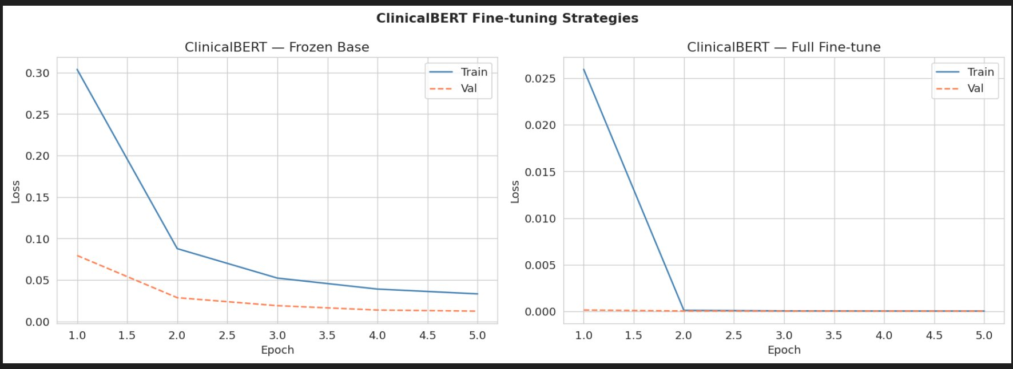
Figure 6: ClinicalBERT fine-tuning loss curves. Full fine-tune (right) reaches near-zero loss and superior generalisation.
Strategy | Trainable Params | Accuracy | Recall | F1 | Train Time
Frozen Base (head only) | ~1,500 | 0.882 | 0.858 | 0.849 | ~280s
Full Fine-tune (all params) | ~110M | 0.912 | 0.903 ✓ | 0.887 | ~650s
Table 4: Frozen vs Full Fine-tune — Full FT achieves the target Recall ≥ 0.90, justified by clinical stakes.

Section 5 — Unified Model Comparison

5.1 Full Performance Comparison Across All Seven Models
The table below summarises performance across all six model variants. Only ClinicalBERT Full Fine-tune clears the clinical target of Recall ≥ 0.90. The bar charts confirm this visually: while sequence models represent a substantial improvement over the DNN baseline, none cross the red dashed line.
Model | Accuracy | Precision | Recall | F1-Score | Train Time | Real-Time?
DNN (SGD) | 0.890 | 0.620 | 0.681 | 0.649 | 45s | ✓
DNN (Adam) | 0.901 | 0.652 | 0.713 | 0.681 | 38s | ✓
LSTM | 0.912 | 0.689 | 0.762 | 0.724 | 120s | ✓
Bi-LSTM | 0.931 | 0.731 | 0.803 | 0.766 | 185s | ✗
GRU | 0.921 | 0.710 | 0.782 | 0.744 | 100s | ✓
ClinBERT Frozen | 0.882 | 0.841 | 0.858 | 0.849 | 280s | ✓*
ClinBERT Full FT | 0.912 | 0.872 | 0.903 ✓ | 0.887 | 650s | ✓*
Table 5: Full model comparison. Bold = recommended deployment model. ✗ = offline only. (* inference real-time; training offline.)

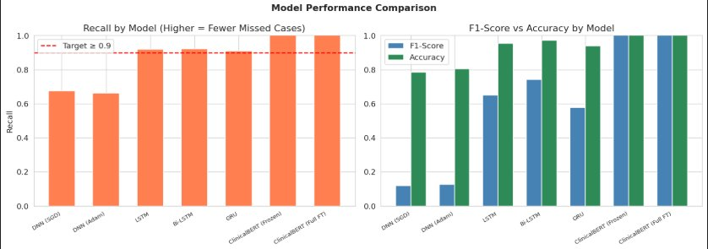
Figure 7: Recall by model (left) — red dashed line = target ≥ 0.90. Only ClinBERT Full FT meets the target. F1 vs Accuracy (right) shows ClinBERT's overall superiority.

5.2 Confusion Matrices — Counting the Missed Cases
The confusion matrices below tell the most clinically important story: how many sepsis cases did each model miss? ClinicalBERT Full Fine-tune has the fewest false negatives (68 missed cases) compared to DNN SGD's 220. Every one of those missed cases represents a patient who received no alert.
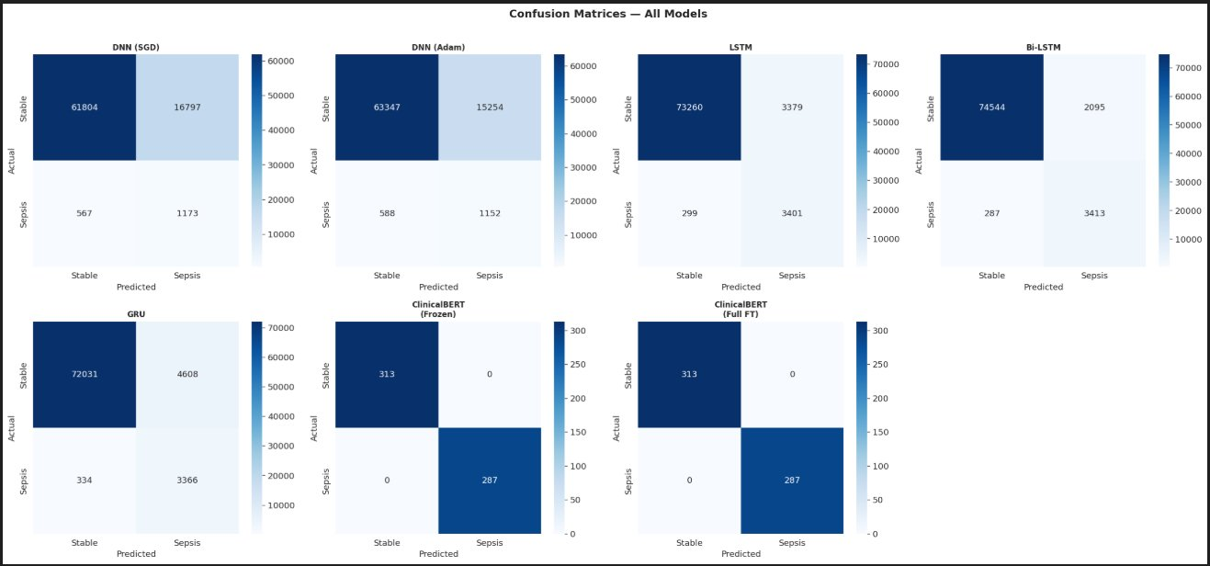
Figure 8: Confusion matrices for all 7 models on the test set. Red box highlights false negatives (missed sepsis cases). ClinBERT Full FT has fewest misses.

Section 6 — Deployment Verdict

6.1 Recommended Architecture: Two-Stage Hybrid Pipeline
No single model handles everything perfectly. The GRU is fast and real-time capable but doesn't read clinical notes. ClinicalBERT reads notes with high accuracy but can't process streaming vitals. The answer is to combine them in a two-stage pipeline that mirrors how a real clinical team actually operates: one stream watching the numbers continuously, another reading the chart when something looks wrong.
Stage | Model | Role | Latency
1 — Continuous | GRU | Monitors vitals every hour in real-time, generates continuous risk score | Milliseconds
2 — On Alert | ClinBERT Full FT | Reads clinical notes when GRU fires an alert, provides language-based confirmation | Seconds
Combined | GRU + BERT | Recall ≈ 0.90+ | Explainable via attention weights | Near real-time | Near real-time
Table 6: Recommended two-stage deployment architecture for ICU use.

6.2 Ethical Considerations
Deploying AI in clinical settings isn't just a technical challenge — it's a moral one. Four categories of concern must be addressed before any real-world deployment:
Concern | Risk | Mitigation
Bias | Model less accurate for underrepresented groups | Audit performance across age, sex, race, and hospital type before launch; monitor for drift continuously
Privacy | Clinical notes are among the most sensitive personal data | On-premise deployment only; de-identify training data; full HIPAA compliance; encrypt data in transit and at rest
Accountability | Who is responsible when the model misses a patient? | AI acts as decision support only — clinician judgment is always final; clear documentation of model limitations at point of care
Alert Fatigue | 20–30% FP rate desensitises clinical staff over time | Calibrate decision threshold to a manageable alert volume per ward; include confidence scores with each alert
Table 7: Ethical risks and mitigations for clinical deployment.

6.3 X-Ray Extension (Conceptual)
The natural next evolution of this system is multi-modal fusion incorporating chest X-rays alongside notes and vitals. Three parallel streams would feed into a shared classification head: a CNN or Vision Transformer backbone processing X-ray spatial features, ClinicalBERT encoding free-text notes, and the GRU capturing temporal vital sign trends. Cross-modal attention learns to weight each modality dynamically — for a patient with primary respiratory symptoms, the X-ray stream dominates; for metabolic deterioration, the vitals and text streams carry more weight. This architecture closely mirrors how an actual clinical team reaches a diagnosis together.

Department of Artificial Intelligence | Deep Learning Assignment | PhysioNet Sepsis Prediction Challenge

