Method Request Response

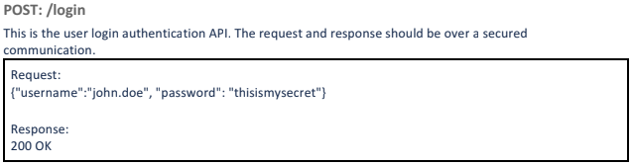

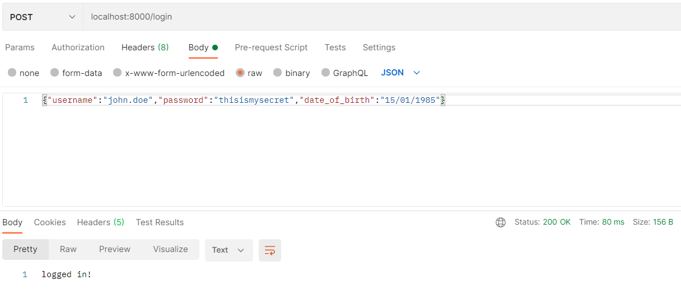

------------------------------------------------------------------------------------------------------------------------------------------

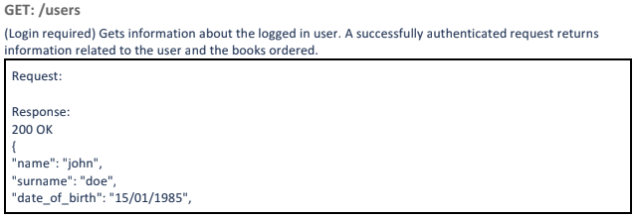

For this part, I created a .json file to store the provided information.

Login is required.



Then getting the information from my created .json file.

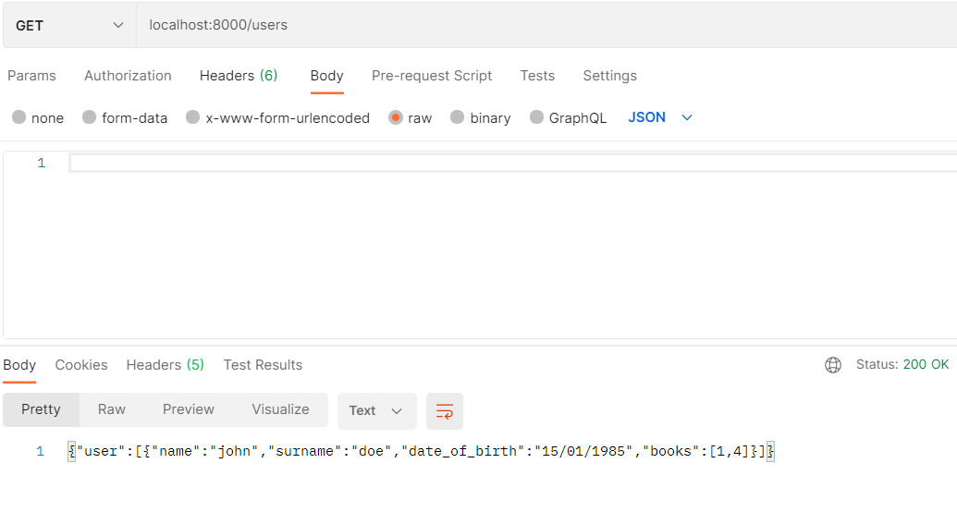

------------------------------------------------------------------------------------------------------------------------------------------

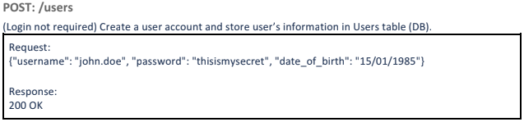

I create a user account and store in my created .json file instead DB.

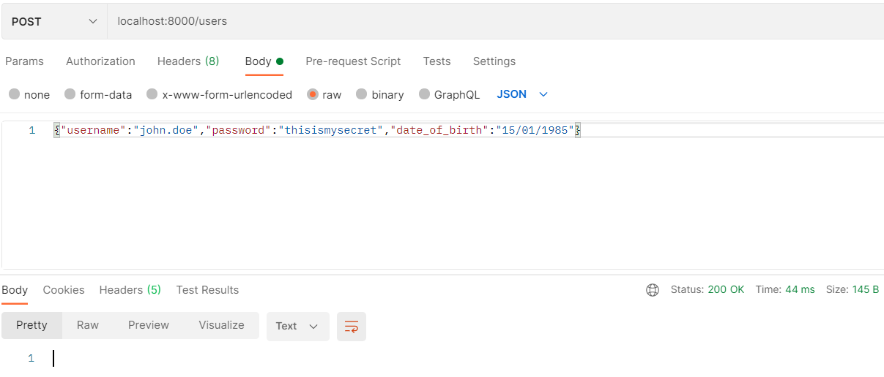

The account is added.

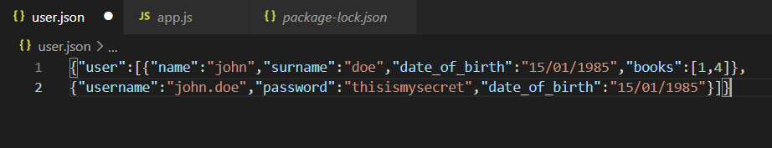

------------------------------------------------------------------------------------------------------------------------------------------

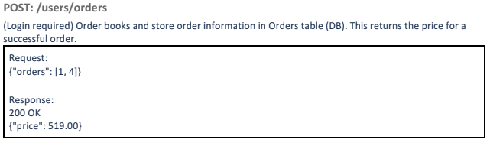

Login is required.



Then posting the orders to get their price. 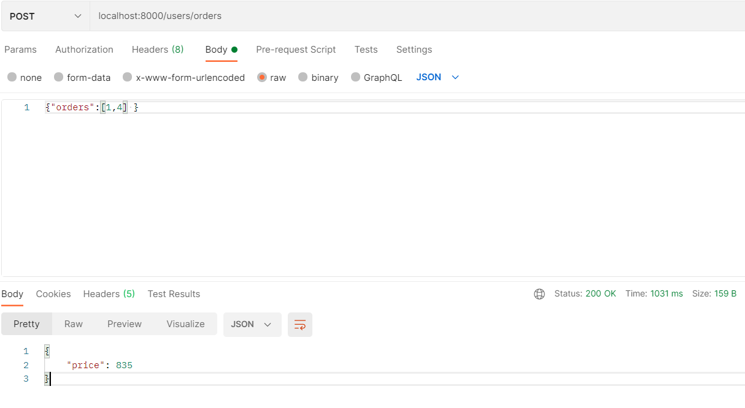

------------------------------------------------------------------------------------------------------------------------------------------

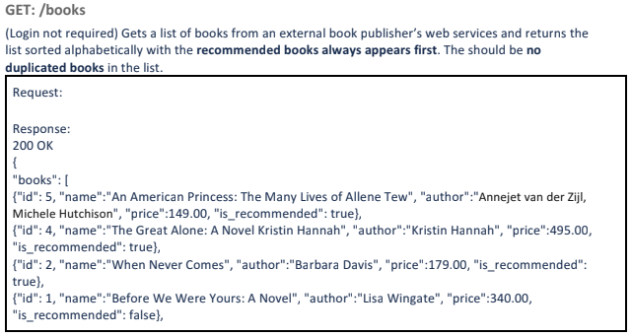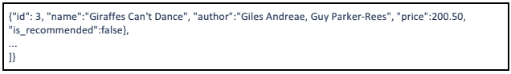

Since the books information is updated, my result quite different from the requirement.

GET: <https://scb-test-book-publisher.herokuapp.com/books> shows a list of books from the publisher (normal + recommended). This list is updated on a weekly basis (every Sunday at midnight).

GET: <https://scb-test-book-publisher.herokuapp.com/books/recommendation> shows a list of recommended books from the publisher.

