work_politics_cop
Global feasibility study, product and business proposal,
privacy model, and technical architecture blueprint
Version 1.0 | 5 August 2026

Prepared as a product-building and commercialisation blueprint

Feasibility verdict
Proceed — but position the product as a trusted workplace-integrity and employee-voice platform, not as a surveillance or “guilt-detection” system. The technology is feasible. Commercial success will depend primarily on trust, independent governance, fair process, legal localisation, and demonstrable protection against retaliation and deanonymisation.

Important notice
This document is a product and business design proposal, not legal, medical, employment-relations or investment advice. Workplace reporting and investigation rules differ by country, sector, collective agreement and fact pattern. Before launch in any jurisdiction, obtain local employment, whistleblower, privacy, evidence, defamation, labour-relations and criminal-law advice. The product must never promise absolute anonymity: identity can be inferred from narrative details, attachment metadata, access patterns, or subsequent legal process even when the platform does not ask for a name.
Language and fairness
The platform should capture observable conduct and evidence rather than assigning labels such as “liar”, “incapable”, “bully” or “racist” before a fair investigation. An allegation is not a finding. Product labels should remain neutral: unverified, under assessment, under investigation, substantiated, unsubstantiated, inconclusive, resolved or referred.

Contents
1. Executive summary
2. 1. Purpose, scope and product thesis
3. 2. Evidence of need and feasibility
4. 3. Product strategy and value proposition
5. 4. Users, jobs-to-be-done and use cases
6. 5. Product modules and detailed features
7. 6. Reporter and case-management journeys
8. 7. Competitive landscape and differentiation
9. 8. Business model and go-to-market
10. 9. Strategic analysis: SWOT, PESTLE, Five Forces and risk
11. 10. Legal, privacy and governance blueprint
12. 11. Technical architecture
13. 12. Multi-tenancy, identity and access control
14. 13. Workflow, event and orchestration architecture
15. 14. Agentic AI design and guardrails
16. 15. Security, threat model and resilience
17. 16. Data model, APIs and integrations
18. 17. Delivery plan, team, costs and roadmap
19. 18. KPIs and validation programme
20. 19. Final recommendation
21. Appendices and references

Executive summary
The proposed product addresses a large, persistent and under-reported class of workplace harm: harassment, retaliation, discrimination, abuse of power, sabotage, unethical conduct, favouritism, conflicts of interest and failures of fair process.
The global evidence is substantial. The ILO–Lloyd’s Register Foundation–Gallup study found that almost 23% of people in employment had experienced violence or harassment at work during their working life; psychological violence and harassment was the most commonly reported form. The same research found that only about half of victims disclosed their experience and that fear of reputational damage, lack of trust, uncertainty about procedures and concern that colleagues would find out were major barriers. [1][2] WHO reports that 12 billion working days are lost each year to depression and anxiety, at an estimated annual cost of US$1 trillion to the global economy. [3]
The commercial gap is not merely “another anonymous hotline”. Existing products already provide anonymous intake, case management and two-way messaging. The stronger opportunity is a trust architecture that combines: privacy-preserving reporting; a private incident journal; conflict-aware routing; evidence integrity; independent escalation; retaliation-protection workflows; fair-process controls; jurisdiction-aware policy guidance; and carefully bounded AI assistance. Competitive benchmarking shows that anonymous two-way communication, structured case management and multi-channel intake are now baseline features rather than sufficient differentiation. [15][16][17][18]
The recommended product position is: “a privacy-first workplace integrity and employee voice platform that helps people speak safely and helps responsible organisations respond fairly.” The project name work_politics_cop may remain the internal codename, but the public brand should be tested: the word “cop” can communicate enforcement to buyers while simultaneously making employees fear surveillance or punishment.
Technically, the product should begin as a modular monolith using React/Next.js, FastAPI and PostgreSQL, with strict tenant isolation and a separate anonymous-reporter identity realm. Temporal is recommended over Celery as the authoritative workflow engine because investigations are long-running, timer-heavy, human-in-the-loop processes that must recover reliably from failures. RabbitMQ should be used only for integration/event fan-out where required, and Prefect should orchestrate AI and analytics pipelines rather than own case state. PostgreSQL Row-Level Security provides an additional database-level tenant boundary, but it must be combined with application policy enforcement, encryption, dedicated deployment options, conflict rules and independent audit controls. [22][23][24][25]
Core decision
Build a platform for safe voice, evidence and fair response — not a machine for scoring guilt, truthfulness, personality, loyalty or employee worth. No AI agent should autonomously decide disciplinary action, dismissal, promotion, credibility or mental-health status.

Recommended launch sequence
1. Phase 0 — trust discovery: conduct interviews with employees, whistleblowers, ethics officers, unions, investigators, employment lawyers, privacy professionals and workplace psychologists; complete jurisdiction-specific legal mapping and a formal LINDDUN/STRIDE threat model.
2. Phase 1 — protected reporting MVP: private journal, anonymous/confidential/identified intake, evidence vault, anonymous mailbox, conflict-safe routing, investigation case management, append-only audit trail and anti-retaliation follow-up.
3. Phase 2 — enterprise hardening: SSO, HRIS integration, data residency, dedicated tenancy, external ombuds workflows, multilingual voice channels, policy localisation, SOC 2/ISO 27001 readiness and independent penetration testing.
4. Phase 3 — bounded intelligence: redaction, translation, chronology extraction, policy retrieval, investigation summaries and privacy-safe organisational pattern detection, always with human approval.
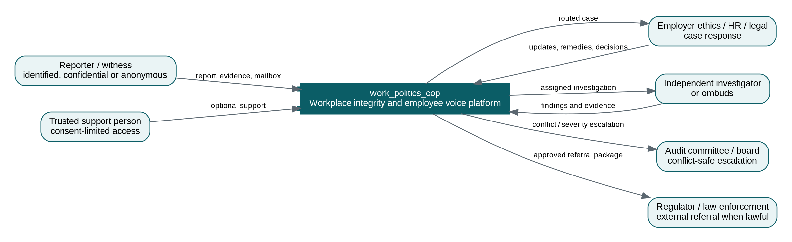
Figure 1. Product system context and stakeholder ecosystem

1. Purpose, scope and product thesis

1.1 The problem to solve
“Office politics” is a broad term. Some influence, coalition-building and negotiation are normal organisational behaviours. The product should therefore target harmful or unlawful conduct and broken decision processes, not political skill itself. The addressable problem includes bullying, harassment, discrimination, retaliation, intimidation, abuse of authority, coercion, sabotage, deliberate exclusion, conflicts of interest, corruption, unethical favouritism, evidence suppression, unsafe work, malicious obstruction and repeated failures to follow policy.
Employees often do not report because reporting may expose them to retaliation, career damage, isolation, disbelief or further abuse. Employers, in turn, may receive vague reports too late, route them to implicated managers, lose evidence in email chains, miss statutory deadlines, fail to communicate with anonymous reporters, or treat a lack of reports as proof that the culture is healthy. These failures harm individuals and families, increase turnover and absence, weaken performance, create litigation and regulatory risk, and allow harmful conduct to become normalised.

1.2 Product thesis
Product thesis
When people can record events safely, understand their options, submit concerns without unnecessary identity exposure, communicate two ways, preserve evidence, avoid conflicted decision-makers and see a fair response, organisations detect harm earlier and gain a better chance to correct systemic problems before they become crises.

1.3 Product boundaries
In scope | Out of scope / prohibited design
Safe incident journalling and structured reporting | Covert employee surveillance or monitoring private communications
Anonymous, confidential and identified reporting modes | Guaranteeing absolute anonymity or immunity from lawful process
Evidence preservation, sanitisation and chain of custody | Editing evidence in a way that obscures the original or misleads investigators
Policy guidance and jurisdiction-aware routing | Providing definitive legal advice without qualified local review
Human-led case assessment and investigation | Automated guilt, honesty, credibility or “toxic employee” scoring
Anti-retaliation planning and voluntary check-ins | Secret productivity monitoring of reporters or accused persons
Privacy-safe aggregate analytics | Individual reputation scores, blacklists or public naming
Support referrals and consent-controlled support circles | AI diagnosis, therapy, crisis counselling or medical recommendations

1.4 Design principles
- Safety before convenience. Minimise identity and metadata collection, make risk visible, and offer safe exit and session-hygiene guidance.
- An allegation is not a finding. Every screen, workflow and analytics view must preserve procedural neutrality.
- Need-to-know access. Case content is never available merely because a person is a system administrator or senior executive.
- No conflicted routing. The platform should detect implicated managers, reporting lines, business units and delegates before assignment.
- Human accountability. AI may assist with clerical and analytical work; accountable humans make decisions and sign findings.
- Evidence integrity. Original files are sealed; sanitised working copies are clearly distinguished and traceable.
- Transparent governance. Employees must understand who operates the platform, who can access data, retention rules, appeal routes and limits of confidentiality.
- Global core, local rules. The technical platform is global; policies, legal notices, deadlines and external channels are jurisdiction-specific.

2. Evidence of need and feasibility

2.1 Scale of workplace violence, harassment and non-reporting
Evidence | Finding | Product implication
ILO / Gallup global study | Almost 23% of employed people reported workplace violence or harassment during working life; psychological violence and harassment was most common. [1][2] | Address more than legal whistleblowing: include bullying, psychological harm, discrimination and repeated patterns.
Disclosure barriers | Only about half disclosed. Reported barriers included perceived futility, reputational fear, unclear procedures, distrust, concern that people at work would find out and fear of punishment. [2] | Trust, anonymity, two-way follow-up, clear procedures and visible progress are core product functions.
WHO mental-health evidence | 12 billion workdays lost annually to depression and anxiety; estimated US$1 trillion annual economic cost. [3] | The business case includes wellbeing, productivity, absence and retention, while the product must avoid medicalising every conflict.
Employee voice research | Research identified civility, validity, safety and egalitarianism, operationalised through assured anonymity, constructive moderation, adequate slowness and controlled access. [14] | Build deliberate friction where it improves quality: reflection prompts, cooling-off options, moderation and controlled access.
Gallup ethics research | Employees are more willing to report when they trust leaders to act ethically. [4] | Software cannot compensate for leadership bad faith; corporate governance and visible response are product dependencies.

2.2 Regulatory and governance drivers
International and national frameworks increasingly expect safe reporting, confidentiality, impartial handling and protection from retaliation. ISO 37002 organises a whistleblowing management system around trust, impartiality and protection, with receiving, assessing, addressing and concluding reports as the core lifecycle. [5] The EU Whistleblower Directive requires internal reporting channels for many organisations and treats confidentiality as a central safeguard. [10] The U.S. Department of Justice evaluates whether corporate compliance programmes are well designed, adequately resourced and effective in practice, including the quality of confidential reporting and investigation mechanisms. [11]
In South Africa, the Protected Disclosures Act provides procedures for disclosing unlawful or irregular conduct and protection for employees making protected disclosures. [7] The 2022 Code of Good Practice on Prevention and Elimination of Harassment applies broadly to employers and employees, describes harassment as unwanted conduct that impairs dignity, expects policies and support, and emphasises a high degree of confidentiality. [6] South Africa’s proposed Protected Disclosures Bill, released for public comment in April 2026, signals further emphasis on confidentiality, witness protection and stronger protection mechanisms; it remains proposed legislation and should not be represented as current law. [8] POPIA imposes security safeguards and breach-notification duties, with the Information Regulator stating that all security compromises must be reported irrespective of perceived risk. [9]

2.3 Technical feasibility
All core functions are technically feasible with mature components: encrypted web and mobile intake, pseudonymous case mailboxes, multi-tenant databases, immutable object storage, durable workflow engines, policy-based access control, evidence hashing, multilingual AI assistance and external integrations. The difficult parts are not basic CRUD development; they are preventing metadata leakage, enforcing access across support and operations teams, dealing with conflicted corporate actors, preserving fair process, proving audit integrity, localising legal rules, and earning trust from both employees and employers.

2.4 Feasibility scorecard
Dimension | Score | Assessment | Condition for success
Problem severity | 5/5 | Large, global and persistent | Maintain a behaviour-and-process focus rather than sensational labels
Technical feasibility | 4/5 | Mature components exist | Senior security engineering, privacy threat modelling and disciplined scope
Commercial attractiveness | 4/5 | Recurring B2B need with compliance and employee-relations buyers | Credible trust model and differentiated outcomes beyond anonymous intake
Legal complexity | 2/5 | High and jurisdiction-dependent | Local counsel, configurable policies and clear non-legal-advice boundaries
Trust/adoption risk | 2/5 | Employees may suspect employer surveillance; employers may fear malicious reports | Independent governance, transparent trust centre, fair-process safeguards
Operational scalability | 3/5 | Software scales; quality investigations do not scale automatically | Partner network, training, SLAs and independent investigator options
Overall | Proceed | Strong opportunity with high execution risk | Launch with design partners and narrow claims

3. Product strategy and value proposition

3.1 Recommended positioning
Positioning statement
For employees, witnesses and organisations that need a safer way to surface and resolve harmful workplace conduct, work_politics_cop is a privacy-first workplace integrity and employee voice platform. It protects reporting, preserves evidence, prevents conflicted handling, supports fair investigations and helps organisations detect systemic risk without turning allegations into automated verdicts.

3.2 Value proposition by stakeholder
Stakeholder | Pain | Value delivered
Reporter / witness | Fear, uncertainty, evidence scattered, no safe follow-up | Private journal; clear options; anonymity risk guidance; secure mailbox; status visibility; anti-retaliation plan
Family member / trusted supporter | Sees harm but lacks safe role or context | Consent-limited support invitation, resources and progress visibility without exposing unrelated case data
HR / employee relations | Email-driven cases, inconsistent triage, poor documentation | Structured intake, SLA workflow, templates, evidence timeline, fair-process checkpoints and audit-ready records
Ethics / compliance | Missed patterns, conflicts, regulatory exposure | Risk taxonomy, independent routing, reporting channels, escalation, trend analytics and board reporting
Investigator / ombuds | Incomplete facts, identity leakage, chain-of-custody gaps | Evidence vault, question workflow, chronology, source-linked summaries and controlled disclosure
Legal / DPO | Privilege, retention, DSAR, breach and jurisdiction risk | Legal holds, purpose-limited access, regional policies, audit logs, breach workflow and export controls
Board / audit committee | Senior-person conflicts and weak visibility | Conflict-triggered escalation, high-severity oversight and privacy-safe governance metrics

3.3 Jobs-to-be-done
- When I experience or witness harmful conduct, help me record facts safely before details disappear.
- When I am unsure whether something is reportable, explain the available routes without pressuring me to submit.
- When I report anonymously, let the organisation ask questions without learning who I am.
- When a person in the normal reporting chain is implicated, route the matter somewhere independent.
- When I fear retaliation, help me document a protection plan and subsequent events.
- When I investigate, give me an evidence-linked timeline and a fair process rather than an AI verdict.
- When I oversee culture, show patterns without exposing individuals or encouraging surveillance.

3.4 Brand recommendation
Keep work_politics_cop as the development codename if it motivates the mission. Before public launch, test names that signal trust, dignity and integrity rather than policing. Candidate directions include WorkSafe Voice, IntegrityBridge, FairWork Signal, SpeakSecure, WorkTrust or DignityLine. A dual-brand model is also possible: a reassuring employee-facing name and a corporate product-suite name. Brand research should include people who have experienced workplace retaliation, because their reaction is more important than the founding team’s preference.

4. Users, jobs-to-be-done and use cases

4.1 Primary personas
Persona | Primary need
Anonymous reporter | Needs no account tied to employer identity; uses a case code, passphrase or recovery key; receives two-way messages.
Confidential reporter | Identity is stored separately and visible only to authorised roles under a declared purpose.
Identified reporter | Uses corporate or external identity and may participate openly in the process.
Witness / collaborator | Adds facts or evidence with controlled visibility and separate consent.
Trusted supporter | Family member, union representative, attorney, advocate or colleague invited to a restricted support view.
Triage officer | Checks immediate safety, jurisdiction, conflicts, completeness and routing.
Case manager | Owns process, deadlines, communication and case record, but may not have all identity permissions.
Investigator / ombuds | Receives scoped access, conducts interviews, reviews evidence and records findings.
Decision-maker | Receives findings and makes a remedy or disciplinary decision under policy; cannot alter evidence.
DPO / privacy officer | Oversees lawful processing, retention, access requests and security incidents.
Audit committee / board delegate | Receives escalated cases involving executives, systemic risk or conflicts.
Platform security operator | Maintains infrastructure without standing access to case content.

4.2 Priority use cases
Use case | Example | Required safeguards
Bullying / psychological harassment | Repeated humiliation, exclusion, threats or impossible work allocation | Pattern chronology; witnesses; neutral taxonomy; wellbeing referral; no automatic diagnosis
Discrimination / racist conduct | Slurs, unequal treatment, biased process or systemic exclusion | Protected-attribute data isolation; legal localisation; careful access; fair response
Retaliation | Demotion, exclusion, threats, poor ratings or dismissal after speaking up | Baseline protection plan; consented HR-event checks; independent escalation; chronology
Abuse of power / horrible boss | Coercive management, intimidation or misuse of authority | Route outside line management; senior-conflict escalation; ombuds option
Sabotage / opportunism | Taking credit, withholding information, manipulating decisions or blocking work | Observable-event capture; document links; avoid personality labels
Fraud / corruption / conflict of interest | Procurement, bribery, financial manipulation or undisclosed relationship | Legal hold, external referral, privileged workspace, high-integrity evidence handling
Safety and health risk | Unsafe work, threats or conditions that endanger people | Immediate-risk protocol, emergency contacts, rapid escalation and clear limits
Process fairness | Biased performance management, recruitment or promotion process | Policy comparison, decision record, conflict rules and appeal workflow

5. Product modules and detailed features

5.1 Reporter safety and private incident journal
- Private journal mode. A person can create an encrypted chronology without sending it to the employer. The interface must make it explicit that journal entries are not reports until submitted.
- Structured event capture. Who, what, when, where, impact, witnesses, supporting material and what outcome the person seeks. Free text remains available.
- Anonymity risk meter. Warn when narrative or attachments contain names, job titles, unique projects, EXIF data, document authorship, tracked changes or other identifying information.
- Safe session design. Discreet page title, configurable neutral icon, quick exit, no marketing trackers, careful browser storage and optional local-device risk guidance.
- Reflection and cooling-off. Allow save-and-return and a “review tomorrow” option for non-urgent cases; this supports adequate slowness without blocking urgent reporting.
- Export for the individual. Provide a timestamped, encrypted personal copy with a warning about secure storage and local legal implications.

5.2 Multi-mode reporting
Mode | Identity handling | Best for | Important limitation
Private journal | No submission; local or platform-encrypted personal vault | Reflection and evidence preservation | Employer is not notified and cannot act
Anonymous | No identity requested; pseudonymous case handle | High fear of retaliation | Details or legal process may still reveal identity
Confidential | Identity stored in separate vault with explicit access policy | Cases where contact or protection is needed | Authorised people may access identity under declared rules
Identified | Reporter identity in case process | Open grievance, witness participation, formal proceedings | Higher visibility and potential interpersonal risk
External referral | Reporter chooses an external recipient or receives guidance | Regulator, union, ombuds, police or legal route | The platform must not imply legal protection without jurisdictional validation

5.3 Anonymous two-way mailbox
- Random high-entropy case identifier and secret recovery phrase; optional passkey/WebAuthn for devices that can safely hold it.
- No required email address, telephone number or corporate SSO for anonymous cases.
- End-to-end message content encryption at rest, with server-side access controlled through the case policy engine.
- Read receipts should be optional and privacy-preserving; do not expose staff identities unnecessarily.
- Reporter can answer questions, add evidence, request an interpreter, nominate a supporter and challenge a conflict.
- Automated reminders must not reveal sensitive content in push, email or SMS notifications.

5.4 Evidence vault and chain of custody
- Dual copy. Store an untouched sealed original and a working sanitised copy. Never overwrite the original.
- Integrity. Calculate cryptographic hashes, record upload time, uploader context, malware-scan result and every access or export.
- Metadata handling. Preview author, comments, tracked changes, EXIF and hidden sheets; let the reporter remove metadata from the working copy while retaining the sealed original.
- Immutability. Use object-lock/WORM controls for evidence and legal holds, with retention policies managed separately from ordinary attachments.
- Disclosure bundles. Generate a signed manifest linking each exported file to its hash, source and redaction history.
- Dangerous content isolation. Documents are untrusted; render in a sandbox and never allow an AI agent to treat embedded instructions as trusted commands.

5.5 Conflict-safe routing
This should be the flagship differentiator. The reporter identifies implicated people, reporting lines, business units, HR partners, legal contacts and close associates. The policy engine intersects this with organisational relationships and configured independence rules. A conflicted user cannot see that a case exists, cannot receive assignment notifications and cannot obtain access through an inherited role. Senior-person or systemic cases route to an independent ombuds, external investigator, audit committee or board delegate according to policy.
- Declarative routing rules by allegation type, severity, geography, legal entity and implicated seniority.
- Conflict declarations by case handlers, with recusal and reassignment workflow.
- Reporter challenge: the reporter can state that the proposed route is unsafe and request independent review.
- No “tenant owner sees everything” shortcut. Ownership of the subscription is not authority to read every allegation.
- Separate oversight summary from raw case content; board dashboards should expose minimum necessary information.

5.6 Case and investigation management
Capability | Design requirement
Triage | Immediate danger, jurisdiction, allegation type, completeness, conflicts, statutory/contractual deadlines and preservation needs
Case plan | Issues, scope, investigator, witnesses, evidence sources, standard of proof, milestones and communication plan
Interviews | Consent, interpreter, support person, recording rules, notes, confirmation and source attribution
Evidence review | Source-linked timeline, relevance tags, privilege markers, redactions and disclosure restrictions
Findings | Separate finding per allegation; rationale; evidence relied upon; contrary evidence; confidence/limitations; reviewer approval
Decision/remedy | Decision-maker distinct from investigator where policy requires; actions, systemic remediation and communication
Appeal/review | Grounds, independent reviewer, additional evidence and final outcome
Closure | Reporter communication, retention class, legal hold, lessons learned, retaliation follow-up and anonymised trend coding

5.7 Anti-retaliation module
- Create a voluntary protection plan: known risks, safe contact method, reporting-line concerns, requested interim measures and designated protection officer.
- Schedule confidential check-ins at configurable intervals using Temporal timers.
- Allow new events to be linked to the original report without merging identities across unrelated cases.
- Optionally compare consented HR events—role change, rating, disciplinary action, termination, transfer—against a baseline, but never treat correlation as proof of retaliation.
- Escalate missed check-ins, protection-plan breaches and alleged threats to an independent role.
- Measure outcomes without penalising managers or employees based solely on unverified reports.

5.8 Support circle and wellbeing referrals
Because workplace harm affects families, the product can support a “trusted support circle”. A reporter may invite a family member, union representative, attorney, counsellor or colleague to a restricted view. The supporter sees only content explicitly shared by the reporter, cannot submit in the reporter’s name, and cannot see employer responses unless consented. The platform may provide country-specific EAP, counselling, legal-aid and emergency-resource directories, but it should not diagnose or replace professional care.

5.9 Organisational analytics and prevention
- Aggregate trends by behaviour, location, function, process stage and time—only above minimum cohort thresholds.
- Separate reporting volume from culture quality: an increase in reports may indicate greater trust, not worsening culture.
- Track response time, communication quality, conflict recusal, evidence completeness, outcome mix, recurrence and retaliation indicators.
- Use differential privacy or noise for sensitive small-group analytics where feasible.
- Never expose a “most complained-about employee” leaderboard or allow drill-down that reconstructs identities.
- Show intervention effectiveness: policy change, manager training, process redesign, workload adjustment or independent review.

6. Reporter and case-management journeys
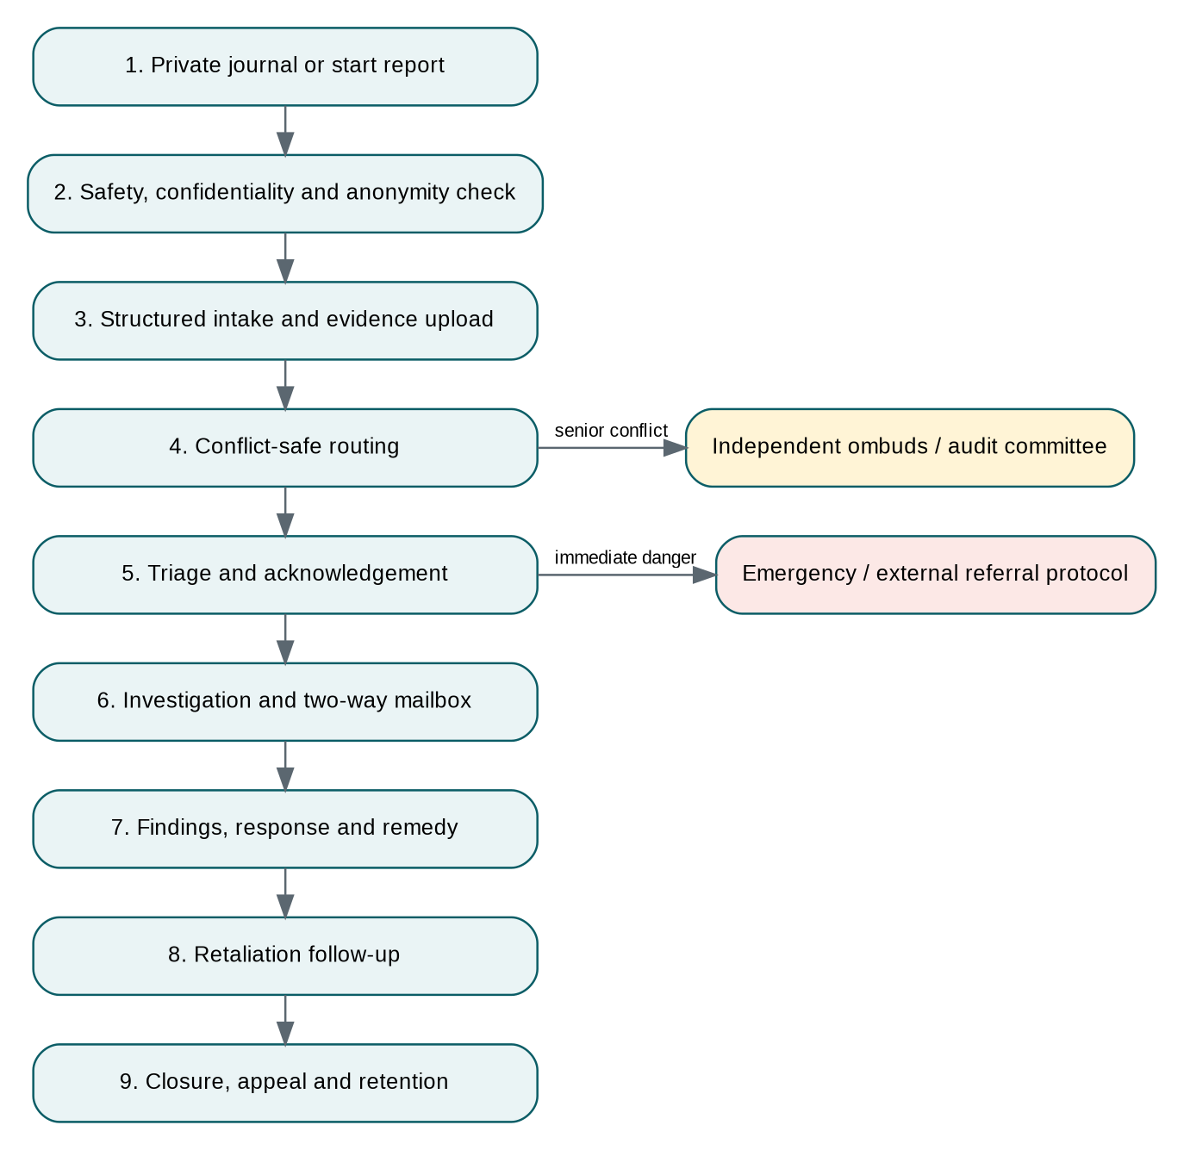
Figure 2. End-to-end protected reporting and case workflow

6.1 Anonymous reporter journey
1. Open a tenant-specific public reporting page that does not require corporate login.
2. Read a plain-language explanation of anonymity, confidentiality, legal limits, emergency routes and data retention.
3. Choose private journal, anonymous report, confidential report or identified report.
4. Complete a safety screen and identify possible conflicts before giving detailed facts.
5. Create events in a timeline, upload evidence and preview identity-revealing metadata.
6. Review an AI-assisted structure/translation only after consenting; the original wording remains available.
7. Receive a case code and secret recovery phrase; the platform cannot recover the secret without a pre-agreed recovery mechanism.
8. Return to the anonymous mailbox, answer questions, see status and record retaliation concerns.
9. Receive a closing explanation and available review/appeal routes without being shown confidential information about other parties.

6.2 Corporate responder journey
1. A new report event triggers policy evaluation, conflict checking and an auditable assignment recommendation.
2. A trained triage officer reviews immediate safety, jurisdiction, conflicts, preservation and the minimum information needed.
3. The reporter receives acknowledgement and realistic next steps within configured SLA.
4. A case plan is approved, an investigator is assigned under least privilege, and evidence sources are preserved.
5. Questions are sent through the anonymous mailbox; all access and exports are logged.
6. The investigator records allegation-level findings; a reviewer checks evidence, contrary material and procedural fairness.
7. A separate decision-maker records action or remedy, subject to local policy and legal advice.
8. The reporter receives an outcome explanation appropriate to privacy and employment-law limits.
9. Retaliation check-ins and systemic remediation remain active after formal closure.

6.3 Emergency and criminal-risk pathway
Do not create a false emergency promise
The app is not an emergency service. Where a report indicates imminent danger, serious violence, self-harm risk, child abuse or other urgent threat, the interface should clearly direct the user to appropriate local emergency or professional services and initiate the tenant’s emergency protocol only within the lawful scope disclosed to the user.

7. Competitive landscape and differentiation

7.1 Market benchmark
The category includes hotline vendors, ethics/compliance platforms, employee-relations case systems, anonymous feedback tools and independent ombuds services. Current products demonstrate that anonymous reporting, multi-channel intake, case management and two-way communication are expected capabilities. For example, AllVoices describes anonymous reporting flowing into structured case management with routing and SLAs; Vault provides app, browser and voice channels with anonymous options; NAVEX EthicsPoint provides anonymous and confidential reporting; and Whispli markets anonymous two-way communication and multilingual channels. [15][16][17][18]
Capability | Category baseline | work_politics_cop differentiation
Anonymous intake | Common | Metadata-minimising architecture, anonymity risk meter and separate reporter realm
Two-way messaging | Common among leaders | Pseudonymous mailbox plus supporter access and conflict challenge
Case management | Common | Allegation-level findings, fair-process checkpoints and anti-retaliation lifecycle
Hotline / voice | Often available | Privacy-safe transcription with audio-access controls and local language routing
Analytics | Common | Minimum cohorts, differential privacy options and no individual complaint rankings
Routing | Rules-based in many tools | Relationship/conflict graph and independent escalation outside implicated hierarchy
Evidence | Attachments common | Sealed original, sanitised working copy, hash manifest and legal-hold workflow
AI | Rapidly emerging | Bounded, source-linked, no truthfulness/guilt scoring, no autonomous adverse action
Personal use | Usually employer-provided | Private incident journal that can remain personal or later convert into a report
Family/support role | Rare | Consent-limited trusted support circle

7.2 Defensible moat
- Trust architecture. Independent security audits, transparent metadata practices, no corporate SSO for anonymous reporting, and verifiable access controls.
- Conflict graph and policy engine. Organisational relationships, seniority, legal entity and declared conflicts drive routing and recusal.
- Retaliation lifecycle. Protection plans, follow-ups and linked events continue beyond case closure.
- Evidence integrity. A stronger chain-of-custody and sanitisation model than simple attachment storage.
- Global-local policy layer. A common workflow core with jurisdiction-specific notices, channels, deadlines and retention.
- Governance credibility. Independent advisory board, public trust centre, fair-process model and clear AI prohibitions.
- Learning network without data exploitation. Use de-identified control effectiveness and taxonomy improvements; never train on tenant allegations without explicit lawful agreement.

7.3 Risks of copying competitor features
Benchmark behaviour, not proprietary implementations. Conduct freedom-to-operate review before adopting distinctive matching, group-reporting or investigative features that may be patented. Build the product from first principles around trust, fairness and evidence, and document independent design decisions.

8. Business model and go-to-market

8.1 Customer segments
Segment | Initial need | Sales motion
South African mid-market and enterprise | Harassment code, protected disclosures, POPIA, employee-relations consistency | Founder-led direct sales with legal/ethics partners
Multinationals operating across Africa | One platform with localised rules and data residency | Enterprise sales and regional implementation partners
Healthcare, education, NGOs and faith-based institutions | Power imbalance, safeguarding and distributed workforces | Sector-specific bundles and independent ombuds options
Government and state-owned entities | Whistleblower protection, procurement integrity and sovereign hosting | Long-cycle tendering; dedicated deployment
Investigation, legal and ombuds firms | Secure multi-client case platform | Channel/partner licence
Insurers and EAP providers | Prevention, early intervention and risk reduction | Embedded partnership and referrals

8.2 Recommended commercial model
- Annual B2B SaaS subscription based on employee population, reporting channels, jurisdictions and deployment tier.
- Implementation fee for policy configuration, data mapping, SSO, training and launch communications.
- Add-ons for independent ombuds triage, managed hotline, external investigators, legal localisation, translation, data residency and dedicated infrastructure.
- Partner licence for employment-law, ethics, EAP and investigation firms managing multiple tenants.
- Free or low-cost personal journal tier may drive awareness, but must be separately governed from employer-sponsored cases and should not rely on advertising or sale of sensitive data.

8.3 Illustrative packaging and pricing hypotheses
Pricing disclaimer
The following amounts are hypotheses for customer discovery, not market quotes or financial forecasts. Validate willingness to pay through 20–30 buyer interviews and 3–5 paid pilots.

Tier | Indicative annual fee | Included | Target
Foundation | R60,000–R180,000 | Web intake, anonymous mailbox, basic case management, policy templates, standard shared tenancy | SMB / NGOs
Professional | R200,000–R600,000 | Advanced routing, evidence vault, retaliation workflow, analytics, SSO and integrations | Mid-market
Enterprise | R700,000–R2,500,000+ | Multi-jurisdiction, dedicated database, custom roles, external ombuds, voice channels, premium support | Large enterprise
Sovereign / Dedicated | Custom | Dedicated cloud account/VPC, customer-managed keys, residency, enhanced assurance and incident response | Government / regulated

8.4 Bottom-up opportunity scenarios
Scenario | Assumption | Annual recurring revenue
South African beachhead SAM | 1,000 target organisations × average R250,000 ARR | R250 million
Three-year achievable SOM | 40 customers × average R350,000 ARR | R14 million
Five-year scale case | 200 customers × average R500,000 ARR | R100 million
Global serviceable scenario | 20,000 organisations × average US$25,000 ARR | US$500 million

These are transparent arithmetic scenarios rather than claims about total market size. The key validation questions are sales-cycle length, procurement requirements, implementation effort, channel cost, willingness to pay for independent governance, and renewal after the first serious case.

8.5 Go-to-market sequence
1. Design-partner cohort. Recruit 3–5 organisations with executive sponsorship, employee representatives and willingness to publish anonymised learning.
2. Trust-centred pilot. Launch one or two channels, independent triage, a clear anti-retaliation protocol and measurable response SLAs.
3. Professional partnerships. Employment-law firms, ethics institutes, EAPs, workplace psychologists, unions, insurers and investigators become credibility and distribution channels.
4. Evidence-led content. Publish practical workplace integrity benchmarks, anonymised control-effectiveness reports and implementation guides rather than sensational office-politics stories.
5. Regional expansion. Add local legal packs, language support and hosting regions only after local advisory review.

8.6 Procurement and adoption objections
Objection | Response
“Anonymous reports will be abused.” | Use structured fact capture, evidence requests, moderation, fair process and knowingly-false-report policy; do not punish unsubstantiated good-faith reports.
“Employees will not trust an employer-paid tool.” | Independent operation option, no corporate SSO for anonymous intake, public trust centre, transparent access logs and independent oversight.
“This creates legal liability.” | The risk already exists; the platform helps detect, preserve, route and respond consistently. Legal configuration and privilege controls remain essential.
“We already have an ethics hotline.” | Position as the response and protection layer: conflict routing, evidence integrity, retaliation follow-up, employee-relations workflows and privacy-safe analytics.
“Implementation will be too complex.” | Start with a standard policy pack and one business unit, then integrate HRIS/SSO after the pilot.
“AI may bias decisions.” | AI is bounded to clerical assistance, source-linked outputs and human approval; adverse decisions are explicitly prohibited.

9. Strategic analysis

9.1 SWOT analysis
Strengths | Weaknesses
Mission-driven solution to a pervasive and costly problem; privacy and conflict-routing differentiation; recurring B2B revenue; strong fit with governance and compliance trends; founder has relevant AI/data/software capability. | Trust must be earned before users submit highly sensitive facts; legal localisation is expensive; enterprise sales cycles are long; investigations depend on customer capability; security and assurance costs are high; the “cop” name may reduce employee trust.

Opportunities | Threats
Under-served African and multilingual markets; independent ombuds partnerships; anti-retaliation workflows; privacy-safe analytics; growing focus on whistleblower protection; channel partnerships with legal, EAP and insurance providers; enterprise demand for responsible AI controls. | Established global vendors; a single deanonymisation or breach incident; corporate capture or retaliation despite the tool; false or malicious reports; defamation and labour disputes; AI prompt injection and data leakage; changing law; unions or workers councils rejecting surveillance-like features.

9.2 PESTLE analysis
Factor | Implication
Political | Whistleblower safety and anti-corruption are politically sensitive. Public-sector deployments require independence, procurement integrity and sovereign hosting options.
Economic | Turnover, absence, litigation and lost productivity support the business case, but compliance budgets can be cyclical and procurement cost-conscious.
Social | Power distance, race, gender, language, disability, immigration status and job insecurity shape willingness to speak. UX must work across literacy and technology levels.
Technological | Encryption, durable workflows and multilingual AI enable the product; AI and metadata also introduce new deanonymisation and prompt-injection risks.
Legal | Whistleblower, labour, harassment, privacy, defamation, evidence, criminal reporting and collective-agreement rules vary by jurisdiction.
Environmental | Distributed and remote work change where harassment occurs. Cloud-region selection and efficient infrastructure matter but are secondary to human and legal impact.
Ethical | The platform holds accusations that can damage careers. Neutrality, proportionality, consent, correction, appeal and access controls are non-negotiable.

9.3 Porter’s Five Forces
Force | Assessment | Strategic response
Competitive rivalry | High: mature hotline and compliance vendors | Do not compete on intake alone; lead with trust architecture, conflict safety, retaliation and evidence integrity
Threat of new entrants | Moderate: basic forms are easy; credible security and enterprise trust are hard | Build assurance, governance, integrations, legal packs and partner network
Buyer power | High among large enterprises | Offer modular deployment, measurable outcomes, dedicated tiers and low-friction pilot
Supplier power | Moderate: cloud, messaging and AI providers can affect cost and privacy | Provider abstraction, regional options, customer-managed keys and exit plans
Substitutes | High: hotlines, email, ombuds, HRIS cases, legal counsel, surveys | Unify the lifecycle and integrate rather than insisting on replacement

9.4 Principal risk register
Risk | Likelihood | Impact | Mitigation
Deanonymisation through logs, metadata or narrative | High | Severe | Minimal edge logs, metadata preview, separate identity realm, privacy testing, explicit limits
Unauthorised insider access | Medium | Severe | No standing case access, ABAC, JIT approval, dual control, tamper-evident audit and alerts
Corporate retaliation despite report | Medium | Severe | Protection plan, independent escalation, check-ins, contractual commitments and visible governance
False/malicious allegation | Medium | High | Structured intake, fair investigation, neutrality, knowingly-false standard, no public naming
AI leakage or biased recommendation | Medium | Severe | Redaction, no training, bounded tools, human review, no adverse decisions, AI RMF controls
Prompt injection in evidence | High | High | Treat files as untrusted, sandbox rendering, content/tool separation, output validation
Regulatory non-compliance | Medium | Severe | Jurisdiction packs, DPO/legal review, configurable retention, data residency and audit
Low employee trust / adoption | High | High | Independent operator option, trust centre, employee consultation, transparent policies and visible follow-up
Case backlog / poor investigation quality | Medium | High | Capacity planning, triage SLAs, trained partner network, escalation and quality review
Vendor or cloud outage | Medium | High | Multi-AZ, durable workflows, tested backups, offline emergency procedures and RTO/RPO targets

10. Legal, privacy and governance blueprint

10.1 Governance before technology
The platform will fail if the subscribing organisation can quietly bypass its own policies. Each tenant must appoint accountable roles, publish access and escalation rules, define independent routes, commit to non-retaliation, train handlers, and accept auditability. The contract should prohibit using the platform to identify anonymous reporters, retaliate, build individual loyalty scores, suppress lawful external reporting or conduct unrelated employee surveillance.

10.2 South African launch baseline
- Map intake categories and workflow to the Protected Disclosures Act, Employment Equity Act, Labour Relations Act, Occupational Health and Safety duties, the harassment Code, POPIA and sector-specific rules.
- Treat the 2026 Protected Disclosures Bill as a proposed reform, not current law. Design for anticipated confidentiality and protection capabilities without claiming statutory effect. [8]
- Exercise a high degree of confidentiality in harassment matters and provide counselling/support information consistent with the 2022 Code. [6]
- Implement POPIA security safeguards, operator/responsible-party allocation, breach detection and notification workflow. The Information Regulator states that all security compromises are reportable and that responsible parties should notify the Regulator and affected data subjects as soon as reasonably possible. [9]
- Support referrals to lawful external channels, but ensure that eligibility for protected-disclosure status is explained by qualified guidance rather than a generic AI assertion.

10.3 Global compliance architecture
Requirement family | Configurable capability
Whistleblower / speak-up rules | Internal and external channels, acknowledgement and feedback deadlines, confidentiality, retaliation protection, record keeping and local notices
Employment and harassment law | Behaviour taxonomy, protected attributes, investigation standards, representation, collective agreements, remedies and appeals
Privacy / data protection | Lawful basis, notices, consent where appropriate, data minimisation, special-category data, residency, transfers, DSAR, retention and breach response
Evidence and legal process | Legal hold, privilege, chain of custody, disclosure, redaction, preservation and regulator/law-enforcement export
Sector rules | Financial services, healthcare, education, child safeguarding, government procurement and professional conduct packs
Works councils / unions | Consultation, co-governance, reporting metrics, collective-agreement routes and employee representative access

10.4 Fair-process charter
- Presumption of neutrality: reports are allegations until assessed.
- Notice and opportunity to respond, subject to safety, preservation and legal constraints.
- Independent and conflict-free decision-makers.
- Proportionate collection and disclosure of personal information.
- Evidence-linked findings that address contrary evidence and limitations.
- Separation between investigator, reviewer and decision-maker where appropriate.
- Correction, review or appeal routes under tenant policy and local law.
- Protection for good-faith reporting and a narrow standard for knowingly false reporting.
- No retaliation against reporters, witnesses, supporters or case handlers.

10.5 Independent governance model
Body | Role
Product ethics and safety advisory board | Independent experts in labour law, privacy, whistleblowing, investigations, psychology, unions/employee voice, security and human rights
Tenant integrity committee | Approves policy, monitors conflicts and receives aggregate metrics; does not obtain default case access
External ombuds / escalation partner | Receives senior-conflict or unsafe-route cases under transparent contractual rules
Security and privacy council | Threat model, incident response, access reviews, supplier controls and assurance programme
AI governance committee | Use-case approval, model cards, impact assessments, evaluation, incident review and prohibited-use enforcement

11. Technical architecture

11.1 Architecture recommendation
Recommended target stack
React/Next.js PWA + FastAPI modular monolith + PostgreSQL + S3-compatible immutable object storage + Temporal for case workflows + RabbitMQ for integration events where needed + Prefect for AI/data orchestration + an AI gateway with bounded agents. Do not run Celery, Temporal and Prefect as overlapping workflow engines.

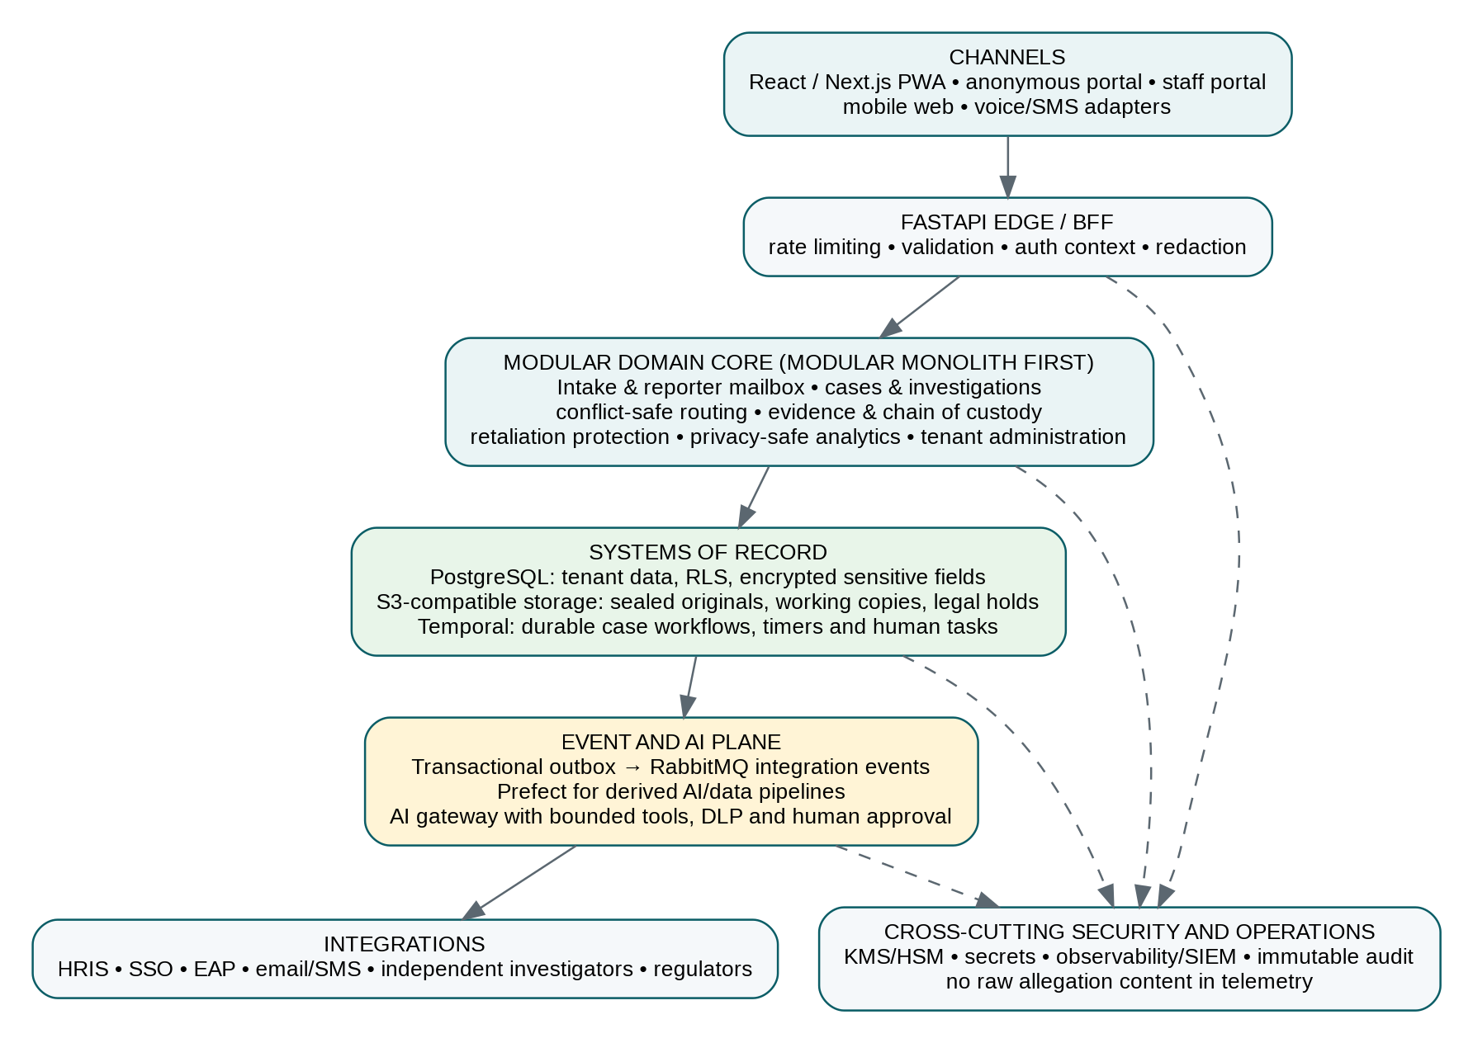
Figure 3. Recommended logical architecture

11.2 Why a modular monolith first
The platform contains strong domain boundaries, but early microservices would increase operational complexity, distributed transaction risk and security surface before load patterns are known. Begin with a modular FastAPI application whose domains have separate packages, schemas, service interfaces, database ownership conventions and event contracts. Extract a service only when there is a clear scaling, isolation, ownership or residency reason.
Domain module | Responsibilities
Identity and tenancy | Tenant provisioning, legal entities, regions, staff identities, reporter handles and deployment metadata
Policy and authorisation | RBAC/ABAC/ReBAC decisions, conflict graph, purpose binding, JIT and break-glass access
Intake and mailbox | Journal conversion, reports, questionnaires, anonymous mailbox, notifications and safe contact
Case and investigation | Triage, allegations, plans, interviews, assignments, findings, decisions, appeals and closure
Evidence | Uploads, hashes, malware scanning, metadata sanitisation, redaction, disclosure and legal hold
Protection and support | Safety plans, retaliation check-ins, supporter consent and referral directory
Analytics and reporting | De-identified metrics, cohort thresholds, board reports and regulatory exports
Integration | HRIS, SSO, messaging, investigators, EAP, regulators and customer webhooks

11.3 Frontend
- Use React with Next.js for routing, accessibility, internationalisation and optional server-side delivery. A React SPA is acceptable where deployment simplicity matters, but the anonymous portal should minimise third-party dependencies and tracking.
- Create separate builds or strong route isolation for anonymous reporter portal and staff portal. Do not load staff analytics, corporate SSO libraries or unrelated trackers into anonymous pages.
- Meet WCAG 2.2 AA, support low bandwidth, keyboard-only use, screen readers, right-to-left languages and easy language switching.
- Use progressive web app capabilities cautiously: offline journal storage can help safety but creates device risk. Make it opt-in, encrypted and clearly explained.
- Implement secure file preview through sanitised server-rendered representations, not direct execution of office or HTML content.

11.4 FastAPI backend
- Pydantic schemas separate public intake, staff views and internal persistence; never reuse a rich internal model as a public response model.
- Dependency-injected auth context carries tenant, actor, purpose, device posture, case assignment and conflict decision.
- Every state-changing endpoint requires idempotency keys where retries are likely.
- Use a transaction plus outbox record for domain events; publish after commit and make consumers idempotent.
- Validate uploads by content, not extension; quarantine, scan and render in an isolated worker.
- Generate OpenAPI for partner integrations but keep anonymous endpoints on a reduced, separately rate-limited surface.

11.5 PostgreSQL and storage
PostgreSQL Row-Level Security can restrict which rows a user or role may select or modify and defaults to deny when RLS is enabled without a policy. It is a valuable defence-in-depth control, but owners and BYPASSRLS roles require special care and RLS does not replace application authorisation. [25]
- Include tenant_id on every tenant-owned record and make it part of indexes and uniqueness constraints.
- Use FORCE ROW LEVEL SECURITY where appropriate and ensure application roles are not table owners and do not have BYPASSRLS.
- Encrypt high-risk fields at the application layer with envelope encryption; database disk encryption alone is insufficient against privileged access.
- Store optional reporter identity in a separate schema/database and key domain, linked through opaque references.
- Store large evidence in object storage with versioning and object lock; the relational database stores metadata, hashes, policy and references.
- Use separate search indexes built from approved redacted text; avoid indexing raw identity or privileged content by default.

12. Multi-tenancy, identity and access control
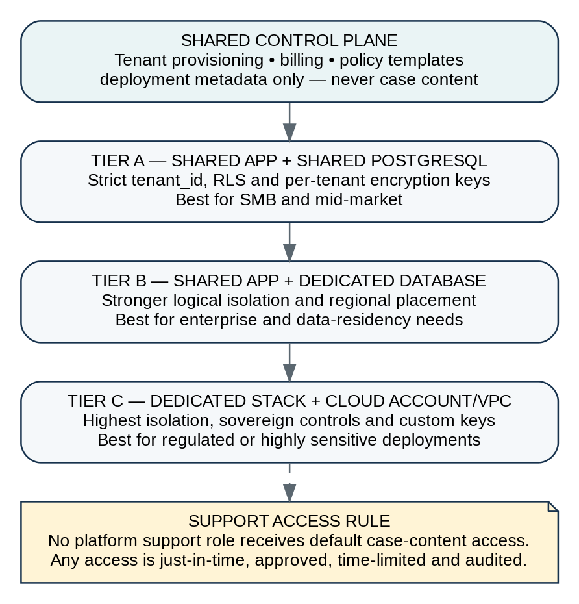
Figure 4. Deployment and tenancy tiers

12.1 Tenancy model
Offer three isolation levels rather than forcing every customer into one model. Shared tenancy supports affordability; dedicated database and dedicated stack options support high-risk customers. All tiers use per-tenant encryption keys and strict policy enforcement. The control plane should hold provisioning and billing metadata, not raw case content.

12.2 Separate identity realms
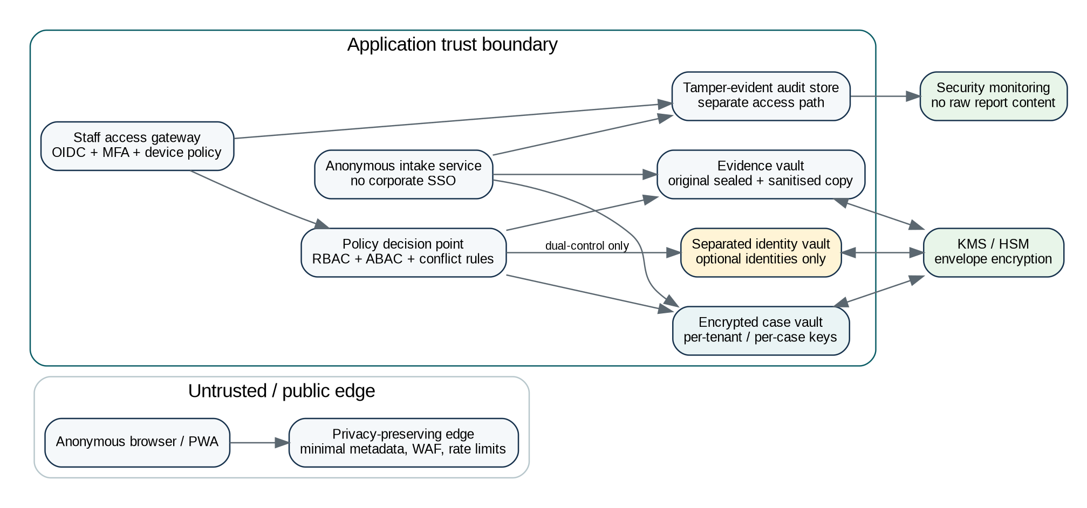
Figure 5. Privacy and trust architecture
Realm | Authentication | Data available
Anonymous reporter | Case code + secret/passkey; no corporate SSO | Only the reporter’s case mailbox and explicitly shared support data
Confidential/identified reporter | External identity or corporate SSO depending policy | Own reports, messages and permitted status
Tenant staff | OIDC/SAML, MFA, device and session policy | Assigned or purpose-authorised cases only
External investigator / ombuds | Federated or platform identity, MFA and scoped invitation | Specific case scope for a fixed period
Platform operations | Privileged workforce identity, PAM and JIT | Infrastructure metadata; case content only through approved break-glass process

12.3 RBAC is necessary but insufficient
Use RBAC for coarse duties and ABAC/ReBAC for context. A person may be an investigator but still lack access because they are in the implicated reporting line, work in the wrong legal entity, have a declared relationship, lack a case assignment, are outside the permitted geography, or have not stated an approved purpose.
Role | Default capability | Explicit restriction
Platform super-admin | Provision infrastructure and tenants | No standing access to case content or reporter identity
Tenant owner | Commercial/configuration administration | Cannot automatically read cases
Ethics administrator | Policy, taxonomy and oversight metrics | Raw case access only if separately assigned
Triage officer | Initial assessment and routing | Identity access only when mode/purpose permits
Case manager | Workflow and communication | Cannot override evidence or conflict decisions
Investigator | Scoped case evidence and interviews | No unrelated cases; no final discipline unless separately appointed
Legal counsel | Privilege and legal guidance workspace | Purpose-bound; access may be jurisdiction/issue limited
DPO / privacy officer | Privacy review, DSAR and incident response | No routine investigation role
Ombuds / audit committee | Escalated case oversight | Minimum necessary content and no broad tenant browsing
Auditor | Read-only controls and audit records | No identity vault or raw content unless explicitly mandated

12.4 Break-glass access
- Require a reason, case scope, time limit, approved incident/change ticket and one or two approvers depending sensitivity.
- Notify the tenant DPO/security contact and create a tamper-evident audit event.
- Prevent bulk search/export and record every object viewed.
- Automatically revoke access and require post-access review.
- Never use break-glass to identify an anonymous reporter for convenience or management curiosity.

13. Workflow, event and orchestration architecture

13.1 Temporal versus Celery
Criterion | Celery | Temporal | Recommendation
Long-running human workflows | Possible but requires custom state/timers | Native durable workflows and timers | Temporal
Crash/retry recovery | Task-level retries; application must manage workflow state | Workflow resumes from durable history | Temporal
Simple background jobs | Excellent and familiar | Capable but heavier | Either
Human approvals and SLA escalation | Custom implementation | Natural workflow signals/updates/timers | Temporal
Operational complexity | Lower if RabbitMQ already exists | Additional platform and workflow discipline | Accept for this mission-critical domain
Authoritative case state | Not ideal as workflow grows | Strong fit | Temporal

Temporal documents durable execution that resumes after crashes, network failures or infrastructure outages, which aligns well with months-long cases and scheduled follow-ups. [22] Use Celery only as a temporary MVP background queue if the team cannot operate Temporal initially; do not run both as competing case workflow engines.

13.2 RabbitMQ role
RabbitMQ should serve integration events, notifications and asynchronous adapters—not hold the only record of case state. Use publisher confirms and consumer acknowledgements, and acknowledge only after the consumer has durably completed its work. For replicated high-availability queues, RabbitMQ recommends quorum queues as the default choice. [24]
- Publish from a PostgreSQL transactional outbox to avoid dual-write inconsistency.
- Carry identifiers and minimal metadata in events; never put raw allegation narrative or evidence in the broker.
- Version event schemas and support replay into non-production using synthetic or redacted data only.
- Use dead-letter handling, retry budgets, idempotency keys and correlation IDs.

13.3 Prefect role
Use Prefect for data and AI workflows that are derived from case state: document processing, redaction, translation, embeddings, aggregate analytics, model evaluation and scheduled compliance reports. Prefect’s event and automation model can trigger these flows, but it should not become the authoritative case lifecycle. [23]

13.4 Core event catalogue
Event | Producer | Consumers
case.reported.v1 | Intake | Temporal starter, notifications, audit
case.conflict_detected.v1 | Policy engine | Temporal, ombuds routing, audit
case.acknowledged.v1 | Case workflow | Reporter mailbox, SLA metrics
evidence.received.v1 | Evidence service | Scan/render pipeline, audit, investigator task
evidence.sanitised.v1 | Prefect pipeline | Case workspace, audit
case.assignment_changed.v1 | Case service | Access policy cache, notifications, audit
case.finding_submitted.v1 | Investigation service | Review workflow, legal review
case.closed.v1 | Temporal | Reporter outcome, retention, analytics, retaliation follow-up
retaliation.concern_reported.v1 | Reporter mailbox | Protection workflow, independent escalation
privacy.security_incident.v1 | Security platform | Incident response, DPO workflow, tenant notice

14. Agentic AI design and guardrails
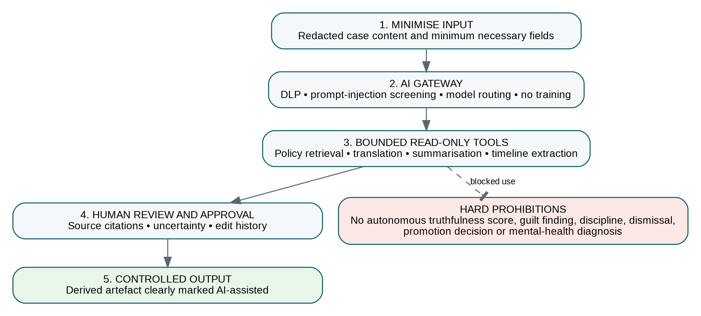
Figure 6. Bounded AI pipeline and prohibited autonomous decisions

14.1 AI use cases that add value
Agent / capability | Permitted task | Human control
Reporter writing assistant | Structure events, suggest missing factual details, simplify language and translate | Reporter approves; original wording preserved
Anonymity assistant | Detect likely names, metadata and unique identifiers | Reporter chooses what to redact; warn that risk remains
Triage copilot | Suggest taxonomy, urgency questions, jurisdiction/policy references and routing considerations | Triage officer decides and records rationale
Evidence chronology agent | Extract dates, actors and source-linked events from approved working copies | Investigator verifies every material entry
Policy retrieval agent | Retrieve tenant policy and local legal guidance with citations | Qualified reviewer confirms applicability
Investigation summary agent | Summarise interviews/evidence and identify unresolved questions | Investigator edits and signs; no credibility score
Translation agent | Translate reports and messages while preserving original text | Human review for high-stakes decisions
Pattern analytics agent | Find aggregate recurring issues above privacy thresholds | Ethics analyst validates; no individual ranking
SLA/remediation agent | Detect overdue actions and propose next tasks | Workflow owner approves actions

14.2 Prohibited AI use
- Truthfulness, deception or credibility scoring from text, voice, facial expression or behaviour.
- Automated findings that a person is racist, a bully, manipulative, incompetent or dishonest.
- Automated discipline, dismissal, promotion, compensation, performance rating or hiring decisions.
- Mental-health diagnosis, suicide-risk diagnosis or treatment recommendations.
- Autonomous disclosure of identity or evidence to an employer, regulator, police or family member.
- Training foundation models on tenant allegations or evidence without explicit lawful contractual agreement and governance review.
- Agent access to broad HRIS, email or messaging systems for covert monitoring.

14.3 AI governance
The NIST AI Risk Management Framework is designed to help organisations manage risks to individuals, organisations and society and to incorporate trustworthiness into AI design, development, use and evaluation. [28] Apply its Govern–Map–Measure–Manage approach to each AI use case. Employment-related AI can trigger high-risk obligations under the EU AI Act; Annex III high-risk rules are scheduled to apply from 2 December 2027. [30] Avoiding autonomous employment decisions materially reduces risk, but legal classification still requires specialist review.
- AI impact assessment and use-case approval before production.
- Model/provider inventory, data-flow map, retention terms, residency and subprocessor review.
- Tenant-configurable AI off switch and per-feature consent where appropriate.
- Prompt and output logging using redacted content; never place raw sensitive evidence in ordinary observability logs.
- Evaluation for hallucination, omission, demographic performance, translation accuracy, prompt injection and sensitive-data leakage.
- Source citations in every investigation-facing AI output and clear uncertainty labels.
- Human override, incident reporting and rollback path.

14.4 Agentic security
OWASP notes that prompt injection can cause models to violate instructions, disclose sensitive information or influence critical decisions, and that retrieval-augmented generation and fine-tuning do not fully eliminate the risk. [29] Every report and attachment is therefore untrusted input. Agents should receive minimum redacted context, use read-only tools by default, operate within per-case scopes, and require explicit human approval before any write, export, notification or external action.

15. Security, threat model and resilience

15.1 Security baseline
Adopt zero trust: no user, device or network location receives implicit trust; authenticate and authorise access before each session and sensitive action. [27] Use OWASP ASVS as a verifiable application-security requirements baseline and contract target. [26]
Control domain | Minimum design
Identity | Phishing-resistant MFA for staff, short sessions for sensitive roles, SCIM deprovisioning, privileged access management and separation of duties
Authorisation | RBAC + ABAC/ReBAC, case assignment, purpose binding, conflict exclusion, JIT and dual-control identity access
Encryption | TLS 1.3 where available, envelope encryption, per-tenant keys, per-case keys for highest sensitivity, customer-managed key option
Secrets | KMS/HSM and secrets manager; no credentials in source, images or workflow definitions
Application | ASVS-based secure SDLC, SAST/DAST/SCA, dependency pinning, SBOM, code review and penetration tests
Evidence | Sandboxed upload pipeline, malware scanning, content disarm/rendering, WORM storage and signed manifests
Audit | Append-only, tamper-evident hash chain, separate store, time synchronisation and independent access
Logging | No raw narratives, evidence, recovery secrets or identity tokens; structured event IDs and privacy-aware diagnostics
Infrastructure | Private networking, egress controls, multi-AZ, immutable infrastructure, image signing and workload identity
Incident response | Tenant notification matrix, POPIA/GDPR workflows, forensic preservation, tabletop exercises and breach communications

15.2 LINDDUN privacy threats
Threat | Example | Mitigation
Linkability | Connecting two anonymous reports to the same person | Separate handles by case, no device fingerprint, rotate tokens, minimise metadata
Identifiability | Unique narrative or file author reveals reporter | Anonymity risk scan, metadata preview, redaction guidance, explicit limits
Non-repudiation | Reporter cannot plausibly deny a sensitive draft on a shared device | Opt-in local storage, neutral UI, quick exit, encrypted journal
Detectability | Employer can see that a worker visited the reporting site | External access options, neutral domains where lawful, HTTPS, no corporate SSO for anonymous portal
Disclosure | Case content exposed to wrong handler | Policy engine, RLS, encryption, JIT, conflict rules, DLP and alerts
Unawareness | User does not understand who can see identity | Layered privacy notice, mode comparison, consent receipts and access explanations
Non-compliance | Retention or cross-border transfer violates local law | Jurisdiction packs, data residency, retention engine, DPO review and audit

15.3 STRIDE security threats
Threat | Example | Mitigation
Spoofing | Attacker impersonates investigator or reporter | MFA, signed invitations, high-entropy reporter secrets, session binding
Tampering | Evidence or findings altered | Hashes, immutable originals, versioning, approvals and audit chain
Repudiation | Handler denies accessing or exporting a case | Tamper-evident audit, signed exports, trusted timestamps
Information disclosure | Cross-tenant query or log leak | RLS, policy tests, encryption, log minimisation and tenant-isolation tests
Denial of service | Flood anonymous intake | Privacy-preserving rate limits, queue isolation, proof-of-work/CAPTCHA alternatives and autoscaling
Elevation of privilege | Tenant admin grants self access to executive case | Separation of subscription admin from case authority, JIT approvals and conflict controls

15.4 Availability and recovery targets
Service | Illustrative target
Anonymous intake and mailbox | 99.95% availability; RTO 1 hour; RPO ≤ 5 minutes
Staff case management | 99.9% availability; RTO 4 hours; RPO ≤ 15 minutes
Evidence vault | Multi-AZ durability, versioning/object lock, restore tests and cross-region option
Workflow engine | Durable state with tested worker and control-plane recovery
Security monitoring | 24×7 alerting for high-severity events at enterprise tier
Backups | Encrypted, isolated, immutable where feasible; quarterly restore test and documented tenant recovery

16. Data model, APIs and integrations
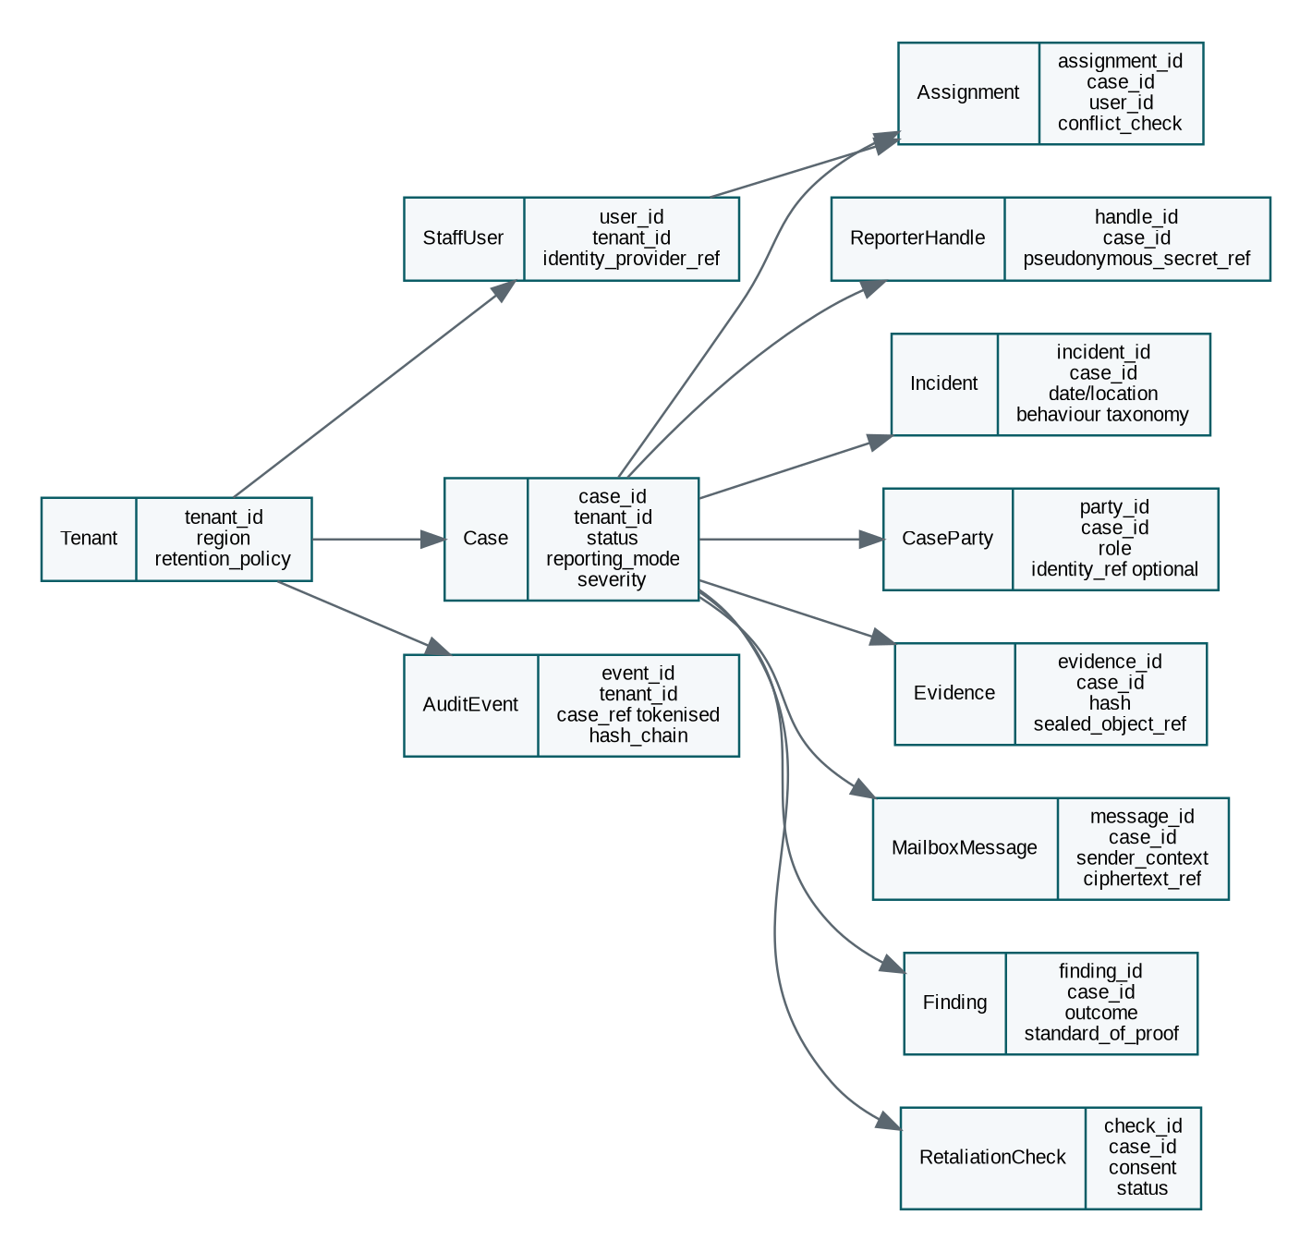
Figure 7. Simplified core data model

16.1 Core entities
Model allegations separately from cases: one report may contain several allegations with different subjects, evidence and outcomes. Keep identity optional and separated. Store policy decisions and access reasons as first-class records rather than reconstructing them from logs.
Entity | Purpose
Tenant / legal entity / organisational unit | Isolation, policy, geography, hierarchy and routing context
Reporter handle / identity vault record | Pseudonymous mailbox; optional identity under separate access policy
Case / allegation / incident | Container, specific issues and event chronology
Case party / relationship | Reporter, witness, subject, manager, supporter, representative and relationship graph
Evidence / redaction / disclosure package | Original, working copies, hashes, access, legal hold and exports
Assignment / conflict / recusal | Who may handle the case and why
Mailbox message / interview / note | Communications and evidence-linked records
Finding / decision / remedy / appeal | Procedural outcome and accountable approvals
Protection plan / retaliation check | Ongoing safety and follow-up
Policy version / jurisdiction rule | What rules applied at a point in time
Audit event / access grant | Tamper-evident accountability
AI run / evaluation / approval | Input scope, model, prompt version, sources, output, reviewer and disposition

16.2 API surface
Surface | Representative endpoints
Public intake | POST /public/tenants/{slug}/cases; POST /public/cases/{handle}/events; POST /public/cases/{handle}/evidence
Anonymous mailbox | POST /public/mailbox/session; GET/POST /public/mailbox/{case}/messages; POST /public/mailbox/{case}/conflict-challenge
Staff cases | GET /cases; GET/PATCH /cases/{id}; POST /cases/{id}/assignments; /findings; /decisions; /appeals
Evidence | Upload-init, scan-status, metadata-preview, sanitise, redact, legal-hold, disclosure-package and signed manifest
Protection | Protection plans, check-ins, retaliation events, safe contact and escalation
Administration | Tenants, legal entities, policies, taxonomies, roles, relationships, routing and retention
Privacy | Consent receipts, DSAR, correction, deletion restrictions, export and breach cases
Integrations | SCIM, HRIS sync, external investigator invitations, EAP referrals, webhooks and regulatory exports

16.3 Integration principles
- Integrate HRIS only for necessary organisational relationships, employment status and consented retaliation checks; avoid importing full performance or medical records.
- Corporate SSO is for staff and identified reporters, never a prerequisite for anonymous reporting.
- Support email, SMS and voice through adapters that suppress sensitive notification content and document provider metadata limits.
- External investigators receive case-scoped access rather than emailed ZIP files.
- Regulatory or law-enforcement exports require an approved workflow, legal basis, redaction and signed evidence manifest.
- Use webhooks with signed payloads, replay protection and tenant-specific secrets; payloads contain references rather than raw allegations.

17. Delivery plan, team, costs and roadmap

17.1 Delivery principles
- Co-design with people who have reported workplace harm; do not rely only on HR and compliance buyers.
- Obtain legal and privacy architecture before finalising data flows.
- Build the trust centre, access model and evidence model before advanced AI.
- Pilot with independent triage and clear organisational commitments, not only software installation.
- Measure trust and process quality, not just number of reports and closure speed.

17.2 24-month roadmap
Phase | Timing | Deliverables | Exit criteria
0. Discovery and assurance | 0–3 months | User research, legal map, threat model, brand tests, prototype, design partners, data-protection impact assessment | Validated problem, three committed pilots, approved trust principles
1. MVP | 4–9 months | Journal, multi-mode intake, mailbox, evidence vault, routing, case management, audit, Temporal workflows, basic analytics | Paid pilot, penetration test, incident runbook, handler training
2. Enterprise readiness | 10–15 months | SSO/SCIM, HRIS, dedicated DB, voice, data residency, external ombuds, legal packs, advanced access controls | Two reference customers, SLA performance, assurance readiness
3. Responsible AI and scale | 16–24 months | AI gateway, translation, redaction, chronology, policy retrieval, privacy-safe patterns, partner marketplace | Documented evaluations, AI impact assessments, no unresolved high-severity findings

17.3 Team
Stage | Lean team
Discovery | Founder/product lead; product designer/researcher; employment-law/privacy counsel; security architect; workplace psychologist/ombuds adviser
MVP | Tech lead; 2 backend engineers; 2 frontend engineers; DevOps/security engineer; QA/automation engineer; product designer; fractional legal/privacy and investigations advisers
Enterprise | Add customer success/implementation, security/GRC, data/AI engineer, mobile/voice engineer, support, sales and partner manager
Scale | Dedicated trust & safety, privacy, threat intelligence, site reliability, research, localisation and independent advisory functions

17.4 Illustrative development budget
Budget basis
These broad South African planning ranges assume a mixed senior team, professional legal/security input, cloud infrastructure and independent testing. They are not quotations and exclude large-scale global sales and acquisition spend.

Stage | Illustrative cost
3-month discovery, legal and prototype | R1.2 million–R2.5 million
6–9 month production MVP | R6 million–R12 million cumulative
12–18 month enterprise-ready platform | R18 million–R35 million cumulative
24-month multi-region/global readiness | R35 million–R70 million cumulative

17.5 Build-versus-buy decisions
Capability | Recommendation
Authentication/SSO | Use a mature OIDC provider; do not build staff authentication
Anonymous reporter secret | Build domain-specific pseudonymous access, using proven cryptographic libraries
Workflow | Temporal Cloud or self-hosted after security/residency review
Object storage/KMS | Cloud-managed services or S3-compatible enterprise storage
Policy engine | Start with internal policy service; evaluate OPA/Cedar/SpiceDB as complexity grows
Malware scanning/content disarm | Buy/integrate mature scanning and sandbox services where data residency permits
Messaging/voice | Provider adapters with contractual metadata and privacy review
LLM | Provider-agnostic gateway; allow customer-approved hosted or private models
Case domain and conflict graph | Build—this is core differentiation
Evidence chain and retaliation workflow | Build—this is core differentiation

18. KPIs and validation programme

18.1 North-star outcome
North-star outcome
A greater proportion of people with legitimate concerns can safely raise them, stay engaged through a fair process, and receive timely protection and response—without increasing identity exposure, retaliation or unjust adverse action.

18.2 Product and trust metrics
Metric | Why it matters | Caution
Report completion rate | Measures friction and clarity | High completion can still reflect coercive or overly broad forms
Anonymous mailbox re-engagement | Shows two-way channel usefulness | Do not use invasive tracking
Time to acknowledgement | Basic trust and SLA | Fast acknowledgement is not the same as quality
Conflict recusal rate | Shows routing safeguards are operating | A high rate may expose bad organisational design, not product failure
Evidence completeness | Supports actionable investigations | Do not penalise reporters who lack documents
Process communication satisfaction | Trust in handling independent of outcome | Collect anonymously and avoid retaliation risk
Retaliation concerns after report | Critical safety signal | Requires context; not automatically substantiated
Repeat issue rate | Tests systemic remediation | Taxonomy consistency is required
Access-policy violations | Security and governance health | Target is zero; near misses also matter
Privacy/security incidents | Existential trust metric | Target is zero; disclose and learn transparently
Tenant renewal / expansion | Commercial value | Do not optimise revenue at expense of reporter safety

18.3 Metrics not to misuse
- Fewer reports are not automatically better; they may indicate fear or loss of trust.
- More substantiated cases are not automatically better; investigation scope and reporting mix vary.
- Fast closure is not automatically better; quality and fairness can require time.
- High manager “risk scores” should not be created from allegations.
- Employee sentiment must not be used to identify or punish likely reporters.

18.4 90-day validation programme
1. Interview at least 15 people who have experienced or witnessed workplace harm, 10 corporate handlers, 5 investigators/ombuds, 5 labour/privacy lawyers and 5 employee representatives.
2. Test brand and trust messages with employees before approaching procurement.
3. Prototype anonymous intake, conflict challenge and mailbox; conduct usability testing across language, disability, literacy and mobile constraints.
4. Run a red-team privacy exercise: attempt to identify a reporter from logs, metadata, attachments, support tickets and admin interfaces.
5. Create three jurisdiction packs: South Africa first, then one EU and one common-law market, each reviewed by local counsel.
6. Secure three paid design partners with written non-retaliation, independent escalation and evaluation commitments.
7. Define pilot success criteria before launch and publish an anonymised lessons report.

19. Final recommendation
work_politics_cop is feasible and addresses a serious global problem. The concept should proceed, provided the product is reframed from a “secretive cop” into a high-confidentiality, privacy-preserving integrity system with transparent governance. The platform’s credibility will come from what it refuses to do as much as from what it does: no covert monitoring, no automatic guilt or honesty scores, no default executive access, no use of allegations to train models, no promise of absolute anonymity and no treatment of an unsubstantiated report as a false report.
The strongest initial product is an enterprise-sponsored but independently governable reporting and case platform with a personal journal entry point. The strongest technical design is a modular FastAPI/PostgreSQL system with separate anonymous and staff identity realms, Temporal-driven durable workflows, immutable evidence storage, policy-based access, a transactional event outbox, optional RabbitMQ integration events and Prefect-managed bounded AI pipelines. The strongest market wedge is conflict-safe routing plus anti-retaliation protection—problems that ordinary hotlines and generic HR tools often handle weakly.
Go / no-go decision
GO to a three-month discovery and design-partner phase. Do not commit to a global production build until employee trust research, South African legal mapping, privacy threat modelling, independent governance and three paid pilot commitments are complete.

Appendix A. MVP MoSCoW backlog
Priority | Capabilities
Must | Tenant setup; private journal; anonymous/confidential/identified intake; reporter mailbox; conflict-safe routing; case management; evidence hashing and sealed originals; audit; policy notices; Temporal workflows; basic exports; security monitoring
Should | Metadata sanitisation; retaliation plans/check-ins; external investigator access; multilingual UI; SSO/SCIM for staff; HRIS relationship sync; legal holds; support circle; board summaries
Could | Voice intake; on-device encrypted journal; differential privacy; customer-managed keys; sovereign deployment; external ombuds marketplace; advanced policy agent
Won’t in MVP | Truthfulness scoring; automated discipline; covert email/Slack monitoring; public accusation boards; reputation scores; autonomous regulator reporting; broad employee surveillance

Appendix B. Non-functional requirements
Category | Requirement
Privacy | Data minimisation; purpose limitation; region-aware processing; separate identity vault; configurable retention; DSAR and legal-hold support
Security | OWASP ASVS target; MFA; zero trust; JIT; encryption; SBOM; independent penetration testing; secure SDLC
Accessibility | WCAG 2.2 AA; keyboard, screen reader, contrast, low literacy and low bandwidth
Internationalisation | Unicode, locale-aware dates, RTL, translation review and language-specific legal notices
Performance | Public intake first contentful load <2.5s on typical mobile; normal API p95 <500ms excluding file/AI jobs
Reliability | Idempotent APIs and consumers; durable workflows; multi-AZ; tested backup/restore; graceful degradation when AI is unavailable
Auditability | Immutable access and decision record; policy version; source-linked AI outputs; export manifest
Maintainability | Modular domain boundaries, typed contracts, automated tests, migrations, ADRs and feature flags
Portability | Containerised services, infrastructure as code, provider abstraction and tenant export/exit process

Appendix C. Suggested repository structure
work_politics_cop/
apps/
reporter-web/ # React/Next.js anonymous and reporter portal
staff-web/ # React/Next.js staff portal
api/ # FastAPI modular monolith
backend/
domains/
tenancy/
identity/
policy/
intake/
cases/
investigations/
evidence/
protection/
analytics/
integrations/
workflows/ # Temporal workflows and activities
events/ # schemas, outbox, RabbitMQ adapters
ai/ # model gateway, prompts, evaluations, guardrails
infrastructure/ # database, storage, KMS, observability
prefect_flows/ # document, translation and analytics pipelines
contracts/ # OpenAPI, event schemas and policy contracts
infra/ # Terraform, Helm/Kubernetes or cloud templates
security/ # threat models, ASVS mapping, incident runbooks
legal_packs/ # versioned jurisdiction configuration
docs/ # ADRs, product and operational documentation

Appendix D. Architecture decision records
ADR | Decision | Reason
ADR-001 | Modular monolith before microservices | Reduce distributed complexity while preserving domain boundaries
ADR-002 | Temporal owns case workflow | Durable long-running human process, timers, recovery and auditability
ADR-003 | Prefect owns derived AI/data pipelines | Separation from authoritative case state
ADR-004 | RabbitMQ is optional integration bus | Reliable fan-out without making broker the source of truth
ADR-005 | Separate anonymous reporter realm | Corporate SSO and staff telemetry can undermine anonymity
ADR-006 | RBAC + ABAC/ReBAC + conflict graph | Role alone cannot express case assignment, purpose, relationship and conflict
ADR-007 | Sealed original evidence plus working copy | Preserve integrity while supporting sanitisation and redaction
ADR-008 | AI cannot make adverse employment decisions | Fairness, safety, legal exposure and trust
ADR-009 | No raw case content in events/logs | Reduce blast radius and accidental disclosure
ADR-010 | Multi-tier tenancy | Balance affordability, residency and high-sensitivity isolation

Appendix E. Research and reference notes
[1] International Labour Organization. Violence and harassment at work has affected more than one in five people. https://www.ilo.org/resource/news/violence-and-harassment-work-has-affected-more-one-five-people
[2] Gallup. Global Study: 23% of Workers Experience Violence, Harassment. https://news.gallup.com/opinion/gallup/406793/global-study-workers-experience-violence-harassment.aspx
[3] World Health Organization. Mental health at work. https://www.who.int/teams/mental-health-and-substance-use/promotion-prevention/mental-health-in-the-workplace
[4] Gallup. Only 4 in 10 Employees Report Unethical Behavior — Here’s How to Fix It. https://www.gallup.com/workplace/390635/employees-report-unethical-behavior-fix.aspx
[5] ISO. ISO 37002:2021 Whistleblowing management systems — Guidelines. https://www.iso.org/standard/65035.html
[6] South African Department of Employment and Labour. Code of Good Practice on Prevention and Elimination of Harassment in the Workplace and confidentiality guidance. https://www.gov.za/news/media-advisories/conferences-summits-seminars-and-workshops/employment-and-labour-conducts-0
[7] South African Government. Protected Disclosures Act 26 of 2000. https://www.gov.za/documents/acts/protected-disclosures-act-26-2000-07-aug-2000
[8] South African Department of Justice and Constitutional Development. Protected Disclosures Bill released for public comment, 9 April 2026. https://justice.gov.za/m_speeches/2026/20260409-Protected-Disclosure-Bill-Min.html
[9] Information Regulator South Africa. POPIA security compromises and safeguards FAQ. https://inforegulator.org.za/popia/
[10] European Union. Directive (EU) 2019/1937 on protection of persons who report breaches of Union law. https://eur-lex.europa.eu/legal-content/EN/TXT/HTML/?uri=CELEX%3A32019L1937
[11] U.S. Department of Justice. Evaluation of Corporate Compliance Programs, updated September 2024. https://www.justice.gov/criminal/criminal-fraud/page/file/937501/dl
[12] Acas. Handling bullying, discrimination and grievance investigations. https://www.acas.org.uk/handling-a-bullying-discrimination-complaint
[13] ILO. Violence and Harassment Convention, 2019 (No. 190). https://www.ilo.org/topics-and-sectors/violence-and-harassment-world-work
[14] Abdulgalimov et al.. Designing for Employee Voice. https://arxiv.org/abs/2003.02976
[15] AllVoices. Anonymous Reporting and case management. https://www.allvoices.co/products/anonymous-reporting
[16] Vault Platform. Reporting and case investigation channels. https://help.vaultplatform.com/en/articles/6638099-what-is-vault-platform
[17] Whispli. Anonymous communication platform. https://www.whispli.com/
[18] NAVEX EthicsPoint. Anonymous and confidential incident reporting. https://secure.ethicspoint.eu/domain/en/default_reporter.asp
[19] NIST. Privacy Framework. https://www.nist.gov/privacy-framework
[20] PostgreSQL. Row Security Policies. https://www.postgresql.org/docs/17/ddl-rowsecurity.html
[21] FastAPI. Security and OAuth2 documentation. https://fastapi.tiangolo.com/tutorial/security/
[22] Temporal. Temporal Platform documentation and durable execution. https://docs.temporal.io/
[23] Prefect. Automation events. https://docs.prefect.io/v3/api-ref/events/automation-events
[24] RabbitMQ. Reliability guide and quorum queues. https://www.rabbitmq.com/docs/reliability
[25] PostgreSQL. Row-Level Security default-deny and policy behaviour. https://www.postgresql.org/docs/17/ddl-rowsecurity.html
[26] OWASP. Application Security Verification Standard. https://owasp.org/www-project-application-security-verification-standard/
[27] NIST. SP 800-207 Zero Trust Architecture. https://csrc.nist.gov/pubs/sp/800/207/final
[28] NIST. AI Risk Management Framework. https://www.nist.gov/itl/ai-risk-management-framework
[29] OWASP GenAI Security Project. LLM01:2025 Prompt Injection. https://genai.owasp.org/llmrisk/llm01-prompt-injection/
[30] European Commission. AI Act enforcement framework and applicability dates. https://digital-strategy.ec.europa.eu/en/policies/enforcement-ai-act

Appendix F. Immediate founder action list
1. Form a small independent advisory group covering employee voice, employment law, POPIA/privacy, investigations, workplace psychology, union/worker representation and application security.
2. Conduct the 90-day validation programme before final brand and architecture commitments.
3. Write the non-negotiable trust charter and tenant contract prohibitions.
4. Prototype the anonymous reporter journey and conflict-safe routing before dashboards or AI.
5. Select three paid design partners that accept independent escalation and anti-retaliation commitments.
6. Implement the target architecture as a modular monolith with Temporal; delay Prefect/AI until the evidence and access models are stable.
7. Commission an external privacy threat model and penetration test before any real allegation data is accepted.
8. Prepare a South African legal pack and privacy impact assessment, then localise one jurisdiction at a time.

