**Test Coverage Report**

1. DreamBankCard Application System -> 90 %

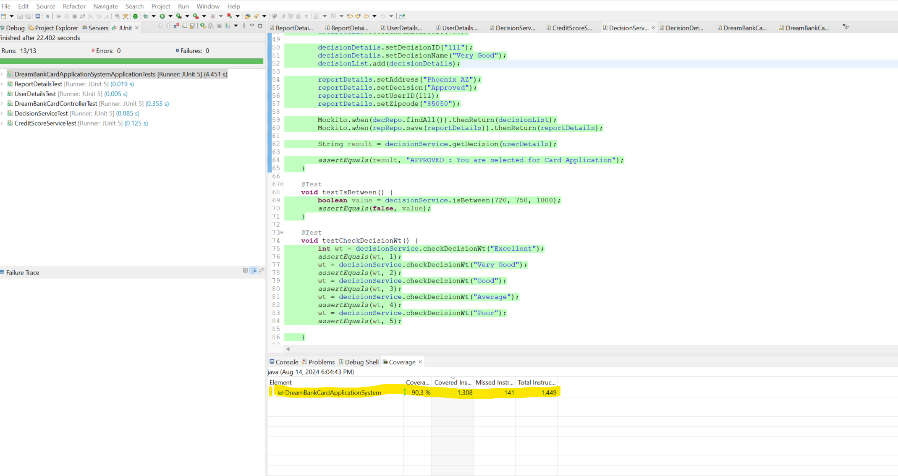

1. Equifax Service – 88%

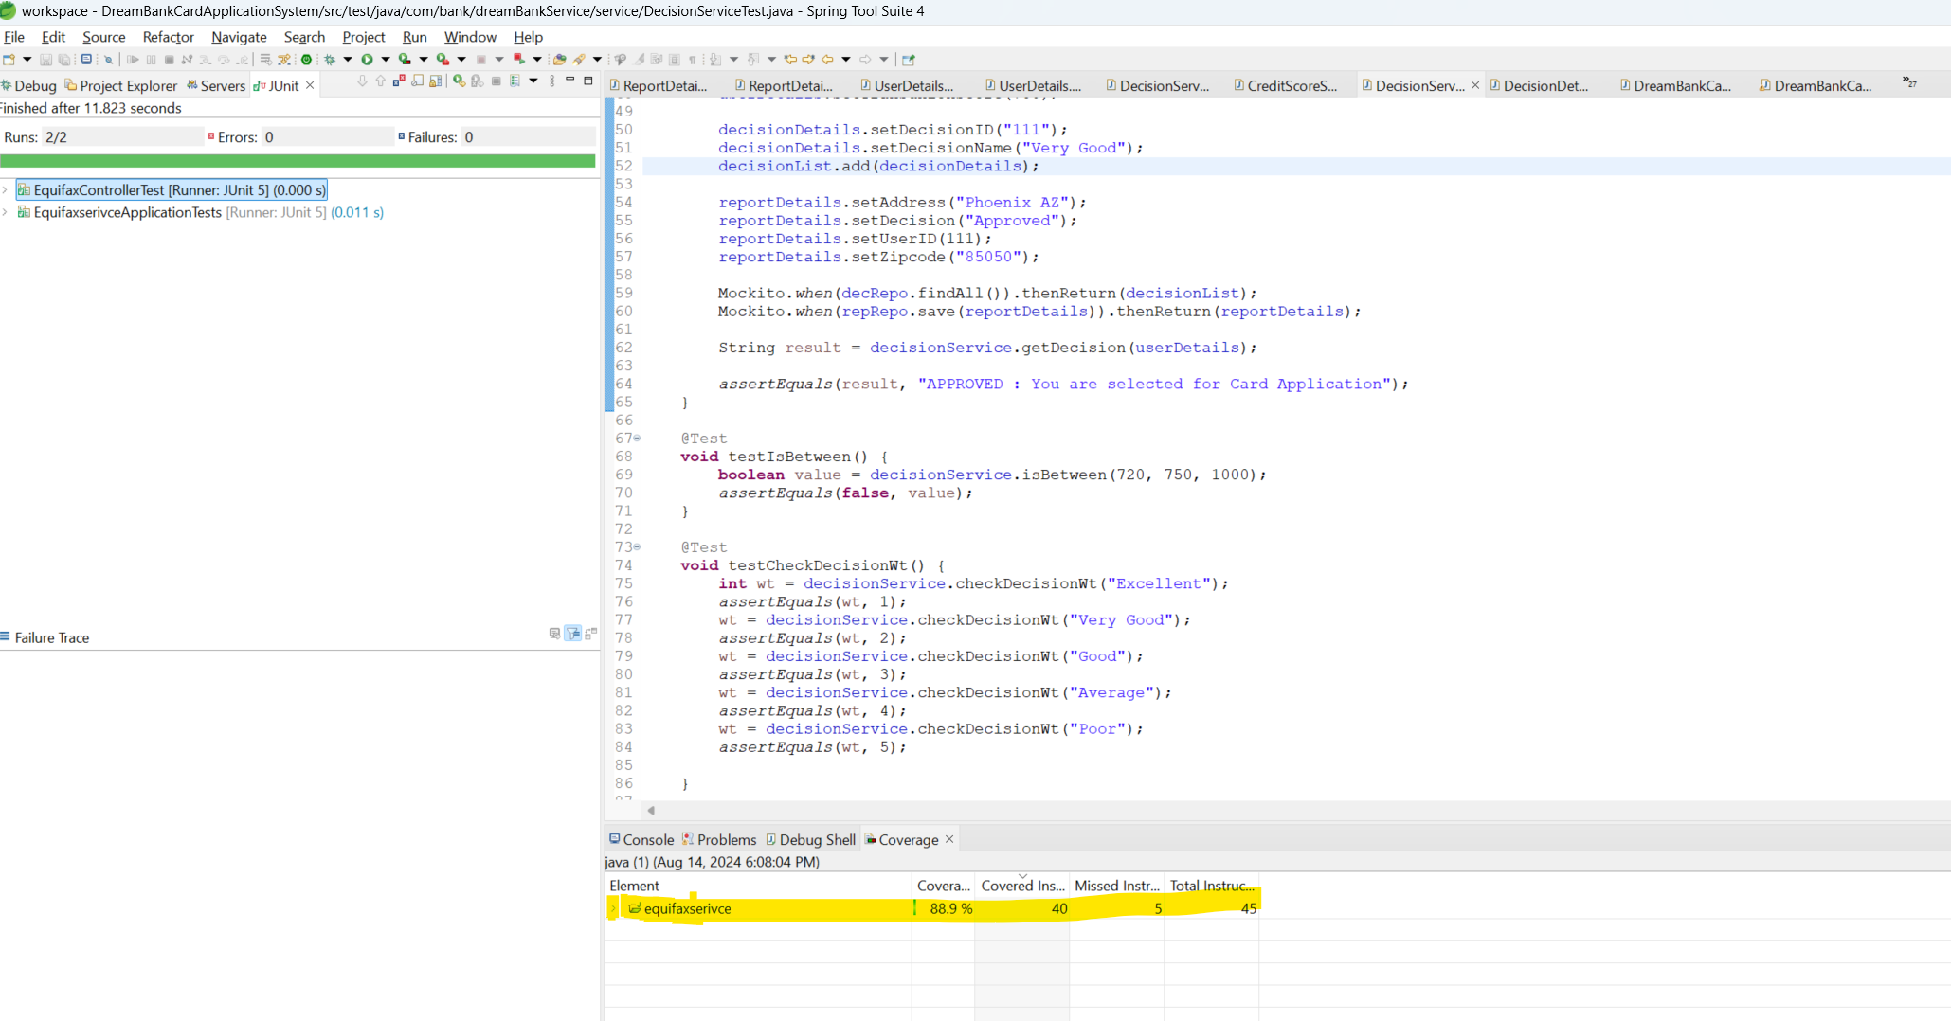

1. Experian Service – 88%

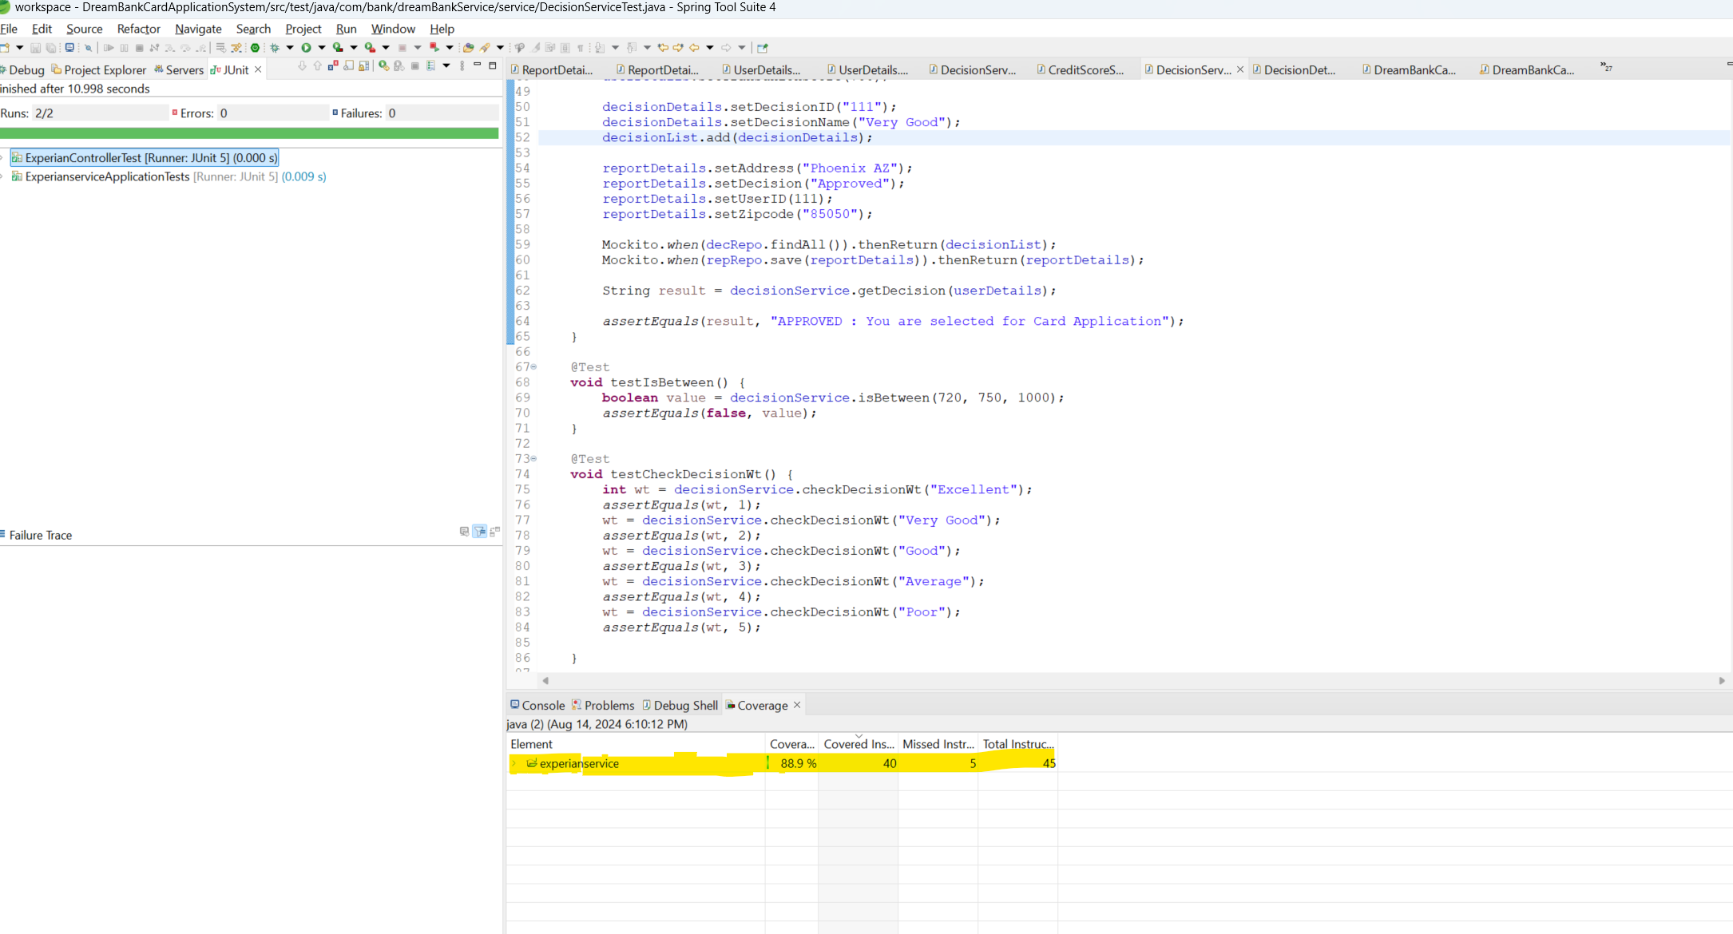

1. Transunion Service – 88 %

