

DINESHKUMAR BM

**DATA ANALYST**

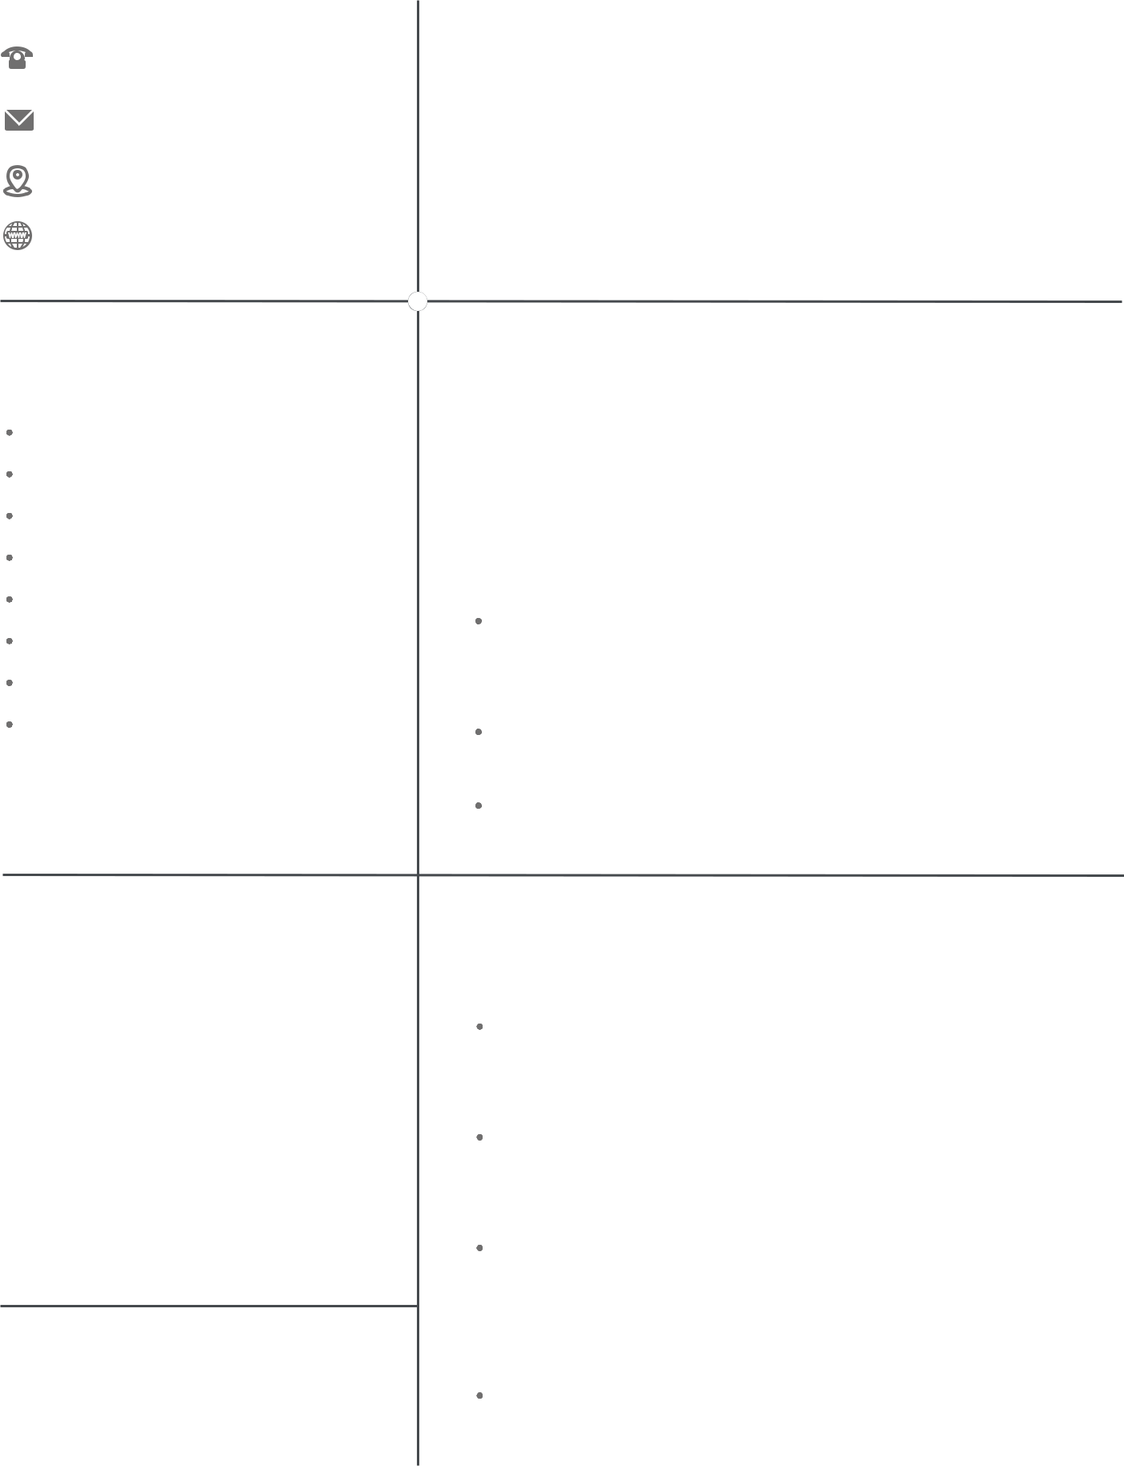

9731854826

dineshkumarbm2@gmail.com

Bangalore, Karnataka

https://www.linkedin.com/in/din eshkumar-bm-63984b177/

**SKILLS**

Power BI

SQL

Excel

Python(Pandas, Scikit-learn)

Statistical analysis

Machine Learning

Jupyter Notebook

Azure Data Bricks

**EDUCATION**

**MCA**

AMC ENGINEERING COLLEGE

BANGALORE

**BSC CS**

Govt Science College

CHITRADURGA

**LANGUAGES**

ENGLISH

KANNADA

**PROFILE**

I am a qualified and professional Data analyst with 1.4 years of experience with in-depth Knowledge of Databse types,reaserch methodologies, and bigdata capture,manipulation and visualization. Thorough and meticulous Data Analyst passionate about helping businesses succeed .

**EXPERIENCE**

DATA ANALYST

Promantus inc

2021 May- Present

Built out the data and reporting infrastructure from the ground up using Power BI and SQL to provide real-time insights into the product, marketing funnels, and business KPIs

Converted Data into actionable insights by predicting and modeling future outcomes.

Utilized MS SQL, Power BI and other dashboard/visualization tools for data intelligence and analysis

**ACCOMPLISHMENT**

Participated in 2021 Open AI4GOOD Wildfire Hackathon hosted by H2o.ai. Out of 160 teams we emerged victorious by placing ourselves in the "Top3" .

Data Mining and Modeling : Collected ,cleaned and provided modeling and analysis of structured and unstructured data used for Wildfire Prediction

Dashboards : Created visually impactful dashboards in Excel and Power BI for data reporting by using pivot tables and charts.Extracted interpreted and analyzed data to identify key metrics and transformation rawdata into meaningful,actionable information

AI Application : designed and built an completely AI application that helped to predict the Wildfire with an 90%accuracy