Nguyễn Minh Khang
MSSV: 1150070019
Máy 38

Lab6

Vào Android Studio tạo 1 project, khi tạo xong project thì ta sẽ tạo 1 package chứa các Activity để dễ phân chia các Activity của các lab khác.
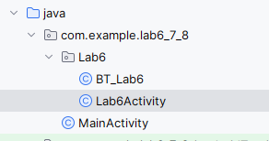
Trong đây ta tạo 2 Activity để thực hiện code của lab 6, Lab6Activity chứa ví dụ của lab6:
package com.example.lab6_7_8.Lab6;
import androidx.appcompat.app.AppCompatActivity;
import android.content.Intent;
import android.os.Bundle;
import android.widget.ArrayAdapter;
import android.widget.Button;
import android.widget.EditText;
import android.widget.Spinner;
import android.widget.TextView;
import android.widget.Toast;
import com.example.lab6_7_8.R;
public class Lab6Activity extends AppCompatActivity {
private Spinner spFrom, spTo;
private EditText edtAmount;
private TextView tvResult, tvAuthor, tvComputer;
private Button btnConvert, btnNextPage;
private String[] currencyNames;
private String[] currencyUnits;
private double[][] rateMatrix = {
{ 1, 0.92, 0.79, 1.50, 1.35, 18.50, 1.66, 83.00, 150.00, 25000.0 },
{ 1.09, 1, 0.86, 1.63, 1.47, 20.10, 1.80, 90.00, 163.00, 27000.0 },
{ 1.26, 1.16, 1, 1.90, 1.71, 23.40, 2.10, 104.00, 188.00, 31000.0 },
{ 0.67, 0.61, 0.53, 1, 0.90, 12.30, 1.10, 55.00, 100.00, 16500.0 },
{ 0.74, 0.68, 0.59, 1.11, 1, 13.70, 1.23, 61.00, 110.00, 18000.0 },
{ 0.054,0.050, 0.043, 0.081, 0.073, 1, 0.090, 4.40, 8.00, 1300.0 },
{ 0.60, 0.56, 0.48, 0.91, 0.81, 11.10, 1, 49.00, 88.00, 15000.0 },
{ 0.012,0.011, 0.0096,0.018, 0.016,0.23, 0.020, 1, 1.80, 310.0 },
{ 0.0067,0.0061,0.0053,0.010,0.0091,0.13,0.011, 0.56, 1, 170.0 },
{ 0.000040,0.000037,0.000032,0.000061,0.000056,0.00077,0.000067,0.0032,0.0059,1 }
};
@Override
protected void onCreate(Bundle savedInstanceState) {
super.onCreate(savedInstanceState);
setContentView(R.layout.activity_lab6);
spFrom = findViewById(R.id.spFrom);
spTo = findViewById(R.id.spTo);
edtAmount = findViewById(R.id.edtAmount);
tvResult = findViewById(R.id.tvResult);
tvAuthor = findViewById(R.id.tvAuthor);
tvComputer = findViewById(R.id.tvComputer);
btnConvert = findViewById(R.id.btnConvert);
Button btnNextPage = findViewById(R.id.btnNextPage);
initCurrencyData();
tvAuthor.setText(getString(R.string.author));
tvComputer.setText(getString(R.string.computer));
ArrayAdapter<String> adapter = new ArrayAdapter<>(
this,
android.R.layout.simple_spinner_item,
currencyNames
);
adapter.setDropDownViewResource(android.R.layout.simple_spinner_dropdown_item);
spFrom.setAdapter(adapter);
spTo.setAdapter(adapter);
spFrom.setSelection(0);
spTo.setSelection(9);
btnConvert.setOnClickListener(v -> convertMoney());
btnNextPage.setOnClickListener(v -> {
Intent intent = new Intent(Lab6Activity.this, BT_Lab6.class);
startActivity(intent);
});
}
private void initCurrencyData() {
currencyNames = new String[]{
getString(R.string.usd_name),
getString(R.string.eur_name),
getString(R.string.gbp_name),
getString(R.string.aud_name),
getString(R.string.cad_name),
getString(R.string.zar_name),
getString(R.string.nzd_name),
getString(R.string.inr_name),
getString(R.string.jpy_name),
getString(R.string.vnd_name)
};
currencyUnits = new String[]{
getString(R.string.usd_unit),
getString(R.string.eur_unit),
getString(R.string.gbp_unit),
getString(R.string.aud_unit),
getString(R.string.cad_unit),
getString(R.string.zar_unit),
getString(R.string.nzd_unit),
getString(R.string.inr_unit),
getString(R.string.jpy_unit),
getString(R.string.vnd_unit)
};
}
private void convertMoney() {
String amountStr = edtAmount.getText().toString().trim();
if (amountStr.isEmpty()) {
Toast.makeText(this, getString(R.string.error_empty_amount), Toast.LENGTH_SHORT).show();
return;
}
double amount;
try {
amount = Double.parseDouble(amountStr);
} catch (NumberFormatException e) {
Toast.makeText(this, getString(R.string.error_invalid_amount), Toast.LENGTH_SHORT).show();
return;
}
int fromIndex = spFrom.getSelectedItemPosition();
int toIndex = spTo.getSelectedItemPosition();
double rate = rateMatrix[fromIndex][toIndex];
double result = amount * rate;
String unitFrom = currencyUnits[fromIndex];
String unitTo = currencyUnits[toIndex];
String resultText = String.format("%.2f %s = %.2f %s", amount, unitFrom, result, unitTo);
tvResult.setText(resultText);
}
}

Khai báo các biến có trong layout
private Spinner spFrom, spTo;
private EditText edtAmount;
private TextView tvResult, tvAuthor, tvComputer;
private Button btnConvert, btnNextPage;
private String[] currencyNames;
private String[] currencyUnits;

Tạo 1 ma trận 10x10 chứa các loại tiền tệ có trong code
private double[][] rateMatrix = {
{ 1, 0.92, 0.79, 1.50, 1.35, 18.50, 1.66, 83.00, 150.00, 25000.0 },
{ 1.09, 1, 0.86, 1.63, 1.47, 20.10, 1.80, 90.00, 163.00, 27000.0 },
{ 1.26, 1.16, 1, 1.90, 1.71, 23.40, 2.10, 104.00, 188.00, 31000.0 },
{ 0.67, 0.61, 0.53, 1, 0.90, 12.30, 1.10, 55.00, 100.00, 16500.0 },
{ 0.74, 0.68, 0.59, 1.11, 1, 13.70, 1.23, 61.00, 110.00, 18000.0 },
{ 0.054,0.050, 0.043, 0.081, 0.073, 1, 0.090, 4.40, 8.00, 1300.0 },
{ 0.60, 0.56, 0.48, 0.91, 0.81, 11.10, 1, 49.00, 88.00, 15000.0 },
{ 0.012,0.011, 0.0096,0.018, 0.016,0.23, 0.020, 1, 1.80, 310.0 },
{ 0.0067,0.0061,0.0053,0.010,0.0091,0.13,0.011, 0.56, 1, 170.0 },
{ 0.000040,0.000037,0.000032,0.000061,0.000056,0.00077,0.000067,0.0032,0.0059,1 }
};

Phần khởi tạo dữ liệu
initCurrencyData();
tvAuthor.setText(getString(R.string.author));
tvComputer.setText(getString(R.string.computer));
Hàm initCurrencyData()
private void initCurrencyData() {
currencyNames = new String[]{
getString(R.string.usd_name),
getString(R.string.eur_name),
getString(R.string.gbp_name),
getString(R.string.aud_name),
getString(R.string.cad_name),
getString(R.string.zar_name),
getString(R.string.nzd_name),
getString(R.string.inr_name),
getString(R.string.jpy_name),
getString(R.string.vnd_name)
};
currencyUnits = new String[]{
getString(R.string.usd_unit),
getString(R.string.eur_unit),
getString(R.string.gbp_unit),
getString(R.string.aud_unit),
getString(R.string.cad_unit),
getString(R.string.zar_unit),
getString(R.string.nzd_unit),
getString(R.string.inr_unit),
getString(R.string.jpy_unit),
getString(R.string.vnd_unit)
};
}
Thứ tự phải trùng với matrix ‘rateMatrix’ đã tạo ở trên

Hàm convertMoney()
private void convertMoney() {
String amountStr = edtAmount.getText().toString().trim();
if (amountStr.isEmpty()) {
Toast.makeText(this, getString(R.string.error_empty_amount), Toast.LENGTH_SHORT).show();
return;
}
hàm này dùng để đổi tiền tệ.
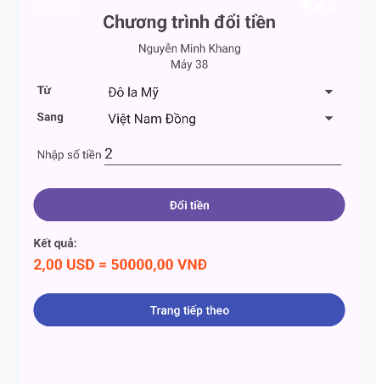

BT-Lab6
package com.example.lab6_7_8.Lab6;
import androidx.appcompat.app.AppCompatActivity;
import android.content.Intent;
import android.os.Bundle;
import android.widget.*;
import com.example.lab6_7_8.Lab6.Lab6Activity;
import com.example.lab6_7_8.R;
public class BT_Lab6 extends AppCompatActivity {
Spinner spFrom, spTo;
EditText edtValue;
TextView tvResult;
Button btnConvert, btnPrePage;
String[] names;
String[] units;
double[][] lengthRate = {
{1, 0.1, 0.01, 0.001, 0.000001},
{10, 1, 0.1, 0.01, 0.00001},
{100, 10, 1, 0.1, 0.0001},
{1000, 100, 10, 1, 0.001},
{1000000,100000, 10000, 1000, 1}
};
@Override
protected void onCreate(Bundle savedInstanceState) {
super.onCreate(savedInstanceState);
setContentView(R.layout.activity_bt_lab6);
spFrom = findViewById(R.id.spFrom);
spTo = findViewById(R.id.spTo);
edtValue = findViewById(R.id.edtValue);
tvResult = findViewById(R.id.tvResult);
btnConvert = findViewById(R.id.btnConvert);
Button btnPrePage = findViewById(R.id.btnPrePage);
initData();
ArrayAdapter<String> adapter = new ArrayAdapter<>(this,
android.R.layout.simple_spinner_item, names);
adapter.setDropDownViewResource(android.R.layout.simple_spinner_dropdown_item);
spFrom.setAdapter(adapter);
spTo.setAdapter(adapter);
btnConvert.setOnClickListener(v -> convertLength());
btnPrePage.setOnClickListener(v -> {
Intent intent = new Intent(BT_Lab6.this, Lab6Activity.class);
startActivity(intent);
});
}
private void initData() {
names = new String[]{
getString(R.string.mm_name),
getString(R.string.cm_name),
getString(R.string.dm_name),
getString(R.string.m_name),
getString(R.string.km_name)
};
units = new String[]{
getString(R.string.mm_unit),
getString(R.string.cm_unit),
getString(R.string.dm_unit),
getString(R.string.m_unit),
getString(R.string.km_unit)
};
}
private void convertLength() {
String input = edtValue.getText().toString().trim();
if (input.isEmpty()) {
Toast.makeText(this, getString(R.string.error_empty), Toast.LENGTH_SHORT).show();
return;
}
double value;
try {
value = Double.parseDouble(input);
} catch (Exception e) {
Toast.makeText(this, getString(R.string.error_invalid), Toast.LENGTH_SHORT).show();
return;
}
int from = spFrom.getSelectedItemPosition();
int to = spTo.getSelectedItemPosition();
double rate = lengthRate[from][to];
double result = value * rate;
String text = value + " " + units[from] +
" = " + result + " " + units[to];
tvResult.setText(text);
}
}

Khai báo biến có trong code
Spinner spFrom, spTo;
EditText edtValue;
TextView tvResult;
Button btnConvert, btnPrePage;
String[] names;
String[] units;
double[][] lengthRate = {
{1, 0.1, 0.01, 0.001, 0.000001},
{10, 1, 0.1, 0.01, 0.00001},
{100, 10, 1, 0.1, 0.0001},
{1000, 100, 10, 1, 0.001},
{1000000,100000, 10000, 1000, 1}
};

Khởi tạo dữ liệu cho Spinner
initData();

Gọi hàm initData() để nạp mảng names, units từ strings.xml
ArrayAdapter<String> adapter = new ArrayAdapter<>(this,
android.R.layout.simple_spinner_item, names);
adapter.setDropDownViewResource(android.R.layout.simple_spinner_dropdown_item);
spFrom.setAdapter(adapter);
spTo.setAdapter(adapter);

Chuẩn bị đơn vị cho dữ liệu
private void initData() {
names = new String[]{
getString(R.string.mm_name),
getString(R.string.cm_name),
getString(R.string.dm_name),
getString(R.string.m_name),
getString(R.string.km_name)
};
units = new String[]{
getString(R.string.mm_unit),
getString(R.string.cm_unit),
getString(R.string.dm_unit),
getString(R.string.m_unit),
getString(R.string.km_unit)
};
}

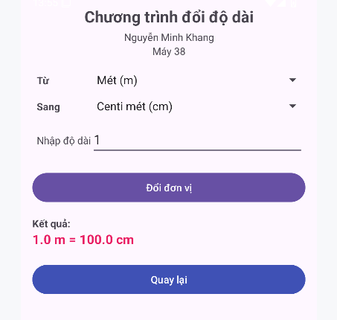

Lab7
Tạo 1 project tương tự như lab6 ở trên
BT1
package com.example.lab7;
import android.os.Bundle;
import android.widget.Button;
import android.widget.Toast;
import androidx.appcompat.app.AppCompatActivity;
public class BT1 extends AppCompatActivity {
Button btnColorSelector, btnDisabledSelector, btnRoundShape, btnShapeGradient, btnSelectorShape;
@Override
protected void onCreate(Bundle savedInstanceState) {
super.onCreate(savedInstanceState);
setContentView(R.layout.activity_bt1);
btnColorSelector = findViewById(R.id.btnColorSelector);
btnDisabledSelector = findViewById(R.id.btnDisabledSelector);
btnRoundShape = findViewById(R.id.btnRoundShape);
btnShapeGradient = findViewById(R.id.btnShapeGradient);
btnSelectorShape = findViewById(R.id.btnSelectorShape);
btnColorSelector.setOnClickListener(v ->
show("Bạn bấm: Colored Selector")
);
btnDisabledSelector.setOnClickListener(v ->
show("Nút này đang disabled")
);
btnRoundShape.setOnClickListener(v ->
show("Bạn bấm: Round Shape")
);
btnShapeGradient.setOnClickListener(v ->
show("Bạn bấm: Shape With Gradient")
);
btnSelectorShape.setOnClickListener(v ->
show("Bạn bấm: Selector Shape")
);
}
private void show(String text) {
Toast.makeText(this, text, Toast.LENGTH_SHORT).show();
}
}
Khai báo các biến
btnColorSelector = findViewById(R.id.btnColorSelector);
btnDisabledSelector = findViewById(R.id.btnDisabledSelector);
btnRoundShape = findViewById(R.id.btnRoundShape);
btnShapeGradient = findViewById(R.id.btnShapeGradient);
btnSelectorShape = findViewById(R.id.btnSelectorShape);
Xử lý các nút bấm khi người dùng nhấn vào
btnColorSelector.setOnClickListener(v ->
show("Bạn bấm: Colored Selector")
);
btnDisabledSelector.setOnClickListener(v ->
show("Nút này đang disabled")
);
btnRoundShape.setOnClickListener(v ->
show("Bạn bấm: Round Shape")
);
btnShapeGradient.setOnClickListener(v ->
show("Bạn bấm: Shape With Gradient")
);
btnSelectorShape.setOnClickListener(v ->
show("Bạn bấm: Selector Shape")
);
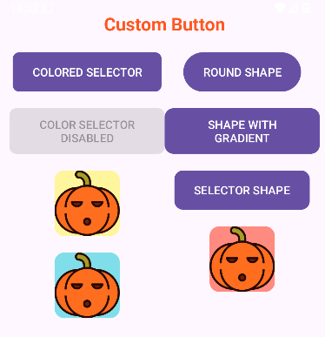
BT2
Khai báo thêm 2 biến vào Activity ở BT1
Button btnShowToast, btnShowDialog;

btnShowToast = findViewById(R.id.btnShowToast);
btnShowDialog = findViewById(R.id.btnShowDialog);
Xử lý logic cho các nút mới vừa thêm vào
btnShowToast.setOnClickListener(v -> showCustomToast());
btnShowDialog.setOnClickListener(v -> showCustomDialog());

Hàm showCustomToast()
- Tạo 1 Toast tùy biến giao diện
private void showCustomToast() {
LayoutInflater inflater = getLayoutInflater();
View view = inflater.inflate(R.layout.custom_toast, null);
TextView txt = view.findViewById(R.id.txtToast);
txt.setText("Đây là Custom Toast");
Toast toast = new Toast(this);
toast.setView(view);
toast.setDuration(Toast.LENGTH_LONG);
toast.show();
}
LayoutInflater là class dùng để biến file XML thành view thật.
getLayoutInflater() lấy ra inflater gắn với Activity hiện tại.

Hàm showCustomDialog()
private void showCustomDialog() {
Dialog dialog = new Dialog(this);
dialog.setContentView(R.layout.custom_dialog);
Button btnClose = dialog.findViewById(R.id.btnClose);
btnClose.setOnClickListener(v -> dialog.dismiss());
dialog.show();
}
Dialog dialog = new Dialog(this); Tạo 1 đối tượng Dialog mới

Tìm nút đóng trong giao diện chính của Dialog để đóng.
Button btnClose = dialog.findViewById(R.id.btnClose);
Gắn sự kiện xử lý nút đóng.
btnClose.setOnClickListener(v -> dialog.dismiss());

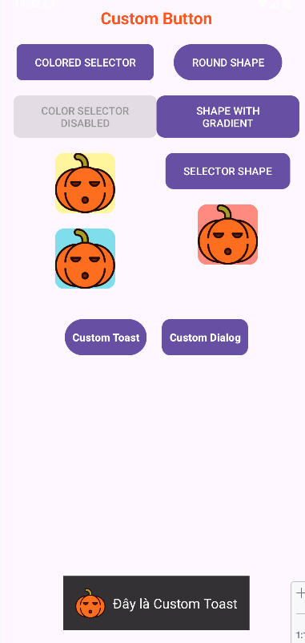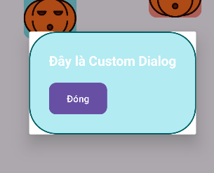
BT3
Chuột phải vào com.example.lab7 chọn New -> Activtity -> Empty View Activity
Tạo 1 Activity BT3
package com.example.lab6_7_8.Lab6;
import androidx.appcompat.app.AppCompatActivity;
import android.content.Intent;
import android.os.Bundle;
import android.widget.ArrayAdapter;
import android.widget.Button;
import android.widget.EditText;
import android.widget.Spinner;
import android.widget.TextView;
import android.widget.Toast;
import com.example.lab6_7_8.R;
public class Lab6Activity extends AppCompatActivity {
private Spinner spFrom, spTo;
private EditText edtAmount;
private TextView tvResult, tvAuthor, tvComputer;
private Button btnConvert, btnNextPage;
private String[] currencyNames;
private String[] currencyUnits;
private double[][] rateMatrix = {
{ 1, 0.92, 0.79, 1.50, 1.35, 18.50, 1.66, 83.00, 150.00, 25000.0 },
{ 1.09, 1, 0.86, 1.63, 1.47, 20.10, 1.80, 90.00, 163.00, 27000.0 },
{ 1.26, 1.16, 1, 1.90, 1.71, 23.40, 2.10, 104.00, 188.00, 31000.0 },
{ 0.67, 0.61, 0.53, 1, 0.90, 12.30, 1.10, 55.00, 100.00, 16500.0 },
{ 0.74, 0.68, 0.59, 1.11, 1, 13.70, 1.23, 61.00, 110.00, 18000.0 },
{ 0.054,0.050, 0.043, 0.081, 0.073, 1, 0.090, 4.40, 8.00, 1300.0 },
{ 0.60, 0.56, 0.48, 0.91, 0.81, 11.10, 1, 49.00, 88.00, 15000.0 },
{ 0.012,0.011, 0.0096,0.018, 0.016,0.23, 0.020, 1, 1.80, 310.0 },
{ 0.0067,0.0061,0.0053,0.010,0.0091,0.13,0.011, 0.56, 1, 170.0 },
{ 0.000040,0.000037,0.000032,0.000061,0.000056,0.00077,0.000067,0.0032,0.0059,1 }
};
@Override
protected void onCreate(Bundle savedInstanceState) {
super.onCreate(savedInstanceState);
setContentView(R.layout.activity_lab6);
spFrom = findViewById(R.id.spFrom);
spTo = findViewById(R.id.spTo);
edtAmount = findViewById(R.id.edtAmount);
tvResult = findViewById(R.id.tvResult);
tvAuthor = findViewById(R.id.tvAuthor);
tvComputer = findViewById(R.id.tvComputer);
btnConvert = findViewById(R.id.btnConvert);
btnNextPage = findViewById(R.id.btnNextPage);
initCurrencyData();
tvAuthor.setText(getString(R.string.author));
tvComputer.setText(getString(R.string.computer));
ArrayAdapter<String> adapter = new ArrayAdapter<>(
this,
android.R.layout.simple_spinner_item,
currencyNames
);
adapter.setDropDownViewResource(android.R.layout.simple_spinner_dropdown_item);
spFrom.setAdapter(adapter);
spTo.setAdapter(adapter);
spFrom.setSelection(0);
spTo.setSelection(9);
btnConvert.setOnClickListener(v -> convertMoney());
btnNextPage.setOnClickListener(v -> {
Intent intent = new Intent(Lab6Activity.this, BT_Lab6.class);
startActivity(intent);
});
}
private void initCurrencyData() {
currencyNames = new String[]{
getString(R.string.usd_name),
getString(R.string.eur_name),
getString(R.string.gbp_name),
getString(R.string.aud_name),
getString(R.string.cad_name),
getString(R.string.zar_name),
getString(R.string.nzd_name),
getString(R.string.inr_name),
getString(R.string.jpy_name),
getString(R.string.vnd_name)
};
currencyUnits = new String[]{
getString(R.string.usd_unit),
getString(R.string.eur_unit),
getString(R.string.gbp_unit),
getString(R.string.aud_unit),
getString(R.string.cad_unit),
getString(R.string.zar_unit),
getString(R.string.nzd_unit),
getString(R.string.inr_unit),
getString(R.string.jpy_unit),
getString(R.string.vnd_unit)
};
}
private void convertMoney() {
String amountStr = edtAmount.getText().toString().trim();
if (amountStr.isEmpty()) {
Toast.makeText(this, getString(R.string.error_empty_amount), Toast.LENGTH_SHORT).show();
return;
}
double amount;
try {
amount = Double.parseDouble(amountStr);
} catch (NumberFormatException e) {
Toast.makeText(this, getString(R.string.error_invalid_amount), Toast.LENGTH_SHORT).show();
return;
}
int fromIndex = spFrom.getSelectedItemPosition();
int toIndex = spTo.getSelectedItemPosition();
double rate = rateMatrix[fromIndex][toIndex];
double result = amount * rate;
String unitFrom = currencyUnits[fromIndex];
String unitTo = currencyUnits[toIndex];
String resultText = String.format("%.2f %s = %.2f %s", amount, unitFrom, result, unitTo);
tvResult.setText(resultText);
}
}
Khai báo biến
SeekBar sbR, sbG, sbB;
TextView txtR, txtG, txtB;
View viewRGB, viewCMY;
int r = 0, g = 0, b = 0;
Ánh xạ (findViewbyId)
sbR = findViewById(R.id.sbR);
sbG = findViewById(R.id.sbG);
sbB = findViewById(R.id.sbB);
txtR = findViewById(R.id.txtR);
txtG = findViewById(R.id.txtG);
txtB = findViewById(R.id.txtB);
viewRGB = findViewById(R.id.viewRGB);
viewCMY = findViewById(R.id.viewCMY);

Tạo 1 listener dùng chung cho cả 3 SeekBar
SeekBar.OnSeekBarChangeListener listener = new SeekBar.OnSeekBarChangeListener() {
@Override
public void onProgressChanged(SeekBar seekBar, int value, boolean fromUser) {
r = sbR.getProgress();
g = sbG.getProgress();
b = sbB.getProgress();
txtR.setText("R: " + r);
txtG.setText("G: " + g);
txtB.setText("B: " + b);
viewRGB.setBackgroundColor(Color.rgb(r, g, b));
int c = 255 - r;
int m = 255 - g;
int y = 255 - b;
viewCMY.setBackgroundColor(Color.rgb(c, m, y));
}
@Override public void onStartTrackingTouch(SeekBar seekBar) {}
@Override public void onStopTrackingTouch(SeekBar seekBar) {}
};
Hàm onProgressChanged
Hàm này được gọi khi SeekBar thay đổi vị trí kéo
r = sbR.getProgress();
g = sbG.getProgress();
b = sbB.getProgress();

Mỗi khi bất kỳ SeekBar nào thay đổi, đều sẽ lấy lại đầy đủ giá trị R, G, B từ 3 SeekBar.
Gán listener cho 3 SeekBar
sbR.setOnSeekBarChangeListener(listener);
sbG.setOnSeekBarChangeListener(listener);
sbB.setOnSeekBarChangeListener(listener);
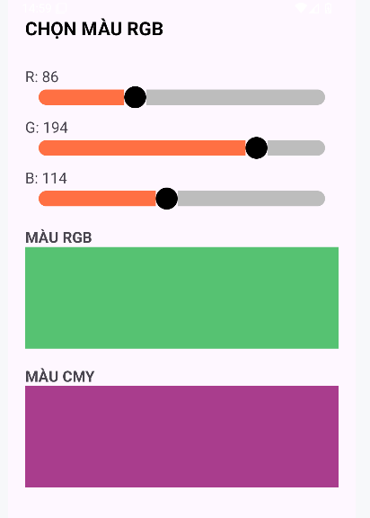
Lab8
Luyện tập
Tạo 1 project mới
Chuột phải vào com.example.lab8 chọn New -> Activtity -> Empty View Activity
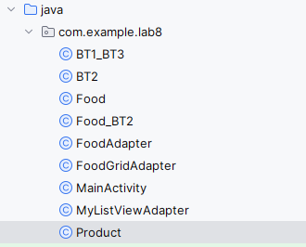

Trong MainActivity
package com.example.lab8;
import androidx.appcompat.app.AppCompatActivity;
import android.content.Intent;
import android.os.Bundle;
import android.widget.Button;
import android.widget.ListView;
import android.widget.TextView;
import java.util.ArrayList;
public class MainActivity extends AppCompatActivity {
ListView lvProducts;
TextView txtSelected;
ArrayList<Product> products;
MyListViewAdapter adapter;
Button btnNextPage;
@Override
protected void onCreate(Bundle savedInstanceState) {
super.onCreate(savedInstanceState);
setContentView(R.layout.activity_main);
lvProducts = findViewById(R.id.lvProducts);
txtSelected = findViewById(R.id.txtSelected);
btnNextPage = findViewById(R.id.btnNextPage);
products = new ArrayList<>();
products.add(new Product(R.drawable.icon_android, "Android", "Hệ điều hành của Google"));
products.add(new Product(R.drawable.icon_ios, "iOS", "Hệ điều hành của Apple"));
products.add(new Product(R.drawable.icon_windows, "Windows Phone", "Hệ điều hành Microsoft"));
adapter = new MyListViewAdapter(
MainActivity.this,
R.layout.row_item,
products
);
btnNextPage.setOnClickListener(v -> {
Intent intent = new Intent(MainActivity.this, BT1_BT3.class);
startActivity(intent);
});
lvProducts.setAdapter(adapter);
lvProducts.setOnItemClickListener((parent, view, position, id) -> {
Product p = products.get(position);
txtSelected.setText("Bạn chọn: " + p.getTitle());
});
}
}
Khai báo các biến
ListView lvProducts;
TextView txtSelected;
ArrayList<Product> products;
MyListViewAdapter adapter;
Button btnNextPage;

Khởi tạo và nạp dữ liệu cho danh sách Products
products = new ArrayList<>();
products.add(new Product(R.drawable.icon_android, "Android", "Hệ điều hành của Google"));
products.add(new Product(R.drawable.icon_ios, "iOS", "Hệ điều hành của Apple"));
products.add(new Product(R.drawable.icon_windows, "Windows Phone", "Hệ điều hành Microsoft"));

Tạo Adapter cho ListView
adapter = new MyListViewAdapter(
MainActivity.this,
R.layout.row_item,
products
);

Còn trong Product.java
package com.example.lab8;
public class Product {
private int photo;
private String title;
private String content;
public Product(int photo, String title, String content) {
this.photo = photo;
this.title = title;
this.content = content;
}
public int getPhoto() { return photo; }
public String getTitle() { return title; }
public String getContent() { return content; }
}
Khai báo các class và thuộc tính
public class Product {
private int photo;
private String title;
private String content;
Hàm tạo
public Product(int photo, String title, String content) {
this.photo = photo;
this.title = title;
this.content = content;
}
Trong MyListViewAdapter
package com.example.lab8;
import android.content.Context;
import android.view.LayoutInflater;
import android.view.View;
import android.view.ViewGroup;
import android.widget.BaseAdapter;
import android.widget.ImageView;
import android.widget.TextView;
import java.util.ArrayList;
public class MyListViewAdapter extends BaseAdapter {
private Context context;
private int layout;
private ArrayList<Product> list;
public MyListViewAdapter(Context context, int layout, ArrayList<Product> list) {
this.context = context;
this.layout = layout;
this.list = list;
}
@Override
public int getCount() {
return list.size();
}
@Override
public Object getItem(int i) {
return list.get(i);
}
@Override
public long getItemId(int i) {
return i;
}
@Override
public View getView(int position, View convertView, ViewGroup parent) {
LayoutInflater inflater = (LayoutInflater) context.getSystemService(Context.LAYOUT_INFLATER_SERVICE);
convertView = inflater.inflate(layout, null);
ImageView img = convertView.findViewById(R.id.imgRow);
TextView txtTitle = convertView.findViewById(R.id.txtTitle);
TextView txtContent = convertView.findViewById(R.id.txtContent);
Product p = list.get(position);
img.setImageResource(p.getPhoto());
txtTitle.setText(p.getTitle());
txtContent.setText(p.getContent());
return convertView;
}
}
Khái bao class và thuộc tính
public class MyListViewAdapter extends BaseAdapter {
private Context context;
private int layout;
private ArrayList<Product> list;
Hàm tạo Adapter
public MyListViewAdapter(Context context, int layout, ArrayList<Product> list) {
this.context = context;
this.layout = layout;
this.list = list;
}
Ghi đè các hàm bắt buộc của BaseAdapter
getCount()
public int getCount() {
return list.size();
}
getItem(int i)
public Object getItem(int i) {
return list.get(i);
}
getItemId(int i)
public long getItemId(int i) {
return i;
}
Hàm getView() nơi tạo ra từng dòng row cho ListView
public View getView(int position, View convertView, ViewGroup parent) {
LayoutInflater inflater = (LayoutInflater) context.getSystemService(Context.LAYOUT_INFLATER_SERVICE);
convertView = inflater.inflate(layout, null);
ImageView img = convertView.findViewById(R.id.imgRow);
TextView txtTitle = convertView.findViewById(R.id.txtTitle);
TextView txtContent = convertView.findViewById(R.id.txtContent);
Product p = list.get(position);
img.setImageResource(p.getPhoto());
txtTitle.setText(p.getTitle());
txtContent.setText(p.getContent());
return convertView;
}
Trong FoodAdapter
package com.example.lab8;
import android.content.Context;
import android.view.LayoutInflater;
import android.view.View;
import android.view.ViewGroup;
import android.widget.BaseAdapter;
import android.widget.ImageView;
import android.widget.TextView;
import java.util.ArrayList;
public class FoodAdapter extends BaseAdapter {
private Context context;
private int layout;
private ArrayList<Food> list;
public FoodAdapter(Context context, int layout, ArrayList<Food> list) {
this.context = context;
this.layout = layout;
this.list = list;
}
@Override
public int getCount() {
return list.size();
}
@Override
public Object getItem(int i) {
return list.get(i);
}
@Override
public long getItemId(int i) {
return i;
}
@Override
public View getView(int position, View convertView, ViewGroup parent) {
LayoutInflater inflater = (LayoutInflater)
context.getSystemService(Context.LAYOUT_INFLATER_SERVICE);
convertView = inflater.inflate(layout, null);
ImageView img = convertView.findViewById(R.id.imgFood);
TextView name = convertView.findViewById(R.id.txtFoodName);
TextView desc = convertView.findViewById(R.id.txtFoodDesc);
Food f = list.get(position);
img.setImageResource(f.getImage());
name.setText(f.getName());
desc.setText(f.getDescription());
return convertView;
}
}
