Risk-Adaptive Security Framework for Controlled Autonomy in Agentic Banking Systems
Project Proposal

Supervisor
Dr. Qamas Gul Khan Safi
Submitted by
Muhammad Khubaib Naveed
(23-CS-14)
Talha Abid
(23-CS-33)
Raja Qasim Ali
(23-CS-48)
Submitted in partial fulfillment of the requirements for CS-400 in

Department of Computer Science,
University of Engineering & Technology Taxila.
2026-2027

Table of Contents
1. Introduction 1
1.1 Domain Background and Context 1
2. Literature Review 1
2.1 Overview and Themes 1
2.2 Summary Matrix of Reviewed Literature 2,3
2.3 Research Gap 4
3. Problem Description 4
4. Objective 5
4.1 Primary Objectives and Deliverables 5
5. Methodology 5
5.1 Proposed Technical Solution 5
5.2 System Architecture and Working Flow 6
5.3 Risk-Adaptive Autonomy Levels 7
5.4 Database Design and ER Diagram 8
5.5 Threat Model Summary 9
6. Testing and Evaluation 9
6.1 Experimental Dataset and Split 9
6.2 Baselines and Ablations 10
6.3 Quantitative Performance Metrics 10
6.4 Hypotheses, Ablation and Statistical Analysis 11
7. Project Scope 11
8. Feasibility Study 12
9. Solution Application Areas 12
10. Tools/Technology 13
11. Required Hardware & Software 13
11.1 Hardware 13
11.2 Software 13
12. Expertise of the Team Members 13
13. Milestones 15
13.1 GANTT Chart 16
14. References 17
Appendix A 19
Appendix B 20

List of Tables
Table 2.1. Summary matrix of reviewed literature (state-of-the-art comparison) 2
Table 5.1. Autonomy levels 7
Table 5.2. Normalised relational design (primary keys underlined in Figure 5.3) 8
Table 5.3. Attack classes used in the benchmark 9
Table 6.1. Compared configurations 10
Table 6.2. Evaluation metrics 10
Table 6.3. Research hypotheses 11
Table 8.1. Risks and mitigation 12
Table 12.1. Distribution of work 14
Table 13.1. Major milestones 15
Table 13.2. GANTT chart 16

List of Figures
Figure 5.1. Proposed working flow and trust boundaries of the Agentic AI Banking Guardian 6
Figure 5.2. Proposed working flow and system architecture of the Agentic AI Banking Guardian 7
Figure 5.3. Entity-relationship diagram of the simulated banking and security database 8

- Introduction
This proposal presents a project on securing large language model (LLM) agents that act on behalf of banking customers, implemented as the Agentic AI Banking Guardian prototype. Giving a language model the ability to call payment tools turns a text-handling problem into an authorization problem, because a mistaken or manipulated tool call can move money irreversibly. The project therefore asks where authority should sit, and how it should adapt to risk when an untrusted model is allowed to propose financial actions. The rest of the proposal covers related work, the research gap, objectives, methodology and evaluation, scope, feasibility, schedule, and the team.
  - Domain Background and Context
Large language model (LLM) agents extend conversational AI by planning multi-step tasks and calling external tools such as APIs, databases and payment services. In retail banking, this lets a customer state a goal in natural language, for example paying a utility bill or adding a beneficiary and having software carry it out. The same capability changes the security picture: an agent that can call state-changing tools can cause irreversible financial effects. OWASP's guidance on agentic applications lists tool misuse, identity and privilege abuse, and goal hijacking among the core risks [1], and names excessive functionality, permissions and autonomy as the roots of excessive agency [2].
The topic is attracting standards and regulatory attention. In February 2026, the NIST National Cybersecurity Center of Excellence opened work on identity and authorization for software and AI agents [3]. The Bank for International Settlements has shown experimentally that a general-purpose AI agent can imitate routine cash-management decisions in a simulated payment system, while discussing the safeguards supervisors may need [4]. In Pakistan, the State Bank of Pakistan's 2025 framework for payment institutions expects risk-based controls such as multi-factor authentication, transaction limits and fraud response [5].
The dominant attack on such agents is prompt injection, in which instructions hidden in data the agent reads, such as a bill description or a retrieved document, override the user's intent [6]. Benchmarks like AgentDojo, which includes an e-banking suite, show that capable models can be hijacked in this way [7]. Defences are therefore moving from filtering text towards system design: keeping authority outside the model and enforcing it deterministically at the tool boundary [8], [9].
This project, the Agentic AI Banking Guardian, works at that boundary. It builds a simulated banking agent on synthetic data and studies whether a provenance-aware, risk-adaptive authorization layer can reduce unsafe autonomy, including attacks that stay within the user's granted permissions, without making legitimate automation impractical. It is a controlled research prototype: no real money, customer data, or live banking rails are involved.
- Literature Review
  - Overview and Themes
This review covers recent work (2023 to 2026) on securing LLM agents that act through tools, organised into four themes, and then compares the studies side by side in Table 2.1.
Attacks and benchmarks. Indirect prompt injection was first shown to compromise real LLM-integrated applications [6] and was then formalised and benchmarked [10]. Agent-specific suites followed: InjecAgent [11], AgentDojo [7], Agent Security Bench [12], and AgentPoison for memory and knowledge-based poisoning [13].
Model-level and detection defences. Spotlighting [14], structured queries [15], guardrail pipelines [16], task-alignment checking [17] and causal-attribution methods [18], [19] lower attack success rates, but they are probabilistic. Nasr et al. [20] bypassed twelve published defences with adaptive attacks, most of which had originally reported near-zero attack success.
Architectural and privilege-based defences. CaMeL separates control flow from data flow and enforces capabilities, solving 77% of AgentDojo tasks with provable security against 84% for an undefended agent [8]. Progent enforces programmable least-privilege tool policies [9], FIDES applies information-flow control [21], IsolateGPT isolates execution [22], and a catalogue of design patterns records the trade-offs [23]. These give strong guarantees for what they model, at some cost in utility and tokens.
Authorization, identity, and commit-time control. Commit-time authorization studies when earlier authority no longer licenses a durable effect [24]; intent-governed access control narrows policy monotonically from the user's request [25]; authorization propagation across multi-agent delegation has been formalised [26]; and the tool-invocation boundary has been surveyed [27]. Directed fuzzing of agent vulnerabilities [28] motivates systematic adversarial testing.
  - Summary Matrix of Reviewed Literature
Table 2.1 summarises the 24 works reviewed, comparing their methods, datasets, reported metrics, and limitations. Figures marked as reported are taken from the cited papers and are not reproduced by this project.
Table 2.1. Summary matrix of reviewed literature (state-of-the-art comparison)
Ref | Author(s), Year | Methodology | Dataset | Key Metrics | Limitations
[24] | Santos-Grueiro, 2026 | Commit-time authorization; fail-closed CommitGuard | 54-task controlled-invalidation suite | Authorized completions 55/270 vs endpoint success 262/270 | Not payment-specific; no provenance escalation
[25] | Zhu & Wang, 2026 | Intent certificates; monotone policy narrowing | OpenPort governance substrate | Design properties | No comparative or adaptive results
[26] | Tallam, 2026 | Formal authorization propagation in multi-agent systems | Conceptual analysis | Seven structural requirements | No empirical results
[27] | Surapani et al., 2026 | Review of tool-boundary authorization architectures | Literature review | Qualitative taxonomy | No system or experiments
[18] | He et al., 2026 | Action-level causal attribution via counterfactual replay | 4 LLMs, 2 agent benchmarks, 13 baseline defences | Attack success rate, utility | High re-execution cost
[19] | Kim et al., 2026 | Leave-one-out attribution; selective sanitisation | AgentDojo, DoomArena | Attack success, utility, latency | Probabilistic; no authorization semantics
[12] | Zhang et al., 2025 | Attack/defence framework and benchmark for agents | Multi-scenario agents, many tools and attacks | Attack success, refusal rate, utility | Little authorization-layer evaluation
[15] | Chen et al., 2025 | Structured queries via fine-tuning | Prompt-injection test sets | Attack success rate, utility | Needs fine-tuning; model-level only
[16] | Chennabasappa et al., 2025 | Layered guardrail (classifier, alignment check, code scanner) | AgentDojo | Attack success reduction, utility | Detection-based; false positives; no adaptive attacks
[17] | Jia et al., 2025 | Tool-call alignment checks against user task | AgentDojo | Attack success rate, utility | LLM-judge dependent; probabilistic
[8] | Debenedetti et al., 2025 | Capability-based control and data-flow separation | AgentDojo | 77% tasks solved with provable security vs 84% undefended | Utility loss; policy-allowed misuse excluded
[23] | Beurer-Kellner et al., 2025 | Design-pattern catalogue (plan-then-execute, dual LLM) | Qualitative case studies | Qualitative utility-security trade-offs | No quantitative evaluation
[21] | Costa et al., 2025 | Information-flow control with labelled data | AgentDojo-based | Task completion under policy | Needs label policies; no payment risk
[9] | Shi et al., 2025 | Least-privilege tool policies; LLM-assisted updates | AgentDojo, ASB, AgentPoison | Attack success 41.2% → 2.2% (AgentDojo); utility | Policy authoring burden; permitted malicious calls remain
[22] | Wu et al., 2025 | Hub-and-spoke execution isolation | LLM app workloads and attacks | Attack blocking, overhead | No payment semantics
[28] | Liu et al., 2025 | Directed fuzzing of taint-style vulnerabilities | Real LLM-agent applications | Vulnerabilities found | Finds bugs; no defence
[20] | Nasr et al., 2025 | Adaptive attacks on published defences | 12 published defences | Attack success >90% for most | Evaluation only; no defence
[4] | Aldasoro & Desai, 2025 | GenAI cash-manager prompt experiments | Stylized RTGS scenarios | Qualitative decision quality | Simulated; safeguards only discussed
[7] | Debenedetti et al., 2024 | Dynamic agent-injection environment | 97 tasks, 629 security cases | Utility, utility under attack, targeted attack success | Fixed attacks; no cumulative/approval checks
[10] | Liu et al., 2024 | Injection attack/defence framework and benchmark | Multiple LLMs, tasks, attacks, defences | Attack success, task utility | Single turn; no tool authorization
[11] | Zhan et al., 2024 | Indirect-injection benchmark for tool agents | 1,054 test cases; 17 user tools, 62 attacker tools | Attack success rate | Static cases; no adaptive attacker
[13] | Chen et al., 2024 | Memory/knowledge-based poisoning with optimised triggers | Agents for driving, QA, healthcare records | Attack success at low poison rate; benign accuracy | Attack only; no defences
[14] | Hines et al., 2024 | Prompt transformations (delimiting, datamarking, encoding) | Injection tasks on GPT-family models | Attack success before/after | Probabilistic; model-dependent
[6] | Greshake et al., 2023 | Indirect prompt injection taxonomy and demos | Real LLM-integrated applications | Qualitative attack success per category | No defence or benchmark

  - Research Gap
Three gaps follow from Table 2.1, within the works reviewed. First, residual in-envelope risk is not measured. The architectural and authorization defences report results on fixed attack suites in which a successful attack is an action the policy should have blocked. None of the reviewed works reports attacks that satisfy every policy rule in a payment workflow, such as a payee substitution that the user then confirms or repeated transfers each below the limit. Second, adaptive evaluation is rare. Nasr et al. [20] show that static evaluation overstates robustness, yet most authorization-layer studies use fixed benchmarks. Third, a controlled comparison is missing. Static limits with confirmation, detection-based guardrails, and plan-then-execute defences have not been compared with a provenance-aware, risk-adaptive layer under identical scenarios, models and statistics. The closest recent works [24], [25] address stale authority and monotone intent narrowing but not graded escalation driven by argument provenance and cumulative exposure.
- Problem Description
Agentic banking assistants let customers delegate payments and account changes to an LLM that plans and calls tools. The LLM is a probabilistic component placed between user intent and financial authority: it may misread a request, follow instructions hidden in a bill or retrieved document, operate with excess permissions, or keep acting after transaction details change. Systems that fail here can move money to the wrong party irreversibly, so they must fail safe and leave evidence.
Deterministic authorization outside the model removes the LLM from the trust base, but it enforces only what its rules express. An attack that stays inside every granted permission, for example an injected payee swap that the user then confirms, or repeated transfers each just below a limit, is not blocked. Published defenses are mostly evaluated on fixed attack suites, whereas adaptive attackers defeat most of them [20]. No study we found measures this residual risk in a payment workflow against static-limit, detection-based and plan-then-execute baselines.
Problem statement: Agentic banking assistants use Large Language Models (LLMs) to perform tasks such as making payments and updating account details. However, these systems can be misled by malicious instructions, change payment details, or misuse their granted permissions, potentially causing serious financial losses. Although existing security measures restrict unauthorized actions, they may fail when attacks occur within permitted limits. Furthermore, many defenses are tested against fixed attacks rather than adaptive ones [20]. Therefore, this study aims to evaluate whether provenance-aware, risk-adaptive authorization can better prevent prompt-injection attacks in banking workflows while keeping legitimate transactions simple and convenient for users.
- Objective
To design, implement and evaluate a deterministic, provenance-aware, risk-adaptive authorization layer for LLM-agent payment tool calls, and to quantify its residual risk under adaptive attack against strong baselines.
  - Primary Objectives and Deliverables
- To design and implement the authorization layer: attenuation-only delegation identities with process isolation, argument provenance tagging, deterministic policy, risk and cumulative-exposure escalation, signed transaction-bound approval, atomic idempotent execution and a tamper-evident audit chain.
- To build a reproducible benchmark: the AgentDojo banking suite plus at least 300 independently labelled custom scenarios with development and held-out splits.
- To evaluate and benchmark against five baselines (unrestricted, RBAC, static limits with confirmation, detection-based guardrail, plan-then-execute) with ablations, at least three LLMs, under static and adaptive attackers.
- Report measured results, including negative findings, in an open reproducible package and a research manuscript.
- Methodology
  - Proposed Technical Solution
The proposed solution treats the LLM as untrusted: it may only propose a tool call. A gateway verifies the caller's delegation chain, validates the call against a schema and labels the provenance of each security-relevant argument (payee, destination, amount) according to where its value came from: typed by the user, confirmed by the user, or copied from untrusted text. A deterministic decision point then derives the minimum autonomy level required, taking the strictest policy, provenance, contextual risk, and cumulative exposure. There is no machine learning in the defense; the AI contribution is the agent under test and an adaptive LLM attacker used for evaluation. Approvals are signed and bound to the exact transaction; execution is atomic and idempotent, and every decision is written to a hash-chained audit log.
  - System Architecture and Working Flow
Figure 5.1 shows the proposed working flow. The orchestrator and the context it read are in the untrusted zone. Everything that can change the financial state is in a trusted zone made of separate processes with separate keys and database roles.
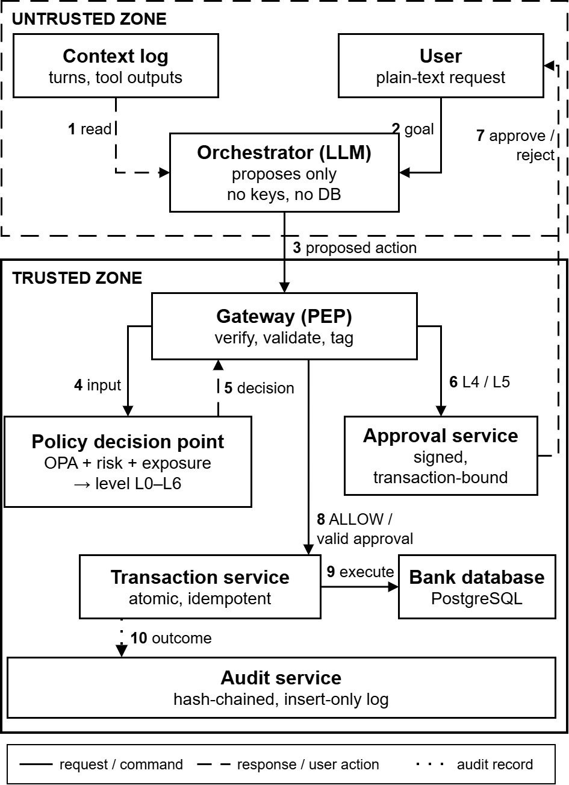
Figure 5.1. Proposed working flow and trust boundaries of the Agentic AI Banking Guardian
The decision function is A = f (U, G, a, π(a), P, R, H, C), where U is the human principal, G the delegation chain, a the proposed action, π(a) the provenance of its arguments, P user and system policy, R the risk result, H the cumulative history in the active window and C session assurance and beneficiary state. Delegation tokens are attenuation-only, in the style of macaroons [29]: a child's scope can only narrow its parent. Approval binding follows the dynamic-linking principle used in strong customer authentication [30], [31].
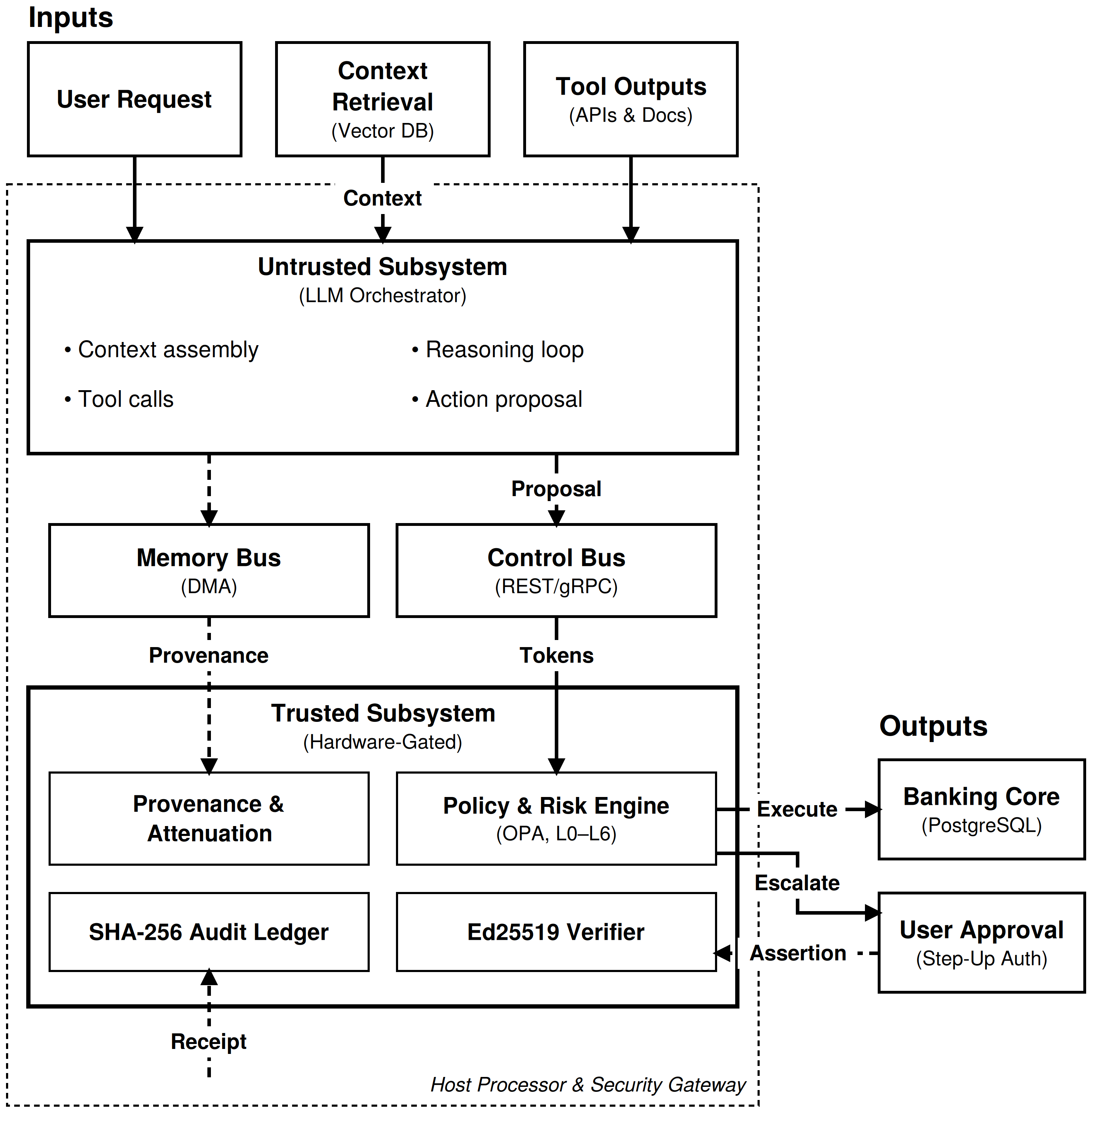Figure 5.2. Proposed working flow and system architecture of the Agentic AI Banking Guardian
  - Risk-Adaptive Autonomy Levels
Table 5.1 lists the autonomy levels. The required level is the maximum of the policy, provenance, risk and cumulative levels, so adding risk or untrusted provenance can never lower it. Any argument labelled DERIVED or lower forces at least L4, and an untrusted payee or destination forces L5. Risk is a transparent weighted score over documented features (amount against the 30-day median, beneficiary age, time of day, session assurance, 24-hour velocity, utilisation of daily and weekly caps). Weights are tuned on the development split only, frozen before final runs and tested by a plus or minus 25% sensitivity analysis.
Provenance labels are ordered from most to least trusted: CONFIRMED (shown to the user as a structured field and explicitly confirmed), TYPED (entered by the user in the current session), DERIVED (computed or copied from system data or from another labelled value) and UNTRUSTED (taken from any text the agent read, such as a bill, document, tool output or memory). A value takes the lowest label of any input it was built from. Matching rules for obfuscated or paraphrased values (attack class A3b) are versioned and evaluated.
Table 5.1. Autonomy levels
Level | Mode | Control
L0 | Informational | No state change
L1 | Recommendation | No execution authority
L2 | Preparation | Draft only; execution gated
L3 | Low-risk autonomous | Only if every check passes and provenance is user-typed or higher
L4 | User confirmation | Exact transaction shown on a screen built from structured fields only
L5 | Strong approval | Step-up authentication and/or designated approver
L6 | Block | No execution path

  - Database Design and ER Diagram
The simulated bank uses PostgreSQL. Figure 5.3 shows the entity-relationship diagram and Table 5.2 the normalised relational design. All tables are in third normal form: every non-key attribute depends on the key, the whole key and nothing but the key. Policy limits are stored per policy version, and balances are held only in accounts. The JSON columns in the risk, action, and audit tables are a deliberate exception: they store immutable evidence of snapshots.
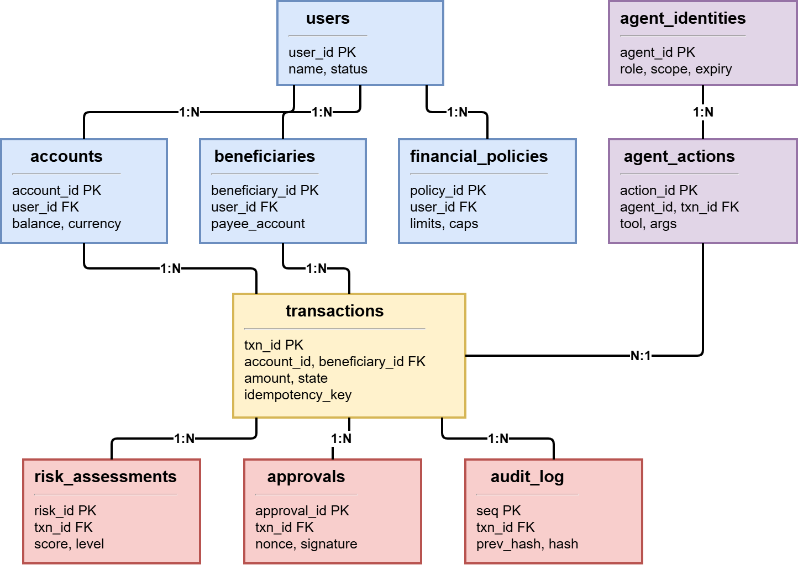
Figure 5.3. Entity-relationship diagram of the simulated banking and security database
Table 5.2. Normalised relational design (primary keys underlined in Figure 5.3)
Table | Primary key | Main attributes and foreign keys
users | user_id | name, status, session_assurance
accounts | account_id | user_id (FK), balance, currency, row version
beneficiaries | beneficiary_id | user_id (FK), payee_account, verified, added_at
financial_policies | policy_id | user_id (FK), version, limits, minimum balance, caps
agent_identities | agent_id | role, public key, parent delegation (FK), scope, expiry
transactions | txn_id | account_id and beneficiary_id (FK), amount, state, version, idempotency key (unique per user)
risk_assessments | risk_id | txn_id (FK), score, level, features, provenance labels
approvals | approval_id | txn_id (FK), nonce, signature, expiry, used
agent_actions | action_id | agent_id and txn_id (FK), tool, arguments, delegation chain
audit_log | seq (insert-only) | txn_id (FK), decision receipt, previous hash, hash

  - Threat Model Summary
The threat model uses STRIDE over the data-flow diagram and follows a risk-based approach consistent with the NIST AI RMF [32]. Table 5.3 lists the attack classes that become benchmark scenario families.
Table 5.3. Attack classes used in the benchmark
ID | Attack class | Example
A1 | Direct injection | User text tells the agent to ignore policy and transfer funds
A2 | Indirect injection | Malicious bill or retrieved text triggers a transfer
A3 | In-envelope injection | Injected payee or amount swap within limits that the user confirms
A3b | Provenance evasion | Obfuscated or paraphrased values to defeat origin matching
A4 | Structuring | Repeated transfers each below the limit
A5 | Persistence | Blocked agent reformulates or retries to evade
A6 | Memory poisoning | Malicious entry persisted across sessions
A7 | Tool poisoning | Malicious tool description or output
A8 | Exfiltration | Data leaked through tool arguments or memo fields
A9 | Integrity | Approval mutation, replay, race, forged binding
A10 | Delegation abuse | Forged or widened token, agent impersonation
A11 | Compromised component | Arbitrary calls from a compromised executor
A12 | Insider | Audit tampering, key access, policy edits
A13 | Misconfigured policy | Conflicting or unsafe user policy

- Testing and Evaluation
This is a research project, so testing validates the scientific accuracy and robustness of the proposed layer against baseline solutions, in addition to ordinary software testing (unit and integration tests with pytest, property-based tests with Hypothesis).
  - Experimental Dataset and Split
The benchmark combines the AgentDojo banking suite [7] with at least 300 custom scenarios in at least 12 families (normal, policy boundary, contextual risk, attack classes A1 to A13, failure and recovery). Families, not templated variants, are the unit of independence. Scenarios are split into a development split (about 40%) for design and tuning, and a held-out test split (about 60%) that is frozen and run once. A second person outside the team labels at least 25% of scenarios independently, and Cohen's kappa is reported. At least three LLMs are used (one local open-weight model and two API-hosted), with at least 10 runs per stochastic scenario, and at least 1,000 fuzzed and concurrent runs for integrity tests.

  - Baselines and Ablations
Table 6.1. Compared configurations
ID | Configuration | Purpose
B0 | Unrestricted agent | Lower bound
B1 | Role-based access control only | Conventional access control
B2 | Static per-transaction limits with uniform confirmation | Realistic industry baseline
B3 | Detection-based guardrail (injection classifier, spotlighting-style prompting) | Detection family
B4 | Plan-then-execute, CaMeL-inspired (simplified re-implementation) | Architectural family
C | Full proposed system | Proposed
C-1 to C-7 | Remove one control: delegation, policy, provenance, risk, cumulative state, approval signing, idempotency | Marginal contribution

  - Quantitative Performance Metrics
Table 6.2. Evaluation metrics
Metric | Definition
Attack success rate (ASR) | Successful security-impacting attack trials divided by attack trials, per attack class
In-envelope ASR (IE-ASR) | ASR over A3, A3b and A4, where every rule-based check passes
Cumulative loss L(B) | Simulated funds diverted by an attacker with query budget B
Integrity violations | Approval-bypass and duplicate executions in fuzzed runs (95% upper bound reported)
Task completion rate | Benign tasks completed correctly against ground truth; also, under attack
Escalation burden | Confirmations and step-ups per benign task; over-block rate
Decision accuracy, precision, recall, F1 | Allow, escalate or deny correctness on the independently labelled subset
Blast radius | Maximum permitted scope and loss after single-component compromise
System efficiency | p50 and p95 control-plane latency, end-to-end latency, tokens per task

  - Hypotheses, Ablation and Statistical Analysis
Table 6.3 states the hypotheses so that each can fail. Ablations remove one control at a time to measure its contribution, and results are compared with baselines B0 to B4 on identical scenarios. For statistics, exact confidence intervals (Wilson or Clopper-Pearson [33]) are reported for proportions, and the rule of three [34] gives the 95% upper bound when zero events are observed. Paired comparisons use McNemar's test or a paired bootstrap resampled by scenario family, with Holm correction, and non-inferiority tests use a margin set in advance. The analysis plan is committed to version control before the held-out run.
Table 6.3. Research hypotheses
ID | Hypothesis | Falsified if
H1 | Under adaptive attack at a fixed budget, the full system has IE-ASR at least 50% lower (relative) than B2 | Reduction below 50% or confidence interval includes 0
H2 | Full system has lower ASR than B3 and B4 on indirect and in-envelope classes, with escalation burden at most 1.5 times B2 | Either comparison fails
H3 | Provenance-conditioned escalation is non-inferior to uniform step-up on IE-ASR with lower escalation burden | Margin violated or burden not lower
H4 | The adaptive attacker finds at least one bypass family not covered by the static suite | None found at the stated budget (reported as positive for the system)
H5 | Compromising one component exposes at most its delegated scope (stated as verification, partly true by construction) | Exposed scope exceeds delegation
H6 | Fuzzed and concurrent runs show zero approval-bypass and duplicate executions; an unkeyed-hash binding variant is defeated | Any violation, or variant not defeated
H7 | Control-plane p95 latency is below 50 ms, so LLM inference dominates end-to-end time | p95 at or above 50 ms

- Project Scope
Included. A simulated retail banking environment on synthetic users and accounts; one agent that plans and uses tools; the authorization, approval and audit layer; a benchmark of normal and adversarial scenarios; baselines and ablations; static and adaptive attackers; and a statistical analysis with a research paper.
Not included. Real money or live payment systems; integration with any bank's core systems; claims of regulatory certification or compliance; training a new language model; production-grade key hardware or enterprise monitoring; a full customer-facing banking application; and multi-agent role decomposition.
Assumptions. All data is synthetic. The language models are used as provided and are not retrained. Results describe the simulated environment and models tested and are not a guarantee of safety in a real bank. The user's financial policy is assumed to be correctly stated except where a scenario family deliberately tests misconfiguration.
- Feasibility Study
With this scope, the project fits the schedule. FYP-I (14 October to January) delivers the threat model, formal specification, evaluation plan, simulated bank, and the authorization core. FYP-II (February to May) delivers the remaining controls, agent integration, benchmark, adaptive attacker, final experiments and report. If the schedule slips, work is cut in this order: formal state-machine model, third LLM, memory-poisoning class. The baselines B2 to B4, provenance tagging, adaptive attacker, held-out evaluation and statistics are never cut.
i. Risks involved
Table 8.1. Risks and mitigation
Risk | How it will be handled
Scope too large for three students | Single technology stack, task leaders and assistants, monthly gates, defined cut order
Provenance matching is too weak or too strict | Measured as attack class A3b and reported honestly; normalisation rules versioned
Results look good only because baselines are weak | Strong baselines B2 to B4, adaptive attacker, external AgentDojo suite, several models and statistics
LLM nondeterminism, API cost and rate limits | Fixed temperature, at least 10 runs, local open-weight model for bulk runs, planned budget
AgentDojo integration problems | Integrate early in FYP-II; fall back to a documented subset
New overlapping papers appear | Monthly literature check; positioning updated; closest works compared where code exists
Skills gaps within the team | Prerequisites consolidated during the literature survey; every task has a leader and an assistant

ii. Resource requirements. Three development computers, a GPU (local workstation or rented, to be decided by the team and supervisor) for open-weight model inference, internet access and a small API budget for hosted models, and free open-source software. No external data collection is needed because all data is synthetic.
- Solution Application Areas
The primary beneficiary is the AI-security research community, which gets a reproducible benchmark, an adaptive attack harness, and measured evidence about residual risk in payment agents. The design is directly relevant to digital banks, fintech companies and payment institutions regulated by the State Bank of Pakistan that plan to offer agentic assistants [5], because it shows what an authorization layer can and cannot guarantee. It also informs enterprise teams who give AI agents access to state-changing tools, and the open-source reference implementation can serve as teaching material.
- Tools/Technology
The project uses Python 3.12 with FastAPI for the gateway, approval, transaction and audit services; Open Policy Agent (Rego) for declarative policy; PostgreSQL with serializable transactions; attenuable signed tokens (Ed25519); a plain tool-calling loop or LangGraph for the agent; AgentDojo for the external benchmark; pytest and Hypothesis for testing; Docker Compose for reproducible deployment; and pandas, SciPy and Matplotlib for analysis. A minimal React or server-rendered page provides the approval screen. Hardware and software are listed in the next section.
- Required Hardware & Software
  - Hardware
- Development PCs (3): modern multi-core CPU, at least 16 GB RAM, 512 GB SSD, Windows 10 or later or Linux
- GPU for local open-weight LLM inference: local workstation or rented GPU
- Experiment host: one machine able to run Docker Compose with the full-service stack and PostgreSQL
- Internet connection for API-hosted LLMs and package installation
  - Software
- Python 3.12, FastAPI, SQLAlchemy, pytest, Hypothesis, pandas, SciPy, statsmodels, Matplotlib
- PostgreSQL, Open Policy Agent (Rego), Docker and Docker Compose
- AgentDojo, LangGraph (optional), a local LLM runtime for open-weight models, and API access to hosted LLMs
- React (minimal approval screen), Git and GitHub, Zotero for references, VS Code, Microsoft Word and Excel
- Expertise of the Team Members
Each member leads one technical area and assists in the others, so that every task has a leader and an assistant. The team will consolidate prerequisite knowledge in each area during the literature survey phase.
Muhammad Khubaib Naveed (23-CS-14): Leads delegation tokens and key management, signed transaction-bound approval, the audit hash chain, and the formal model of safety properties.
Raja Qasim Ali (23-CS-48): Leads the threat model, gateway and process isolation, the policy, risk and cumulative-exposure engine, the simulated bank and database, attack scenarios and integrity fuzzing.
Talha Abid (23-CS-33): Leads the agent and LLM integration, provenance tagging, baselines B0 to B4, AgentDojo integration, the adaptive attacker, and statistical analysis.
Table 12.1 gives the distribution of work (● leader, ○ assistant).
Table 12.1. Distribution of work
S# | Task | Khubaib | Talha | Raja
1 | Literature survey and gap analysis | ○ | ● | ○
2 | Threat model and security requirements | ○ | ○ | ●
3 | Formal model and safety properties | ● | ○ | ○
4 | Evaluation plan (hypotheses, metrics, splits) | ○ | ● | ○
5 | Write the proposal | ● | ○ | ○
6 | Design the simulated bank and database | ○ | ○ | ●
7 | Build the simulated bank and database | ○ | ○ | ●
8 | Develop delegation tokens and key management | ● | ○ | ○
9 | Develop the gateway and process isolation | ○ | ○ | ●
10 | Develop policy, risk and cumulative-exposure engine | ○ | ○ | ●
11 | Develop provenance tagging | ○ | ● | ○
12 | Develop signed approval service and approval screen | ● | ○ | ○
13 | Develop atomic execution, idempotency and state machine | ● | ○ | ○
14 | Develop the tamper-evident audit chain | ● | ○ | ○
15 | Develop the agent runner and LLM integration | ○ | ● | ○
16 | Implement baselines B0 to B4 | ○ | ● | ○
17 | Integrate the AgentDojo banking suite | ○ | ● | ○
18 | Build the custom benchmark scenarios | ○ | ○ | ●
19 | Integrity fuzzing and property-based tests | ○ | ○ | ●
20 | Develop the adaptive attacker | ○ | ● | ○
21 | Independent labelling and benchmark freeze | ○ | ○ | ●
22 | Final experiments, ablations and statistics | ○ | ● | ○
23 | Write mid-term and monthly reports | ● | ○ | ○
24 | Write the final report and research manuscript | ● | ○ | ○
25 | Prepare the presentation and demonstration | ○ | ● | ○
26 | Design the project poster | ○ | ○ | ●

- Milestones
Table 13.1 lists the major milestones, and the Gantt chart in Table 13.2 shows the schedule of all tasks. FYP-I runs from 14 October 2026 to January 2027 and FYP-II from February to May 2027.
Table 13.1. Major milestones
When | Milestone | Evidence
Oct 2026 | Proposal approved; literature survey, threat modelling and monthly reporting started | Approved proposal
Nov 2026 | Threat model and security requirements complete; bank and database designed; evaluation plan drafted | Threat model and requirements documents
Dec 2026 | Formal model, safety properties and evaluation plan complete; literature survey and gap analysis closed | Specification and plan documents
Jan 2027 | Simulated bank built; authorization core prototype (delegation tokens, gateway, initial policy checks) demonstrated independently of any LLM; FYP-I presentation and Final-term report | Demo and Final-term report
Feb 2027 | Delegation tokens, gateway and process isolation, and policy, risk and cumulative-exposure engine complete; provenance tagging complete | Test results and code review
Mar 2027 | Control layer complete (signed approval, atomic execution, audit chain); agent runner integrated with LLMs; tamper, replay and race tests fail safe | Test results
Apr 2027 | Baselines B0 to B4, AgentDojo integration, custom scenarios and adaptive attacker complete; independent labelling done; benchmark and analysis plan frozen | Frozen repository tag
May 2027 | Integrity fuzzing and final held-out experiments, ablations and statistics complete; final report, manuscript, poster and demonstration delivered | Results dataset and plots; report, paper, artifact

13.1 GANTT Chart
Table 13.2. GANTT chart (FYP-I: Oct to Jan, FYP-II: Feb to May)
Task | Oct | Nov | Dec | Jan | Feb | Mar | Apr | May
Literature survey and gap analysis
Threat model and security requirements
Formal model and safety properties
Evaluation plan
Write the proposal
Design bank and database
Build bank and database
Delegation tokens and keys
Gateway and process isolation
Policy, risk and cumulative engine
Provenance tagging
Signed approval service and screen
Atomic execution and state machine
Tamper-evident audit chain
Agent runner and LLM integration
Baselines B0 to B4
AgentDojo integration
Custom benchmark scenarios
Integrity fuzzing and property tests
Adaptive attacker
Independent labelling and freeze
Final experiments and statistics
Monthly reports
Final report and manuscript
Presentation and demonstration
Project poster

- References
[1] OWASP GenAI Security Project. "OWASP Top 10 for Agentic Applications." December 2025. https://genai.owasp.org/.
[2] OWASP GenAI Security Project. "LLM06:2025 Excessive Agency." 2025. https://genai.owasp.org/llmrisk/llm062025-excessive-agency/.
[3] Booth, H., B. Fisher, R. Galluzzo, and J. Roberts. "Accelerating the adoption of software and AI agent identity and authorization." NIST National Cybersecurity Center of Excellence, Concept Paper (initial public draft), February 2026. https://www.nccoe.nist.gov/projects/software-and-ai-agent-identity-and-authorization.
[4] Aldasoro, I., and A. Desai. "AI agents for cash management in payment systems." BIS Working Papers, no. 1310. Bank for International Settlements, November 2025. https://www.bis.org/publ/work1310.htm.
[5] State Bank of Pakistan. "Technology risk management framework for payment institutions." PSP&OD Circular No. 04 of 2025, October 2025. https://www.sbp.org.pk/circulars/pspod-circular-no-04-of-2025.
[6] Greshake, K., S. Abdelnabi, S. Mishra, C. Endres, T. Holz, and M. Fritz. "Not what you've signed up for: Compromising real-world LLM-integrated applications with indirect prompt injection." In Proceedings of the 16th ACM Workshop on Artificial Intelligence and Security (AISec), 2023.
[7] Debenedetti, E., J. Zhang, M. Balunovic, L. Beurer-Kellner, M. Fischer, and F. Tramèr. "AgentDojo: A dynamic environment to evaluate prompt injection attacks and defenses for LLM agents." In Advances in Neural Information Processing Systems (NeurIPS), Datasets and Benchmarks Track 37, 2024.
[8] Debenedetti, E., et al. "Defeating prompt injections by design." arXiv preprint arXiv:2503.18813 (2025).
[9] Shi, T., et al. "Progent: Programmable privilege control for LLM agents." arXiv preprint arXiv:2504.11703 (2025).
[10] Liu, Y., Y. Jia, R. Geng, J. Jia, and N. Z. Gong. "Formalizing and benchmarking prompt injection attacks and defenses." In Proceedings of the 33rd USENIX Security Symposium, 1831-1847. Philadelphia, PA, 2024.
[11] Zhan, Q., Z. Liang, Z. Ying, and D. Kang. "InjecAgent: Benchmarking indirect prompt injections in tool-integrated large language model agents." In Findings of the Association for Computational Linguistics: ACL 2024, 2024.
[12] Zhang, H., et al. "Agent Security Bench (ASB): Formalizing and benchmarking attacks and defenses in LLM-based agents." In Proceedings of the International Conference on Learning Representations (ICLR), 2025.
[13] Chen, Z., Z. Xiang, C. Xiao, D. Song, and B. Li. "AgentPoison: Red-teaming LLM agents via poisoning memory or knowledge bases." In Advances in Neural Information Processing Systems (NeurIPS) 37, 2024.
[14] Hines, K., et al. "Defending against indirect prompt injection attacks with spotlighting." arXiv preprint arXiv:2403.14720 (2024).
[15] Chen, S., J. Piet, C. Sitawarin, and D. Wagner. "StruQ: Defending against prompt injection with structured queries." In Proceedings of the 34th USENIX Security Symposium, 2383-2400. 2025.
[16] Chennabasappa, S., et al. "LlamaFirewall: An open-source guardrail system for building secure AI agents." arXiv preprint arXiv:2505.03574 (2025).
[17] Jia, F., T. Wu, X. Qin, and A. Squicciarini. "The Task Shield: Enforcing task alignment to defend against indirect prompt injection in LLM agents." In Proceedings of the 63rd Annual Meeting of the Association for Computational Linguistics (ACL), 2025.
[18] He, Y., et al. "AttriGuard: Defeating indirect prompt injection in LLM agents via causal attribution of tool invocations." In Proceedings of the 35th USENIX Security Symposium. Baltimore, MD, 2026. arXiv preprint arXiv:2603.10749.
[19] Kim, M., et al. "CausalArmor: Efficient indirect prompt injection guardrails via causal attribution." arXiv preprint arXiv:2602.07918 (2026).
[20] Nasr, M., et al. "The attacker moves second: Stronger adaptive attacks bypass defenses against LLM jailbreaks and prompt injections." arXiv preprint arXiv:2510.09023 (2025).
[21] Costa, M., et al. "Securing AI agents with information-flow control." arXiv preprint arXiv:2505.23643 (2025).
[22] Wu, Y., F. Roesner, T. Kohno, N. Zhang, and U. Iqbal. "IsolateGPT: An execution isolation architecture for LLM-based agentic systems." In Proceedings of the Network and Distributed System Security Symposium (NDSS), 2025.
[23] Beurer-Kellner, L., et al. "Design patterns for securing LLM agents against prompt injections." arXiv preprint arXiv:2506.08837 (2025).
[24] Santos-Grueiro, I. "Temporary authority, permanent effects: Commit-time authorization for LLM agents." arXiv preprint arXiv:2607.10487 (2026).
[25] Zhu, G., and C. Wang. "Intent-governed tool authorization for AI agents." arXiv preprint arXiv:2606.22916 (2026).
[26] Tallam, K. "Authorization propagation in multi-agent AI systems: Identity governance as infrastructure." arXiv preprint arXiv:2605.05440 (2026).
[27] Surapani, R. K., et al. "Authorization architectures for tool-using AI agents." arXiv preprint arXiv:2609.15906 (2026).
[28] Liu, F., et al. "Make agent defeat agent: Automatic detection of taint-style vulnerabilities in LLM-based agents." In Proceedings of the 34th USENIX Security Symposium, 2025.
[29] Birgisson, A., J. G. Politz, Ú. Erlingsson, A. Taly, M. Vrable, and M. Lentczner. "Macaroons: Cookies with contextual caveats for decentralized authorization in the cloud." In Proceedings of the Network and Distributed System Security Symposium (NDSS), 2014.
[30] European Commission. "Commission Delegated Regulation (EU) 2018/389 supplementing Directive (EU) 2015/2366 with regard to regulatory technical standards for strong customer authentication and common and secure open standards of communication." Art. 5 (dynamic linking), 2018.
[31] Lodderstedt, T., J. Richer, and B. Campbell. "OAuth 2.0 Rich Authorization Requests." RFC 9396. IETF, May 2023.
[32] Tabassi, E. "Artificial Intelligence Risk Management Framework (AI RMF 1.0)." NIST AI 100-1. National Institute of Standards and Technology, January 2023. https://doi.org/10.6028/NIST.AI.100-1.
[33] Brown, L. D., T. Cai, and A. DasGupta. "Interval estimation for a binomial proportion." Statistical Science 16, no. 2 (2001): 101-133.
[34] Hanley, J. A., and A. Lippman-Hand. "If nothing goes wrong, is everything all right? Interpreting zero numerators." JAMA 249, no. 13 (1983): 1743-1745.

