CS-340 Module 2 Assignment
CRUD in MongoDB
Matthew Biletnikoff

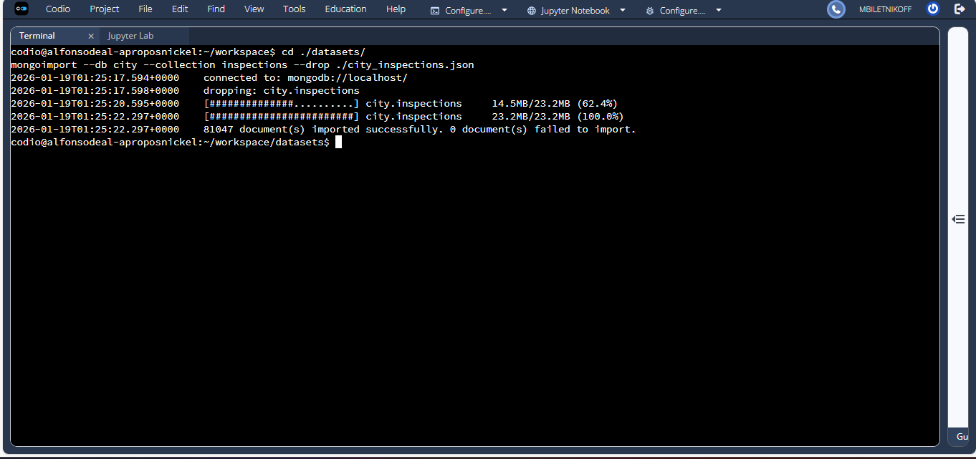
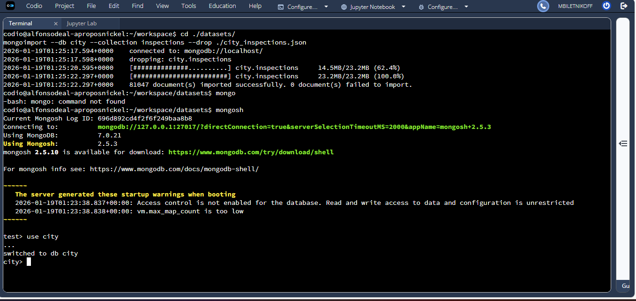
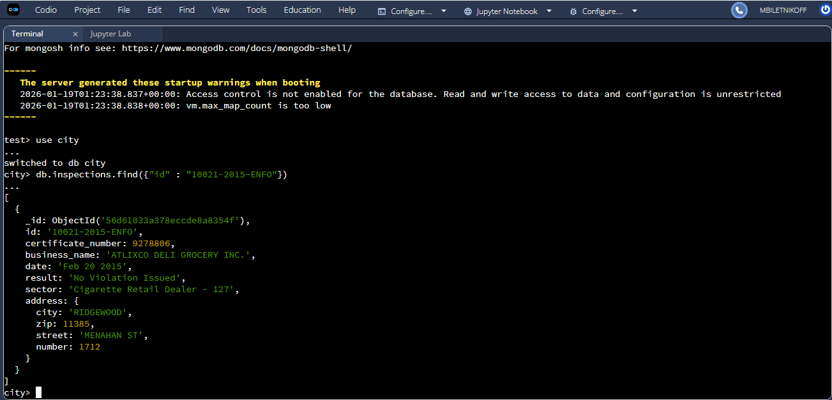
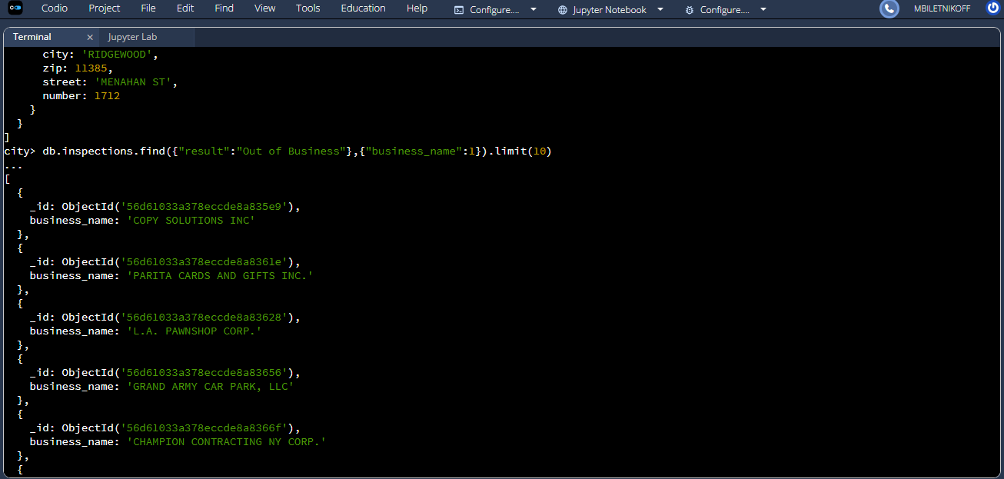
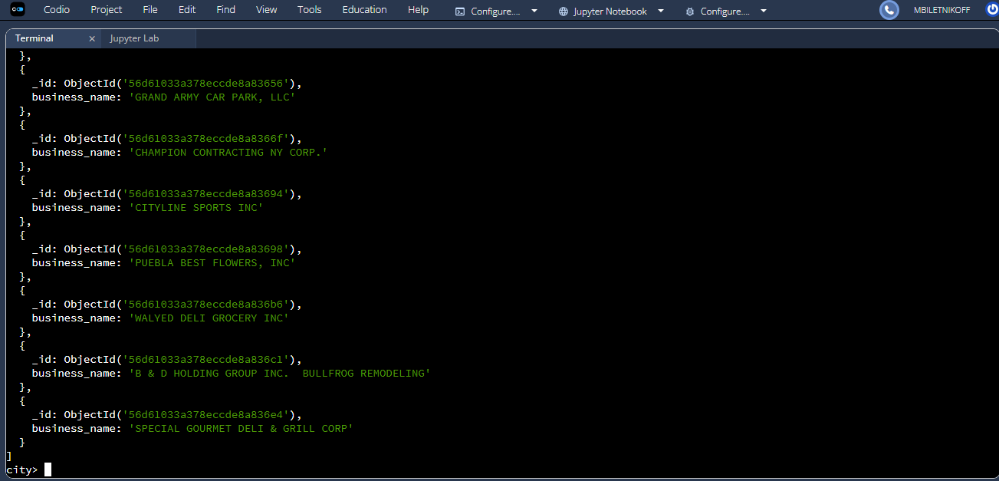
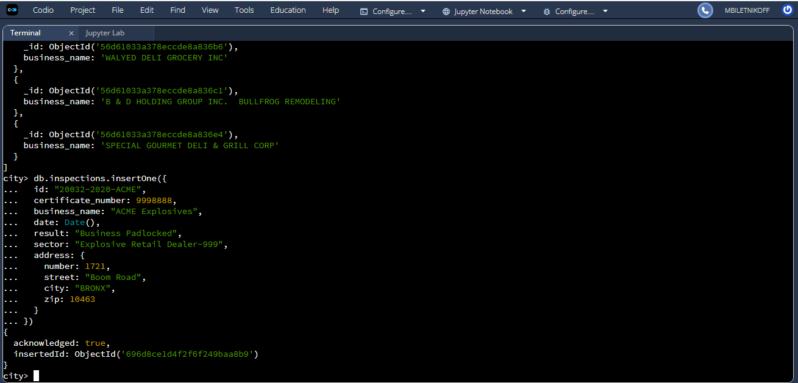
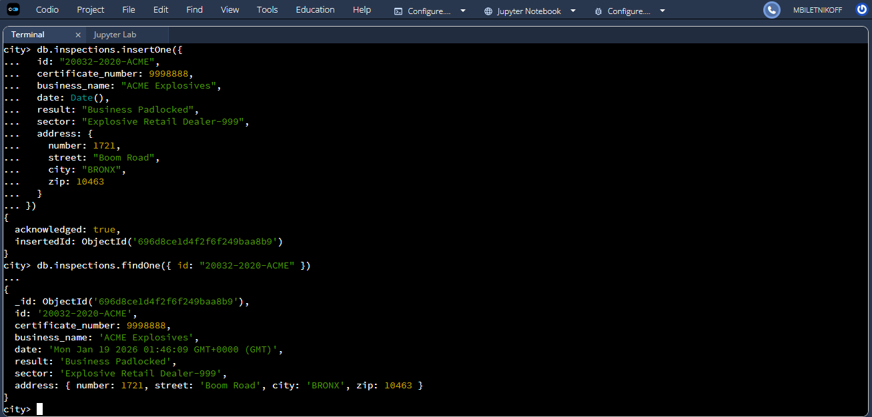
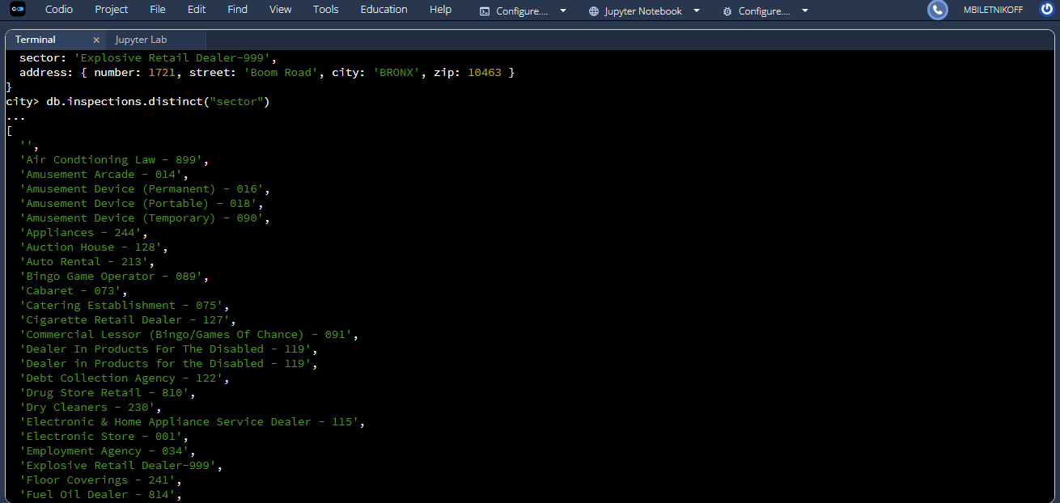
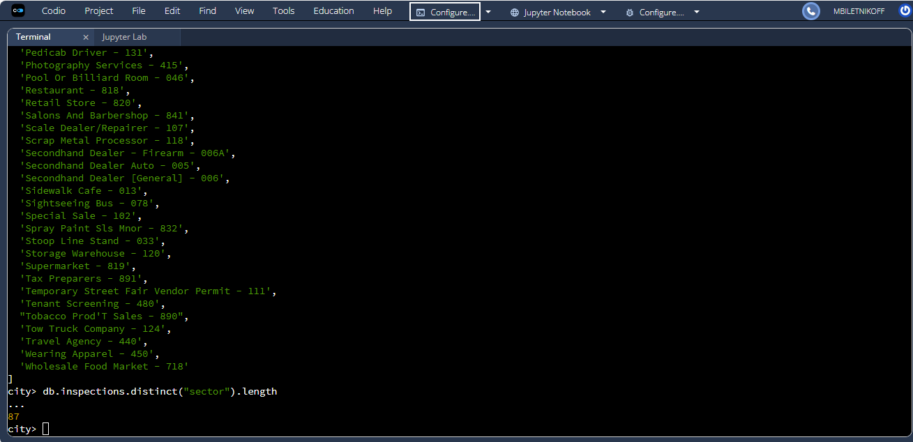
Using the MongoDB distinct() function on the sector field, the inspections collection contains 87 unique inspection sectors. This count was obtained programmatically using MongoDB queries rather than manual counting.
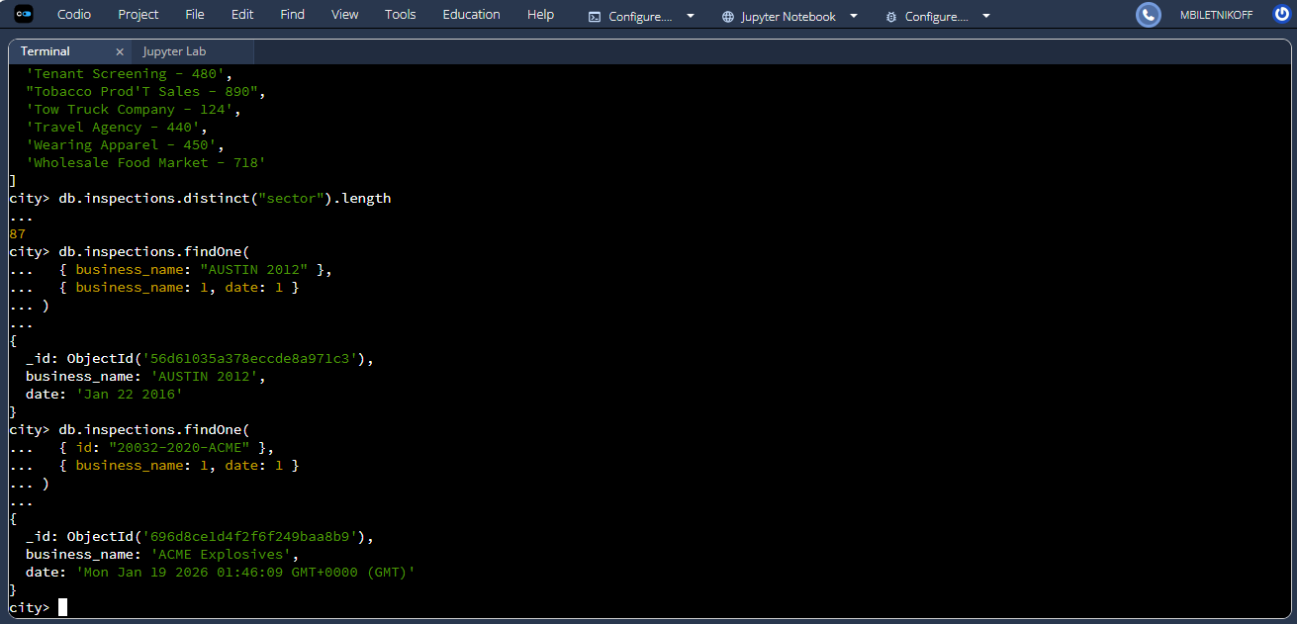
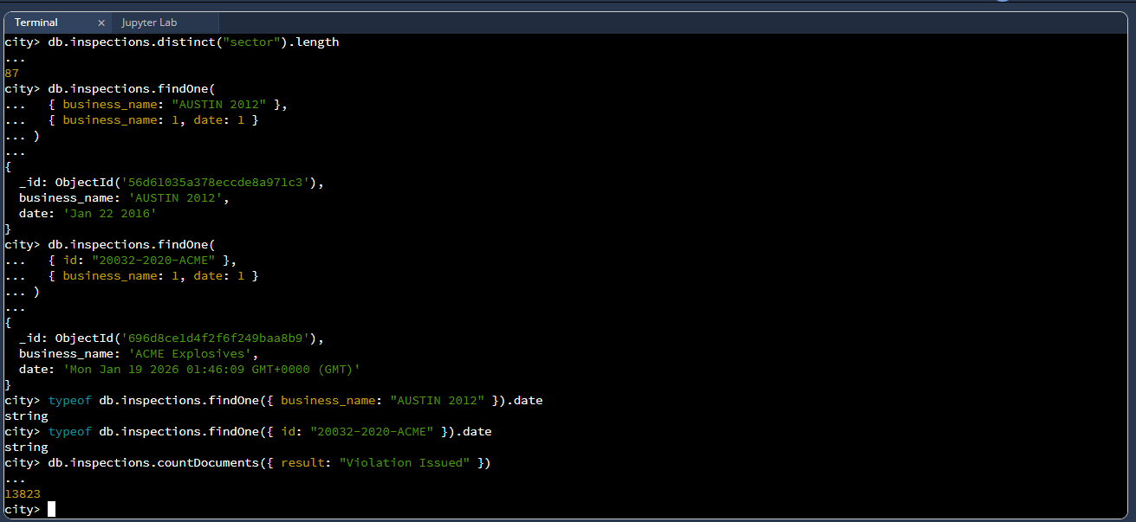
The inspection date for the business named "AUSTIN 2012" is stored as a string value (for example, "Jan 22 2016"). The inspection date for the inserted "ACME Explosives" document, which was created using the Date() function, is also returned as a string when queried in this environment. This was verified using the typeof operator, which returned string for both values.
Using the MongoDB countDocuments() function, there were 13,823 businesses with a result of "Violation Issued" prior to deletion. After removing one document with this result, the total count was reduced to 13,822, confirming the deletion was successful.

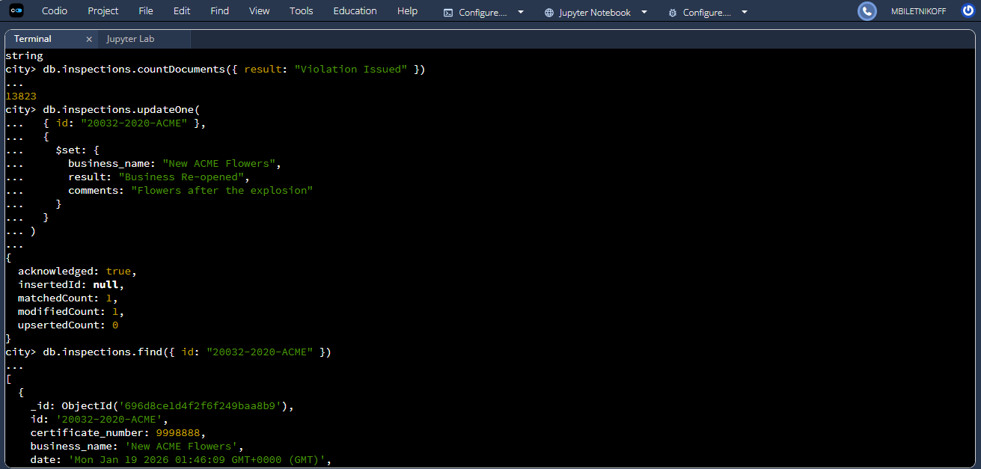
The inspection document with the ID "20032-2020-ACME" was updated using the updateOne() command. The business name was changed to "New ACME Flowers", the inspection result was updated to "Business Re-opened", and a comment stating "Flowers after the explosion" was added. The update was verified by querying the document after modification.

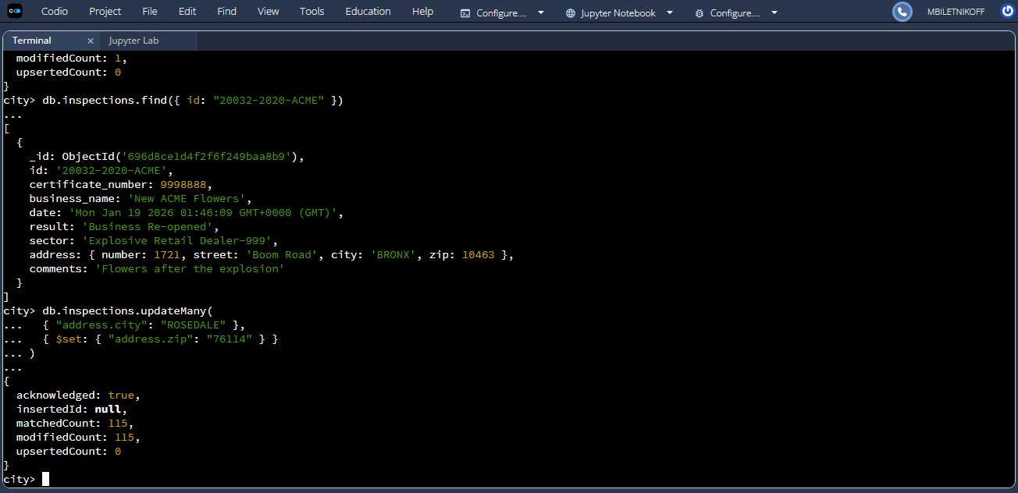
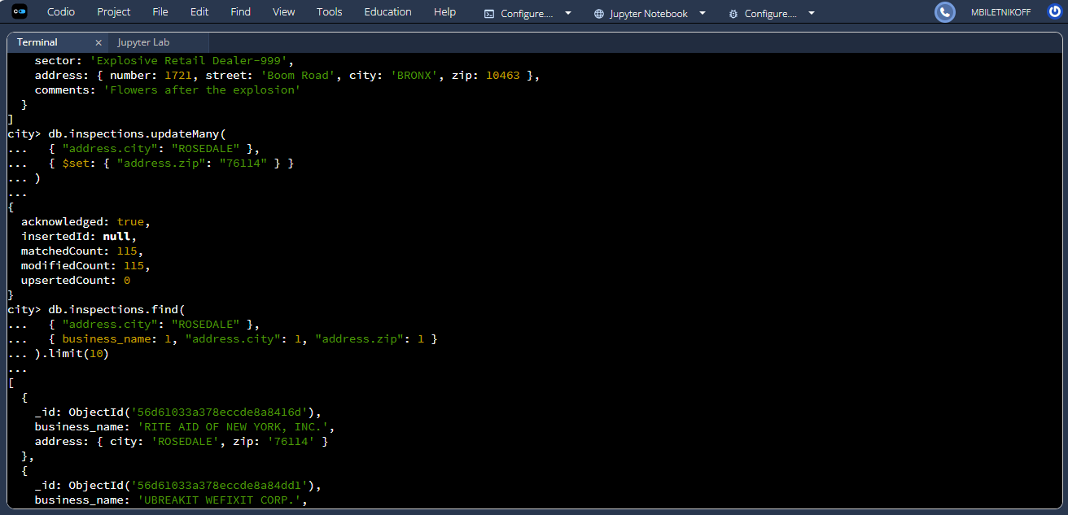
All documents containing "ROSEDALE" in the address.city field were updated using the updateMany() command. The zip code within the address subdocument was changed to "76114" for all matching records. Verification queries confirmed the update was applied correctly.
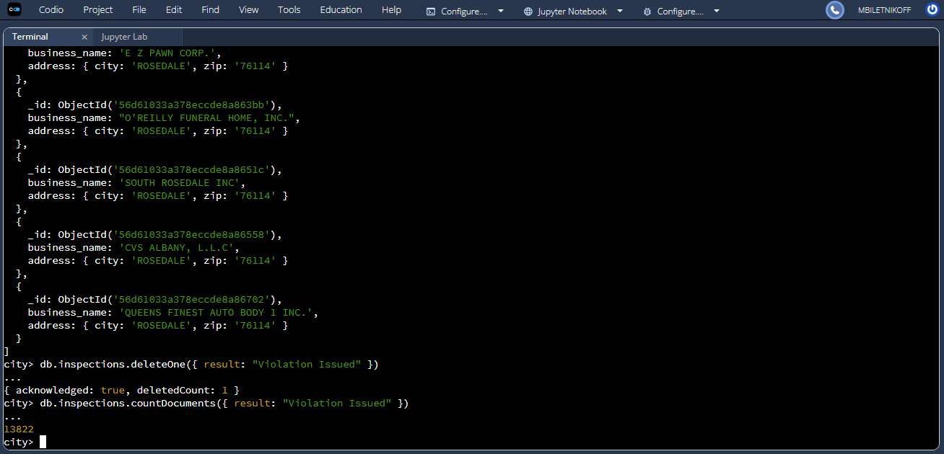
The first document with a result of "Violation Issued" was removed from the inspections collection using the deleteOne() command. The deletion was verified by confirming that the total number of documents with this result decreased by one.

