CS340 Module 3 Milestone
Database Indexing and Authentication
Matthew Biletnikoff

Importing the AAC Shelter Outcomes CSV File into MongoDB
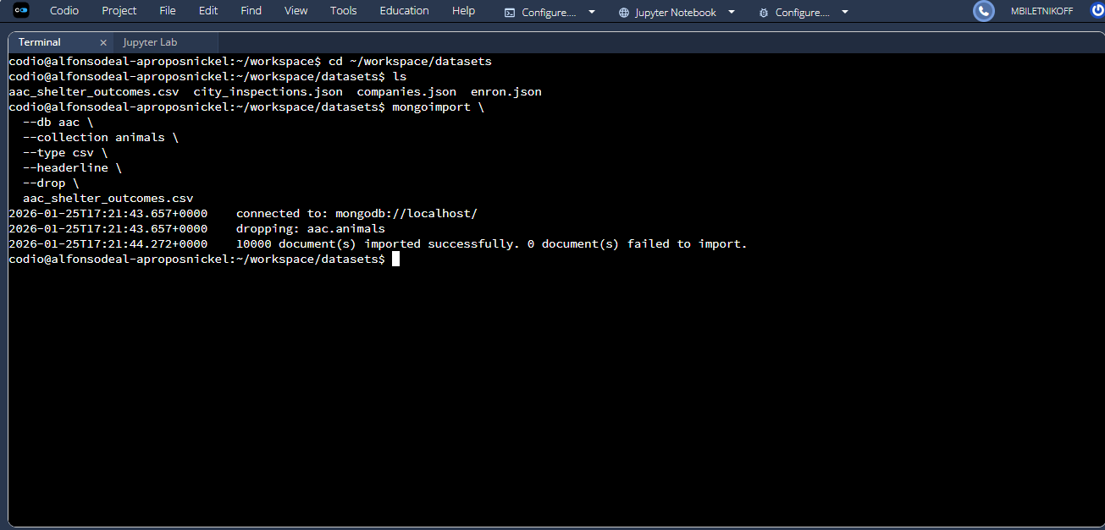
Creating a simple Index on the Breed Field
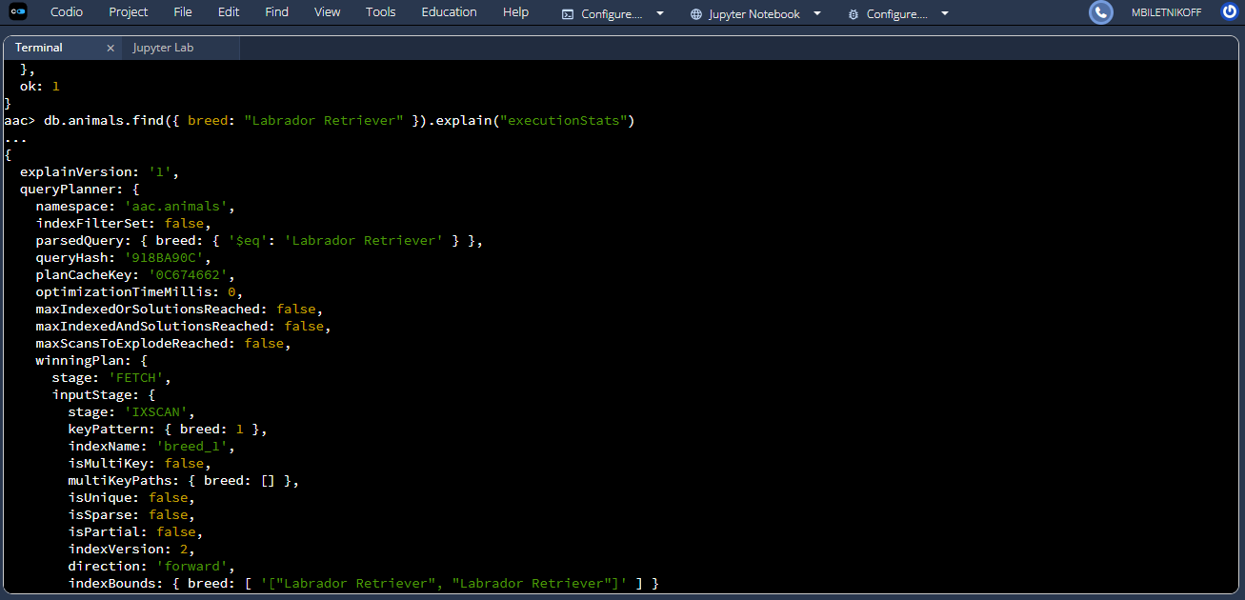
Verifying Simple Index Usage with Explain
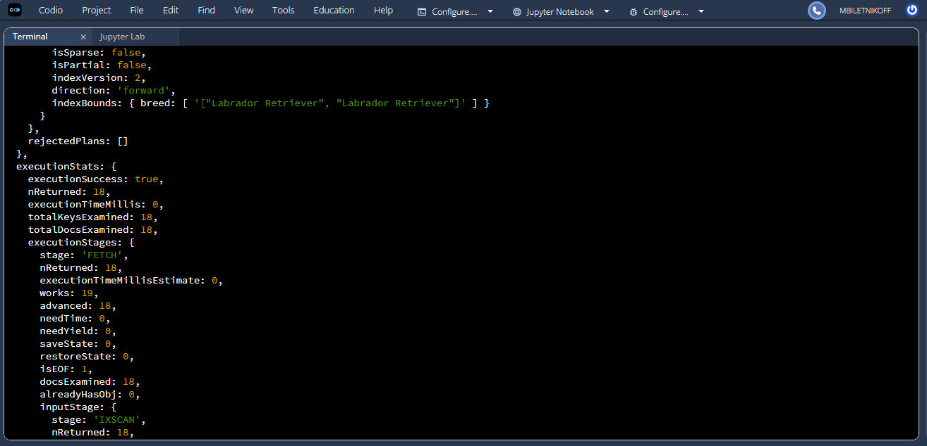
Creating a Compound Index on Breed and Outcome Type
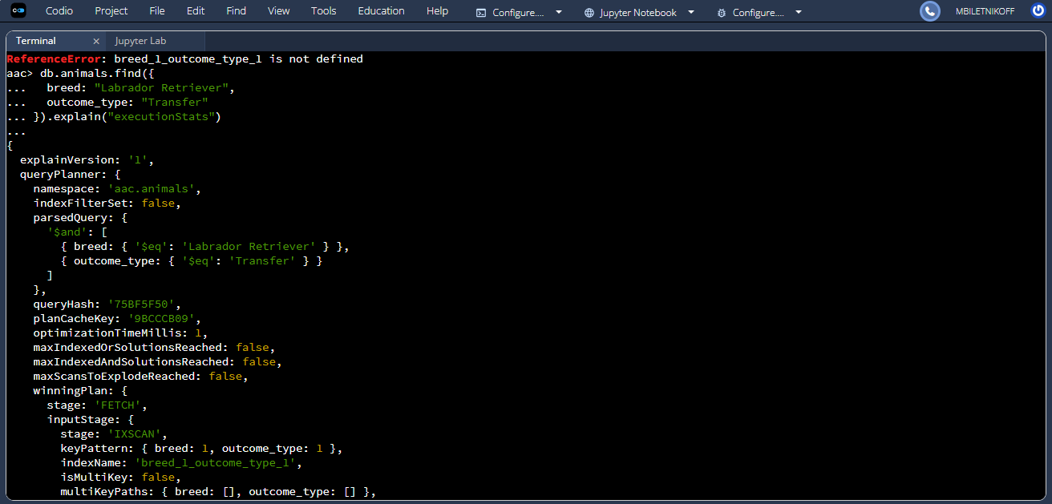

Verifying Compound Index Usage with Explain
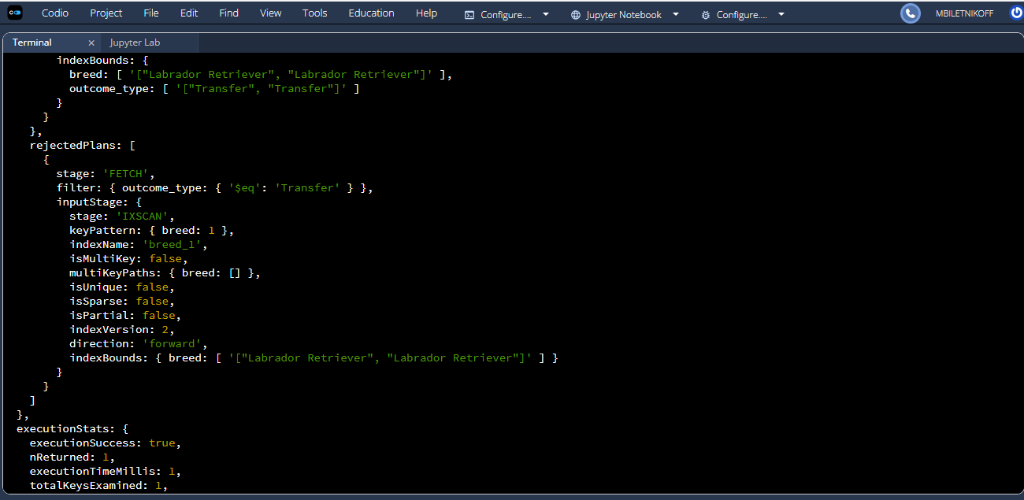
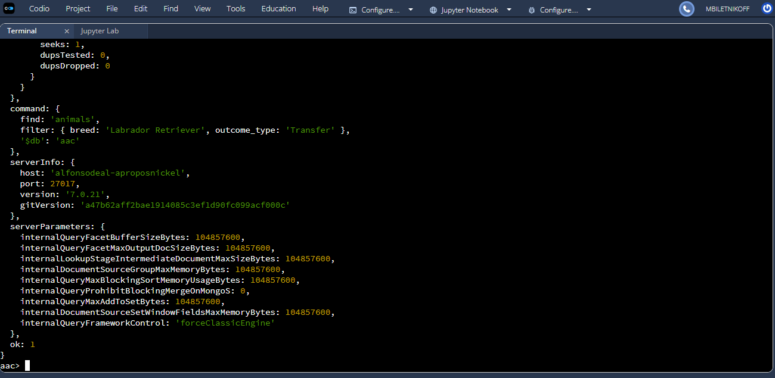

Creating the aacuser Account in the Admin Database
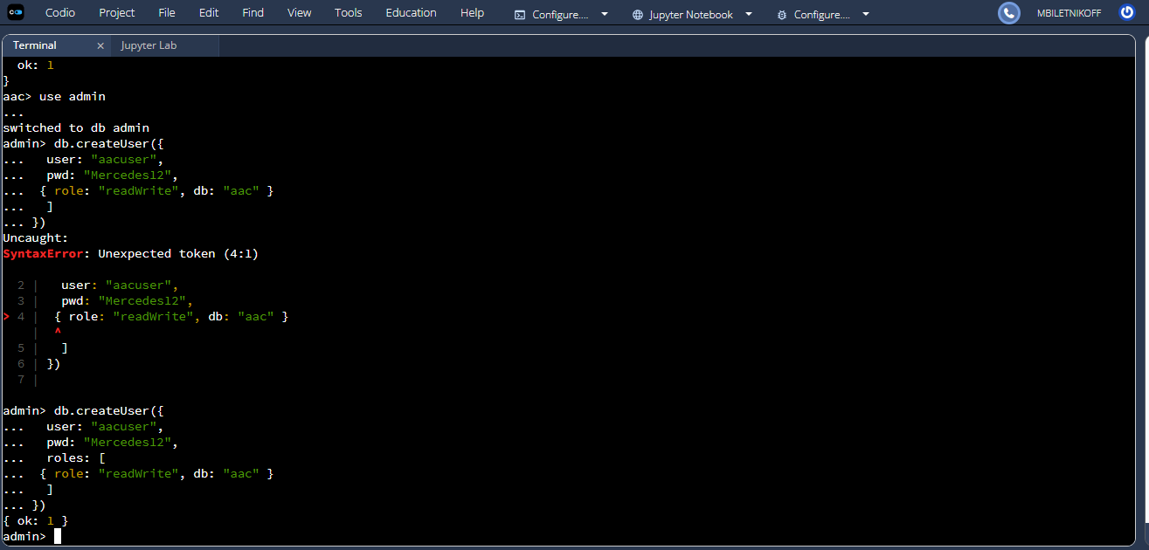
Logging into MongoDB as aacuser
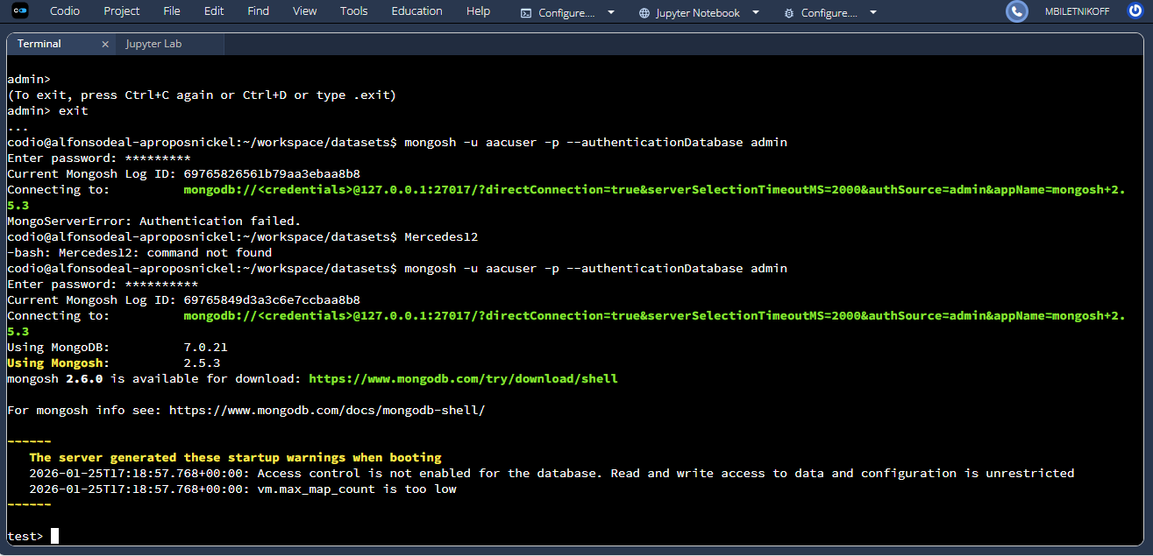

Verifying Database Access for aacuser
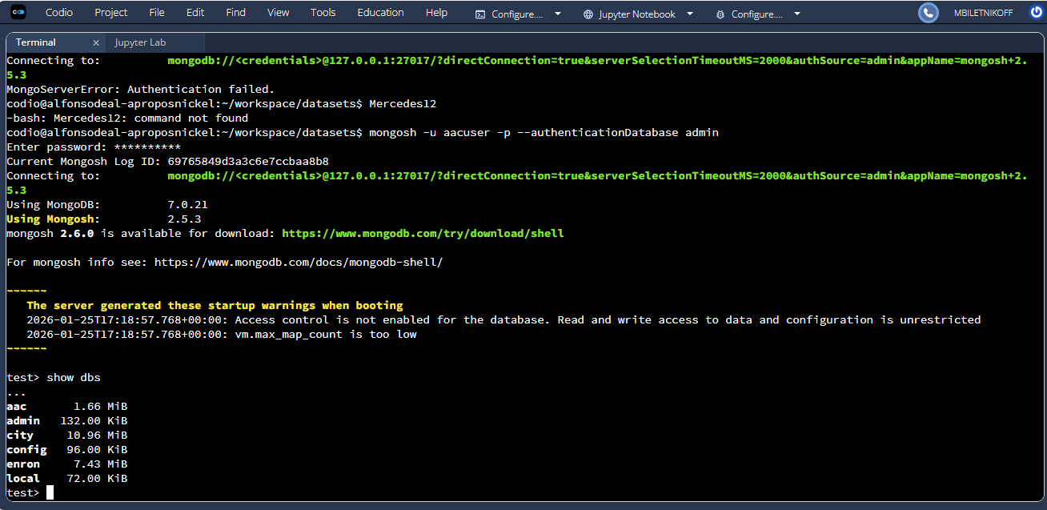
Verifying Authentication Status Using connectionStatus
