CS340 Module 4
Create and Read in Python
Matthew Biletnikoff

Testing CRUD Module Import and Instantiation
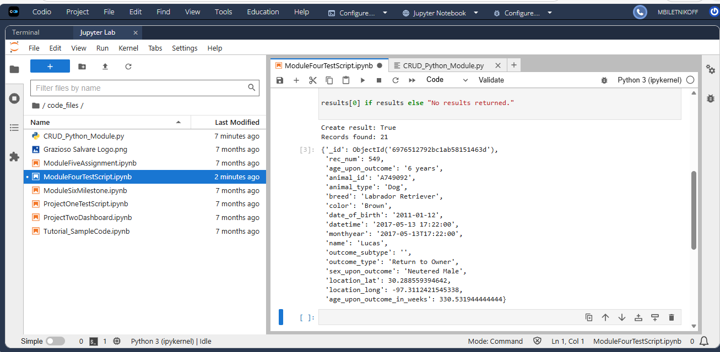
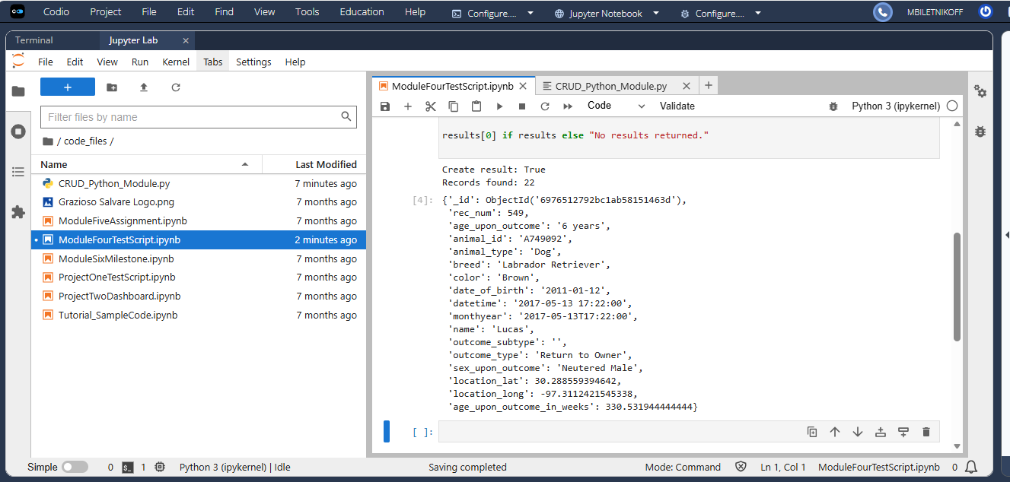
Testing Create Operation Using the CRUD Python Module
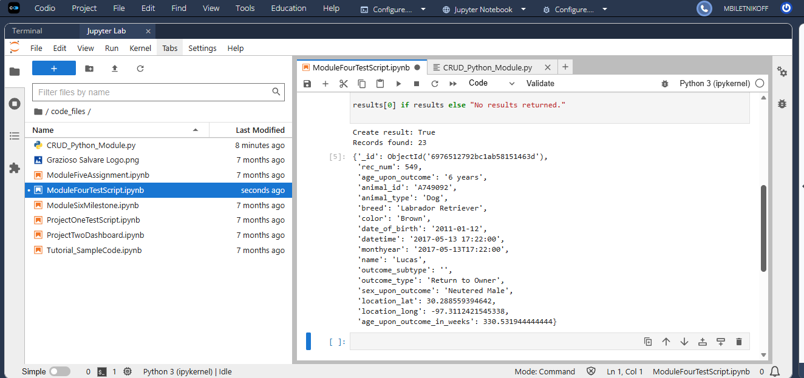
Testing Read Operation Using the CRUD Python Module
