CS 340 – Client/Server Development
Project Two – Grazioso Salvare Rescue Dashboard
Student: Matthew Biletnikoff
Course: CS 340
Instructor: Helen Gebre-Amlak
Date: 2/22/2026

Project Overview
This project enhances the Grazioso Salvare Animal Rescue Dashboard by implementing interactive filtering, dynamic data visualization, and geolocation mapping using a MongoDB backend and a Dash front-end application.
The system allows users to filter animals by rescue type. When a filter is selected, the dashboard dynamically updates:
- The DataTable
- The breed distribution chart
- The geolocation map
The backend is supported by a custom Python CRUD module that connects to MongoDB and retrieves data based on specified query conditions.
Application Startup
The application is launched in Jupyter Notebook using the following command:
app.run_server(mode="inline", port=8050)
Once executed, the dashboard renders directly inside the Jupyter environment.

Initial Dashboard View (Reset – All Records)
When the application loads, the Reset (All) filter is active by default. All animal records are displayed in the DataTable.
Visible components include:
- Grazioso Salvare logo
- Unique identifier: “Matthew Biletnikoff – CS 340 Dashboard”
- Rescue type filter (radio buttons)
- Interactive DataTable (sorting, filtering, pagination enabled)
- Breed distribution chart
- Interactive geolocation map
Figure 1: Dashboard displaying all records (Reset filter selected).
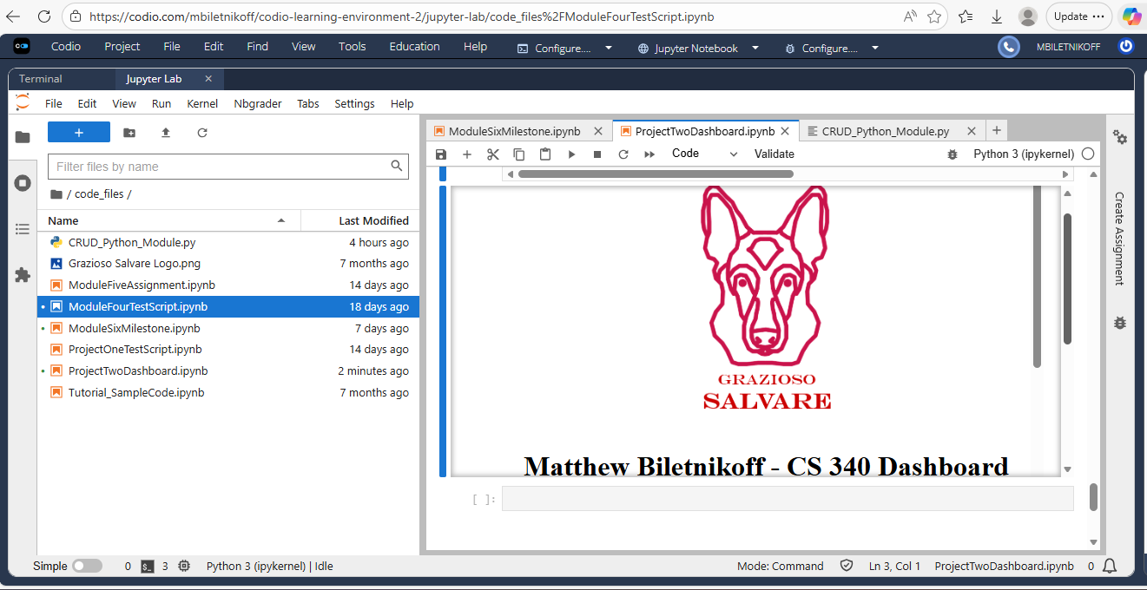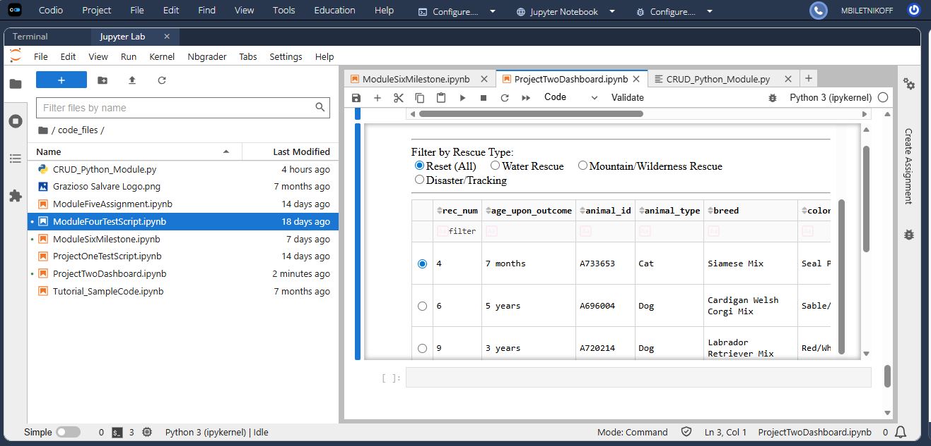
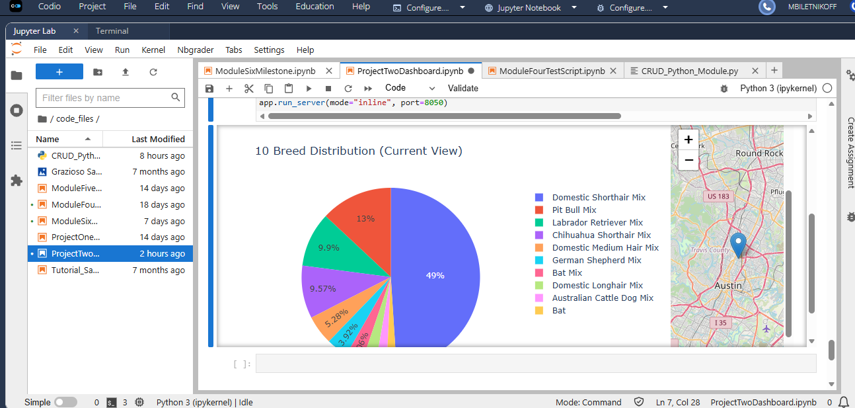
Water Rescue Filter
Query Conditions:
- Animal Type: Dog
- Breed: Labrador Retriever Mix, Chesapeake Bay Retriever, Newfoundland
- Sex: Intact Female
- Age: 26–156 weeks
When the Water Rescue filter is selected:
- The DataTable updates to show only matching records.
- The breed distribution chart recalculates based on the filtered dataset.
- The map updates to display the selected animal’s geolocation.
Figure 2: Dashboard filtered for Water Rescue criteria.

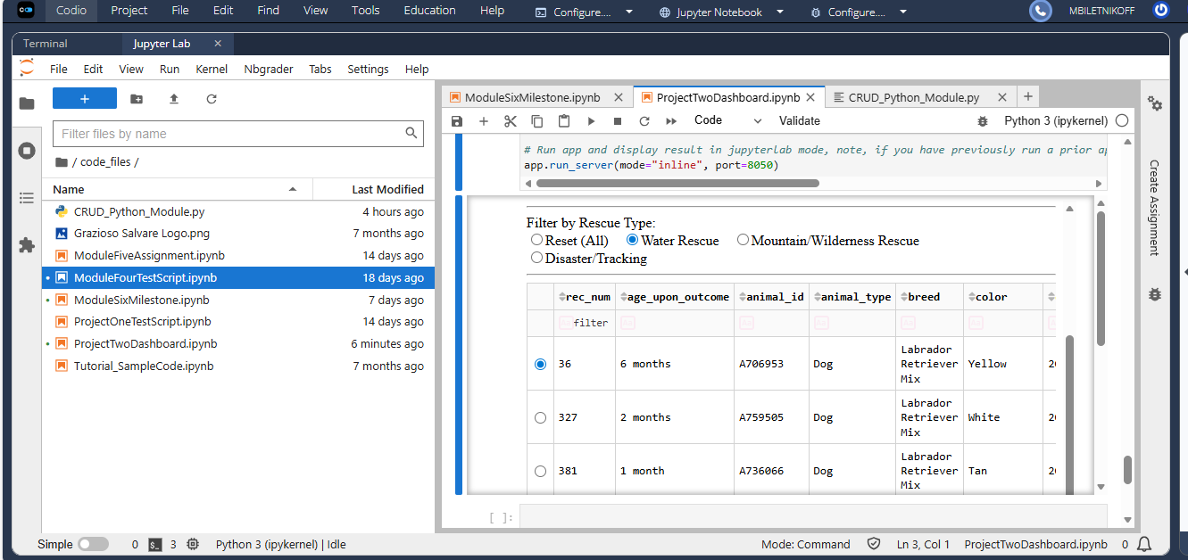
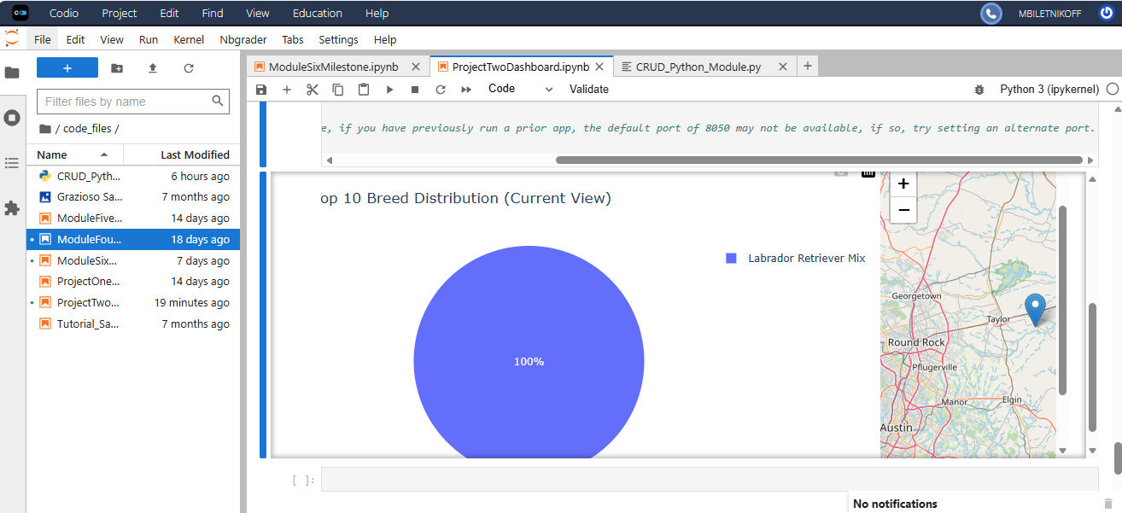

Mountain / Wilderness Rescue Filter
Query Conditions:
- Animal Type: Dog
- Breed: German Shepherd, Alaskan Malamute, Old English Sheepdog, Siberian Husky, Rottweiler
- Sex: Intact Male
- Age: 26–156 weeks
Selecting this filter dynamically updates all dashboard components to reflect the filtered dataset.
Figure 3: Dashboard filtered for Mountain/Wilderness Rescue criteria
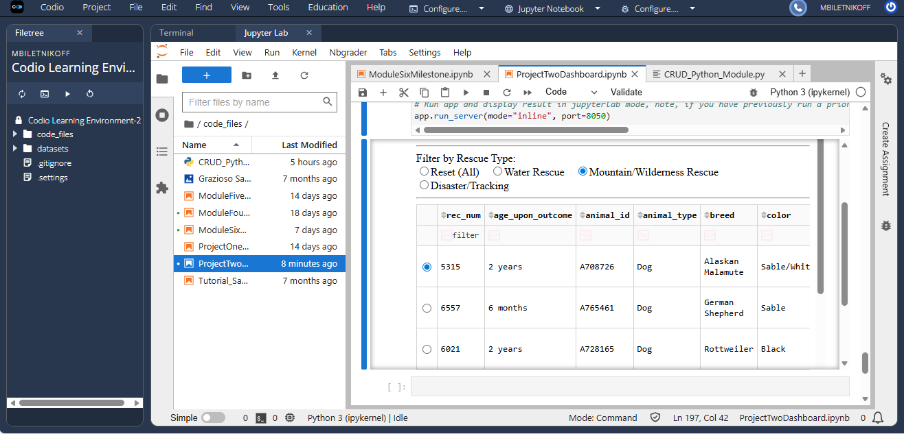
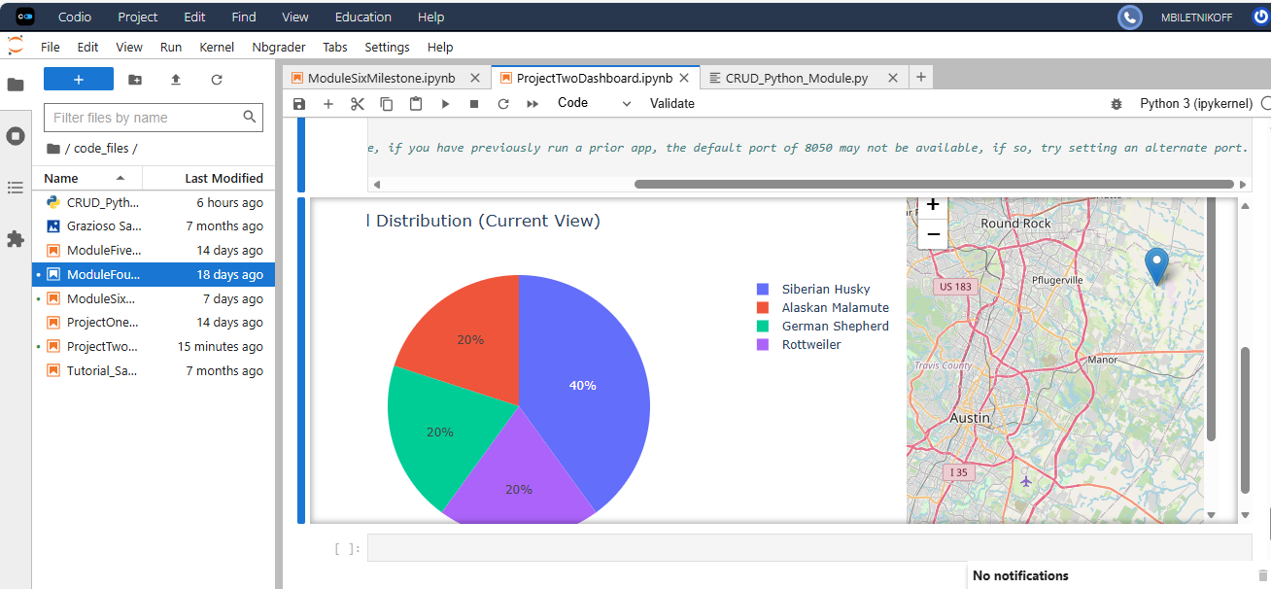
Disaster / Individual Tracking Filter
Query Conditions:
- Animal Type: Dog
- Breed: Doberman Pinscher, German Shepherd, Golden Retriever, Bloodhound, Rottweiler
- Sex: Intact Male
- Age: 20–300 weeks
When this filter is selected:
- The DataTable shows only Disaster/Tracking candidates.
- The breed distribution chart updates accordingly.
- The map reflects the currently selected row’s location.
Figure 4: Dashboard filtered for Disaster/Tracking criteria.
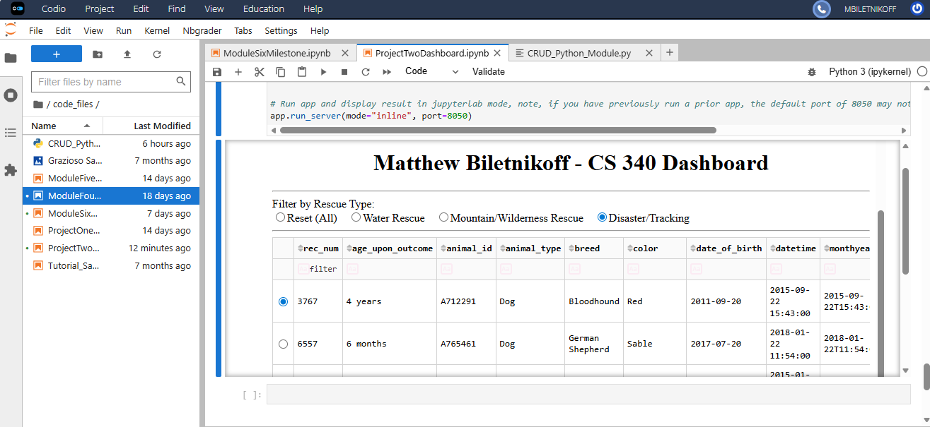
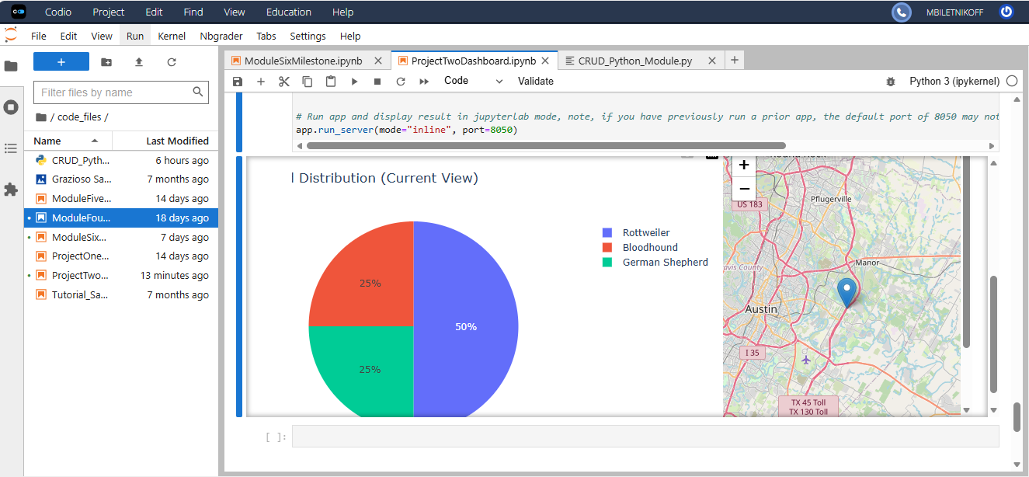

Reset Filter (Return to All Records)
Selecting Reset restores the dashboard to its original unfiltered state.
Figure 5: Dashboard reset to display all records.

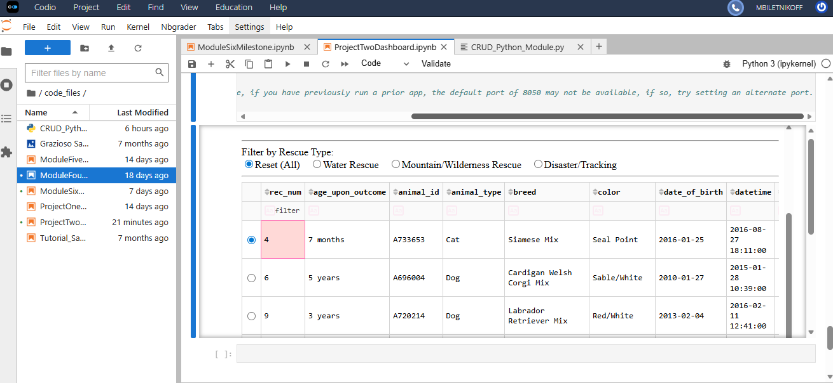
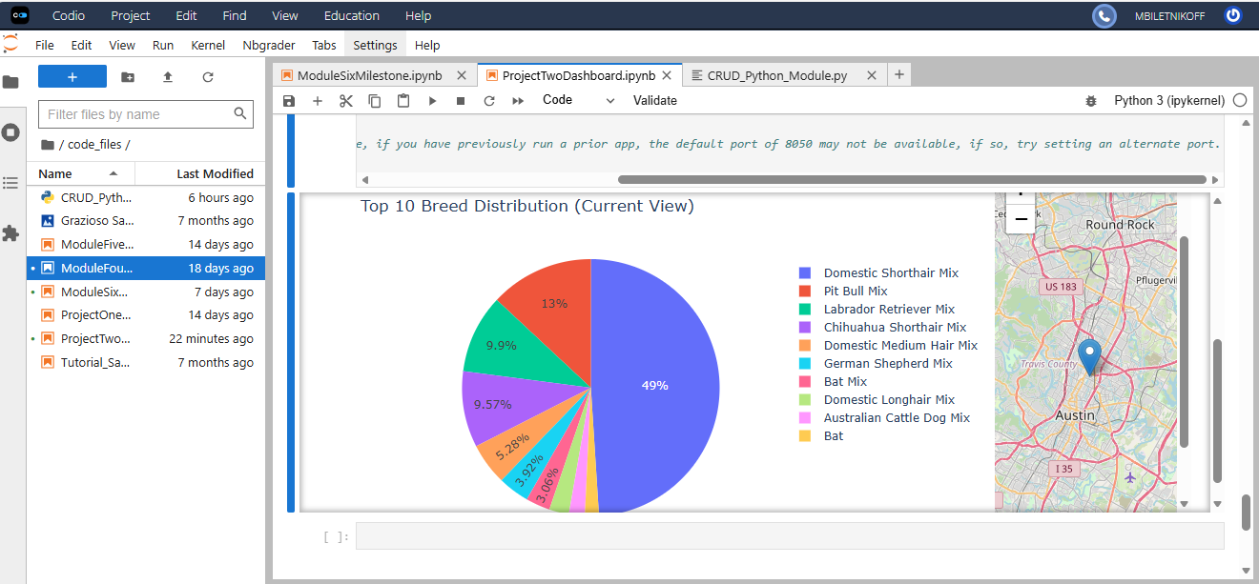

CRUD Module Overview
The application connects to MongoDB using a custom Python module:
File: CRUD_Python_Module.py
Class: AnimalShelterCRUD
The following methods are implemented:
- create() – Inserts a new document
- read() – Retrieves documents based on a MongoDB query
- update() – Modifies existing documents
- delete() – Removes documents
The read() method supports MongoDB projection to remove the _id field:
db.read(query, {"_id": 0})
This prevents ObjectID serialization errors within Dash’s DataTable component.

Dashboard Architecture
Backend
- MongoDB
- PyMongo
- Custom Python CRUD module
Frontend
- Dash
- Dash DataTable
- Plotly Express (breed distribution visualization)
- Dash Leaflet (geolocation mapping)

Interactive Features Implemented
- Radio button filtering
- Dynamic MongoDB query execution
- DataTable sorting and filtering
- Breed distribution chart (Top 10 breeds in current view)
- Interactive geolocation map
- Single-row selection highlighting

Challenges Encountered
- MongoDB _id field caused DataTable rendering errors
→ Resolved using projection {"_id": 0}
- Age filtering initially returned too few results
→ Corrected using proper age ranges specified in the project requirements
- Duplicate return block in the map callback
→ Removed redundant code to prevent syntax errors
- Indentation error in CRUD module
→ Fixed improper return placement inside the read() function

Conclusion
The Grazioso Salvare Rescue Dashboard successfully demonstrates client-server interaction through MongoDB integration and dynamic dashboard updates using Dash.
The application fulfills all Project Two requirements, including:
- Interactive filtering
- Data visualization
- Geolocation mapping
- Modular CRUD implementation
- Clean and functional UI design
The system is fully operational and ready for submission.

