Mark Mekosh

PHYS510

Midterm

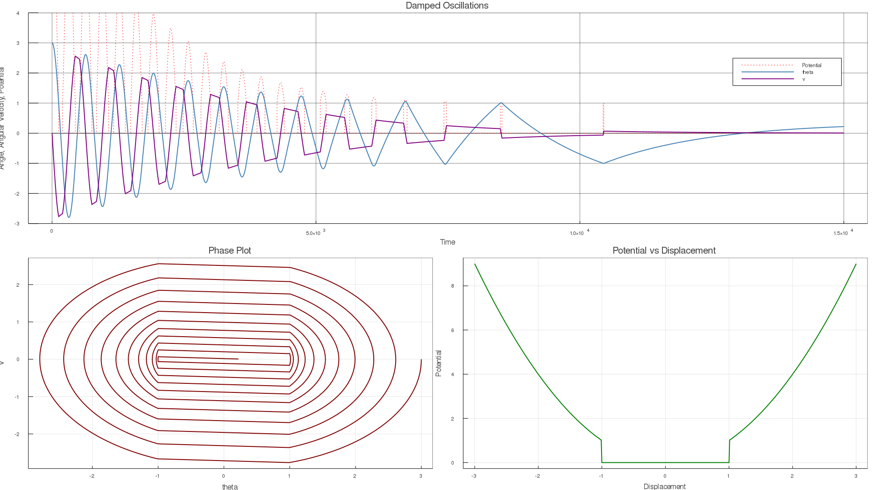

The top plot shows the behavior of the angle, angular velocity, and potential as a function of time. The angle is shown in blue, the angular velocity in purple, and the potential in dashed red. If the angle passes the value 1 or -1, then the potential function spikes up. This behavior makes sense when looking at the potential vs displacement graph. While the angle is between -1 and 1, there is no potential, and the object in question only moves based on its current velocity. Once the object moves outside of that range it gains a potential that forces it back in the opposite direction. Eventually due to the damping effect the object goes back into the range of zero potential, but doesn’t have enough velocity to leave the range. It gets stuck at some final displacement that is not zero based on these initial conditions. If the potential well was completely parabolic, then the object would come to rest back at zero because that would be the lowest potential state. For this case all values between -1 and 1 are at the minimum potential state, and the initial conditions determine where in the range -1 to 1 the object will end up. The phase plot shows how the angle changes rapidly while outside of the flat portion of the well, and more slowly while inside that portion. This is also seen in the purple portion of the top graph. In between the spikes of the potential plot (when the object is in the flat portion) the angular velocity doesn’t change much, but when the angle increases past -1 or 1, the potential spikes, and the angular velocity changes rapidly.