import numpy as np

import matplotlib.pyplot as plt

fig, ax = plt.subplots()

x = np.linspace(1.8, 2.8)

y = np.linspace(2.6, 4.2)

ax.plot(x, y)

ax.grid()

plt.title("---")

plt.xlabel("x")

plt.ylabel("y")

plt.show()

x1 = np.linspace(1.6, 2.6)

y2 = np.linspace(4.6, 5.1)

ax.plot(x1, y2)

ax.grid()

plt.title('---')

plt.xlabel("x")

plt.ylabel("y")

plt.show()

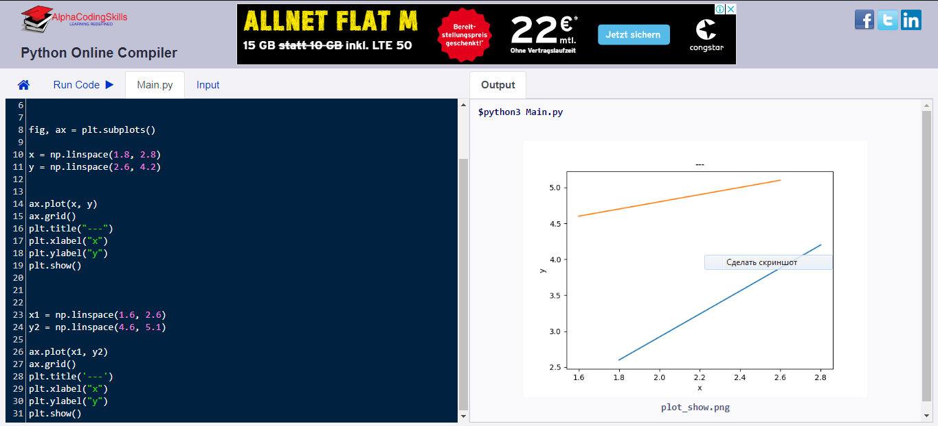

import numpy as np

import matplotlib.pyplot as plt

fig, ax = plt.subplots()

x1 = np.linspace(1.6, 1.9)

y2 = np.linspace(2.6, 5.1)

ax.plot(x1, y2)

ax.grid()

plt.title('---')

plt.xlabel("x")

plt.ylabel("y")

plt.show()

