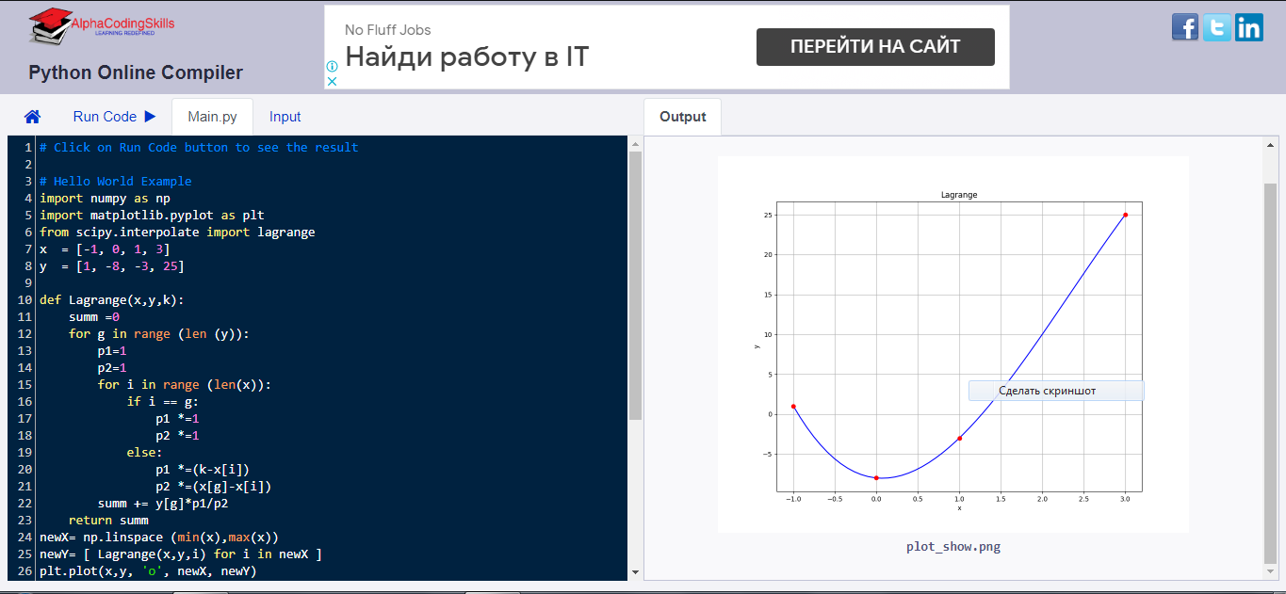

import numpy as np

import matplotlib.pyplot as plt

from scipy.interpolate import lagrange

x = [-1, 0, 1, 3]

y = [1, -8, -3, 25]

def Lagrange(x,y,k):

summ =0

for g in range (len (y)):

p1=1

p2=1

for i in range (len(x)):

if i == g:

p1 \*=1

p2 \*=1

else:

p1 \*=(k-x[i])

p2 \*=(x[g]-x[i])

summ += y[g]\*p1/p2

return summ

newX= np.linspace (min(x),max(x))

newY= [ Lagrange(x,y,i) for i in newX ]

plt.plot(x,y, 'o', newX, newY)

plt.xlabel('x')

plt.ylabel('y')

plt.grid(axis='both')

plt.title('lb7')

plt.show()

f= lagrange(x,y)

fig=plt.figure(figsize=(10,8))

plt.plot(newX, f(newX), 'b',x,y,'ro')

plt.title('Lagrange')

plt.grid()

plt.xlabel('x')

plt.ylabel('y')

plt.show()

