6ADDBASE - Midterm Activity August 20, 2025

WD-304

MongoDB Query Operators

Name: Mangalino Kurt Juztine S.

**Instructions**. Satisfy the following items by providing the necessary commands required by each item. Provide the commands by getting a screenshot of the commands executed and result. Change the default background color and font of your mongo shell.

1. **Find all shoes where the brand is 'Vans'.**

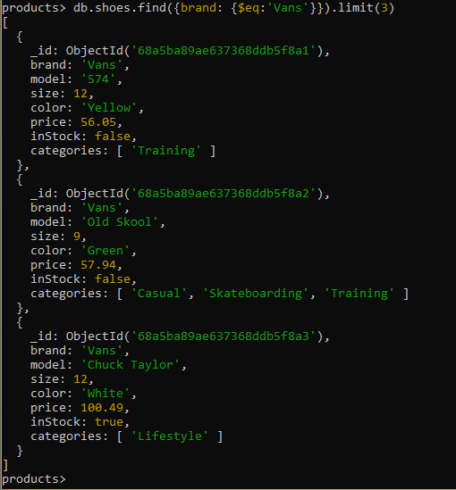

1. **Retrieve shoes where the price is greater than 142.11.**

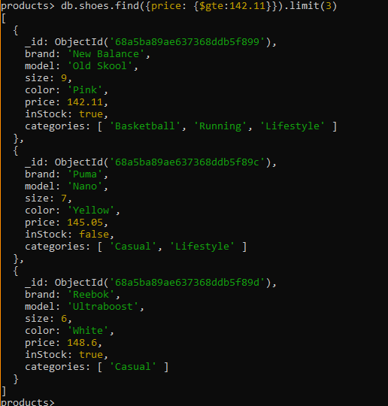

1. **Find shoes where the color is not 'Red'.**

1. **Get shoes where the size is less than or equal to 6.**

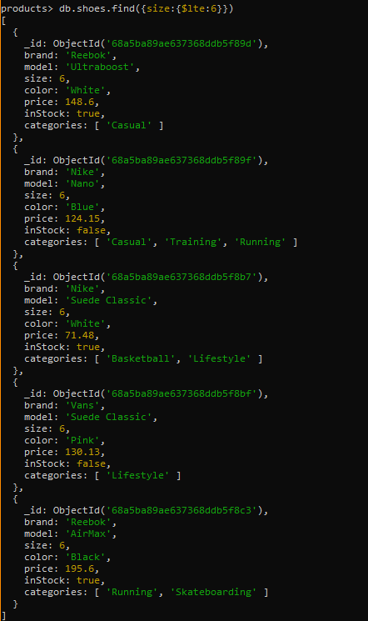

1. **Find shoes where the category is either 'running' or 'sneakers'.**

1. **Retrieve shoes where the price is between 50 and 150.**

1. **Find shoes where the brand is 'Vans' and the color is 'Red'.**

1. **Get shoes where the size is not greater than 6.**
2. **Find shoes where the brand is not 'Vans' and the category is not 'running'.**
3. **Search for all shoes which are color Red. Display only 5 and sort them by from lowest to biggest price.**
4. **Search for all shoes with brand “Puma” and sort them from bigger size to lower size.**