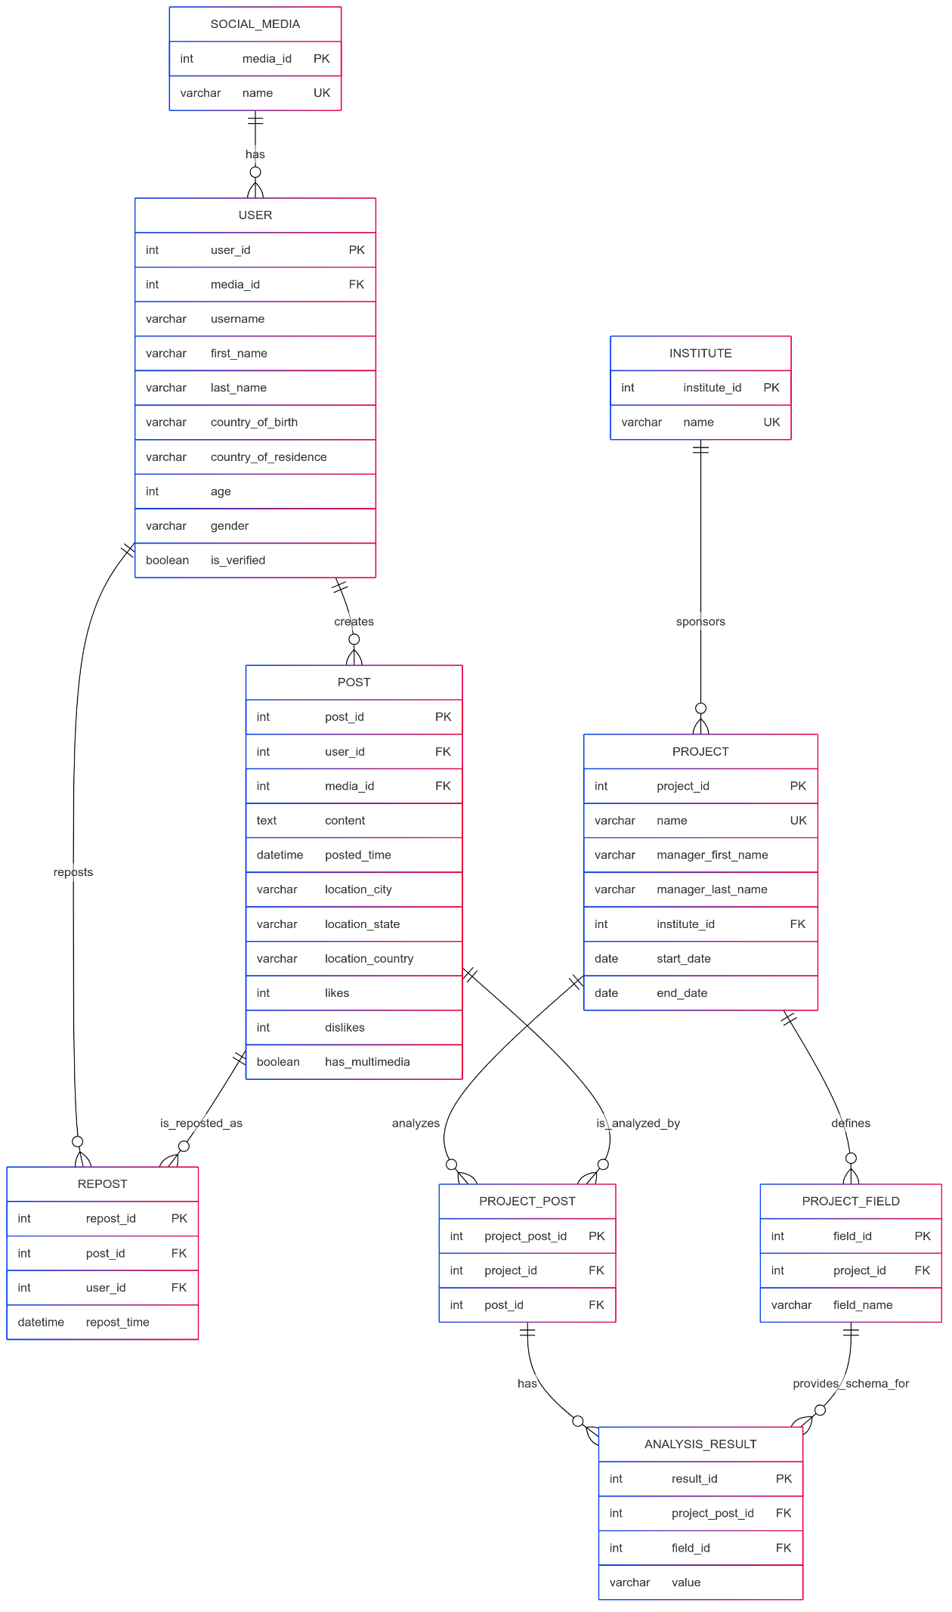

This is the web_page link: [er_model_link](https://mermaidchart.com/play#pako:eNqVVV1v2jAU_SuRn2kVBgWWN9QGiY21FYGHTUiWG1_Aa2Ij20GltP99TuI0JDWoy1N8v-_xPddHFAsKKEAg7xjZSJKuuGe-6OF2Op7hX-HddOy9vV1diaO3jMK5F3hbokqb4mx1jw_RwuhiCUSDQz8PrYWEnVDaWhSytgVTuDQCiqtUj_OHH-Hth6094sk0nN0ZFwprxuGyrY1OOEkOr-AooGVoyrC2FD8dGqHxqdv4fjz7HU0jPA-j5WxxClCzzLP2Oyn2jILCKt5CSvBayNJ_eh8tpovlImyVaHzUTnAlpE3kuLNjKcs_xrWXAmUEM-o9_qwVeyLjLZEeJyl4S6t4Pw1ZXGErVKZAtiM1UkwcKXKnPM1nzZpJpbFbl5CzqlhkXMsDFmv8xKTeXrSQoAzAPIZmxWTjCLwBTkHW8ichEiA8n4c9SLZmQB1AFRPRAiqfYRdQFYCTrwCo4UWbVrgGrmspNSzTzNya5Un-74BPxEQzwXHM9OGCWmkT7pJ7iWSz2oQ9VyyqRJSplrQCz1ACp1mSl2l6dOBn2d9CsNwDLgwr-eQL2H6AZcPVYDVKqNnWqoJxpZnONPw_fyrCtidDir8Q6y_FO1WkZiNtTIOXOFPZOLjzqZk2Sp6ZBKkxbYxDoTCkOBG7erRbrtWpoUtCnRdYQ-DaF6VfXb4zo5N0Nu7ZwXHndc1UI2d7bX-aVGXG-1LCcxP7gZALhj1JsgoB1EEpyJQwap7rIv0KafNgwAoF5pcS-bxCK57bkUyL6MBjFGiZQQdJkW221SHb5RdpX_tKuCP8jxCnRxQc0QsKrgbD62_Dftf3h_3B4KY7HHXQwYhHw8G1f_O92-8O_e-9UX_03kGvRYTu9eim1_Nzl4Hvd0c947GRedW2mGLB3uY7BQWD9391eY9q)

*-- Here, we use auto-increment for the ID. Later, we will consider using the Snowflake algorithm or other methods to generate IDs.*

