***Pasteurization temperature’s effect on malic acid concentration in apple juice***

**1: Introduction**

**1.1: Topic Background**

Apples are among the most popular fruits, and their associated products – such as apple juice, apple cider, and apple sauce – are also widely recognized and consumed. From a young age, I’ve always been specifically enchanted by the sweet and pure taste of apple juice. However, entering middle school science, I was introduced to the pH scale. As I learned about the varying pH’s of common foods and items, I was shocked by the fact that apple juice not only acidic, but as acidic as other drinks such as orange juice, which I had always imagined as being more acidic!

Since then, I’ve been interested in learning more about the acids in apple juice. I soon found that the concentration of the well-known ascorbic acid in apple juice was low as compared to malic acid, which accounted for most of the acid concentration (Cash). I was intrigued as I had never heard of malic acid before. Upon further research, I learned that malic acid may be good for health. At home, I’ve sometimes pressed fresh apples for juice before, but we never pasteurized our juice since we would drink it right away. Hence, I began to wonder about the effect of pasteurization on the concentration of malic acid in the juice.

**1.2: Investigation Background**

*Investigative Question: How does the temperature during pasteurization of apple juice affect malic acid concentration in the juice?*

In this investigation, I will be looking at the effect of pasteurization temperature on malic acid concentration in apple juice. The independent variable in this investigation will be the temperature in degrees Celsius during the pasteurization process, and the dependent variable will be the resulting malic acid concentration by molarity. Malic acid is the main acid in apple juice, accounting for more than 95% of the acid concentration in apple juice by moles. Pasteurization is a process which most, if not all, commercial juices undergo, in which the beverage is heated to a given temperature and held at that temperature for 15-20 minutes. The aim of pasteurization is to stop the juice from fermenting and to kill off any organisms inside that could cause the juice to spoil (Vigo Presses Ltd).

This investigation will include first pasteurizing the apple juice by heating it on a hot plate. Then, I will utilize acid-base titration to approximate the malic acid concentration of the processed apple juice. Malic acid is a weak diprotic acid with pKa1=3.51 and pKa2=5.03 (National Center for Biotechnology Information). Basic sodium hydroxide will be added to the acidic apple juice, and the amount of sodium hydroxide needed to reach the second equivalence point will be used to calculate the concentration of H+ cations in the juice. The second equivalence point is used because due to pKa1 and pKa2 being close, the second equivalence point is very significant graphically while the first equivalence point is barely noticeable. The concentration of H+ can then be used to give a rough approximation of the concentration of malic acid inside the juice.

The controlled variables will include the concentration of sodium hydroxide during titrations, the length of pasteurization, and the volumes of apple juice used in each respective step. In pasteurization, heating will be done with 100.0mL samples of juice and the temperature will be held constant for 15 minutes. In the titration, the concentration of the sodium hydroxide used for titration will be 2.00M, and all titrations will be done with a 30.0mL sample of juice. Apple juice from the same carton will also be used for all trials to ensure consistency in the starting malic acid content. Additionally, all titrations will be done in the same chemistry classroom under the same settings, meaning the temperature during readings will presumably stay constant. This is important because pH decreases under an increase in temperature (Westlab Group).

**1.3: Assumptions**

For this investigation, two assumptions will be made. First, we will assume that malic acid is the only acid present in apple juice (conventionally, the acid content of apple juice is reported as malic acid) and thus the measured pH’s are solely representative of malic acid concentration. Second, the effects of possible evaporation during the heating and/or storage process will be neglected.

**1.4: Safety, Environmental, and Ethical Concerns**

This investigation has relatively few safety, environmental, or ethical concerns. The only safety concern is that the 2.00M sodium hydroxide may cause irritation to the eyes and skin, meaning goggles must be worn at all times and all beakers, pipets, and burets which have contained NaOH must be thoroughly washed after use (Centers for Disease Control and Prevention).

The only environmental concern is that the apple juice and NaOH solutions resulting from titration can’t be simply poured down the sink. Instead, they will be put into a devoted plastic waste bag and disposed of properly after the experiment. Additionally, only one carton of apple juice has been devoted to this investigation, so there is also little ethical concern about wasting.

**1.5: Hypothesis**

My hypothesis about this experiment is that increasing the temperature of pasteurization will lower the malic acid concentration. I am basing my prediction off another common acid in fruit juices and other foods – ascorbic acid – whose content decreases in increasing amounts when greater heat is applied (UKEssays).

**2: Experimental Design**

This experiment consists of 2 steps – pasteurizing the juice and titrating the juice. Following are diagrams of the experimental setups.

*Diagram 1: Sketch of pasteurization setup*

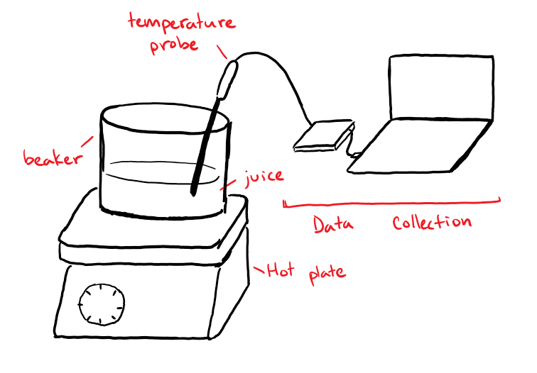

*Diagram 2: Sketch of titration setup*

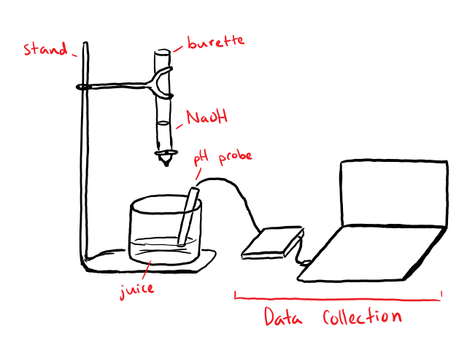

**3: Materials**

The materials required in this investigation are:

* Apple juice
* LoggerPro lab data collection software
* 6 150mL beakers
* 2 pipets
* Temperature probe
* Hot plate
* pH probe
* Burette and stand
* 2.00M NaOH

**4: Procedure**

This investigation will include two procedures – that of the pasteurization of the juice, and that of the titration used to evaluate acid concentration. The pasteurization step will be executed prior to the titration step.

**4.1: Pasteurization Procedure**

1. Use a pipet to carefully transfer 100.0mL of apple juice into a 150mL beaker
2. Insert a temperature probe into the beaker to gauge the temperature
3. Place the beaker onto a hot plate and heat to 40.°C
4. Hold the temperature constant (fluctuating within +/- 5°C) for 15 minutes
5. Remove the temperature probe and let the juice cool for 5 minutes
6. Label and seal the beaker with parafilm, and then store it until ready for titration
7. Repeat steps 1-6 for temperatures of 50.°C, 60.°C, 70.°C, and 85°C

**4.2: Titration Procedure**

1. Use a pipet to carefully transfer 10.0mL of 2.00M NaOH into the burette
2. Use a pipet to carefully transfer 30.0mL of 40.C pasteurized apple juice into a 150mL beaker and place under the stand
3. Place the pH probe into the beaker of apple juice
4. Slowly add NaOH from the burette into the beaker of juice, recording the pH at regular intervals on a volume of NaOH added to pH chart
5. Slow down to adding by intervals of 0.05mL when the graph of NaOH added to pH starts sloping up at an increasing rate
6. Stop the procedure after 4 data points with a first derivative (in pH/vol) lower than the data point with the highest recorded first derivative have been collected
7. Repeat steps 2-6 for samples of apple juice pasteurized at 50.°C, 60.°C, 70.°C, and 85°C

**5: Data**

Following is a sample graph of the titration data collected. First derivative values were generated by LoggerPro during the data collection.

*Graph 1: NaOH added to pH and d1 at a pasteurization temperature of 40.°C*

Following is the titration data for each of the temperatures tested. Each set of data consists of the point with the highest first derivative and 2 points above and 2 points below that point.

*Table 1: NaOH added to pH at a pasteurization temperature of 40.°C*

|  |  |  |
| --- | --- | --- |
| NaOH added (mL) | pH | d1 (pH/vol) |
| 1.00 | 6.20 | 7.98 |
| 1.05 | 6.56 | 14.27 |
| 1.10 | 7.64 | 20.40 |
| 1.15 | 8.84 | 16.45 |
| 1.20 | 9.33 | 10.28 |

*Table 2: NaOH added to pH at a pasteurization temperature of 50.°C*

|  |  |  |
| --- | --- | --- |
| NaOH added (mL) | pH | d1 (pH/vol) |
| 0.70 | 5.68 | 10.18 |
| 0.80 | 6.98 | 14.60 |
| 0.85 | 7.91 | 17.65 |
| 0.90 | 8.93 | 12.37 |
| 1.00 | 9.86 | 7.73 |

*Table 3: NaOH added to pH at a pasteurization temperature of 60.°C*

|  |  |  |
| --- | --- | --- |
| NaOH added (mL) | pH | d1 (pH/vol) |
| 0.70 | 5.76 | 8.16 |
| 0.75 | 6.18 | 15.39 |
| 0.80 | 7.24 | 22.71 |
| 0.85 | 8.77 | 16.99 |
| 0.95 | 9.85 | 11.42 |

*Table 4: NaOH added to pH at a pasteurization temperature of 70.°C*

|  |  |  |
| --- | --- | --- |
| NaOH added (mL) | pH | d1 (pH/vol) |
| 0.70 | 6.03 | 10.19 |
| 0.75 | 6.84 | 18.10 |
| 0.80 | 8.00 | 20.99 |
| 0.85 | 9.07 | 17.43 |
| 0.90 | 9.67 | 13.53 |

*Table 5: NaOH added to pH at a pasteurization temperature of 85°C*

|  |  |  |
| --- | --- | --- |
| NaOH added (mL) | pH | d1 (pH/vol) |
| 0.80 | 6.08 | 11.69 |
| 0.85 | 6.75 | 19.07 |
| 0.90 | 8.11 | 20.73 |
| 0.95 | 8.98 | 15.12 |
| 1.00 | 9.58 | 12.88 |

Additionally, the data for titration of the unpasteurized juice is included below to act as a control.

*Table 6: NaOH added to pH for the unpasteurized apple juice*

|  |  |  |
| --- | --- | --- |
| NaOH added (mL) | pH | d1 (pH/vol) |
| 0.70 | 5.51 | 7.41 |
| 0.80 | 6.05 | 18.04 |
| 0.85 | 8.55 | 21.18 |
| 0.90 | 9.32 | 13.32 |
| 0.95 | 9.73 | 7.77 |

**6: Data Analysis**

**6.1: Concentration Calculation**

We will find the concentration of malic acid for each of the temperatures tested. A sample calculation is shown below for the unpasteurized control. Exact measured values will be used in this section – errors will be propagated in the next section.

First, we will find the concentration of H+ cations. The equivalence point is where the moles of OH- anions (disassociated from the NaOH) added is equivalent to the moles of H+ cations originally present. Here, d1 peaks when 0.85mL of NaOH have been added, so that is the equivalence point.

Given 0.85mL NaOH was added and the juice sample was 30.0mL:

$$0.85 mL NaOH\left(\frac{1 L}{1000 mL}\right)\left(\frac{2.00 mol NaOH}{1 L NaOH}\right)\left(\frac{1 mol OH^{-}}{1 mol NaOH}\right)\left(\frac{1 mol H^{+}}{1 mol OH^{-}}\right){\left(30.0 mL\right)}^{-1}\left(\frac{1000 mL}{1 L}\right)$$

$$=0.0567\frac{mol}{L} H^{+}=0.0567 M H^{+}$$

Here at the second equivalence point, 2 H+ cations have disassociated from every molecule of malic acid (C4H6O5), so:

**6.2: Error Calculation**

There is an inherent error margin in these calculations due to the nature of the equipment used. The burette used in the titration goes down to 0.1mL tick marks, so the error in NaOH volume measurement is half of that, or ±0.05mL NaOH.

A sample calculation for the error in the concentration of the unpasteurized control is shown below.

The relative uncertainty is:

$$\frac{±0.05 mL NaOH}{0.85 mL NaOH}\left(\frac{100\%}{1}\right)=±5.88\%$$

Therefore, the error in the molarity calculation is:

$$±5.88\%\left(\frac{1}{100\%}\right)0.028 M C_{4}H_{6}O_{5}=±0.00165 M C_{4}H_{6}O_{5}=±0.002 M C_{4}H_{6}O_{5}$$

There is also error in the measured temperatures, as it was nearly impossible to hold the temperature steady on the hot plate. Therefore, we will assume there were fluctuations within approximately ±5°C of the recorded temperature.

**6.3: Data Summary**

Repeating this process for all the temperatures, we obtain the following results.

*Table 7: Temperature of pasteurization to molarity*

|  |  |
| --- | --- |
| Temperature (°C) | Molarity (M C4H6O5) |
| None (control) | 0.028±0.002 |
| 40.±5 | 0.037±0.002 |
| 50.±5 | 0.028±0.002 |
| 60.±5 | 0.027±0.002 |
| 70.±5 | 0.027±0.002 |
| 85±5 | 0.030±0.002 |

*Graph 2: Temperature of pasteurization to concentration of C4H6O5*

**7: Evaluation**

**7.1: Data Evaluation**

The graph of the data from this investigation starts high at a low pasteurization temperature, and then lowers at a decreasing rate as the pasteurization temperature increases. The last data point at 85°C can either signify that the curve goes up if pasteurization temperature increases even further, or it can simply be an outlier. As it is presumably bad practice to extrapolate trends based on the behavior of one data point, we will assume that it is an outlier.

At the same time, it is also interesting to note that the concentration of the unpasteurized control is 0.028M, which is lower than that of the pasteurization temperatures of 40°C and 85°C, but higher than that of the pasteurization temperatures of 60°C and 70°C. This suggests that either the curve slopes down as pasteurization temperature approaches zero, or that my experimental data is extremely inconsistent.

In general, there is no sort of curve which can be successfully fit through this data. The type curve with the highest R2 value when fit through this data is shown below. Even so, many points on the chart are situated far from the line of best fit.

*Graph 3: Temperature of pasteurization to concentration of C4H6O5 with line of best fit drawn through the data*

As hard as it is to assume a new trend based off of the behavior of one or two data points which may even be possible outliers, it is equally unreasonable to recognize a trend when a considerable portion of data points in the plot are behaving in a nonconforming manner. Hence, I would assert that the results of this experiment are rather inconclusive, as we can infer minimally about pasteurization temperature’s relation to concentration from the collected data. We can only say that it faintly seems that an increase in pasteurization temperature decreases malic acid concentration at a decreasing rate.

**7.2: Experimental Weaknesses**

Overall, this investigation had many weaknesses, some of which could have generated enough error to significantly affect the shape of the graph. Primarily, both assumptions made (malic acid accounting for all acid in the juice and the negligible effects of evaporation) could have impacted the result of the experiment. Firstly, malic acid does not actually account for the entire acid content in apple juice – there are other acids present, and they may have responded differently to the heating. Hence, the fluctuation in amount of H+ cations does not solely represent the fluctuation in malic acid levels.

Additionally, evaporation (during either heating or storage) could have decreased the volume of the 100mL heating samples, which in turn increases the measured concentration (as the malic acid remains). Therefore, the 30mL titration samples I extract from it will have more malic acid and hence have a higher concentration. However, measures have been taken to minimize such effects. Firstly, all tested temperatures are below 100°C, the boiling point of water. Hence, not much water should have escaped theoretically. Secondly, parafilm was used to seal the beakers of pasteurized apple juice, so possible evaporation during storage is limited as well. Nonetheless, the effects of evaporation are present (namely that during heating), especially in the 70.°C and 85°C trials. This may account for the increase in concentration at those temperatures.

A further weakness in my experiment comes from the fact that I used 2.00M NaOH. Most of my titrations required less than 1mL of NaOH to complete, suggesting that the concentration used was way too high. This causes for great error in measuring the volume of NaOH used because the burette can only read down to 0.1mL. This makes it very likely that the intervals at which I added NaOH missed the exact equivalence point.

**7.3: Experimental Strengths**

Despite the weaknesses, this experiment had some strengths as well. Firstly, the experimental procedure is straight-forward. Hence, despite a shortage of time, I was able to get 5 data points, which is often sufficient to show a trend.

Secondly, as mentioned in the introduction, this experiment has few safety, environmental, or ethical concerns. The fact that there are little consequences in carrying out this experiment makes it more repeatable and classroom friendly.

**7.4: Future Improvements**

If this experiment were to be done again, I would first try to limit the effects of evaporation. I would do so by heating larger samples of juice so that the effects of vaporization are limited. After heating, I will also let the samples cool with acceptable covers on so that the water stays inside. Additionally, I will also do titration immediately after heating to eliminate the evaporation during the storage process (since parafilm does not prevent 100% of evaporation).

Furthermore, I will use a lower concentration of NaOH (presumably 0.50M or lower) so as to obtain more precise measurements of concentration (by lowering the effect of the absolute error on the final calculations of concentration).

**7.5: Conclusion:**

Evidently, this experiment has many weaknesses and places for further improvement. The data is rather inconsistent and inconclusive. Nonetheless, given current data, the following is concluded on the note that several assumptions were made throughout the calculation and analysis process:

*Increasing the temperature of the pasteurization of apple juice decreases the malic acid concentration in the juice at a decreasing rate as pasteurization temperature increases.*

**8: Bibliography**

Cash, David. “Acid-Base Titrations: Comparing the Acid Content of Low-Acid Fruit Juices to Regular Fruit Juices.” Chem13 News Magazine, 7 Dec. 2018, uwaterloo.ca/chem13-news-magazine/october-2013/feature/acid-base-titrations-comparing-acid-content-low-acid-fruit.

“Effect of Temperature on Vitamin C in Orange Juice.” UKEssays.com, [www.ukessays.com/essays/biology/degradation-of-vitamin-c-in-orange-fruits-biology-essay.php](http://www.ukessays.com/essays/biology/degradation-of-vitamin-c-in-orange-fruits-biology-essay.php).

“How Do I Preserve My Apple Juice?” Vigo Presses Ltd, [www.vigopresses.co.uk/AdditionalDepartments/Useful-Information/More-fruit-related-guides/How-do-I-preserve-my-apple-juice](http://www.vigopresses.co.uk/AdditionalDepartments/Useful-Information/More-fruit-related-guides/How-do-I-preserve-my-apple-juice).

“How Does Temperature Affect PH? Westlab.” Westlab Group, www.westlab.com/blog/2017/11/15/how-does-temperature-affect-ph.

“Malic Acid.” National Center for Biotechnology Information. PubChem Compound Database, U.S. National Library of Medicine, pubchem.ncbi.nlm.nih.gov/compound/Malic-acid#section=Dissociation-Constants.

“Sodium Hydroxide.” Centers for Disease Control and Prevention, Centers for Disease Control and Prevention, 21 June 2019, [www.cdc.gov/niosh/topics/sodium-hydroxide/default.html](http://www.cdc.gov/niosh/topics/sodium-hydroxide/default.html).