Physics IA

**Introduction**

As an avid user of mechanical pencils, I often find it irritating to have the pencil lead snap when writing. As a result, whenever I had a choice between 0.5 mm, 0.7 mm, and 0.9 mm mechanical pencils, I would always choose the type with thicker lead because it would be more resistant to snapping. However, I’ve always been curious about just how increases in lead diameter affect force needed to snap the lead. Having found online searches fruitless, I have thus decided to answer that question in this paper:

**How does the diameter of a piece of lead from a mechanical pencil affect the amount of force needed to snap it?**

Background

To find this relationship, I will suspend a container with a string from elevated mechanical pencil leads of various diameters. Mass will then be steadily added into the container until the lead snaps. The only force acting on the pencil lead will be the weight force of the mass, which can be found with the following equation:

$$W=mg$$

Where $W$ is the weight force, $m$ is the total mass of the object causing the force, and $g$ is Earth’s gravitational field strength, which is approximately $9.81 N {kg}^{-1}$ (Nave). The mass that will be added into the container is water because it can be injected continuously. I will not be able to directly mass the container and water because this experiment will be carried out at home due to the coronavirus. Instead, because water has a set density at room temperature, I will use the volume of the water added to find its mass. Then, that mass will be added to the mass of the container and string holding the water, to find the total mass of everything exerting a weight force on the lead. Specifically, water at a room temperature of ${21}^{∘}C$ has a density of approximately $0.99802 g {mL}^{-1}$. The mass $m$ in grams of a volume $V$ in mL of water is therefore $:$

$$m=0.99802×V$$

As this experiment is a study of forces on a small scale and only uses water and household items, there are no significant ethical concerns to account for.

Variables

The independent variable in this investigation will be the diameter of the mechanical pencil lead – I will test leads of diameter 0.3 mm, 0.5 mm, 0.7 mm, 0.9 mm, and 1.3 mm. These diameters will be used because they are the only readily attainable variations of diameters from one manufacturer. The dependent variable in this investigation is the force needed to snap the lead, which is equivalent to the weight force exerted on the lead by the masses.

The controlled variables in this investigation include:

* The width between the ledges on which the lead is suspended is 1.4 cm. This is the maximum width for which an empty container can hang on the 0.3 mm lead and not snap it.
* It will be attempted to let the string contact the lead at a point that is 0.7 cm away from both supports, so that the lead can experience maximum force.
* The same container and string will be used throughout all trials.
* All leads are of the brand June Gold, so they are from the same manufacturer and their material compositions are comparable.

**Experimental Setup**

The materials used for this investigation are varying sizes of mechanical pencil lead, a string and container, high ledges to elevate the lead, water, a 5 mL syringe for measuring volume, and a device for recording data. A scale will be needed later for massing.

The procedure for this experiment will be as follows:

1. Obtain needed materials
2. Place the 0.3 mm pencil lead between the high ledges and carefully hang the container from it with a string
3. Slowly inject water into the container with the syringe until the lead snaps, keeping track of the volume of water added
4. Record the volume of water added
5. Repeat steps 2-4 four more times, for a total of five trials
6. Repeat steps 2-5 for the 0.5 mm, 0.7 mm, 0.9 mm, and 1.3 mm pencil leads
7. Mass the container and string, and any extra masses used in the process to snap the lead when water was not enough
8. Plot and analyze the data

Pictures of the experimental setup are depicted below:

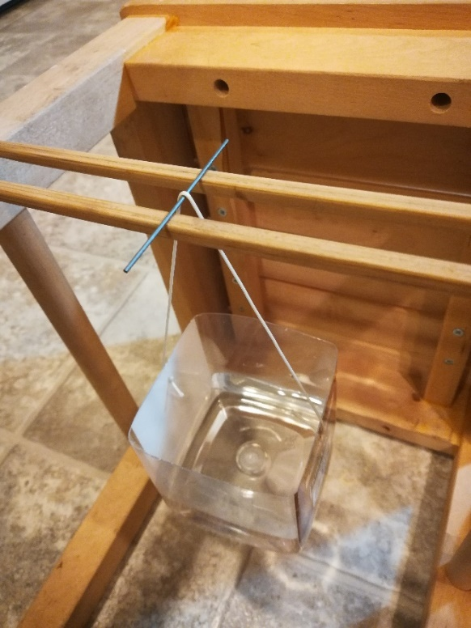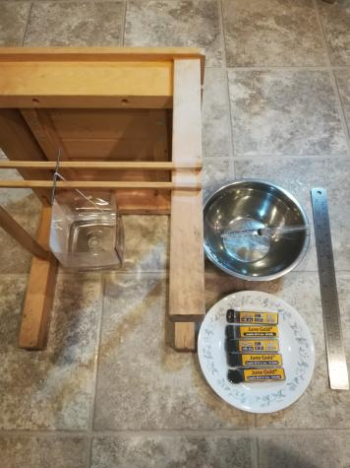

**Experimental Data**

Diameter of lead (mm) to volume of water put into container (mL)

|  |  |  |  |  |  |
| --- | --- | --- | --- | --- | --- |
|  | 0.3 mm | 0.5 mm | 0.7 mm | 0.9 mm | 1.3 mm |
| Trial 1 | 5.6±0.24 | 20.0±0.80 | 135.0±5.40 | 284.8±11.40 | 300.6±12.04 |
| Trial 2 | 6.8±0.28 | 33.6±1.36 | 138.4±5.56 | 328.2±13.16 | 265.8±10.64 |
| Trial 3 | 5.0±0.20 | 24.4±1.00 | 143.2±5.76 | 352.2±14.12 | 315.0±12.60 |
| Trial 4 | 9.2±0.40 | 38.2±1.56 | 134.4±5.40 | 310.0±12.40 | 340.0±13.60 |
| Trial 5 | 5.4±0.24 | 39.6±1.60 | 147.4±5.92 | 367.4±14.72 | 332.4±13.32 |

The experiment did not go entirely as expected – for the 1.3 mm lead, the lead did not snap even when the container was full of water. Hence, for the 1.3 mm lead only, I added small metal bars into the container to serve as extra masses. Their mass will be accounted for in the calculation for force.

All non-water materials have also been massed at school:

* The container and the string have a total mass of $28.86±0.01$ g
* The masses put into the container to help snap the 1.3 mm lead have a total mass of $110.07±0.01$ g

Uncertainties

The uncertainties of the values in the raw data are justified as follows:

The scale is of the brand Scout Pro and can obtain masses down to the hundredths digit. The uncertainty of its measurements is its unit of lowest significance, or 0.01.

The lowest unit of significance on the syringe used is 0.2 mL, so the uncertainty in one of its measurements is 0.2 mL. However, because the syringe can only take in 5 mL at a time, the total uncertainty of each measurement must be rounded up to the nearest 0.2 mL. Therefore, given a measurement $x$ in mL, the uncertainty of that measurement in mL is:

$$U=\frac{ceiling\left(\left(\frac{0.2}{5}\right)x×25\right)}{25}$$

**Analysis**

To plot this data, the arithmetic average of all my trials per data point will be used. To find the averages of the measurements $x$ across the five trials for each data point, the following formula will be used:

$$x_{avg}=\frac{x_{1}+x_{2}+x_{3}+x_{4}+x_{5}}{5}$$

The uncertainties of these averages are therefore the average of the uncertainties for each trial. When the data for each diameter is averaged, the following table is obtained:

|  |  |
| --- | --- |
| Diameter of Lead (mm) | Water put into Container (mL) |
| 0.3 | 6.4±0.27 |
| 0.5 | 31.2±1.26 |
| 0.7 | 139.7±5.61 |
| 0.9 | 328.5±13.16 |
| 1.3 | 310.8±12.44 |

To find the force, the total mass of everything hanging from the lead must first be found. This can be done by calculating the mass of the water added and then adding that to the mass of the container and string used. In the case of the 1.3 mm lead, the mass of the extra weights added will be summed into the calculation too. Next, because the weight force on the mass is equivalent to the net force experienced by the lead and the weight force $W=mg$, the force $F$ experienced by the pencil lead can be found with the equation:

$$F=mg$$

Sample Calculation

A sample calculation is shown below for the force exerted on the 1.3 mm:

The density of water at room temperature is approximately $0.99802 g {mL}^{-1}$. Hence, the mass of the water added is:

$$310.8±12.44 mL\left(0.99802\frac{g}{mL}\right)=310.2±12.42 g$$

The mass hanging from the lead for the 1.3 mm trials include the water, the container holding the water, the string attached to the lead, and the extra masses that were added in for only the 1.3 mm trials. The mass of the container and the string combined is $28.86±0.01 g$, and the mass of the extra weights were $260.07±0.01 g$ in total. Hence, the total mass of everything hanging from the lead is:

$$(310.2±12.42 g)+(28.86±0.01 g)+(260.07±0.01 g)=599.1±12.44 g$$

To find the force withstood by the lead, the aforementioned equation $F=mg$ can be applied. However, since the mass must be in kilograms but my results are in grams, a conversion rate of $1000 g=1 kg$ must be used. Thus, the force exerted on the lead is:

$$F=mg=\left(599.1±12.44 g\right)\left(\frac{1 kg}{1000 g}\right)\left(9.81 N {kg}^{-1}\right)=5.88±0.122 N$$

When this calculation is applied to all diameters, the following data is obtained:

|  |  |
| --- | --- |
| Diameter of Lead (mm) | Force to Snap (N) |
| 0.3 | 0.346±0.00276 |
| 0.5 | 0.588±0.0125 |
| 0.7 | 1.65±0.0550 |
| 0.9 | 3.50±0.129 |
| 1.3 | 5.88±0.122 |

Data Visualization

When plotted, the following chart is obtained. An equation of best fit has been added to model a likely relationship between the diameter and snapping force.

From this graph, it is evident that as the diameter of the lead increases, more force is needed to snap it. Furthermore, if extrapolated, the line of best fit passes through the origin, which makes physical sense – as the diameter of the lead approaches zero, the force required to snap it should approach zero as well. Additionally, the relationship between the diameter and the snapping force most closely resembles that of a second-degree power function. This is roughly supported in a linearization which takes the square root of the snapping force:

Unfortunately, considering the plot and its linearization, the data is inconclusive as it is not possible to fit a line through all the points within error bar bounds. However, the relationship between the lead diameter and snapping force is definitely not linear – from the graph, it can be seen that as the diameter of the lead increases, the force needed to snap it increases at an increasing rate. Furthermore, a square relationship, as suggested by the line of best fit, makes sense because diameter bears a square relationship with cross-sectional area, and cross-sectional area is directly proportional to the number of bonds in the material that are broken when the lead snaps. Additionally, the linearization still vaguely resembles a linear graph, suggesting that a square relationship is close.

**Conclusion**

In conclusion, the collected data supports the fact that as the diameter of mechanical pencil lead increases, more force is needed to snap it. However, the data is inconclusive about the specific relationship between the diameter of the lead and the force needed to snap it. It vaguely suggests a square relationship, which would make sense intuitively, but such a conclusion is weakly supported experimentally.

Experimental Evaluation

Overall, this experiment had both strengths and limitations. The biggest strength was that the data mostly made sense – the line of best fit passed through the origin, and the data consistently supported that as lead diameter increases, snapping force increases as well.

However, this experiment also had several weaknesses. The most glaring shortfall was that the collected data simply did not bear any decipherable relationship, as no line of best fit could be regressed within the error bars of all the points. This can be attributed to random errors that could have taken several forms in this experiment. First, I tried to place the string on the lead at a position equidistant from the supports, or 0.7 cm away from both of them. However, because I executed the procedure alone and without special equipment, I was not able to measure and ensure preciseness in this positioning, which may have spurred inconsistency between the trials. Additionally, it was extremely hard to find a separating distance between the two supports such that the weight of the empty container and string would not snap the 0.3 mm lead. As the 0.3 mm was extremely fragile, I could only place the supports for the lead 1.4 cm apart at max, which made snapping the 0.9 and 1.3 mm leads difficult and could have caused errors in measurements for thicker leads.

If I could redo this experiment, there are several things I would change. First, I would use masses other than water to build up most of the weight needed to snap the thicker leads and only use water to finish off the process, similar to what I did with the 1.3 mm lead this time. This will reduce the inaccuracy from using repeated measurements, because the syringe in this experiment had a small capacity. Additionally, assuming that I have access to more resources, I would also use a graduated pipette instead of a syringe to measure volume, because it would be more precise and can hold greater volume at once. Furthermore, I would try to find a lighter container so that I could place the supports further apart, because the 0.3 mm lead wouldn’t snap as easily. If this were done, I could be more confident that in my trials, I am placing the string in a spot that is equidistant from the supports.

**Bibliography**

Nave, R. (n.d.). Weight. Retrieved December 27, 2020, from http://hyperphysics.phy-astr.gsu.edu/hbase/mass.html

USGS. (n.d.). Water Density. Retrieved December 27, 2020, from https://www.usgs.gov/special-topic/water-science-school/science/water-density?qt-science_center_objects=0