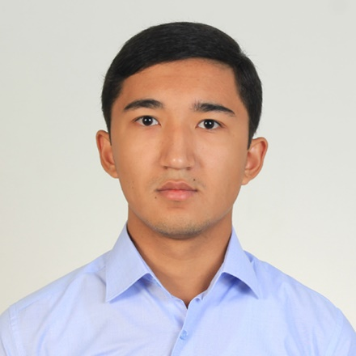tab

I am still stuyding at lucsid logistic academy. Really experienced at dealing with numbers and mathematic problems. Can speak english fluently. I have a thirst for knowledge as well as gaining experience that never stops me from learning . I think those talents passed from my dad (who is in the field of science and pHD doctor). Loyalty to the company stands in the first place and there is no therms like „tiredness” or „laziness” in my life. I became interested in this job 1 years ago and that’s why I chose „Transport logistics” as my major at the university. In addition, geography is my favourite subject which helps me working with maps.

**Experience**

Nowadays I’m looking for an occupation which will be beginning of my job experience.

**Education**

Tashkent Statue University of Economic

* Technologically savvy
* Flexible character
* Service-focused
* Have good concentration
* Decision maker under pressure
* Communication skills
* Understand maps, scales, distance(miles, km)

**Skill** **Highlights**

**Summary**

* Walking
* IT
* Reading
* Playing various games (table tennis, football, playstation)

**Hobbies** :

* English – B2
* Uzbek – C2
* Tel: 99-085-23-17
* Email: [mirsobitovv2317@gmail.com](mailto:mirsobitovv2317@gmail.com)
* Address: Tashkent, Shaykhantohur, Gulzor street Ipakchi 3 house.

**Contact**:

**Languages**:

*Mirsobitov Lazizbek*