Modul pro mikrokontroléry Atmel AVR32 řady AT32UC3A

Jakub Kákona

Modul obsahuje potřebné součástky pro provoz mikrokontroléru Atmel AVR32 řady AT32UC3A.

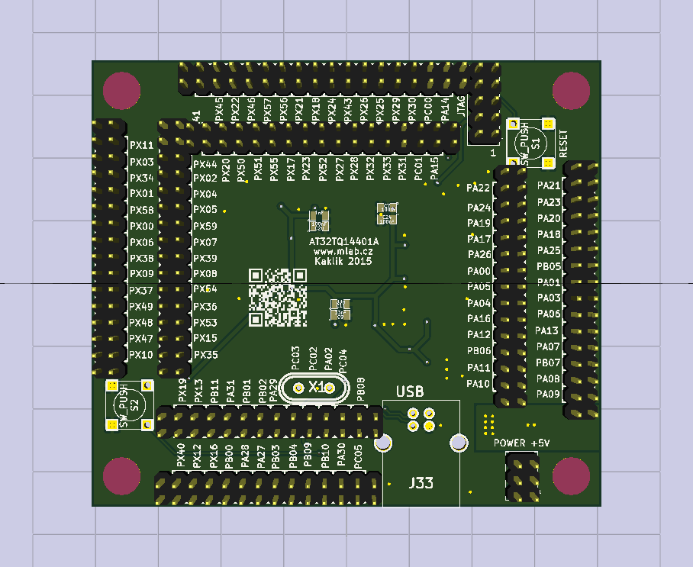

# Technické parametry

|  |  |  |
| --- | --- | --- |
| **Parametr** | **Hodnota** | **Poznámka** |
| Napájení | 5 V |  |
| Rozměry | 80 x 70 x 16 mm | Výška nad základní deskou |

# Osazení a oživení

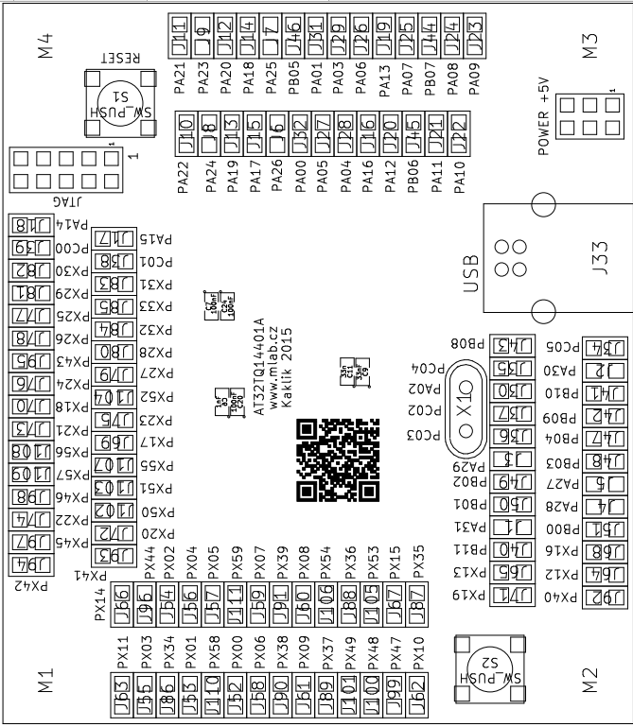 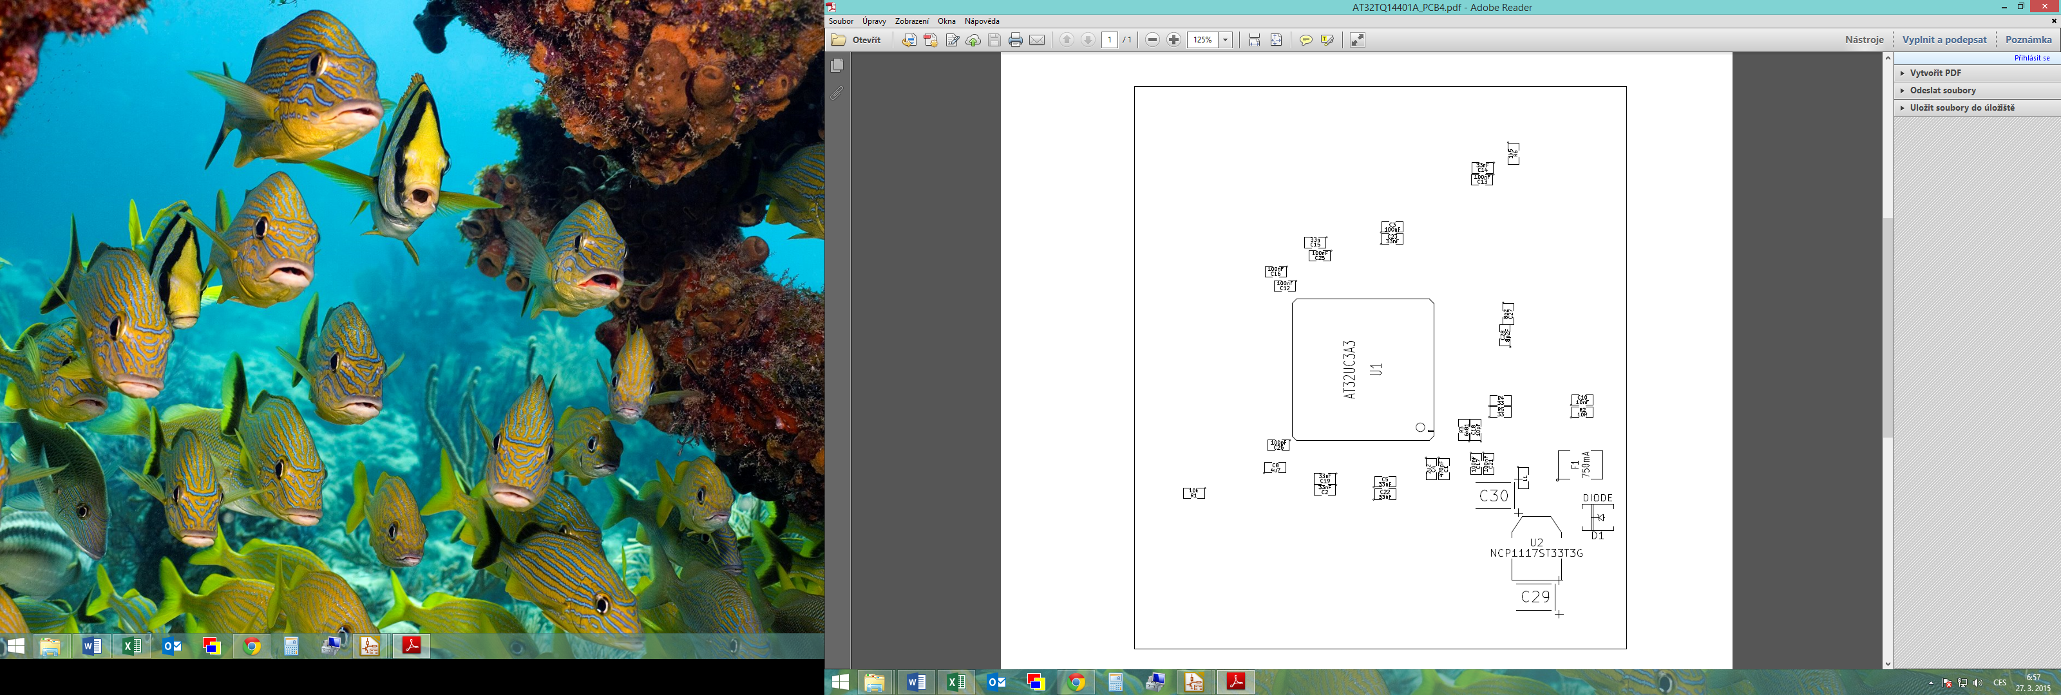

## Osazení

|  |  |  |  |
| --- | --- | --- | --- |
| Označení | Množství | Hodnota | Pouzdro |
| U1 | 1 | AT32UC3A3 | TQFP144 |
| C1 | 1 | 470pF | SM0805 |
| C2,C5,C9,C14,C19,C22,C23 | 7 | 33nF | SM0805 |
| C3,C7,C12,C13,C16,C17,C20,C21,C24,C25 | 10 | 100nF | SM0805 |
| C4 | 1 | 2u2 | SM0805 |
| C6 | 1 | 1nF | SM0805 |
| C8 | 1 | 4u7 | SM0805 |
| C10 | 1 | 10nF | SM0805 |
| C11,C15 | 2 | 33n | SM0805 |
| C18 | 1 | 10pF | SM0805 |
| C26 | 1 | 100pF | SM0805 |
| C27,C28 | 2 | 8p2 | SM0805 |
| F1 | 1 | 750mA | SM1812 |
| J33 | 1 | USB | USB_B |
| R1 | 1 | 10k | SM0805 |
| R3 | 1 | 6k81 | SM0805 |
| R4,R5 | 2 | 33 | SM0805 |
| R6 | 1 | 1k5 | SM0805 |
| X1 | 1 | 12MHz | Crystal_HC49-U_Vertical |
| D1 | 1 | DIODE | DO-214AC(SMA) |
| J1 - J111 | 110 | JUMP_2_CONN | Pin_Header_Straight_2x01 |
| L1 | 1 | BLM21PG300SN1 | SM0805 |
| R2 | 1 | 10R | SM0805 |
| U2 | 1 | NCP1117ST33T3G | SOT223 |
| C29,C30 | 2 | 10uF | TantalC_SizeB_EIA-3528_Reflow |
| M1,M2,M3,M4 | 4 | HOLE 3mm | MountingHole_3mm |
| CON1 | 1 | AVR-JTAG-10 | Straight_2x05 |
| J112 | 1 | HEADER_2x03 | Straight_2x03 |
| S1,S2 | 2 | SW_PUSH | SW_PUSH_SMALL |