Power operational amplifier module
Jakub Kákona
This module is designed to use as power driver for middle current applications.
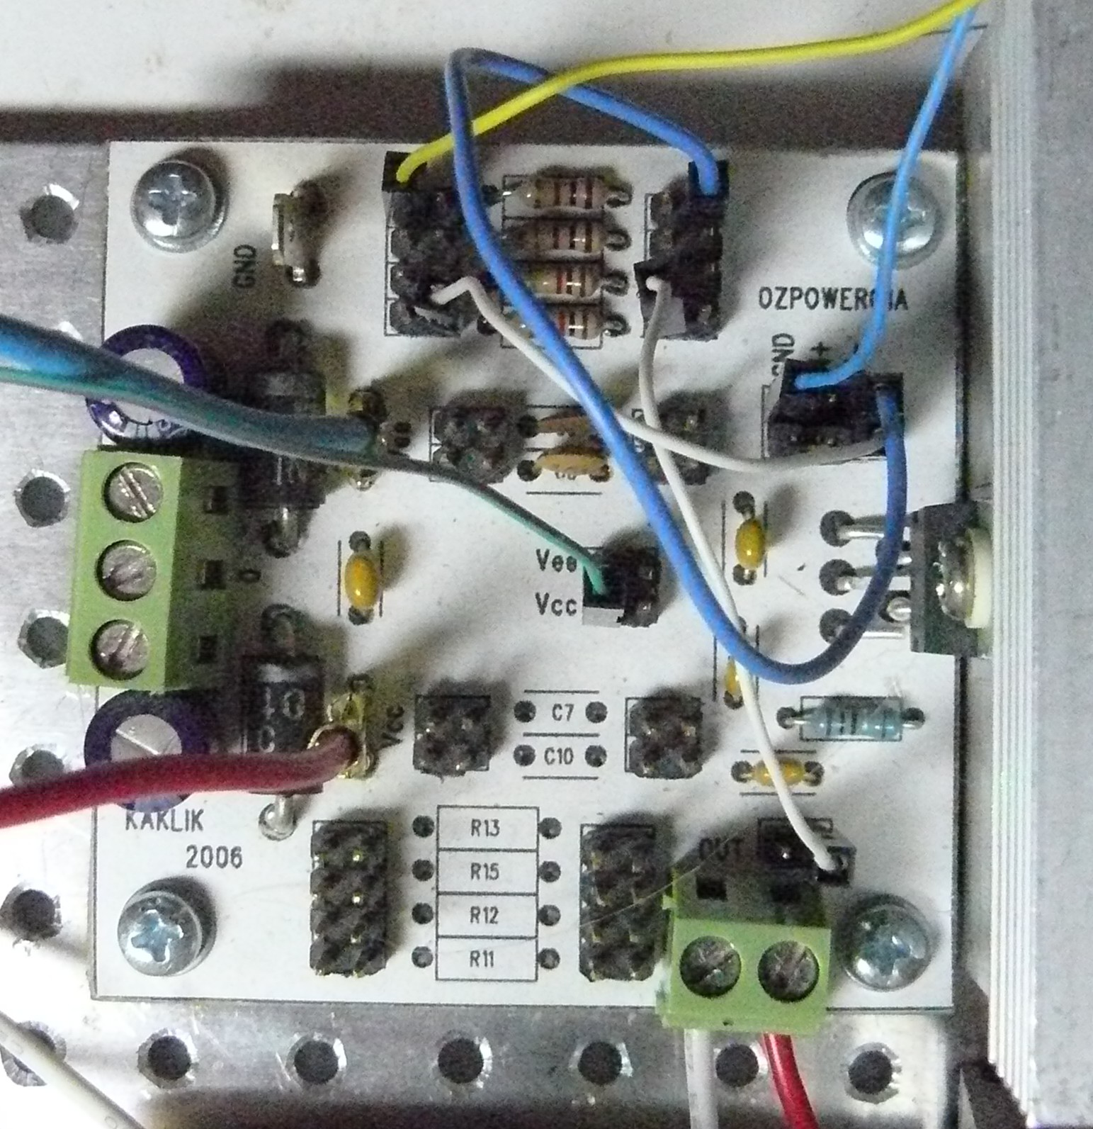

1. Technical parameters 2
2. Construction 2
2.1. Introduction 2
2.2. Module circuit 2
2.3. Integrated circuits 2
2.4. Mechanical construction 2
3. Assembling and testing 2
3.1. Assembling 2
3.2. Testing 2
4. Bugs and ideas 3

Technical parameters
Parameter | Value | Note
Max current | 3A | With forced cooling
Supply Voltage | ±20V

Construction

Introduction

Module circuit
Circuit of this module is derived from catalog informations.
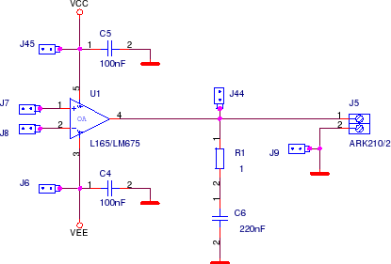
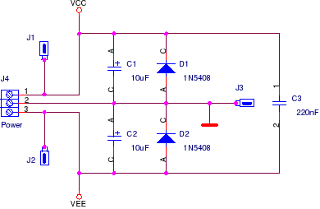

Integrated circuits
Almost any power operational amplifier in pentawatt 5 package is suitable for mount to PCB. The construction is tested with L165.

Mechanical construction
Module is optimized to allow mounting of a heat sink on the power chip package. All dimensions are compliant with MLAB standard.

Assembling and testing

Assembling
Assembling of this module is quite basic.
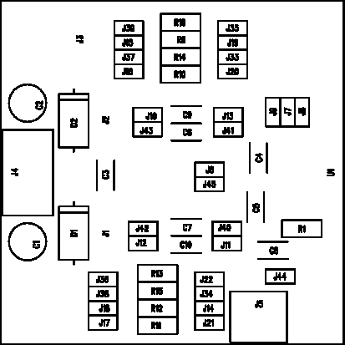
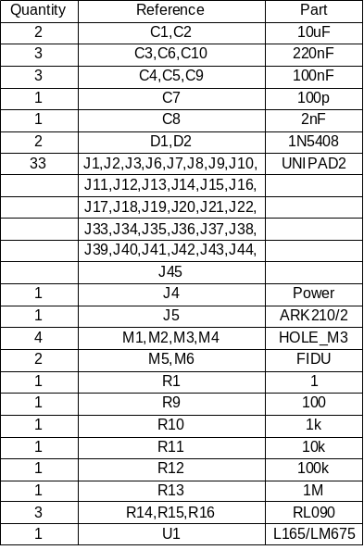

Testing
If we want to test this module we must do it carefully. Because we working with some type of power electronic and connecting full voltage source without current limitation isn't good idea.
We must use an CURRENT LIMITED source. For do this practice.

Bugs and ideas
There is no known any important problems at the moment.

