Project 2

# Introduction

This is Project 2 for STAT 557 2018 Spring by Meridith Bartley and Fei Jiang. The aim of this project is to practice the k-means algorithm and the k-nearest neighbor algorithm. In this project we applied {METHOD} to {WHAT TYPE} data in order to {ACHEIVE WHAT}.

# Description of Data

The examined group comprised kernels belonging to three different varieties of wheat: Kama, Rosa and Canadian, 70 elements each, randomly selected for the experiment. High quality visualization of the internal kernel structure was detected using a soft X-ray technique. It is non-destructive and considerably cheaper than other more sophisticated imaging techniques like scanning microscopy or laser technology. The images were recorded on 13x18 cm X-ray KODAK plates. Studies were conducted using combine harvested wheat grain originating from experimental fields, explored at the Institute of Agrophysics of the Polish Academy of Sciences in Lublin.

Boxplots for each attribute used as explanitory variables in the subsequent classification models are included below. This EDA allows for early indication of which variables may possibly be ommitted during dimention reduction. That is, what properties do not differ significantly between seed types.

## Exploritory Data Analysis

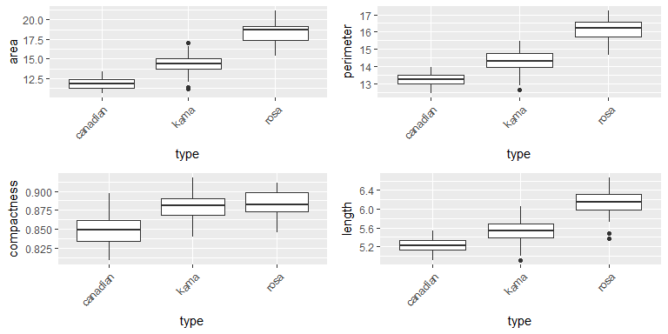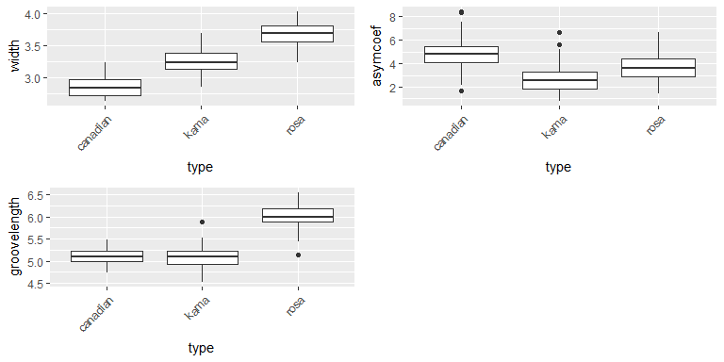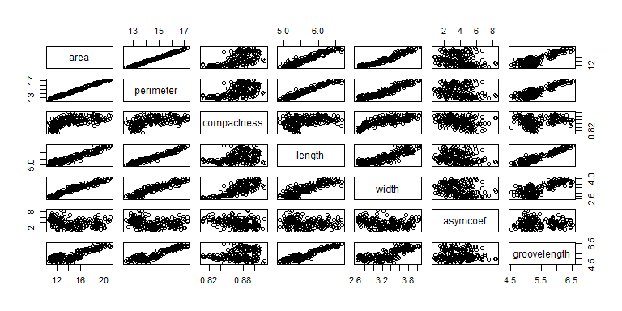

# Principle Component Analysis

In order to test whether dimension reduction will improve predictions we also conducted Principle Component Analysis on the original dataset to get a new dataset with fewer dimensions. According to our PCA results, the first two component in total can explain about 99.302% of variance of the original database. The coefficients of the relevent componets are listed in the table below. Therefore, we took the first two components and the seed type values to build a new dataset with less dimensions.

|  |  |  |  |  |  |  |  |
| --- | --- | --- | --- | --- | --- | --- | --- |
|  | PC1 | PC2 | PC3 | PC4 | PC5 | PC6 | PC7 |
| Standard deviation | 3.28532 | 1.459265 | 0.2713485 | 0.1135231 | 0.0524235 | 0.0396289 | 0.0054457 |
| Proportion of Variance | 0.82939 | 0.163630 | 0.0056600 | 0.0009900 | 0.0002100 | 0.0001200 | 0.0000000 |
| Cumulative Proportion | 0.82939 | 0.993020 | 0.9986800 | 0.9996700 | 0.9998800 | 1.0000000 | 1.0000000 |

|  |  |  |
| --- | --- | --- |
|  | PC1 | PC2 |
| area | -0.8842285 | 0.1008058 |
| perimeter | -0.3954054 | 0.0564896 |
| compactness | -0.0043113 | -0.0028947 |
| length | -0.1285445 | 0.0306217 |
| width | -0.1110591 | 0.0023723 |
| asymcoef | 0.1276156 | 0.9894105 |
| groovelength | -0.1289665 | 0.0822334 |

# Analysis

In the following analysis with two methods (k means and k-nearest neighbor algorithms - both supervised and unsupervised) and two datasets (original and dimension-reduced), we randomly selected 80% of the entire data as training data and the rest 20% as test data.

## K-Means Algorithm - Unsupervised clustering of Origianl Dataset

|  |  |  |  |
| --- | --- | --- | --- |
|  | 1 | 2 | 3 |
| canadian | 0 | 70 | 0 |
| kama | 1 | 12 | 57 |
| rosa | 60 | 0 | 10 |

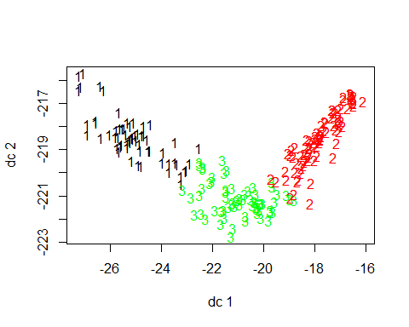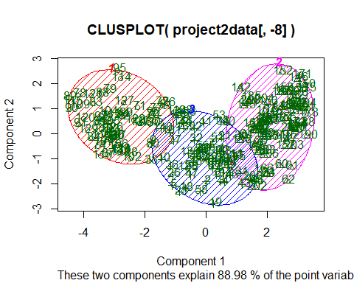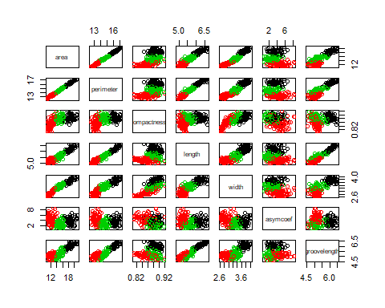

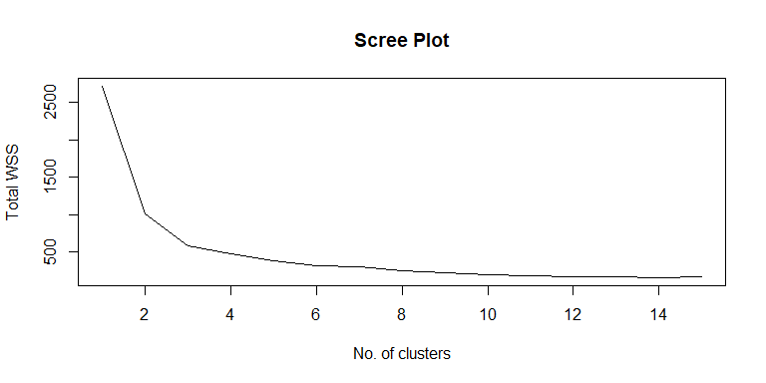

## K-Nearest Neighbor - Supervised clustering in Original Dataset

In this section, supervised K-nearest clustering is applied in the original dataset. The true and predictied lables in training and test data are shown in the figures below. In those figures, only first two predictors were shown. In general, in the training data, we obtained the accuracy rate of 92.9% and in the testing data, the accuarcy rate is about 90.5%. We think we reached a satisfying accuracy rate.

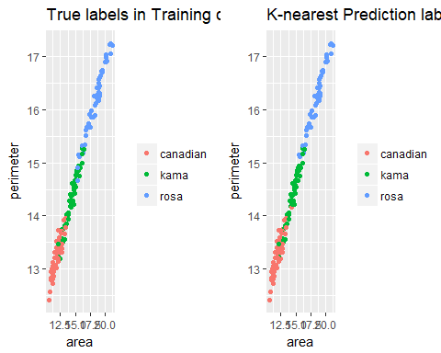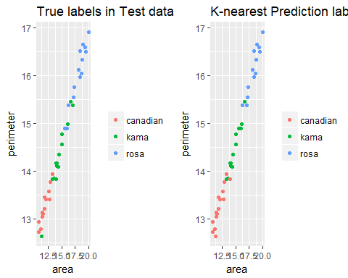

## K-Means and K-Centers Algorithm - Unsupervised clustering in Reduced Dataset (First Two Principle Components)

In this section, we applied unsupervised K-Means and K-Centers clustering algorithms to the reduced dataset (first two principle components).We tried 9 different numbers of clusters: 2 to 10 and plotted the scatter plot for each cluster number and for each algorithm. As the below figures show, there are differences between K-Center and K-Means clustering results. That is because k-means focuses on average distance while k-center focuses on worst scenario.

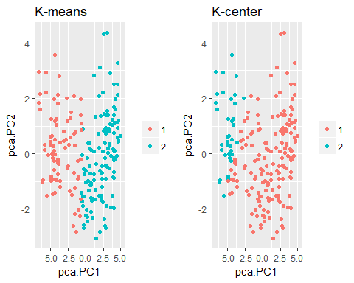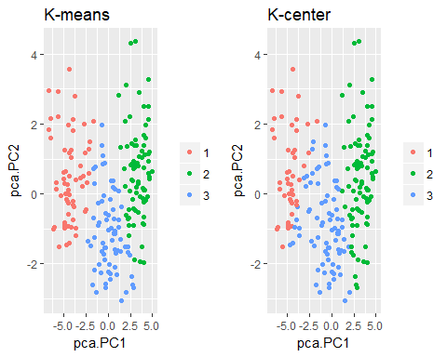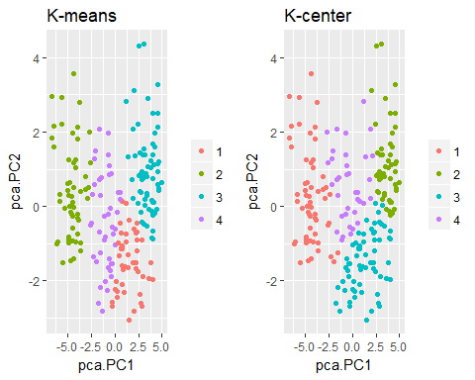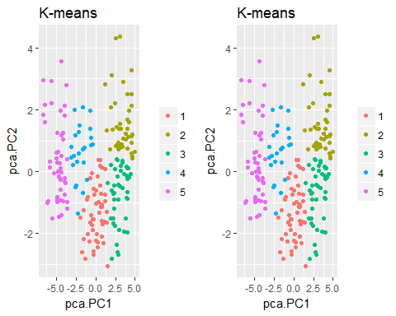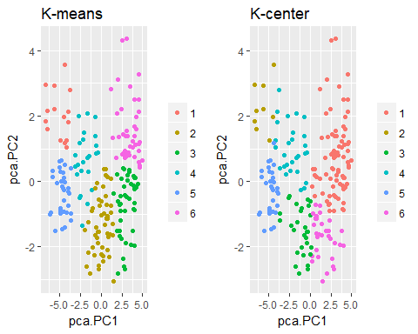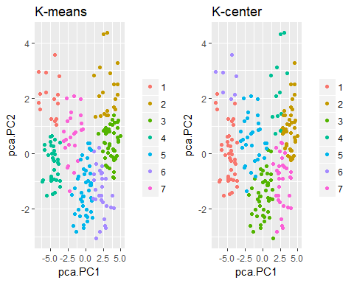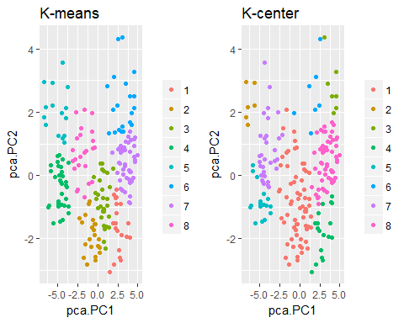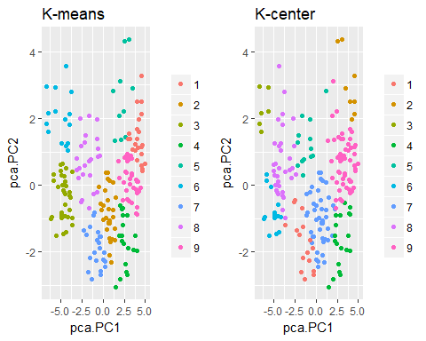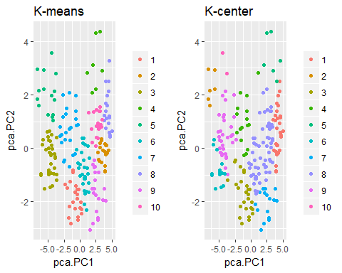

# Conclusions

To sum up, we finisehd the following analysis in this project.

1. The supervised K-nearest clustering method achieved over 90% accuracy in both training and test data, which is satisfying.
2. Applying differet k values, we explored the contrasting difference between k-means and k-center clustering methods.

# Contributions

The different tasks required to complete this project were equally divided between Meridith and Fei. K-means and cross-valiation analyses were completed by Meridith while Fei was responsible for K-nearest and K-center comparison. Both members of this group contributed to the presentation slides and this report.