Project 4

# Introduction

This is Project 4 for STAT 557 2018 Spring by Meridith Bartley and Fei Jiang. The aim of this project is to practice EM algorithm, mixture discriminant analysis (MDA) algrithm and compare MDA with QDA.

# Description of Data used for EM Algorithm

This dataset contains Wisconsin breast cancer data over the US downloaded from UCI Machine Learning Data Repository. With no missing data there are around 570 records, each of which includes ten real-valued features are computed for each cell nucleus (thickness,size.unif, shape.unif, adhesion, size.cell, nuclei, chromatin, nucleoli, mitoses) and the corresponding diagnosis (malignant or benign)

# Description of Data used for MDA and QDA

This dataset contains soil sample data over the US downloaded from Natural Resources Conservation Service (NRCS). After removing the incomplete data records and excluding the data records with impossible values, there are around 14,000 records left, each of which includes physical and chemical properties of soil samples (sand, silt, clay, organic carbon, bulk density, CEC soil, CEC clay, base saturation, and pH) and the corresponding soil classification group (soil order).

Boxplots for each physical and chemical property used as explanitory variables in the subsequent classification models are included below. This EDA allows for early indication of which variables may possibly be ommitted during dimention reduction. That is, what properties do not differ significantly between soil Orders.

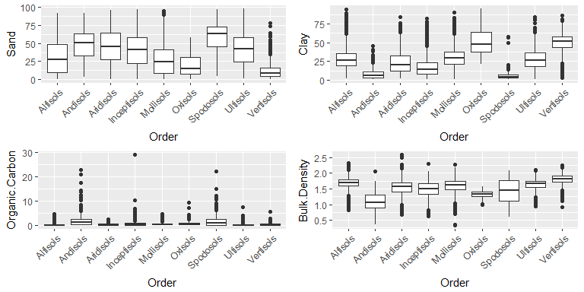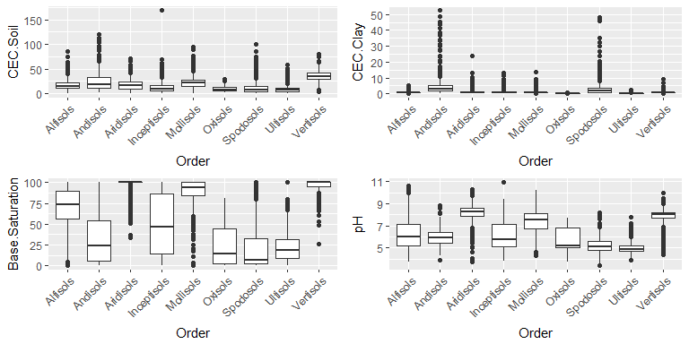

# Analysis

# EM Algorithm for Mixture of Gaussians in the breast cancer dataset

In this application of an EM algorithm for a mixutre of Gaussians we randomly divided our dataset to training data (70%) and test data (30%). We applied the EM algorithm to training data to get the model and then evaluated its accuracy in test data. Resulting plots and precition confusion table are included below.

## Warning in plot.window(...): "alpha" is not a graphical parameter

## Warning in plot.xy(xy, type, ...): "alpha" is not a graphical parameter

## Warning in axis(side = side, at = at, labels = labels, ...): "alpha" is not  
## a graphical parameter  
  
## Warning in axis(side = side, at = at, labels = labels, ...): "alpha" is not  
## a graphical parameter

## Warning in box(...): "alpha" is not a graphical parameter

## Warning in title(...): "alpha" is not a graphical parameter

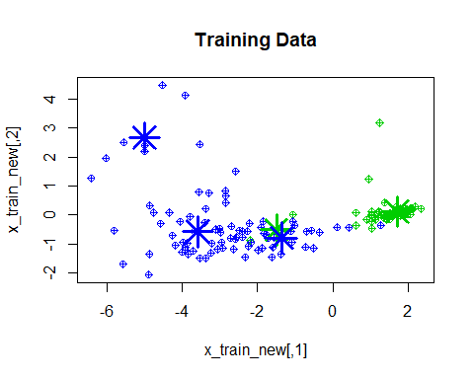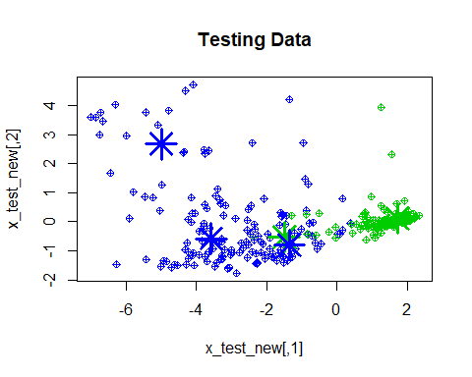

|  |  |  |
| --- | --- | --- |
|  | benign | malignant |
| benign | 312 | 5 |
| malignant | 11 | 151 |

## MDA and the effects of different numbers of components in the soil database

In this part of the analysis, we randomly divided our dataset to traning data (80%) and test data (20%). We applied MDA in training data to get the model and then evaluated its accuracy in test data. In order to test the effects of the number of components in model performance and elaborate the dilemma between model complexity and prediction accuracy, we conducted MDA with the number of components included ranging from 2 to 8. The plot below shows the increasing prediction accuracy with the increasing number of components included. Along with the number of components increasing from 2 to 8, the predicting accuracy increased from 51% to 61%. From a perspective of balancing model complexity and prediction accuracy, we chose our final MDA model with four components included and used that model to conduct following comparison with QDA model. 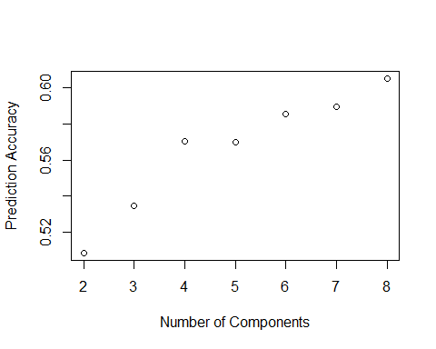

## Comaprison between MDA and QDA for the soil database

In this analysis, we conducted MDA and QDA analysis based on the same training and test dataset and the same first four components. The prediction accuracy for each soil types and overall accuracy of these two methods are shown in the table below. For the table we can see that the overall accuracy of MDA and QDA are very similar (57% for MDA and 56% for QDA). However, their ability in correctly predicting individual soil groups differed. For instance, MDA is better at Inceptisols and Mollisols while QDA is better at Aridisols and Vertisols.

|  |  |  |  |  |  |  |  |  |  |  |
| --- | --- | --- | --- | --- | --- | --- | --- | --- | --- | --- |
|  | Alfisols | Andisols | Aridisols | Inceptisols | Mollisols | Oxisols | Spodosols | Ultisols | Vertisols | Overall |
| MDA | 0.57 | 0.35 | 0.43 | 0.28 | 0.71 | 0.35 | 0.41 | 0.74 | 0.56 | 0.57 |
| QDA | 0.54 | 0.26 | 0.69 | 0.04 | 0.58 | 0.35 | 0.58 | 0.81 | 0.74 | 0.56 |

# Conclusion

In this project, we finished up two part.

In the first part, we coded a EM algorithm for mixed Gaussians and applied it to a breast cancer dataset. Code for the EM functions are included in the Appendix below.

In the second part, we conducted MDA on our dataset and explored the increasing prediction accuracy with the increasing model complexity. Through comparison with QDA on the same dataset using same predictors, we found out the comparably acceptable performance of these two methods.

# Contributions

The different tasks required to complete this project were equally divided between Meridith and Fei. Both members of this group contributed to the presentation slides and this report.

## Appendix

library(ggplot2)  
library(DAAG)  
library(dplyr)  
library(magrittr)  
library(MASS)  
library(caret)  
library(nnet)   
library(scales)  
library(klaR)  
library(stats)  
library(grid)  
library(gridExtra)  
library(mclust)  
library(mvtnorm)  
library(mda)  
  
  
### split data into test and training sets  
# df: data set  
# train_amt: proportion of data to use for training  
# resp_idx: which column the class variable is (for breast cancer data this is 10)  
split_data <- function(df, train_amt, resp_idx) {  
 N <- floor(nrow(df) * train_amt)  
 ind <- sample.int(nrow(df), size = N)  
 x_train <- as.matrix(df[ind,-resp_idx])  
 x_test <- as.matrix(df[-ind,-resp_idx])  
 class_train <- df[ind,resp_idx]  
 class_test <- df[-ind,resp_idx]  
 return(list(x_train = x_train,  
 x_test = x_test,  
 class_train = class_train,  
 class_test = class_test))  
}  
  
### EM algorithm  
# x: covariates (as a matrix, one row = one observation)  
# y: response (as a factor)  
# R: number of subclasses for each class  
# tol: condition for convergence  
# maxit: maximum number of iterations for EM to run  
EM <- function(x, y, R, tol = 1e-6, maxit = 10) {  
 labs <- levels(y)  
 K <- length(labs)  
 M <- ncol(x)  
 N <- nrow(x)  
 pi <- array(0, dim = c(K, R))  
 mu <- array(0, dim = c(K, M, R))  
 sigma <- diag(M)  
 y <- as.numeric(y)  
 ### come up with starting points using kmeans  
 for(k in 1:K) {  
 ind <- which(y == k)  
 mu[k, , ] <- t(kmeans(x[ind, ], R)$centers)  
 pi[k, ] <- rep(1/R, length = R)  
 }  
 converged <- F  
 ### main EM loop  
 # while(!converged) {  
 for(it in 1:maxit) {  
 # E step  
 p <- array(0, dim = c(N, R))  
 for(i in 1:N) {  
 k <- y[i]  
 for(r in 1:R) {  
 p[i,r] <- pi[k,r] * dmvnorm(x[i, ], mu[k, ,r], sigma)  
 }  
 p[i, ] <- p[i, ]/sum(p[i, ])  
 }  
 # M step  
 for(k in 1:K) {  
 ind <- which(y == k)  
 for(r in 1:R) {  
 pi[k,r] <- sum(p[ind,r])/length(ind)  
 mu[k, ,r] <- colSums(x[ind, ]*p[ind,r])/sum(p[ind,r])  
 }  
 }  
 tally <- 0  
 for(i in 1:N) {  
 z <- y[i]  
 for(r in 1:R) {  
 tmp <- x[i, ] - mu[z, ,r]  
 tally <- tally + p[i,r] * (tmp %o% tmp)  
 }  
 }  
 sigma <- tally/N  
 # check convergence  
  
 }  
 return(list(pi = pi,  
 mu = mu,  
 sigma = sigma,  
 class_labels = labs))  
}  
  
### predict classes  
# em: object from the result of EM function above  
# x: new data (as a matrix, one row = one observation)  
em_predict <- function(em, x) {  
 pi <- em$pi  
 mu <- em$mu  
 sigma <- em$sigma  
 labs <- em$class_labels  
 K <- dim(mu)[1]  
 R <- dim(mu)[3]  
 classes <- rep(NA, nrow(x))  
  
 for(i in 1:nrow(x)) {  
 probs <- rep(0, K)  
 for(k in 1:K) {  
 for(r in 1:R) {  
 probs[k] <- probs[k] + pi[k,r] * dmvnorm(x[i, ], mean = mu[k, ,r], sigma = sigma)  
 }  
 }  
 classes[i] <- which.max(probs)  
 }  
 return(factor(classes, labels = labs))  
}  
#EM data  
# read data in and format it  
data <- read.csv('http://archive.ics.uci.edu/ml/machine-learning-databases/breast-cancer-wisconsin/breast-cancer-wisconsin.data', header = F, na.strings = '?')  
names(data) <- c('id','thickness','size.unif','shape.unif','adhesion','size.cell','nuclei','chromatin','nucleoli','mitoses','class')  
data$class <- as.factor(data$class)  
levels(data$class) <- c('benign','malignant')  
data <- data[-which(is.na(data$nuclei)),-1] # leave ID column out and remove NAs  
  
  
# Basic clearning of our dataset   
project1data <- read.csv(file = "project1data.csv")  
project1data <- project1data[,-c(1,2,4)] #remove the ID and Horizon columns which are useless,Silt is redundant information since it could be calculated from Sand and Clay.   
project1data <- project1data[sample(nrow(project1data),nrow(project1data)),] ###shuffle rows  
  
  
  
varlist <- names(project1data)[-9]  
  
customPlot <- function(varName) {  
  
project1data %>%   
group_by_("Order") %>%   
select_("Order",varName) %>%   
ggplot(aes_string("Order",varName)) + geom_boxplot() +   
 theme(axis.text.x = element_text(angle = 45, hjust = 1))  
  
}  
  
grid.arrange(grobs = lapply(varlist[1:4],customPlot))  
grid.arrange(grobs = lapply(varlist[5:8],customPlot))  
  
  
# pairs(project1data)  
# cor(project1data[, -9])  
  
  
  
# Create new dataset with PCA   
pca = prcomp(project1data[,-9])  
# print(pca$rotation)  
summary.pca = summary(pca)  
# print(summary.pca)  
project1data.new = data.frame(pca=pca$x[,1:8],Order=project1data$Order)   
  
#table of the variance and coefficients  
#knitr::kable(summary.pca$importance)  
#knitr::kable(pca$rotation[, 1:4])  
  
  
#data partition  
train_id <- caret::createDataPartition(y=project1data.new$Order, p=0.8,list = FALSE)  
train <- project1data.new[train_id,]  
test <- project1data.new[-train_id,]  
# Mixture Discriminant Analysis (MDA)  
  
  
  
  
  
  
R <- 3 # number of subclasses  
training_amount <- 0.3  
  
X <- split_data(data, training_amount, 10)  
x_train <- X$x_train  
x_test <- X$x_test  
class_train <- X$class_train  
class_test <- X$class_test  
  
# run MDA  
fit <- EM(x_train, class_train, R)  
# classify test data  
fit_pred <- em_predict(fit, x_test)  
# resulting confusion matrix and error rate  
# confusion(fit_pred, class_test)  
  
# try PCA  
x <- rbind(x_train, x_test)  
x_scaled <- apply(x, 2, function(x) (x - mean(x))/sd(x))  
eig <- eigen(cov(x_scaled))  
# eig$values/sum(eig$values)  
V <- eig$vectors[ ,1:2]  
x_new <- as.matrix(x_scaled %*% V)  
x_train_new <- x_new[1:nrow(x_train), ]  
x_test_new <- x_new[-(1:nrow(x_train)), ]  
  
fit2 <- EM(x_train_new, class_train, R)  
fit_pred2 <- em_predict(fit2, x_test_new)  
# confusion(fit_pred2, class_test)  
  
#training plot  
plot(x_train_new, pch = 10, alpha = 0.5, col = as.numeric(class_train)+2,   
 main = "Training Data")  
points(t(fit2$mu[1, , ]), pch = 8, cex = 3, lwd = 3, col = 3)  
points(t(fit2$mu[2, , ]), pch = 8, cex = 3, lwd = 3, col = 4)  
#testing plot  
plot(x_test_new, pch = 10, col = as.numeric(class_test)+2,  
 main = "Testing Data")  
points(t(fit2$mu[1, , ]), pch = 8, cex = 3, lwd = 3, col = 3)  
points(t(fit2$mu[2, , ]), pch = 8, cex = 3, lwd = 3, col = 4)  
  
  
  
knitr::kable(table(fit_pred2, class_test))  
  
  
#mda - 2 component   
mda.2 <- mda(Order ~ pca.PC1 + pca.PC2 , data = train)  
#predict test data  
mda2.predict = predict(mda.2, newdata=test)  
# Assess the total accuracy of test data  
ct2.mda <- table(test$Order, mda2.predict)  
totcorrect2.mda <- sum(diag(prop.table(ct2.mda)))  
# Assess the accuracy of the prediction for each soil class (Order) in test data  
#cc2.mda <- diag(prop.table(ct2.mda, 1))  
  
#mda - 3 component   
mda.3 <- mda(Order ~ pca.PC1 + pca.PC2+ pca.PC3 , data = train)  
#predict test data  
mda3.predict = predict(mda.3, newdata=test)  
# Assess the total accuracy of test data  
ct3.mda <- table(test$Order, mda3.predict)  
totcorrect3.mda <- sum(diag(prop.table(ct3.mda)))  
  
#mda - 4 component   
mda.4 <- mda(Order ~ pca.PC1 + pca.PC2+ pca.PC3+ pca.PC4 , data = train)  
#predict test data  
mda4.predict = predict(mda.4, newdata=test)  
# Assess the total accuracy of test data  
ct4.mda <- table(test$Order, mda4.predict)  
totcorrect4.mda <- sum(diag(prop.table(ct4.mda)))  
  
#mda - 5 component   
mda.5 <- mda(Order ~ pca.PC1 + pca.PC2+ pca.PC3+ pca.PC4 + pca.PC5, data = train)  
#predict test data  
mda5.predict = predict(mda.5, newdata=test)  
# Assess the total accuracy of test data  
ct5.mda <- table(test$Order, mda5.predict)  
totcorrect5.mda <- sum(diag(prop.table(ct5.mda)))  
  
#mda - 6 component   
mda.6 <- mda(Order ~ pca.PC1 + pca.PC2+ pca.PC3+ pca.PC4 + pca.PC5+ pca.PC6, data = train)  
#predict test data  
mda6.predict = predict(mda.6, newdata=test)  
# Assess the total accuracy of test data  
ct6.mda <- table(test$Order, mda6.predict)  
totcorrect6.mda <- sum(diag(prop.table(ct6.mda)))  
  
#mda - 7 component   
mda.7 <- mda(Order ~ pca.PC1 + pca.PC2+ pca.PC3+ pca.PC4 + pca.PC5+ pca.PC6+ pca.PC7, data = train)  
#predict test data  
mda7.predict = predict(mda.7, newdata=test)  
# Assess the total accuracy of test data  
ct7.mda <- table(test$Order, mda7.predict)  
totcorrect7.mda <- sum(diag(prop.table(ct7.mda)))  
  
#mda - 8 component   
mda.8 <- mda(Order ~ pca.PC1 + pca.PC2+ pca.PC3+ pca.PC4 + pca.PC5+ pca.PC6+ pca.PC7+ pca.PC8, data = train)  
#predict test data  
mda8.predict = predict(mda.8, newdata=test)  
# Assess the total accuracy of test data  
ct8.mda <- table(test$Order, mda8.predict)  
totcorrect8.mda <- sum(diag(prop.table(ct8.mda)))  
  
plot(x=c(2:8),y=c(totcorrect2.mda,totcorrect3.mda,totcorrect4.mda,totcorrect5.mda,totcorrect6.mda,totcorrect7.mda,totcorrect8.mda),xlab = "Number of Components", ylab = "Prediction Accuracy")  
  
#mda - 4 component   
mda <- mda(Order ~ pca.PC1 + pca.PC2+ pca.PC3+ pca.PC4 , data = train)  
#predict test data  
mda.predict = predict(mda, newdata=test)  
# Assess the accuracy of the prediction for each soil class (Order) in test data  
ct.mda <- table(test$Order, mda.predict)  
cc.mda <- diag(prop.table(ct.mda, 1))  
# Assess the total accuracy of test data  
totcorrect.mda <- sum(diag(prop.table(ct4.mda)))  
  
  
#qda  
qda.fei <- MASS::qda(Order ~pca.PC1 + pca.PC2+ pca.PC3+ pca.PC4, data = train)  
  
#predict test data  
qda.predict = predict(qda.fei, newdata=test)  
  
# Assess the accuracy of the prediction for each soil class (Order) in test data  
ct.qda <- table(test$Order, qda.predict$class)  
cc.qda <- diag(prop.table(ct.qda, 1))  
  
  
### comparison   
#mda  
correct.mda <- diag(prop.table(ct.mda, 1))  
# total percent correct  
totcorrect.mda <- sum(diag(prop.table(ct.mda)))  
  
#qda  
correct.qda <- diag(prop.table(ct.qda, 1))  
# total percent correct  
totcorrect.qda <- sum(diag(prop.table(ct.qda)))  
  
  
##table   
  
model_comparison <- data.frame(rbind(correct.mda, correct.qda))  
model_comparison$Overall=c(totcorrect.mda,totcorrect.qda)  
  
model_comparison <-model_comparison %>%set_rownames(c("MDA", "QDA"))  
knitr::kable(round(model_comparison, digits = 2))  
  
#p <- ggplot(test, aes(x = Sand, y = Clay, color = mda.predict)) + geom_point() + stat_contour(aes(x = Sand, y = Clay, z = mda.predict), data = test) + labs(title="MDA Decision Boundaries")  
#p