Temperatura EMA CADIC

SIAG

## Quarto

Quarto enables you to weave together content and executable code into a finished document. To learn more about Quarto see <https://quarto.org>.

## Running Code

When you click the **Render** button a document will be generated that includes both content and the output of embedded code. You can embed code like this:

library(tidyverse)

── Attaching core tidyverse packages ──────────────────────── tidyverse 2.0.0 ──  
✔ dplyr 1.1.4 ✔ readr 2.1.5  
✔ forcats 1.0.0 ✔ stringr 1.5.1  
✔ ggplot2 3.5.1 ✔ tibble 3.2.1  
✔ lubridate 1.9.3 ✔ tidyr 1.3.1  
✔ purrr 1.0.2   
── Conflicts ────────────────────────────────────────── tidyverse_conflicts() ──  
✖ dplyr::filter() masks stats::filter()  
✖ dplyr::lag() masks stats::lag()  
ℹ Use the conflicted package (<http://conflicted.r-lib.org/>) to force all conflicts to become errors

EMA_CADIC <- read_delim (file = "EMA_CADIC.csv" , delim = ";")

Rows: 238501 Columns: 11  
── Column specification ────────────────────────────────────────────────────────  
Delimiter: ";"  
chr (6): datetime, outTemp, dewpoint, windDir, windGustDir, rain  
dbl (3): unixepoch, windSpeed, windGust  
num (2): outHumidity, barometer  
  
ℹ Use `spec()` to retrieve the full column specification for this data.  
ℹ Specify the column types or set `show_col_types = FALSE` to quiet this message.

ggplot(data = EMA_CADIC)



EMA_CADIC_numerica <- EMA_CADIC %>%   
 mutate (outTemp_2 = as.numeric(outTemp))

Warning: There was 1 warning in `mutate()`.  
ℹ In argument: `outTemp_2 = as.numeric(outTemp)`.  
Caused by warning:  
! NAs introducidos por coerción

EMA_CADIC_filter <- EMA_CADIC %>% filter(!is.na(outTemp)) #   
  
EMA_CADIC_str <- EMA_CADIC %>%   
 mutate (outTemp_3 = as.numeric(str_replace (outTemp, "," , ".")))  
  
ggplot(data = EMA_CADIC_str) +   
 geom_point(aes(x = unixepoch , y = outTemp_3))

Warning: Removed 356 rows containing missing values or values outside the scale range  
(`geom_point()`).

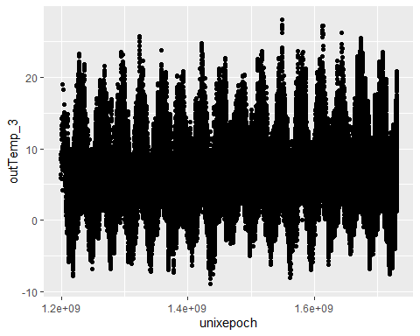

You can add options to executable code like this

[1] 4

The echo: false option disables the printing of code (only output is displayed).