

**Software Design   
 Specification (SDS)**

BabbleBot

Version 1.0

Prepared by:

Group 6  
Mad DJs

|  |  |  |
| --- | --- | --- |
| * Morgan McKeithan |  | Mckeithanm15@students.ecu.edu |
| * Ashley Fraley |  | Fraleya14@students.ecu.edu |
| * Jeremiah Smith |  | Smithjere14@students.ecu.edu |
| * Eric Sengmany |  | Sengmanye14@students.ecu.edu |
| * Daehan Barnes |  | Barnesda14@students.ecu.edu |

|  |  |
| --- | --- |
| Instructor: | Dr. Kamran Sartipi |
| Course: | CSCI 3030 (Software Engineering I) |
| Date: | 10/30/2017 |

Contents

Revisions ii

1 Introduction 1

1.1 Purpose 1

1.2 System Overview 1

1.3 Definitions, Acronyms and Abbreviations 1

1.4 Supporting Materials 1

1.5 Document Overview 1

2 Architecture 2

2.1 Overview 2

2.2 Component 1..n 2

3 High-Level Design 3

4 Low-Level Design 4

4.1 Modules Overview 4

4.2 Module Specifications 4

4.2.1 Module X1 4

4.2.2 Module X2 5

Appendix A – Group Log 6

Revisions

| Version | Primary Author(s) | Description of Version | Date Completed |
| --- | --- | --- | --- |
| 1.0 | Morgan McKeithan, Eric Sengmany, Jeremiah Smith, Ashley Fraley, Daehan Barnes | Complete first version of the BabbleBot Software Design Specification document | 10/30/17 |

# Introduction

## Purpose

This document provides a complete example of the first version of a Software Design Specification document for the machine learning chat bot, BabbleBot. This document is primarily based on the SRS document that was earlier prepared. In the remainder of section 1, we specify the purpose of this document, the overview of BabbleBot, and the sources used in the production of this document.

## System Overview

BabbleBot Software System runs is accessed through a website. The minimal requirements related to the user accessing the website are listed in section 2.4 (Operating Environment) of the BabbleBot SRS v. 1.0 document. The system will make use of the BabbleBot database by sending user input to the program and accessing the database to formulate a response to then send back to the website to show the user. The database will interact on the Internet with Scrub dictionary in order to gain the part of speech of new words to be entered into the database. The main purpose of BabbleBot is to educate users on sentence structure.

## Definitions, Acronyms and Abbreviations

AI – artificial intelligence

ML – machine learning

## Supporting Materials

**The following standards apply**:

J-STD-016-1995 IEEE/EIA Standard for Information Technology, Software Lifecycle Processes, Software Development, Acquirer-Supplier Agreement

IEEE-STD-P1063 IEEE Standard for Software User Documentation

**The following texts and documents have been used in the process of developing this document**:

[1] SDS for MiniThermostat template

## Document Overview

The next section of the BabbleBot SDS v. 1.0 provides the architectural view of the system. It shows the BabbleBot system broken down into subsystems and the reasons for each subsystem. Subsections of section 2 describe the subsystems and their corresponding interfaces. Section 3 provides a control view of BabbleBot and describes the details of each state of the system. Section 4 provides a low-level design of the system.

# Architecture

This section provides the architecture design of the BabbleBot software system. It includes the final version of the system component diagram which shows the different subsystems, their interfaces, and their dependencies on related subsystems. Section 2.2 discusses the different components of BabbleBot. The next section provides the Component Diagram.

## Overview../Desktop/Screen%20Shot%202017-10-30%20at%2011.24.52%20AM.png

As illustrated in the component diagram above, BabbleBot architecture consists of three main components:

1. User Interface/Website
2. BabbleBot Program
3. Database

In order to make the architecture more understandable, maintainable, and adoptable for changes it was decomposed according to the different functional areas that the system covers. The BabbleBot SRS covers the functionality in more detail of each component.

## User Interface

Babblebot will be showcased on an aesthetically pleasing platform to capture user attention and allow for easier conversing.

* Input box - the input box allows for a user to send data to the BabbleBot program
* Conversation History box (Output) – this interface comes from the BabbleBot program – it will be the history of responses that are created by BabbleBot
* Sentence structure diagram area (Output) – this interface comes from the BabbleBot program – a tree will be displayed showing the parts of speech of each word that the user inputs

## BabbleBot Program

Whether it is a question or statement, BabbleBot will read in user input, analyze it, and send out an appropriate response as well as a sentence structure diagram

* Retreieve input from website
* Compare input with BabbleBot’s existing database
* Send output back to website

## BabbleBot Database

The BabbleBot database consists of stored words and their parts of speech. The stored words are words that have been previously inputted to BabbleBot. After each new input, BabbleBot will add to the database in order to improve itself.

# High-Level Design

The High-Level Design section describes in further detail the interactions between the system components and their corresponding interfaces. To illustrate the dynamic behavior of the BabbleBot system, a statechart showing how the components interact with each other is shown.

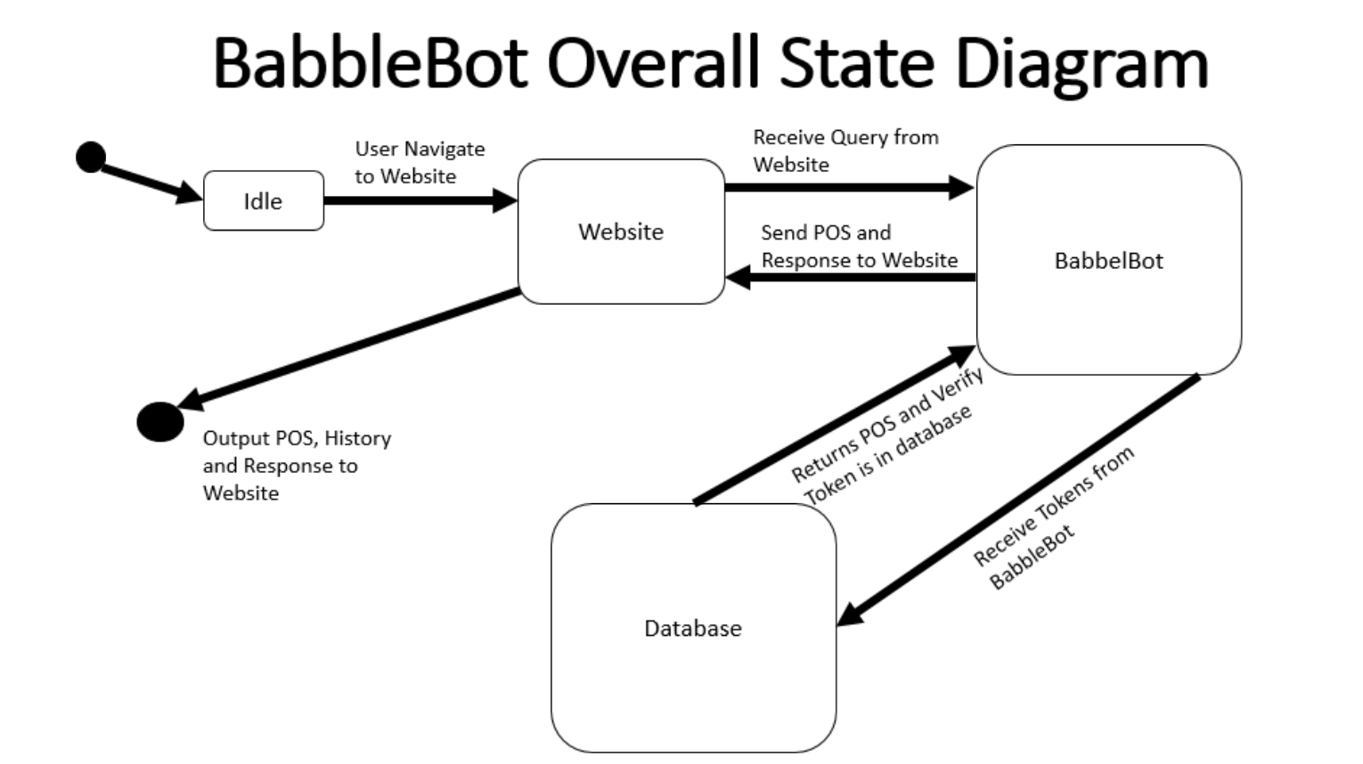

# Low-Level Design

The following sections describe the low-level design of the BabbleBot software system. It breaks down previously discussed components into modules. The next section provides an overview of the modules and then the following sections go more into detail on the interface and design of each module.

## Modules Overview

BabbleBot system was decomposed to _ independent modules. A brief description of each module is provided below:

**Name: About**

**File Name:** About.html

**Naming Convention:**

**Short Description:** This module is a part of the website component. It is an additional feature that tells about our software.

**Container Component:** User Interface

**Name: Babble Bot Interface**

**File Name:** Babble Bot.html

**Naming Convention:**

**Short Description:** This module is a part of the website component. It is where the user will be able to access the BabbleBot program and its user interface. The interface will include a conversation history and input text box, with the conversation history showing all of your previous cached conversations with BabbleBot and with the input box being where the user inputs new queries to BabbleBot.

**Container Component:** User Interface

**Name: Home**

**File Name:** Home.html

**Naming Convention:**

**Short Description:**

**Container Component:** User Interface

## Module Specifications

*<This section refers to two major types of module specifications. The first concentrates on module interface and the second on its design. In the following sections you will provide a detailed description of the module interface and its design. You will illustrate its design using Statecharts.*

*TO DO: Start with providing a short introduction of what the reader should expect to find in this section. >*

### User interface/Website Module

*< There are many different techniques used to specify both – the interface and the design. For interface the techniques can be TDN, GDN, etc. For the design a pseudo-code might prove to be useful. In this template we use a hybrid of several different techniques to specify the interface, and Statechart to specify the design. Remember, module interface is like a tip of an iceberg, it should only show what the others must see.>*

*TO DO: Use the following template to specify the module interface for Module X1.*

|  |  |
| --- | --- |
| **Used External Modules:** | List the modules this module has a USES relation with. |
| **Used External Data Type:** | List the data types, provided by other modules, that this module uses, that will prove to be important in understanding its interface or design. |
| **Internal State Variables:** | List the module’s internal state variables. |
| **Internal Constants:** | List (if any) the internal constants |

|  |  |
| --- | --- |
| **Exported Function(s)** | **Description** |
| The name of the functions | Provide a description of the function, specifying its inputs, outputs and tasks it performs. |

|  |  |
| --- | --- |
| **Internal Function(s)** | **Description** |
| The name of the functions | Provide a description of the function, specifying its inputs, outputs and tasks it performs. |

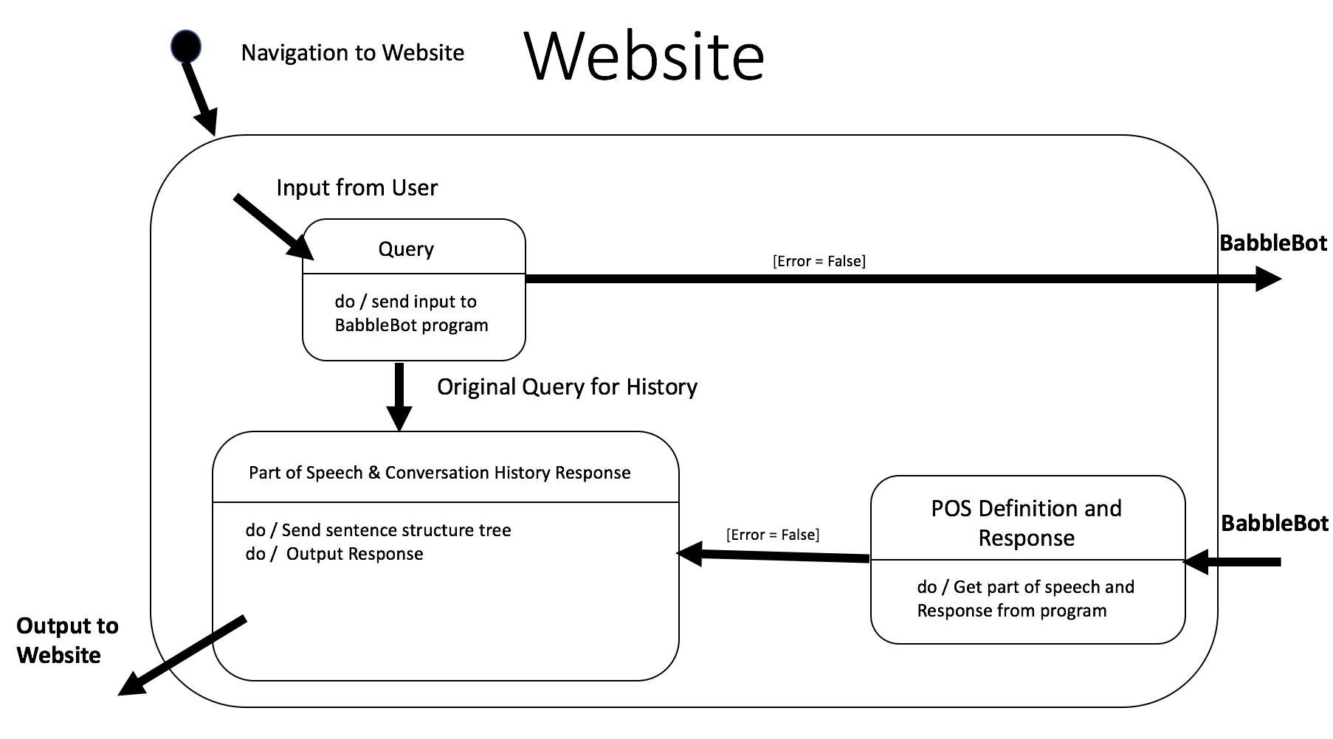

### BabbleBot Program Module

The BabbleBot program is the most important module of the system. It directs data traffic where it should go. It also is able to put “part-of-speech” tags on words as well as create a response for BabbleBot to send to the user of the website.

|  |  |
| --- | --- |
| **Used External Modules:** | NLTK (Natural Language Tool Kit) |
| **Used External Data Type:** | List the data types, provided by other modules, that this module uses, that will prove to be important in understanding its interface or design. |
| **Internal State Variables:** | List the module’s internal state variables. |
| **Internal Constants:** | List (if any) the internal constants |

|  |  |
| --- | --- |
| **Exported Function(s)** | **Description** |
| The name of the functions | Provide a description of the function, specifying its inputs, outputs and tasks it performs. |

|  |  |
| --- | --- |
| **Internal Function(s)** | **Description** |
| The name of the functions | Provide a description of the function, specifying its inputs, outputs and tasks it performs. |

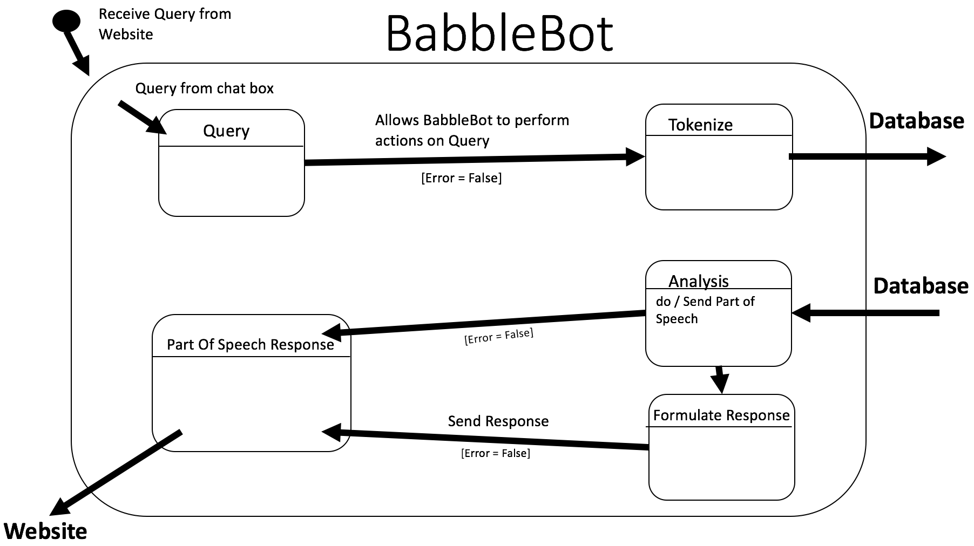

### BabbleBot Database Module

|  |  |
| --- | --- |
| **Used External Modules:** | List the modules this module has a USES relation with. |
| **Used External Data Type:** | List the data types, provided by other modules, that this module uses, that will prove to be important in understanding its interface or design. |
| **Internal State Variables:** | List the module’s internal state variables. |
| **Internal Constants:** | List (if any) the internal constants |

|  |  |
| --- | --- |
| **Exported Function(s)** | **Description** |
| The name of the functions | Provide a description of the function, specifying its inputs, outputs and tasks it performs. |

|  |  |
| --- | --- |
| **Internal Function(s)** | **Description** |
| The name of the functions | Provide a description of the function, specifying its inputs, outputs and tasks it performs. |

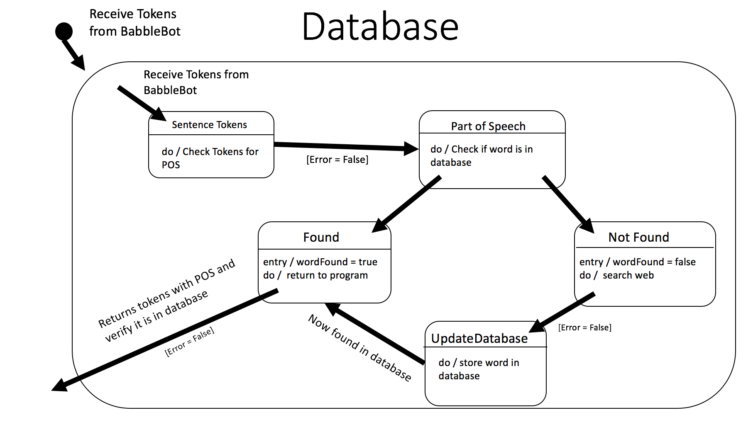

Appendix A – Group Log

GroupMe discussion – October 18, 2017: Split SDS into sections

GroupMe discussion – October 21, 2017: Discuss any problems/updates

Group meeting – October 28, 2017: work on further programming of BabbleBot and figure out how to appropriately fill out section 4 of the SDS

Group meeting – October 30, 2017: finalize StateCharts