Part1

Q1

Initial Centroids:

{0: array([ 5.1, 3.5, 1.4, 0.2]), 1: array([ 4.9, 3. , 1.4, 0.2]), 2: array([ 4.7, 3.2, 1.3, 0.2])}

After first iteration

{0: array([ 2.55 , 2.55 , 2.85 , 2.525]), 1: array([ 2.375, 2.4 , 2.325, 2.45 ]), 2: array([ 2.35 , 2.35 , 2.425, 2.225])}

After Second

{0: array([ 4.075, 3.9 , 4.1 , 3.275]), 1: array([ 2.375, 2.4 , 2.325, 2.45 ]), 2: array([ 2.55 , 2.375, 2.35 , 2.35 ])}

Q2

Q3

Q4

Part2

Q1)

The sample 26 and the sample 27

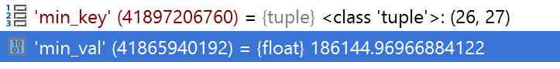

The first two clusters that meged

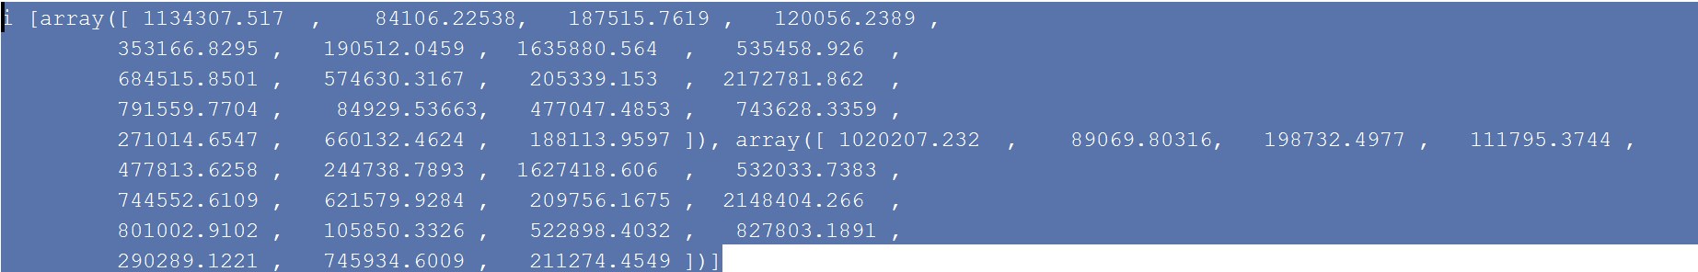

The second two clusters that merged

