**A Project Report**

**ON**

**POPULATION ANALYSIS**

FOR AISSCE 2022 EXAMINATION

[AS A PART OF INFORMATICS PRACTICES COURSE]

**SUBMITTED BY-**

NAME: **VARUN KHANDAI**

ROLL NO.:

**[UNDER THE GUIDANCE OF**

**MS. P.DEEPTI (HOD)]**

**CERTIFICATE**

This is to certify that **VARUN KHANDAI** of class XII-B(Non-Medical) has successfully completed the project work under the guidance of Ms. P.Deepti. He has done his work all in original and finished it in due course of time as per CBSE guidelines.

**Name: Varun Khandai**

**Class&Sec: XII-B**

**Stream: Science (Non-Medical)**

**HOD PRINCIPAL**

**Ms. P.Deepti Ms. Monika Mehan**

**ACKNOWLEDGEMENT**

I undertook this project work, as the part of my XII IP course. I had tried to apply my best knowledge and experience, gained during and class work experience. However, developing software is generally a quite complex and time-consuming process. It requires a systematic study, insight vision and professional approach during the design and development. Moreover, the developer always feels the need, the help and good wishes of the people near you, who have considerable experience and idea.

I would like to extend my sincere thanks and gratitude to my teacher **Ms. P. Deepti**, for giving valuable time and moral support to develop this software.

I also feel indebted to my friends for the valuable suggestions during the project work.

**NOTE**

* Here we are comparing the Population and Density of 10 different states of India in year 2001 and 2011.
* Line-chart(s), Bar-chart(s) and Histogram(s) has been used in this project.
* As an IP student, I respect everyone’s hard work and the sources I have used in this project. I have mentioned them in the **Reference** page. You can visit those sources to know more.

**CONTENT**

* Introduction
* Project Details
* Objective and Scope of the project
* System requirement
* What is python, installing Python
* Importing .csv file
* Python program
* Print of every program
* Print of mean, median and mode

**INTRODUCTION**

A population is defined as a group of individuals of the same species living and interbreeding within a given area. Members of a population often rely on the same resources, are subject to similar environmental constraints, and depend on the availability of other members to persist over time. Scientists study a population by examining how individuals in that population interact with each other and how the population as a whole interacts with its environment.

The field of science interested in collecting and analyzing these numbers is termed population demographics, also known as demography.

 Demographics can include any statistical factors that influence population growth or decline, but several parameters are particularly important: population size, density, age structure, fecundity (birth rates), mortality (death rates), and sex ratio.

We know that population growth in India is growing rapidly from the year 2001(*Census 2001*). If this is not controlled, then surely India will be surpassing China in next 2-3 years in terms of population and we know that isn’t a good thing for us. Moreover, there will be a much increase in the illiteracy rate and unemployment rate. So as to control this, some measures should need to be followed as per the measures given by **Ministry of Health and Welfare of India.**

Refer to this link to know more: <https://main.mohfw.gov.in/sites/default/files/56324455632156323214.pdf>

OBJECTIVE AND SCOPE OF THE PROJECT

Our project has all the data related to ***Population*** and ***Analysis*** of the data supporting with graphs.

It also calculates the mean, median and mode

No project is fine, our project can also be improved by increasing the variety of data in it.

SYSTEM REQUIREMENT

**Python Minimum Hardware Requirements**

* Modern Operating **System**:
* x86 64-bit CPU (Intel / AMD architecture)
* 4 GB RAM.
* 5 GB free disk space.



WHAT IS PYTHON

Python is an interpreted, high-level, general-purpose programming language. Created by Guido van Rossum and first released in 1991, Python's design philosophy emphasizes code readability with its notable use of significant whitespace.

INSTALLING PYTHON

* Download and Install Python from: <https://www.python.org/>

WHAT IS .CSV FILE

A comma-separated values file(CSV) is a delimited text file that uses a comma to separate values. Each line of the file is a data record. Each record consists of one or more fields, separated by commas. The use of the comma as a field separator is the source of the name for this file format.

IMPORTING .CSV FILE

A CSV file can be prepared in any excel sheet.

This file can be given a name and then can be saved in the system.

Any such database file can be imported in Python Pandas.

Thus, enabling the database task easy and importing data, thus compiling data

This will reduce our re-preparation of data in Python Pandas.

Also, it helps in reducing work load and complexity of programming.

The csv file thus imported can be used for performing various tasks as per the necessity of the programmer and instructions of the customer.

The steps involved in importing csv files are as follows:

import pandas as pd

df = pd.read_csv (r'Path where the CSV file is stored\File name.csv')

print (df)

**Step 1: Capture the File Path**

Firstly, capture the full path where your CSV file is stored. In my case, the CSV file is stored under the following path:

**C:\Users\VARUN\Desktop\varproject.csv**

You’ll need to modify the Python code below to reflect the path where the CSV file is stored on ***your*** computer. Don’t forget to include the:

* File name (as highlighted in green). You may choose a different file name, but make sure that the file name specified in the code matches with the actual file name.
* File extension (as highlighted in blue). The file extension should always be ‘.csv’ when importing CSV files.

**Step 2: Apply the Python code**

Type/copy the following code into Python, while making the necessary changes to your path.

Here is the code for your example (you can find additional comments within the code itself):

import pandas as pd

df = pd.read_csv (**r'C:\Users\VARUN\Desktop\varproject.csv'**) #read the csv file (put 'r' before the path string to address any special characters in the path, such as '\' and to read it without any errors). Don't forget to put the file name at the end of the path + ".csv"

print (df)

### Step 3: Run the Code

Finally, run the Python code and you’ll get the output in Python.

PYTHON PROGRAM

**LINE-CHART OF POPULATION vs DENSITY(2001)**

import pandas as pd

df=pd.read_csv(r'C:\Users\VARUN\Desktop\varpro.csv')

import matplotlib.pyplot as plt

df.plot(kind='line', color=['red','green'],marker="X", markersize=10,linestyle="--",linewidth=3)

plt.title('Population vs Density(2001)')

plt.xlabel('States')

plt.ylabel('Population(in lakhs) and Density(per sq. km)')

ticks=df.index.tolist()

plt.xticks(ticks,df.States)

plt.grid(True)

plt.show()

**BAR-CHART OF POPULATION vs DENSITY(2001)**

import pandas as pd

df=pd.read_csv(r'C:\Users\VARUN\Desktop\varpro.csv')

import matplotlib.pyplot as plt

df.plot(kind='bar', x='States', title='Popuation vs Density(2001)', color=['blue', 'magenta'], edgecolor='Black', linewidth=1)

plt.ylabel('Population(in lakhs) and Density(per sq. km)')

plt.grid(True)

plt.show()

**HISTOGRAM OF POPULATION vs DENSITY(2001)**

import pandas as pd

df=pd.read_csv(r'C:\Users\VARUN\Desktop\varpro.csv')

import matplotlib.pyplot as plt

df.plot(kind='hist', title='Population vs Density(2001)', color=['red','pink'], grid=(True), edgecolor='Black', linewidth=1)

plt.xlabel('Population(in lakhs)')

plt.ylabel('Density(per sq. km)')

plt.show()

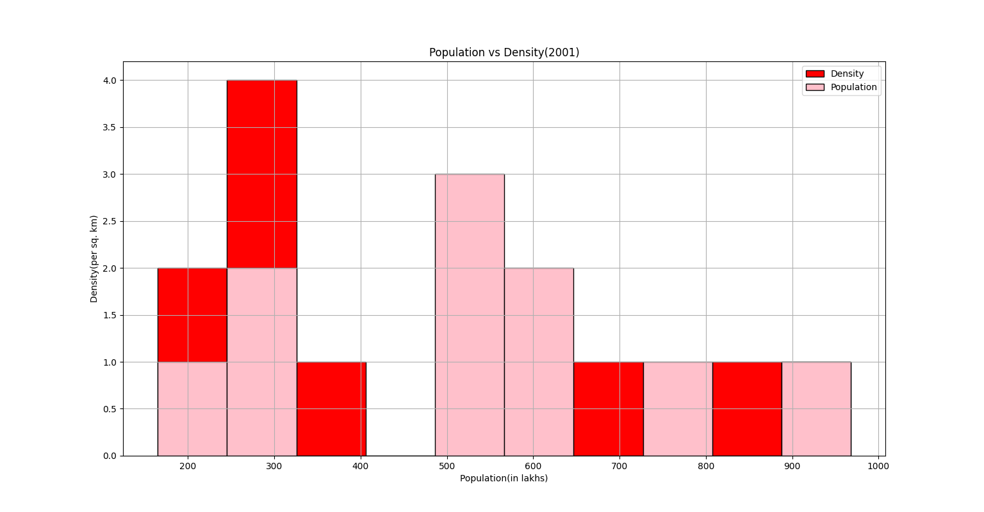

**LINE-CHART OF POPULATION vs DENSITY(2011)**

import pandas as pd

df=pd.read_csv(r'C:\Users\VARUN\Desktop\varproject.csv')

import matplotlib.pyplot as plt

df.plot(kind='line', color=['red','green'],marker="X", markersize=10,linestyle="--",linewidth=3)

plt.title('Population vs Density(2011)')

plt.xlabel('States')

plt.ylabel('Population(in 1000) and Density(per sq. km)')

ticks=df.index.tolist()

plt.xticks(ticks,df.States)

plt.grid(True)

plt.show()

**BAR-GRAPH OF POPULATION vs DENSITY(2011)**

import pandas as pd

df=pd.read_csv(r'C:\Users\VARUN\Desktop\varproject.csv')

import matplotlib.pyplot as plt

df.plot(kind='bar', x='States', title='Popuation vs Density(2011)', color=['blue', 'magenta'], edgecolor='Black', linewidth=1)

plt.ylabel('Population(in 1000) and Density(per sq. km)')

plt.grid(True)

plt.show()

**HISTOGRAM OF POPULATION vs DENSITY(2011)**

import pandas as pd

df=pd.read_csv(r'C:\Users\VARUN\Desktop\varproject.csv')

import matplotlib.pyplot as plt

df.plot(kind='hist', title='Population vs Density(2011)', color=['red','pink'], grid=(True), edgecolor='Black', linewidth=1)

plt.xlabel('Population(in 1000)')

plt.ylabel('Density(per sq. km)')

plt.show()

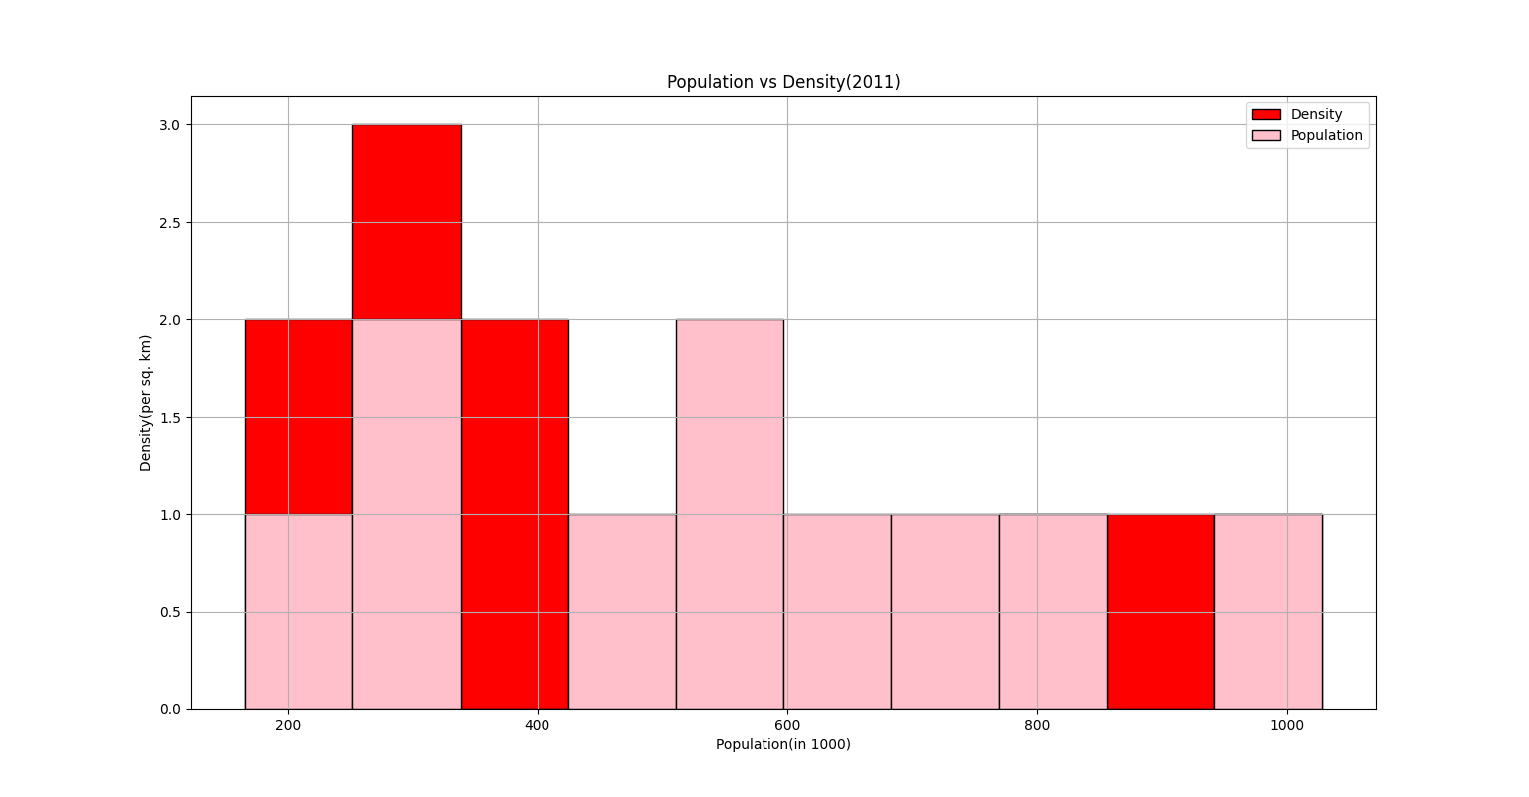

**Calculating Mean, Median and Mode of Population(2001)**

import pandas as pd

stp01={'States':["Uttar Pradesh","Andhra Pradesh","West Bengal","Rajasthan","Jharkhand","Madhya Pradesh","Maharashtra","Gujarat","Karnataka","Kerala"], 'Population':[166197921,76210007,80176197,56507188,26945829,60348023,96878627,50671017,52850562,31841374]}

df=pd.DataFrame(stp01)

print(df)

**Calculating Mean, Median and Mode of Density of Population(2001)**

import pandas as pd

std01={'States':["Uttar Pradesh","Andhra Pradesh","West Bengal","Rajasthan","Jharkhand","Madhya Pradesh","Maharashtra","Gujarat","Karnataka","Kerala"], 'Density':[690,277,903,165,338,196,315,258,319,819]}

df=pd.DataFrame(std01)

print(df)

**Calculating Mean, Median and Mode of Population(2011)**

import pandas as pd

stp11={'States':["Uttar Pradesh","Andhra Pradesh","West Bengal","Rajasthan","Jharkhand","Madhya Pradesh","Maharashtra","Gujarat","Karnataka","Kerala"], 'Population':[166053,75728,80221,56473,26909,60385,96752,50597,52734,31839]}

df=pd.DataFrame(stp11)

print(df)

**Calculating Mean, Median and Mode of Density of Population(2011)**

import pandas as pd

std11={'States':["Uttar Pradesh","Andhra Pradesh","West Bengal","Rajasthan","Jharkhand","Madhya Pradesh","Maharashtra","Gujarat","Karnataka","Kerala"], 'Density':[829,308,1028,200,414,236,365,308,319,860]}

df=pd.DataFrame(std11)

print(df)

**References**

* Data of Population and Density (2001)-

<http://www.educationforallinindia.com/page159.html>

* Data of Population and Density (2011)-

<https://data.gov.in/>

* For research work-

<https://censusindia.gov.in>

<https://ncert.nic.in/textbook/pdf/leip102.pdf>

Thank You