What’s new in PRoNTo v3.0 and to do

Data and design

Main interface: Masks are set to ‘none’ for MEEG and .mat types (see below).
Modality: Still need to specify the modality name, then a new field, called ‘data format’ offers three input formats to choose from: nifti (as before), MEEG (electrophysiological data in the SPM format) or .mat (any type of matrix). The design field has different options according to the data format selected. This is because the events should already be saved in the MEEG data (input: epoched signal). For nifti inputs, the options are the same as before. For .mat, the option is ‘no design’. However, in the future, the ‘specify design’ option could be allowed. For MEEG, it will load automatically the ‘Events in file’. Clicking on ‘Events in file’ leads to the ‘specify design’ window.

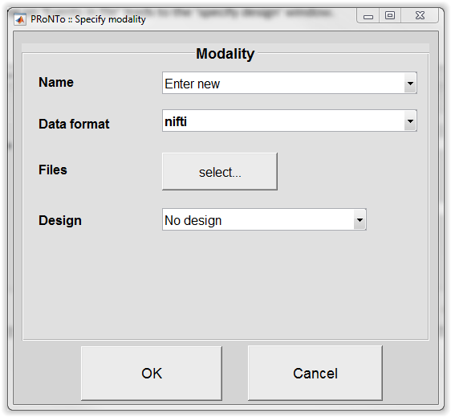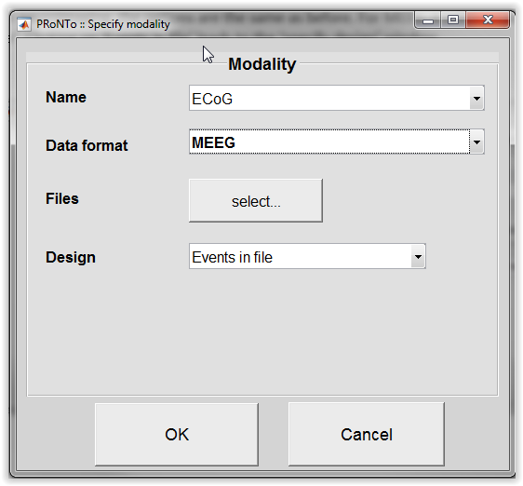
Fig. 1: Modality window with data type.

Specify design
The design window will be automatically filled with the events name, onsets (in seconds) and duration (in seconds). The units is set to seconds and the interscan interval corresponds to the intersample time (i.e. 1/sampling rate). For both neuroimaging and MEEG, there are 2 new columns where regression targets and covariates can be entered per trial in each category (need to have same number of elements as the number of trial onsets).
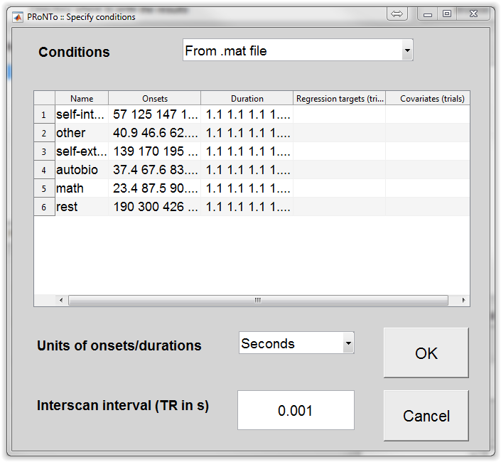
Fig. 2: Specify design for MEEG data set

PRT
In the modality field, a ‘type’ subfield was added, to account for the modality type. The same field was added to the ‘PRT.masks’ as well.

PRT.group.subject.modality
- mod_name: 'ECoG'
- covar: []
- rt_subj: []
- design: [1x1 struct]
- scans: 'F:\Data\Faces_Vinitha\S14_64\Animal\preprocess\SPrtf_raeMfffdR_spm...'
- type: 'MEEG'

PRT.masks
- type: 'MEEG'
- mod_name: 'ECoG

The RT and covariates per trial are saved in the ‘conds’ field of the ‘design’
PRT.group.subject.modality.design.conds(1)
- cond_name: 'animal_F'
- onsets: [1x50 double]
- durations: [1x50 double]
- scans: [1x50 double]
- blocks: [1x50 double]
- discardedscans: [0x1 double]
- hrfdiscardedscans: []
- rt_trial: []
- cov_trial: []

Batch:
Those changes have been transposed to the batch: when choosing a modality, the ‘Data format’ field allows to choose between ‘nifti’, ‘MEEG’ or ‘.mat’, whether the user specified the design by scans or by subjects. As the batch is not ‘dynamic’, the different design options specify for which data format they are available. The help of each field was also revised.
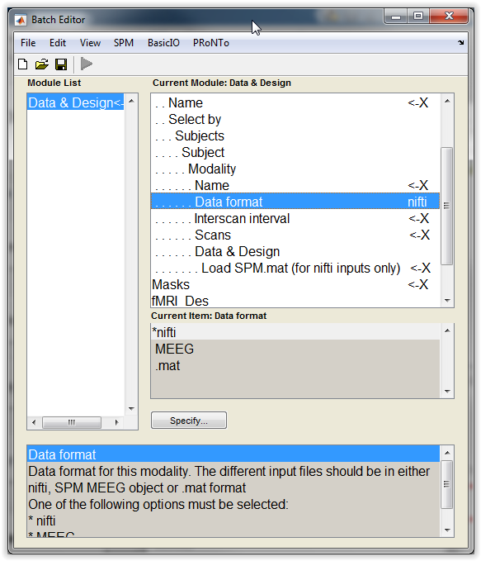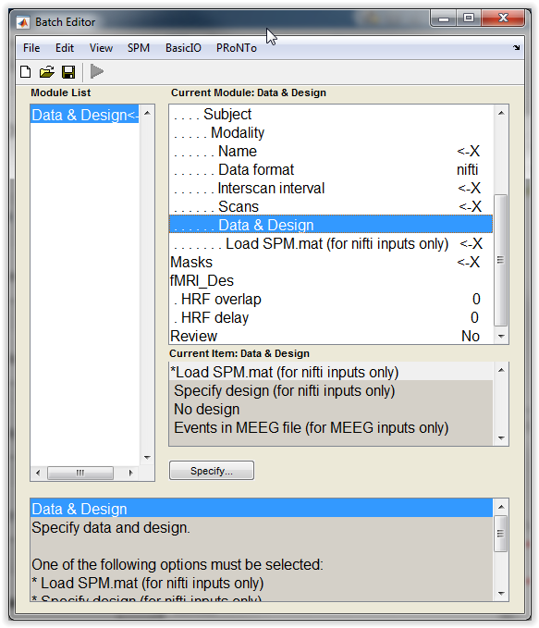
Fig. 3: Batch when choosing one data format. The choices for available design have been made more explicit.
Regarding the masks, the user needs to specify a ‘mask’ for each modality, as before. However they need to choose a file only for the ‘nifti’ input modalities. This is not optimal but might be less confusing. It is also easier in the code, as the number of masks serves as a check for all the modalities that are defined (i.e. checking number of modalities is the same across subjects and so on…). For MEEG or .mat, the type of modality is displayed but not further action is required.
In the code, checks make sure that the right type of design is selected for MEEG (‘Events in MEEG file’) or for .mat (‘no design’). This can easily be modified when extending the ‘.mat’ option to ‘new_design’ later on. There is also a restriction that the number of files for either a MEEG or .mat modality should be 1 (everything should be contained in this specified file, for each subject and modality). Different runs of EEG/MEG experiments can be entered as different modalities and later concatenated in ‘trials’ at the feature set stage.
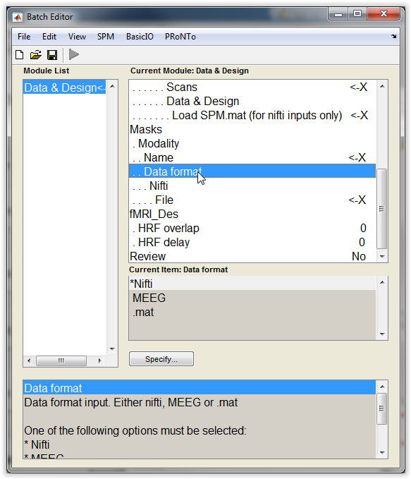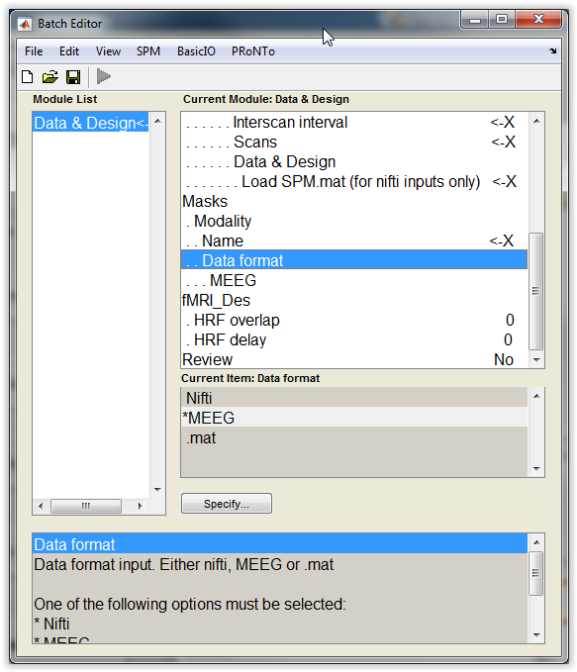
Fig 4: Batch for the masks and each data modality

I was not able to add regression targets and covariates per trial in the MEEG case of the design. I added it to the ‘no design case’ (which is the same as specifying one regression target/covariate per subject or image). This allows regression when having modalities with multiple images and modalities with only one image mixed/to be combined. I also added the option for the ‘specify design’ option, with one regression target/covariate vector per trial onset. This option is also implicit in the ‘multiple conditions’ case.
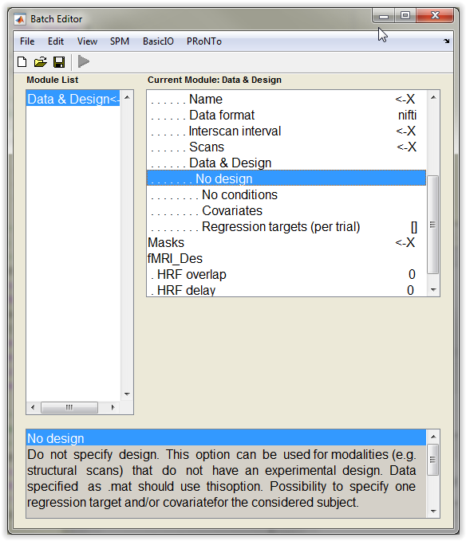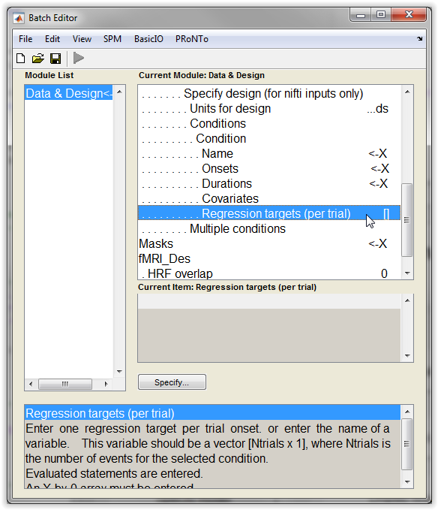
Fig 5: Batch inputs for regressions per trial in the ‘no design’ case (only one value allowed) or in the ‘specify conditions’ case (one value per trial onset expected).

To do:
- Add regression targets and covariates for each condition in the batch for the ‘events in file’ option (need to specify a repeat branch over the conditions, unless they specify a .mat with cells, one cell per condition).
- Test all options, especially in batch
- Allow for ‘specify design’ when loading a .mat

Feature sets

Main interface opens if multiple modalities of the same type, as before. If multiple modalities of different types, the user needs to specify for which data type the feature set will be built (Fig. 3) before the main window opens.
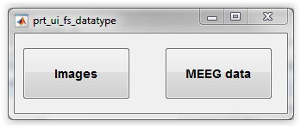
Fig. 1: Select feature set type
If ‘Images’ is selected, no changes. If ‘MEEG’ is selected, a completely new window opens. It is specific for MEEG data and allows to play on the 2 or 3 dimensions in the data. The list of ‘modality’ only includes MEEG modalities as defined in the data and design.

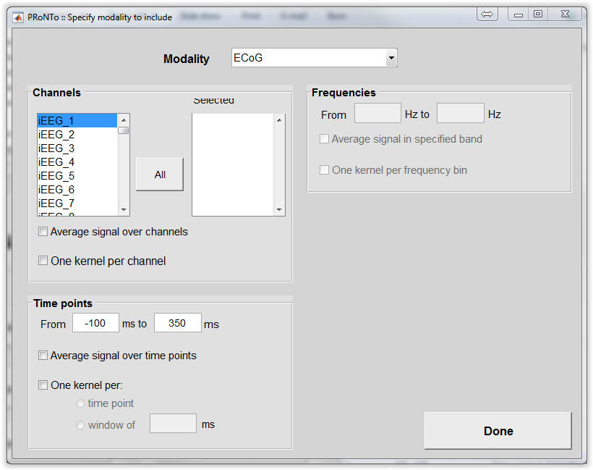
Fig. 2: Specify kernel features for MEEG.

The user can play on the channels, selecting them all or only some. Channels marked as bad in the MEEG object are displayed in red. It is possible to average the signal over the selected channels, or to build one kernel per channel. Similarly, the user can select a sub time window by specifying which ms to include in the kernel. The signal can then be averaged over time points, or one kernel can be built (per time point or per sub-time window of xx ms). If the data set contain frequency information (i.e. multiple frequency bins), the user can select which bins to analyze, average the signal within the band of interest or build on kernel per frequency bin. It is not possible to average over one dimension and select multiple kernels for that same dimension (which is logical). It is however perfectly acceptable to build multiple kernels one more than one dimension (e.g. one kernel per channel and per sub-time window of 50ms). Frequent use with ECoG data: select all the good channels, time points after stimulus onset [0 350ms] and the high frequency broadband (70 to 170 Hz), average the signal within the frequency band, build multiple kernels on the channels.
In the main window, it is possible to concatenate multiple modalities (i.e. runs) in samples or to build one kernel per modality (e.g. EEG and MEG). This last option should however disappear soon as the code now allows to combine feature sets at the modelling level.

Code
A feature set is built, both for MEEG and images, creating a new file array for each modality. For MEEG, the selected dimensions are used to build a mask (2nd level) and the kernel is built similarly to the previous neuroimaging version of the code. The main difference is that it is now possible to average across one or multiple dimensions. This means that another loop had to be added to read the data from the file array in the other direction (i.e. selecting all variables from one trial, by blocks of trials, instead of blocks of variables across all trials). The code only enters this loop if averaging across one dimension was selected (as it is less efficient than the other way round).

PRT

The PRT structure has been affected by these changes for the fs and fas:
PRT.fs(1)
- fs_name: 'TCChans'
- k_file: 'TCChans'
- id_col_names: {'group' 'subject' 'modality' 'condition' 'block' 'scan'}
- fas: [1x1 struct]
- modality: [1x1 struct]
- id_mat: [550x6 double]
- multkernelROI: 1
- multkernel: 0
- atlas_name: 'Ch_fr_tp'

PRT.fs(1).modality
- mod_name: {'ECoG'}
- aver: [0 0 0]
- multkern: [1 0 0]
- normalise: [1x1 struct]
- idfeat_fas: [17199x1 double]
- dim_m: {[49x1 double] [1] [1x351 double]}
- idfeat_img: {49x1 cell}
- igood_kerns: [1x49 double]

In PRT.fs.modality, the fields ‘aver’ and ‘multkern’ were added. They represent on which dimensions averaging or multiple kernels were performed. It is important for the construction of the weights later on. The ‘dim_m’ field also keeps the indexes of which channels, frequency bins and time points were used. Again, it is useful for the weights and the display of the weights (to obtain channel labels for example).
Regarding the file array structure, the hdr is the object of the first file for the first subject of the modality. It allows to keep the channel labels, time points and frequency bins, as we would for image orientation or so. ‘idfeat_img’ is empty as it is not possible/useful to have a 1st level mask.
PRT.fas
- mod_name: {'ECoG'}
- dat: [550x33696 file_array]
- hdr: [96x351x550 meeg]
- idfeat_img: []

To do:
Batch
- Add feature set type (neuroimaging or MEEG)
- Build the complete hierarchy for the MEEG format, with the 3 dimensions
Code
- Check that all the subjects indeed have the same channels (just taking the first subject of the modality for the moment), same time points and same frequency bins. For now the code only gets the indexes corresponding to the 1st subject in each dimension, but it is possible that another subject would miss a channel for example and the indexes would not match anymore.

Specify model

It is now possible to combine feature sets at the modelling level. If a MKL method is used, the kernels will be used in the MKL (even if they themselves contain multiple kernels). If a single method is chosen, the kernels will be added. This feature has been added to both the batch and the GUI.
When specifying the classes, some of the restrictions we previously imposed were lifted. For example, it is not needed that all the subjects have all the conditions. This is especially the case when the user wants to pool multiple conditions together. The code will simply ‘skip’ that condition for subjects who do not have it.

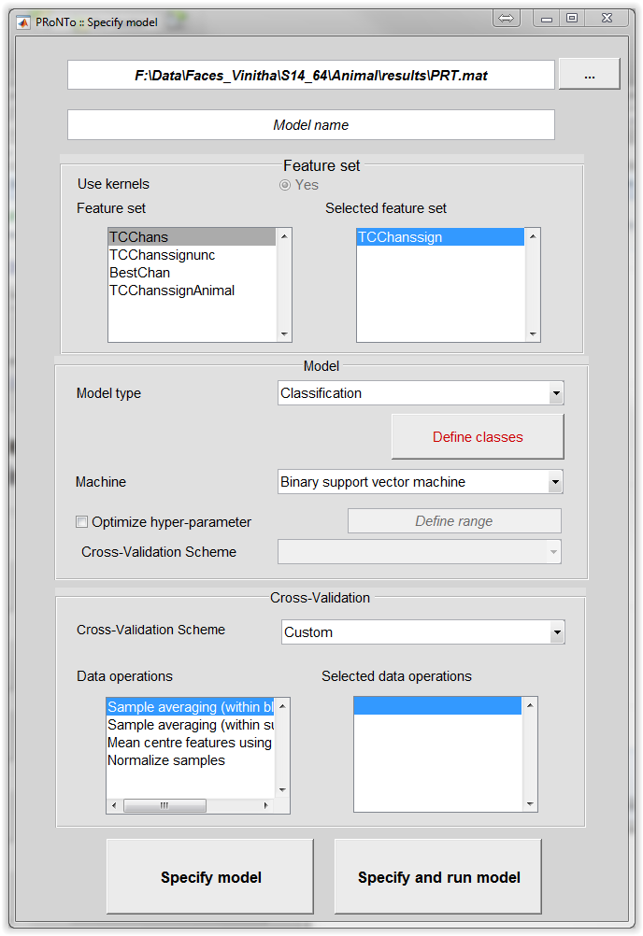
Fig. 1: Specify model, GUI.

In the batch, it is also possible to subsample the classes such that they match (as close as possible) the number of trials in the class with the lowest number of samples. If multiples classes are pooled together, this subsampling takes care to include as many trials from each of the pooled categories as they are represented in the pooling.
Example: 20 faces vs 30 buildings + 30 animals. Result: 20 faces vs 10 buildings + 10 animals
In relation with this addition, a new cross-validation was added: Leave-One-Block-per-Class-Out (and its k-folds counterpart). It gets complex with pooling and subsampling, as the code is selecting the trials condition by condition. I added a random shuffling of the train/test division in the class containing pooled categories to make sure that one category is not left aside entirely in one fold, another in another fold, etc…
Example: fold 1: 5 faces out, 3 buildings + 2 animals out (normal version of the code: 5 faces out, 5 buildings out in fold 1).

When multiple kernels are present, it is possible to build a MKL model with all of them (or signle kernel and they are added) or use single kernel methods on each of them independently. There is an extra flag: ‘Use kernels independently’ Yes or No (default: No). This turned out to be useful for me, when I selected ‘significant channels’ (FDR corrected) on one session and used them in a multivariate way on another session. It is also useful to determine the ‘best’ kernel when looking at the MKL results. I would expect this to be replaced by a proper feature selection module though.
Changes to the PRT: if only one model, then as usual. Otherwise, PRT.model.output is the same size as the number of independent models.
PRT.model
- model_name: 'Indmod_SVM_F_NF_TCChans'
- input: [1x1 struct]
- output: [1x49 struct]

Other fields were added to take into account the new functionalities (subsample, indmodels):
PRT.model.input
- use_kernel: 1
- type: 'classification'
- machine: [1x1 struct]
- use_nested_cv: 0
- nested_param: []
- subsample: 1
- indmodels: 1
- class: [1x2 struct]
- fs: [1x1 struct]
- samp_idx: [71x1 double]
- include_allscans: 0
- targets: [71x1 double]
- targ_allscans: [324x1 double]
- covar: [71x1 double]
- cov_allscans: [324x1 double]
- cv_k: 5
- cv_mat: [71x5 double]
- cv_type: 'locbo'
- cv_type_nested: 'lobo'
- cv_k_nested: 0
- operations: 3
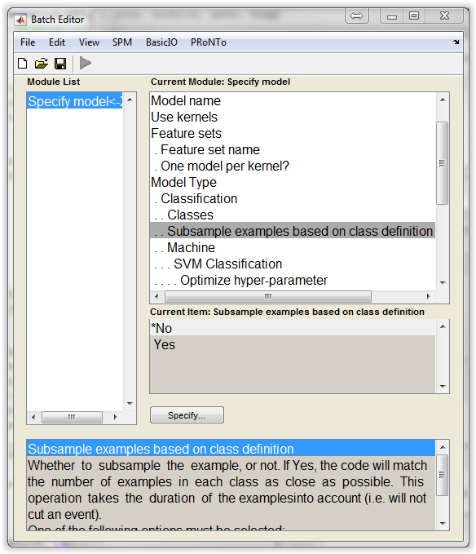
Fig 2: Batch with possibility to select multiple feature sets, build one model per kernel instead of using them together and subsampling the examples for classification.
Code:
One main change in the code is how the selection of the best (set of) parameters is performed when performing a grid search. This is completely transparent for the user but instead of selecting the median of the best values, the code selects now the center of the largest stable area.

To do:
GUI:
- Implement flag for independent models when multiple kernels
- Subsampling option not present yet
Both:
Have an option to load another model and change a few parameters. This is especially useful (and the only way to do) when comparing 2 models/feature sets with subsampling involved. Fields that could be modified easily: model name, feature set, machine, hyper-parameter (+ cross-validation? But would rather not).
Use AUC instead of balanced accuracy to select best hyperparameter? More work should be done on how to select the best hyperparameter.

Run model
It is possible to save the permutations in a model, and then impose the same permutations in another model. This option has not been interfaced yet, but it allows to compare 2 models and obtain a p-value thanks to permutations (prt_compare2models_perm.m).
To do:
- Batch: have another option to ‘Use permutations from model <-- Model name’.
- GUI: this needs to be interfaced as well, but in the ‘display results’ window I guess.
Not sure where to add the ‘Compare 2 models’. Maybe we can add a ‘Utils’ category?

Weights
The weights are built for the MEEG objects similarly to the images, with one new MEEG object per modality. It is also possible to build the betas, as for neuroimaging. The resulting MEEG object will then have the same beta value for all the features selected in its kernel. If one kernel per channel was built, then there will be one value per channel, the same at all time points. It would be different if kernels were built on channels and time points.

To do:
- Not implemented in the batch (but the GUI did not change much so not sure how the batch should be modified).
- Allow to average across a certain dimension for the MEEG models, a posteriori.

Reviewing options
No changes, only functionalities to add:
Display results:
- Change from folds to PRT.model.output(k) when one model per kernel specified. This will display the average performance for each kernel instead of for each fold.
Display weights:
- How to display MEEG weights and betas?

