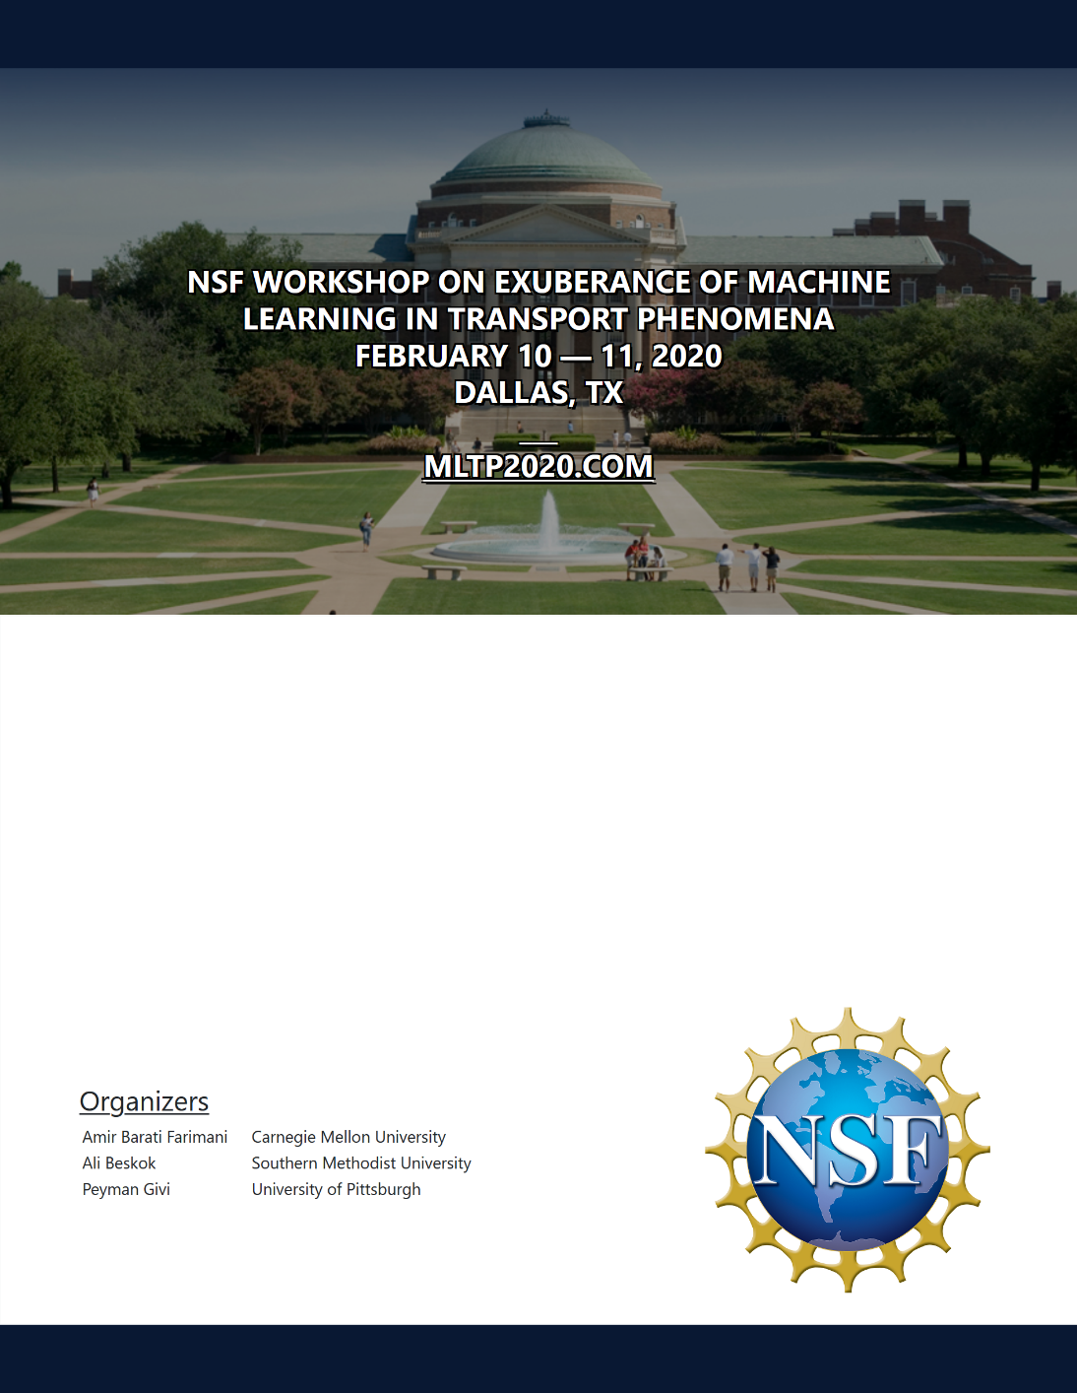

**Machine Learning in Transport Phenomena**

The objective of this workshop is to assess the state of progress in development, implementation and application of Machine Learning (ML) in transport phenomena. Of particular interest are applications in fluid dynamics, including turbulence, heat & mass transfer, multi-phase flows, biological transport, combustion and other reactive flows. Considering the complexity of such phenomena, the question is to what to expect from ML and to what extend such learnings can assist in modeling and inference of transport phenomena. Distinguished scholars with expertise in both machine learning and transport phenomena are invited to discuss their recent results, and to identify the paths to be taken in future to merge ML into transport modeling.

**Agenda**

Monday, February 10, 2020.

|  |  |
| --- | --- |
| 8:30 AM | Welcoming Remarks |
| 9:00 AM to 10:20 PM | Technical Session |
| 10:20 AM to 10:40 PM | Coffee Break |
| 10:40 AM to 12:00 PM | Technical Session |
| 12:00 PM to 1:30 PM | Lunch |
| 1:30 PM to 2:50 PM | Technical Session |
| 2:50 PM to 3:30 PM | Coffee Break |
| 3:30 PM to 5:00 PM | Panel Discussion |
| 5:00 PM | Poster Session |

Tuesday, February 11, 2020.

|  |  |
| --- | --- |
| 8:30 AM | Welcoming Remarks |
| 9:00 AM to 10:20 PM | Technical Session |
| 10:20 AM to 10:40 PM | Coffee Break |
| 10:40 AM to 12:00 PM | Technical Session |
| 12:00 PM to 1:30 PM | Lunch |
| 1:30 PM to 2:50 PM | Technical Session |
| 2:50 PM to 3:30 PM | Coffee Break |
| 3:30 PM to 5:00 PM | Panel Discussion |
| 5:00 PM | Adjourn |

**Invited Lectures**

**Monday, February 10, 2020:**

|  |  |  |
| --- | --- | --- |
| **Session & Chair** | **Time** | **Presentation** |
|  | **8:00-8:30** | Registration and Breakfast. |
|  | **8:30-9:00** | NSF Program Managers and Organizers Welcome. |
| Session I.  Chair: Professor Hessam Babaee, University of Pittsburgh | **9:00-9:40** | Professor Steven Brunton, University of Washington: [Introduction to data driven modeling and machine learning](https://mltp2020.com/Abstracts/MLTP2020_Abstract_Brunton.pdf) |
| **9:40-10:20** | Professor George Karniadakis, Brown University: [Physics-informed neural networks (PINNs) in fluid mechanics and heat transfer](https://mltp2020.com/Abstracts/MLTP2020_Abstract_Karniadakis.pdf) |
|  | **10:20-10:40** | Coffee Break. |
| Session II.  Chair: Professor Tony Rosato, New Jersey Institute of Technology | **10:40-11:20** | Professor Michael Mahoney, University of California, Berkeley: [Machine learning and science?](https://mltp2020.com/Abstracts/MLTP2020_Abstract_Mahoney.pdf) |
| **11:20-12:00** | Professor Sharath Girimaji, Texas A&M University: [Machine learning for turbulence modeling: A perspective](https://mltp2020.com/Abstracts/MLTP2020_Abstract_Girimaji.pdf) |
|  | **12:00-13:30** | Lunch. |
| Session III  Chair: Dr. Ramakanth Munipalli, AFRL/RQRC | **13:30-14:10** | Professor Karen Willcox, University of Texas at Austin: [Challenges and progress in learning physics-based reduced models for combustion processes](https://mltp2020.com/Abstracts/MLTP2020_Abstract_Willcox.pdf) |
| **14:10-14:50** | Professor Linau Ren, Tsinghua University: [Machine learning in turbulent reactive flow simulations](https://mltp2020.com/Abstracts/MLTP2020_Abstract_Ren.pdf) |
|  | **14:50-15:30** | Coffee Break. |
| Moderator: Professor Dimitrios Papavassiliou, University of Oklahoma | **15:30-17:00** | Panel Discussion. |
|  | **17:00-18:30** | Poster Session. |

**Invited Lectures**

**Monday, February 10, 2020:**

|  |  |  |
| --- | --- | --- |
| **Session & Chair** | **Time** | **Presentation** |
|  | **8:00-8:45** | Registration and Breakfast. |
|  | **8:45-9:00** | Introduction and Overview. |
| Session IV.  Chair: Dr. Cosmin Safta, Sandia National Laboratories | **9:00-9:40** | Professor Michael Brenner, Harvard University: [Machine learning for PDE’s](https://mltp2020.com/Abstracts/MLTP2020_Abstract_Brenner.pdf) |
| **9:40-10:20** | Dr. Kevin Carlberg, University of Washington: [Nonlinear model reduction: Using machine learning to enable rapid simulation of extreme-scale physics models](https://mltp2020.com/Abstracts/MLTP2020_Abstract_Carlberg.pdf) |
|  | **10:20-10:40** | Coffee Break |
| Session V.  Chair: Professor Alan McGaughey, Carnegie Mellon University | **10:40-11:20** | Dr. Mujeeb Malik, NASA Langley Research Center: [CFD vision 2030 and potential for machine learning](https://mltp2020.com/Abstracts/MLTP2020_Abstract_Malik.pdf) |
| **11:20-12:00** | Professor Justin Sirignano, University of Illinois at Urbana-Champaign: [Deep learning closure models for large-eddy simulation](https://mltp2020.com/Abstracts/MLTP2020_Abstract_Sirignano.pdf) |
|  | **12:00-13:30** | Lunch |
| Session VI.  Chair: Professor Sangyeop Lee, University of Pittsburgh | **13:30-14:10** | Professor Gianluca Iaccarino, Stanford University: [(Machine) Learning to differentiate](https://mltp2020.com/Abstracts/MLTP2020_Abstract_Iaccarino.pdf) |
| **14:10-14:50** | Professor Weinan E, Princeton University: [Machine learning for fluid dynmics](https://mltp2020.com/Abstracts/MLTP2020_Abstract_E.pdf) |
|  | **14:50-15:30** | Coffee Break. |
| Moderator: Professor D. Scott Stewart, University of Illinois at Urbana-Champaign | **15:30-17:00** | Panel Discussion. |
|  | **17:00** | Adjourn. |

**List of Posters**

|  |  |  |
| --- | --- | --- |
| **Title** | **Authors** | **Affiliation** |
| A soft computing approach for estimating the specific heat capacity ofmolten salt-based nanofluids | Ahmed Abdelhalim1,  Debjyoti Banerjee2 | 1Cairo University.  2Texas A&M University |
| A framework for reduced-order modeling of turbulent reacting flows | Opeoluwa Owoyele1,  Tarek Echekki2,  Pinaki Pal2 | 1Argonne National Laboratory,  2North Carolina State University |
| Neural network flame closure model for liquid propellant rocket engine | Zeinab Shadram | University of California Irvine |
| Subgrid-scale parametrization of unresolved scales in forced Burgers equation using Generative Adversarial Networks (GAN) | Jeric Alcala,  Ilya Timofeyev | University of Houston |
| Oil production analysis by machine learning methods | Darkhan Akhmed-Zaki  Timur Imankulov,  Yedil Nurakhov,  Yerzhan Kenzhebek | al-Farabi Kazakh National University |
| Multi-fidelity learning with heterogeneous domains | Soumalya Sarkar,  Michael Joly,  Paris Perdikaris | University of Pennsylvania |
| In-situ coupled OpenFOAM and TensorFlow: Generic data science for CFD | Romit Maulik1,  Himanshu Sharma1,  Saumil Patel2,  Bethany Lusch1,  Elise Jennings1 | 1Argonne Leadership Computing Facility Argonne National Laboratory  2Computational Physics Division Argonne National Laboratory |
| Data-driven modeling for fluid dynamics: Turbulence closure model order reduction and superresolution | Suraj Pawar1,  Shady Ahmed1,  Harsha Vaddireddy1,  Romit Maulik2,  Omer San1,  Adil Rasheed3 | 1Oklahoma State University  2Argonne National Laboratory  3Norwegian University of Science and Technology |
| PDE discovery using convolutional LSTM | Kazem Meidani,  Amir Barati | Carnegie Mellon University |
| Machine learning potential for phonon transport in perfect Si and Si with vacancies | Ruiqiang Guo,  Hasan Babaei,  Amirreza Hashemi,  Sangyeop Lee | University of Pittsburgh |

**List of Posters**

|  |  |  |
| --- | --- | --- |
| **Title** | **Authors** | **Affiliation** |
| Machine learning enabled study of phonon transport from first principles | Sangyeop Lee,  Ruiqiang Guo | University of Pittsburgh |
| Predicting time dependent solutions to the viscous Burger's equation using Gaussian Process Regression | Francis Ogoke1,  Michael Glinsky2,  Amir Barati1 | 1Carnegie Mellon University  2Sandia National Laboratories |
| Data-driven prediction of a multi-scale Lorenz 96 chaotic system using deep learning methods: Reservoir computing ANN and RNN-LSTM | Pedram Hassanzadeh  Ashesh Chattopadhyay  Devika Subramanian | Rice University |
| Learn a low-rank arbitrary Lagrangian Eulerian frame to reduce the dimensionality of convection dominated nonlinear flows | Rambod Mojgani  Maciej Balajewicz | University of Illinois at Urbana-Champaign |
| KiNet: A deep neural network representation of chemical kinetics | Weiqi Ji,  Sili Deng | Massachusetts Institute of Technology |
| Physics embedded neural networks for spatio-temporal turbulence | Arvind Mohan1,  Nicholas Lubbers1,  Daniel Livescu1,  Misha Chertkov2 | 1Los Alamos National Laboratory  2University of Arizona |
| Machine Learning for Turbulence in Supernovae | Platon Karpov  Chengkun Huang  Ghanshyam Pilania  Stan Woosley  Chris Fryer | Los Alamos National Laboratory |
| Deep learning for transport in heterogeneous media: forward and inverse problems | Haiyi Wu,  Wen-Zhen Fang,  Hongwei Zhang,  Qinjun Kang,  Guoqing Hu,  Wen-Quan Tao,  Rui Qiao | Virginia Polytechnic Institute and State University |
| Neural Network potential for lattice dynamics calculations and thermal conductivity prediction | Jie Gong,  Hyun-Young Kim,  Alan McGaughey | Carnegie Mellon University |
| Prospect of data-driven red blood cell micro mechanical models for computational simulations | Amir Saadat  Eric Shaqfeh | Stanford University |

**List of Posters**

|  |  |  |
| --- | --- | --- |
| **Title** | **Authors** | **Affiliation** |
| Real-time reduced order modeling for chemical kinetics | Arash Nouri,  Hessam Babaee,  Peyman Givi | University of Pittsburgh |
| Predicting droplet traffic in microfluidic networks using machine learning | Masoud Norouzi Darabad,  Siva Vanapalli,  Mark Vaughn | Texas Tech University |
| Time-dependent POD (tPOD): real-time reduced order modeling | Michael Donello,  Hessam Babaee | University of Pittsburgh |
| Data-driven classification and modeling of combustion regimes in a detonation wave | Supraj Prakash1,  Shivam Barwey1,  Malik Hassanaly2,  Venkat Raman1 | 1University of Michigan  2National Renewable Energy Laboratory |

**Notes**

_____________________________________________________________________________________

_____________________________________________________________________________________

_____________________________________________________________________________________

_____________________________________________________________________________________

_____________________________________________________________________________________

_____________________________________________________________________________________

_____________________________________________________________________________________

_____________________________________________________________________________________

_____________________________________________________________________________________

_____________________________________________________________________________________

_____________________________________________________________________________________

_____________________________________________________________________________________

_____________________________________________________________________________________

_____________________________________________________________________________________

_____________________________________________________________________________________

_____________________________________________________________________________________

_____________________________________________________________________________________

_____________________________________________________________________________________

_____________________________________________________________________________________

_____________________________________________________________________________________

_____________________________________________________________________________________

**Venues**

The workshop will be held at Martha Proctor Mack Ballroom, located on the third floor of the Umphrey Lee Center at 3300 Dyer Street, Dallas, TX in Southern Methodist University.

