5.5

**Sociogram**

**User Manual**

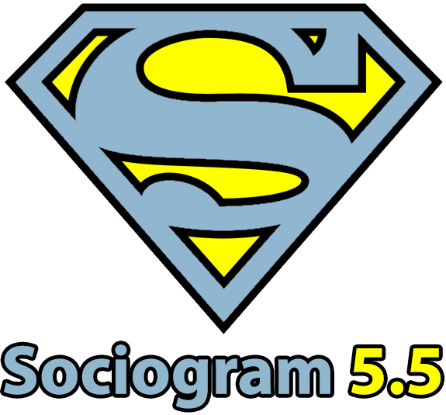

# Contents

This document contains instructions how to use the Sociogram 5.5 program.

**Krimar, informacijske storitve**

**and**

**Mikro Graf Art d.o.o.**

**Ljubljana, 2022**

[**slavc.zust@mga.si**](mailto:slavc.zust@mga.si)

1 Contents 1

2 Introduction 4

3 Program description 4

4 Hardware requirements 4

5 Program installation 5

5.1 Installation in Windows 5

5.2 Installation in Mac OS X 5

5.3 Installation in Linux 5

6 Program protection 5

7 Using the program 5

7.1 Selecting language settings 6

7.2 Selecting the type of use 6

7.3 Program activation 7

7.4 Application Management button 8

7.5 Entering respondents 8

7.5.1 Adding and deleting persons 9

7.5.2 Importing persons from a file 9

7.6 Importing students from the Lopolis program 10

7.6.1 Exporting students from Lopolis 10

7.6.1.1 Select railway station 11

7.6.1.2 Select action 11

7.6.1.3 Specify Export content 12

7.6.1.4 Select all attributes to be exported 13

7.6.1.5 Export into CSV file (in desired location) 13

7.6.2 Importing the exported file into Sociogram 14

7.6.2.1 Click the button Import from file 14

7.7 Importing into Sociogram 14

7.7.1 Importing students from a saved Sociogram 14

7.7.2 Exporting persons into a file 14

7.8 Printing surveys and entering survey results 14

7.8.1 Survey questions 15

7.8.2 Printing 15

7.8.2.1 Printing surveys 15

7.8.2.2 Printing a table 15

7.8.3 Entering survey results 15

7.8.4 Distribution of positive or negative choices 16

7.9 Visualizing positive and negative choices in the form of a nomogram 16

7.10 Exporting survey results into Microsoft Excel 17

7.11 Graphic display of sociograms 18

7.11.1.1 Managing the graph 18

7.11.1.2 Saving graphs 19

7.12 Sociometric classification 19

7.12.1 Exporting into Microsoft Office 20

8 Further assistance and information 22

# Introduction

Sociometry is a method for measuring social relationships within a group. Such measurement is particularly helpful in communities such as classes in primary and secondary schools, and it is an indispensable tool for coaches leading sports teams.

Sociometry can be used to measure the social characteristics of a team, cohesion between individuals, to determine how popular they are in the group or perhaps excluded from it and lonely, to what degree they do not get along with other group members, whether they like their company or not, and how much the group appreciates their opinion.

A sociometric test helps assess a group’s social structure and a sociogram is the graphic representation of the test, which precisely reveals the social structures within the group and the position of each individual. In addition to the sociogram, testing also indicates the sociometric status of each individual and the cohesion index for the whole group.

# Program description

The Sociogram 5.5 program is an update to the successful 4.01 version from the 1990s. The new Sociogram is developed on the latest platforms with additional functionalities. Our aim is to make your work simple and automatic. Our goal and motto: **“A sociogram in 10 minutes”**.

Sociogram 5.5 is the joint product of two organizations, Krimar, informacijske storitve, and Mikro Graf Art d.o.o., and was created in autumn 2014 (version 5.0).

# Hardware requirements

To use the program you need a personal computer. Sociogram will work with operating systems Microsoft Windows XP, Vista, 7, 8, 10 or newer. Linux and Max OS X (Intel) systems are also supported. Using the program requires no additional hardware.

If the Adobe Acrobat program or the Java runtime environment are not already installed on your computer, all the required installations will be made while you set up Sociogram.

Activating the program **also requires an Internet connection**!

In case you haven’t purchased the program yet, you can use it in DEMO mode, which does not allow you to enter or remove any respondents. Once you have a license code, you can use it to activate the program during startup to unlock its full functionality.

# Program installation

## Installation in Windows

Start the setup by running the **Sociogram_Setup.exe** installation program, which you have downloaded online or received by post after completing your product purchase.

Click on the Next button and wait for the Wizard to finish the installation. It is also recommended to agree with the installation of Adobe Reader if not installed already.

## Installation in Mac OS X

Open the Sociogram.dmg installation pack, which you have downloaded online or received by post.

Drag the Sociogram icon into a folder for applications and start it from there.

## Installation in Linux

The **Sociogram.sh** startup script was prepared to run the application in Linux environments. It will work perfectly only if the Java runtime environment and the PDF default document viewer are installed on the system beforehand.

If you don’t have advanced skills in using Linux environments, your administrator should help you install the program.

# Program protection

Each Sociogram 5.5 program you purchase is protected with a serial number. The serial number uniquely matches the name of the organization that ordered the program and this name cannot be changed at a later time.

Each purchased serial number allows you to activate i.e. install the program 3 times.

It is prohibited to use the program for any purposes outside your organization or institute, change program listings, change installation files or perform any actions inconsistent with normal software use. Any established breach will be dealt with by the District Court in Ljubljana.

# Using the program

Once installed, start the program by double-clicking its shortcut.

## Selecting language settings

Sociogram 5.5 is available in three languages: Slovene, Croatian and English. During the first startup, select your default language. You can change it later in the program settings.

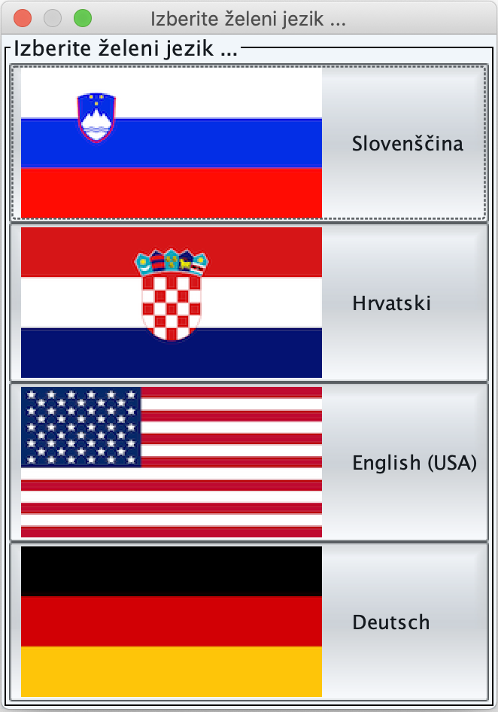

## Selecting the type of use

Sociogram 5.5 is designed for use in several modes. The following types of use are supported:

* Schools: primary and secondary schools, other educational institutions
* Associations, work groups, etc.: leisure groups and loosely organized groups of people.
* Companies, teams, etc.: business settings

During the first startup, select your preferred mode of use. You can change it later in the program settings.

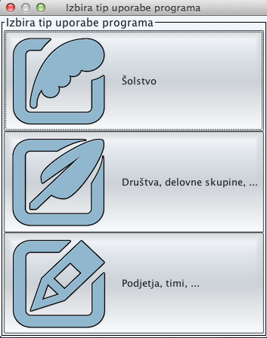

## Program activation

If you have not bought the program yet, it will ask you during startup whether you want to activate it (**IMPORTANT: for successful activation you must be connected to the Internet!**). A selection box will appear:

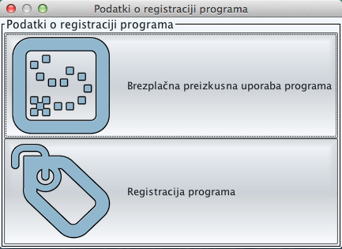

In case you select the free trial version, the program will start in DEMO mode where you cannot add or remove your own respondents.

Until you register the program as required (orders can be placed at the website <http://krimar.si/sociogram>, this box will always appear during program startup. If you select the Registration option, the following box will pop up:

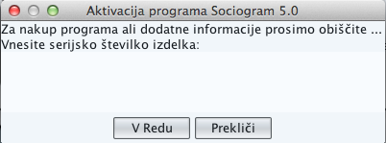

You should enter the product serial number into the input field and press the OK button. When typing, be mindful of capital and lower-case letters as well as hyphens. Don’t press the Enter key or Space Bar.

If successfully activated, you can start using the program, and if not, a box will appear saying you entered the wrong serial number.

**CAUTION**: **If not requested otherwise when purchased, Sociogram 5.5 can only be installed 3 times!**

## Application Management button

|  |  |
| --- | --- |
|  | In the top left-hand corner you will find the Application button for access to the main menu, where you can create a new sociogram, open a saved one, save the current one or leave the program.  There are two smaller buttons next to the Management button – **Info** and **Help**.  Clicking on **Help** will open a document with the help you are currently reading.  Clicking on **Info** will open a window with basic information about the program. |

## Entering respondents

This window is the entry point to the program. This is where you can enter all the respondents included in the survey. The number of respondents you enter will correspond to the number of survey sheets later printed out by the program.

For each sociogram, you can enter additional data (e.g. class teacher, academic year), which depend on the selected mode of Sociogram use.

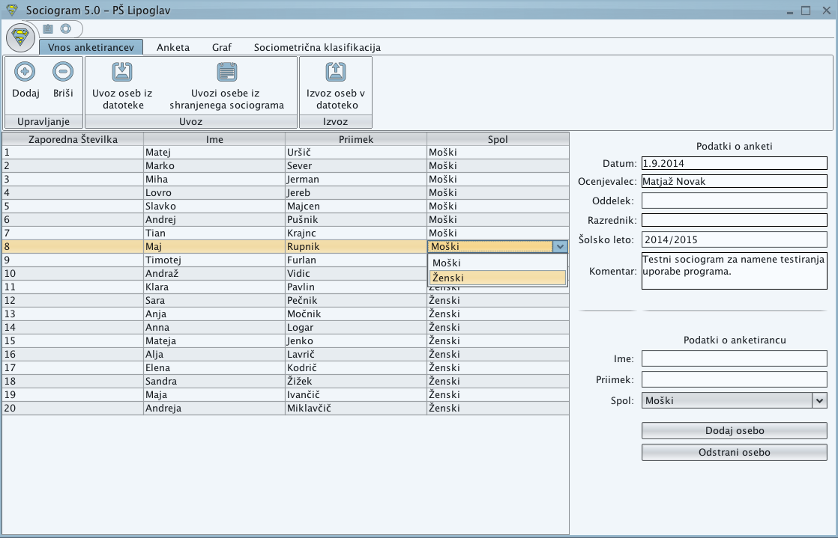

### Adding and deleting persons

To add a person, type their name and surname into the fields located at the bottom right, select their gender and click the **Add person** button. If preferred, you can also use the **Add** button which is located at the top right-hand side under the Management button.

Once added, a person can be deleted by selecting them and clicking the **Remove person** button at the bottom or the **Delete** button at the top left.

Information about added persons can be edited. You can change the name, surname and gender. To do this, double-click the field you want to change/edit.

### Importing persons from a file

Frequently, we have a pre-existing list of students and such a list can be applied to Sociogram. Sociogram supports CSV and TXT files. In these files, one respondent should be entered in each row, and the order in the first row should indicate the position of name, surname and gender. The file must have these three attributes. It may also have additional attributes, and Sociogram will work out by itself which column corresponds to a respective attribute. The attributes must be separated by a semi-colon (;).

Such a file can be imported e.g. from the Lopolis program (see next section), Microsoft Excel or simply written by yourself in Notepad. Since this is a general type of file, you can prepare the data from various company management programs, programs used in schools etc.

For a clearer explanation, you can watch the video instructions on how to use Sociogram.

An example of a properly structured file, where the gender of respondents can be indicated in the following ways:

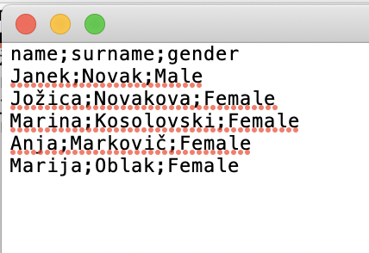

## Importing students from the Lopolis program

If you have to enter a large number of students manually and they are already listed in the Lopolis system, the easy way is to import the data directly from the system.

**You should first export the students from Lopolis into a CSV file and then import the CSV file into Sociogram.**

### Exporting students from Lopolis

To export student data from the Lopolis program, you need access to the **Railway Station** module. If you haven’t got such access rights, ask the school administrator to assign the rights to you or export the data for you.

To export data, follow the steps below:

#### Select railway station

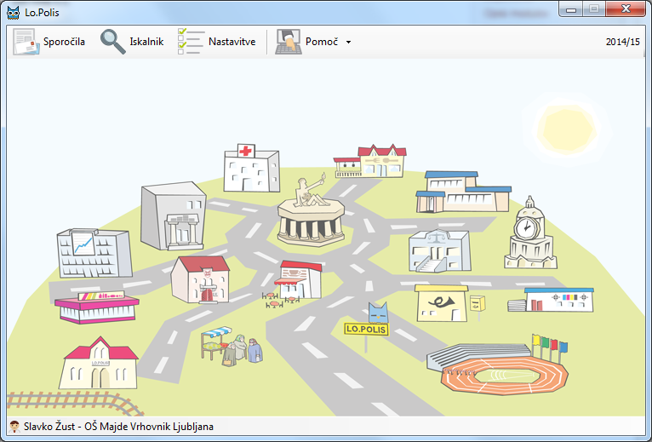

#### Select action

**1.**

**2.**

#### Specify Export content

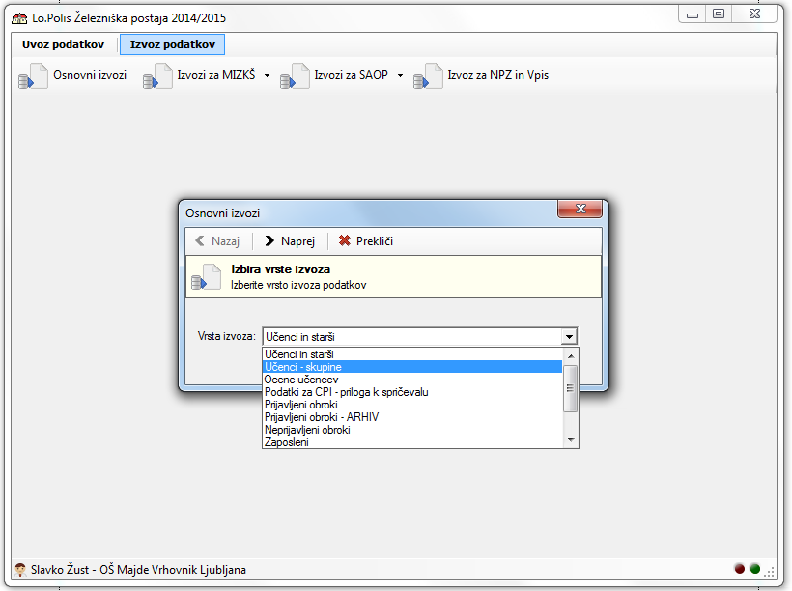

**1.**

**2.**

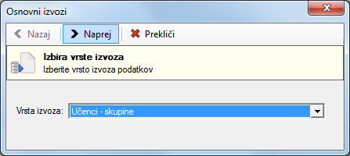

#### Select all attributes to be exported

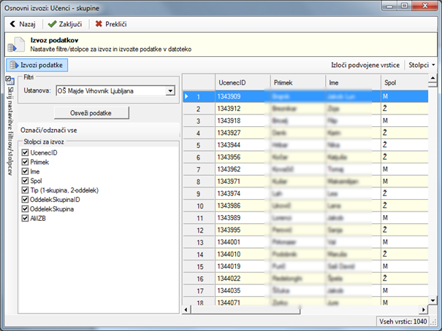

**2.**

**1.**

#### Export into CSV file (in desired location)

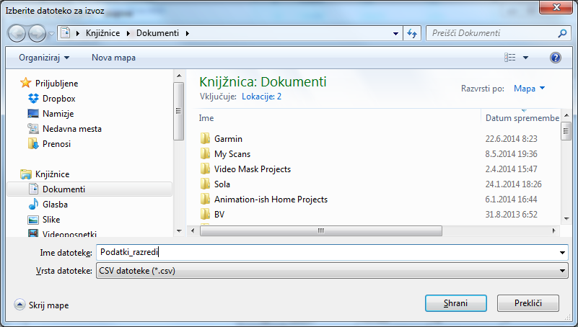

**2.**

**1.**

**CAUTION!**

### Importing the exported file into Sociogram

The file, which was saved in the previous step, must now be imported into Sociogram. If Sociogram is not open yet, run the program and follow the next steps:

#### Click the button Import from file

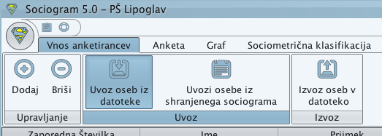

Then select the file you have just exported and the information about the respondents will be imported.

## Importing into Sociogram

### Importing students from a saved Sociogram

This feature is useful because relationships between persons in a group tend to change. If measuring relationships between students in a class, the situation at the beginning of the year is bound to change entirely by the end of the year as the students get to know each other better.

This feature can therefore be used to import persons from a previously saved sociogram and include them in new survey.

### Exporting persons into a file

Persons already listed in a sociogram can be exported into a CSV or TXT text file structured in the format described above (7.5.2). Such a file can be used in other programs or in Sociogram when so required.

## Printing surveys and entering survey results

The Survey tab contains all the tools that make it easy to select a survey question, print out the surveys and sociometric table, and enter survey results. In addition, you can print an image of the distribution of positive or negative choices or export the input into Microsoft Excel for further processing.

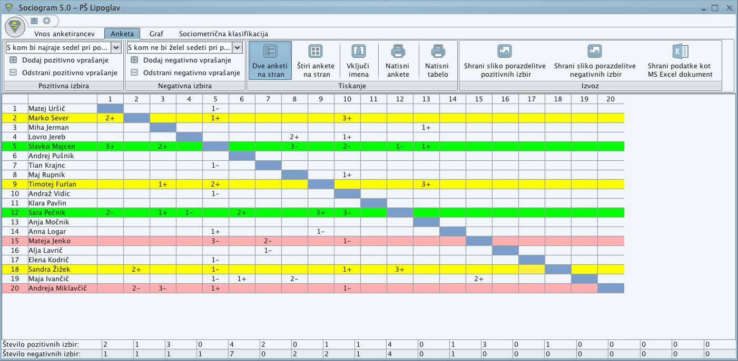

### Survey questions

You can select the survey question to be printed on the survey sheets from two groups, Positive choice and Negative choice.

Use the **add/remove question** buttons to add your own questions or delete existing questions. The list must always contain at least one question, which means you cannot delete a single question. However, you can add as many questions as you like. All the questions will be saved and available the next time you run Sociogram.

### Printing

#### Printing surveys

Before printing the survey sheets, you can select from two types of printing – either two or four surveys per one A4 page. If you wish, use the **Include names** button to have the participants’ names printed on the survey sheets. After clicking the **Print surveys** button, select the preferred printer and start printing.

#### Printing a table

You can also print out a sociometric table by clicking the **Print table** button. The printed sociometric table will contain the values you have entered.

### Entering survey results

Use the mouse to enter the survey results. Left-click the mouse to check positive choices in the relevant field and right-click for negatives. An incorrectly checked choice can be deleted by clicking the left button on the mouse again. A row will turn yellow if only all the positive choices are entered, and red if only all the negative choices are entered. Once all the positive and negative choices are entered for a person, the row turns green.

While entering choices, hovering the mouse over an input field will display the names of two persons currently having their choices entered. The current number of positive or negative choices for each respondent is displayed at the bottom of the page.

### Distribution of positive or negative choices

In the Survey tab, click the button "Save image of positive/negative choice distribution” to display the distribution based on your input. This image can then be saved and used in other programs as part of a report on the completed sociogram.

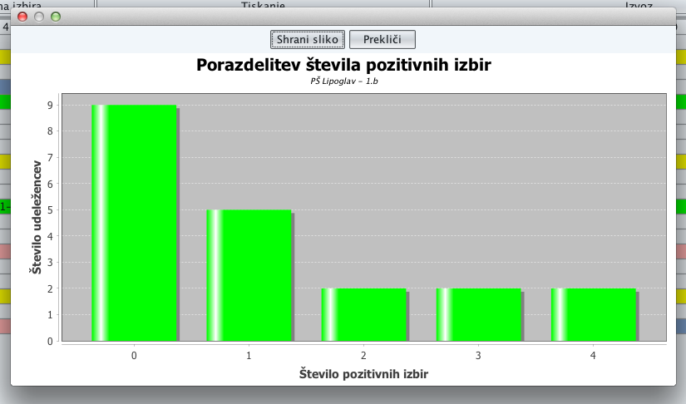

## Visualizing positive and negative choices in the form of a nomogram

In the Survey tab, click the button “Choices by participant” to display the distribution based on your input. This image can then be saved and used in other programs as part of a report on the completed sociogram.

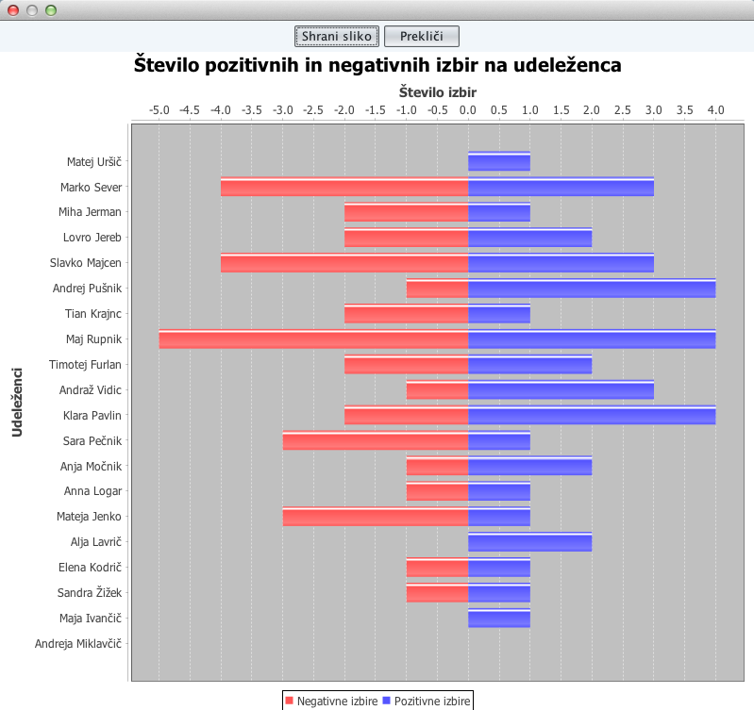

## Exporting survey results into Microsoft Excel

Clicking the far right button in the Survey tab will export all the entered choices and calculated sums of positive and negative choices into a table. The exported data can be used for further processing in other programs.

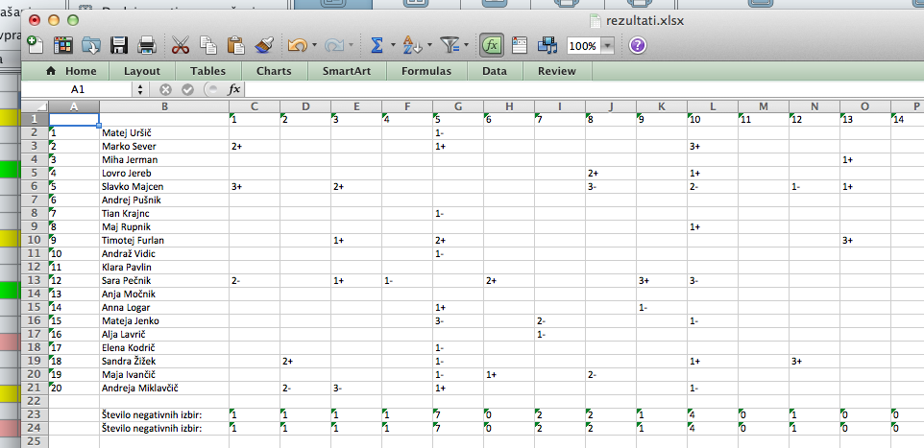

## Graphic display of sociograms

The **Graph** tab contains a module that will display a sociogram as a graph. Here, various ways of presenting a graph can be selected as well as printed out. Based on the survey results entered under the previous tab, two graphs will appear on this screen. The left shows the respondents relative to the number of positive or negative choices, arranged on concentric circles. The right graph is arranged quite freely. To improve the graphic presentation, respondents can be moved as required on both graphs.

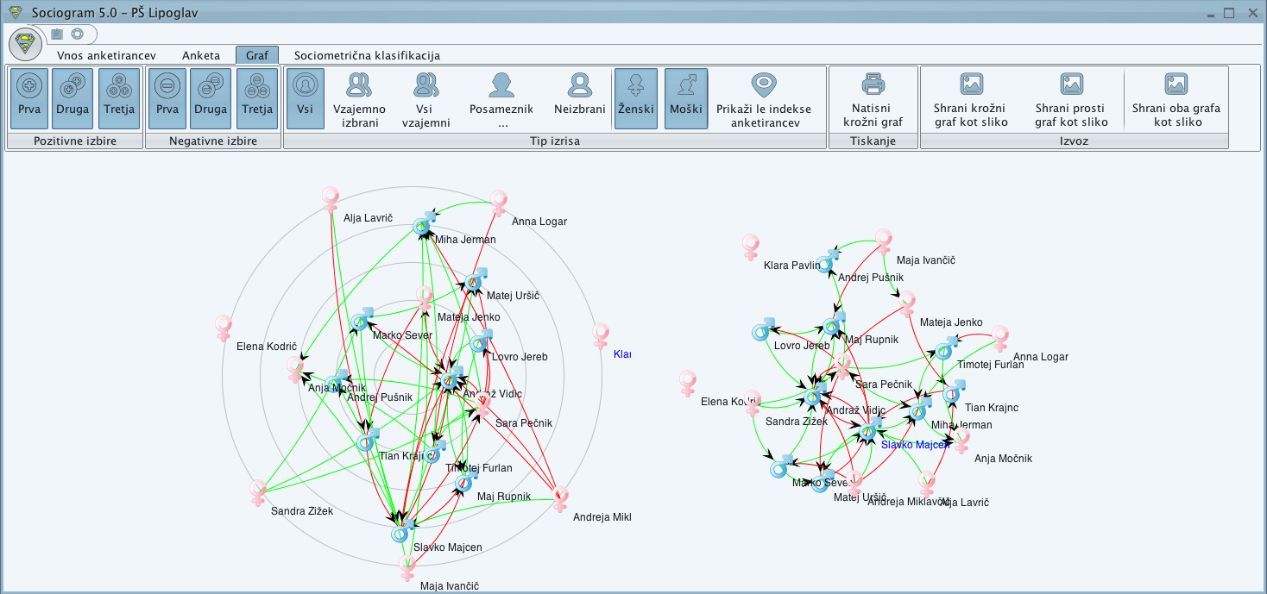

#### Managing the graph

On starting the program, the group of positive and negative choices (top left) is set so as to display all links for all respondents and both sexes. We are usually interested in specific types of links, e.g. the first positive and first negative links. To show them on the graph, exclude the second and third links by clicking the relevant buttons.

To change the type of graph structure, for example to view only mutual choices, individuals or non-selected respondents rather than all of them, click the relevant button. If you press the **Individual** button, the selection box will ask you to choose the individual by selecting her or him from a drop-down list. The graph will only show the links relevant to the selected person.

The **Mutual choices** option displays only the respondents mutually nominated at the same level, whereas the **All mutuals** option displays all mutual choices regardless of the level of selection.

The display can also be changed with regard to gender. To show only female or male respondents, exclude the gender you do not wish to view by clicking the proper button.

If you are happy with the graph and want to print it out or use it in a report, click the "Print graph" button in the Printing section, select the preferred printer and start printing.

#### Saving graphs

Should you want to save one or both graphs as an image, press the relevant button on the right side of the tab. Before saving, you can make further changes to the layout of the respondents on the graph.

## Sociometric classification

Finally, the **Sociometric classification** tab helps you calculate sociometric characteristics, display two-dimensional sociometric classification as a graph, and display sociometric indexes for individuals and the cohesion index for the group. All results can be exported as a pre-prepared report into Microsoft Word or Excel.

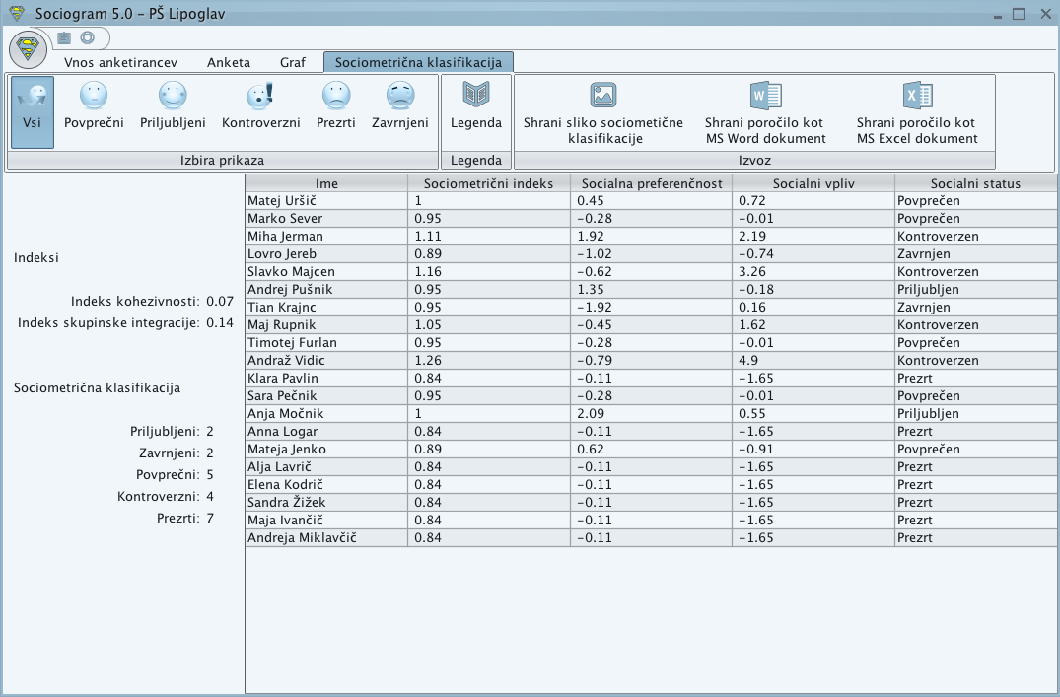

To learn more about calculating values, click on the Key button. A PDF document will appear with information about how these results were obtained.

By clicking buttons in the **Select view** group (**All, Average, Popular, Controversial, Neglected, Rejected**) you can display only the respondents matching the range of your choice.

Clicking the button “Save sociometric classification image” will display an image of two-dimensional sociometric classification which can also be saved.

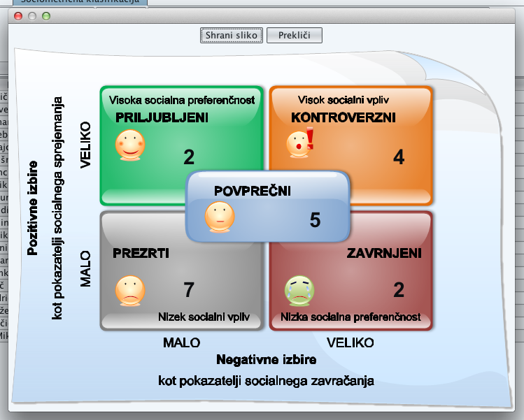

### Exporting into Microsoft Office

The calculated matrices can be exported into the Microsoft Excel program. You can also generate a pre-prepared report in Microsoft Word. This report will contain additional data about your sociogram – the data you entered under the "Enter respondents" tab.

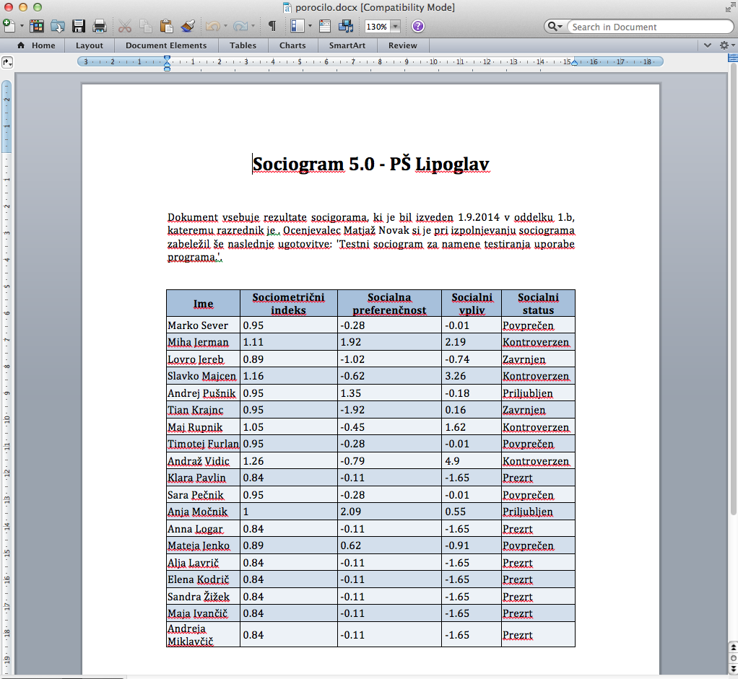

# Further assistance and information

For any assistance, further information or support please contact Mikro Graf Art d.o.o.

Basic company information.

Mikro Graf Art d.o.o.  
Archinetova 7  
1120 Ljubljana  
Mobile: +386 41 782 099  
E-mail: [slavc.zust@mga.si](mailto:slavc.zust@mga.si)  
Web: <http://krimar.si/sociogram>