

**GAME ENGINE II**

420-JV9-AS

Marc-Andre Larouche

**Into the Unknown**

Sohyun Yi

Sidakpreet Singh

Philipe Gouveia

Date: 2020, March, 2nd

LaSalle College

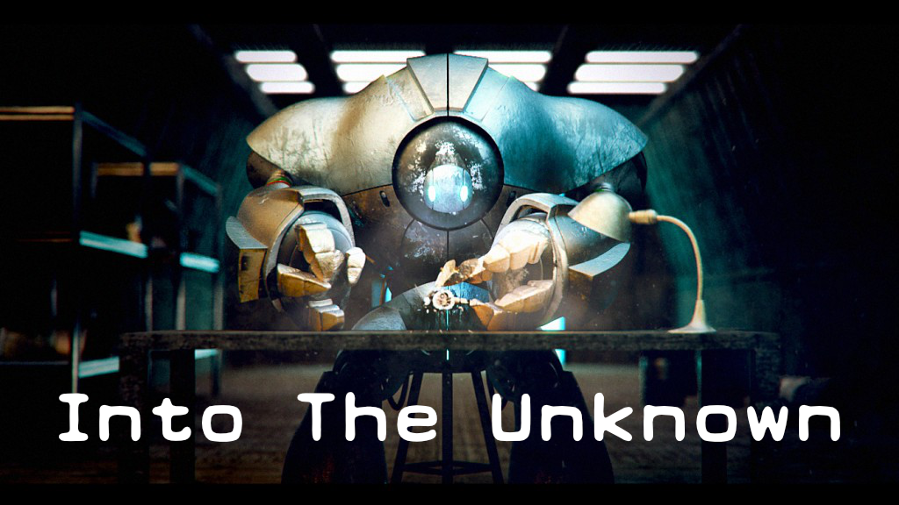

Table of Contents

Section 1: About the Game 4

Section 2: About the Manual 5

2.1 – Control Scheme: 5

2.1.1 – Keyboard & Mouse: 6

2.1.2 – Joystick: 6

2.2 – Important Visuals: 7

Section 3: About the development process 8

Section 4: References 9

# Section 1: About the Game

Into the unknown is Puzzle game with a Sci-Fi history atmosphere. In the game the player can control two main characters to solve puzzles throughout all the stages. Aside from the main characters, there is one vehicle which can be used to move from one land station to another. On each of the stations the player will find puzzles to be solved in order to understand the game and to figure out the mystery about the planet. At parts of the game the player might be challenged to take decisions that can alter the end of the game.

The game happens on the year 287 D.M. The A.I, built by the main character, informs him that, for an UNKNOWN reason, they were switched off for about 13 years, as its database has no data within this time gap. The mystery lies there, as the last thing the A.I remembers is when the **engineer** has successfully built the **sphere**, the second playable character. In addition, the only thing the A.I’s sensor can detect is a weak radio signal from a nearby land station. What it might be?

# Section 2: About the Manual

## 2.1 – Control Scheme:

|  |  |
| --- | --- |
| Keyboard & mouse | Joystick |
| esc / right mouse | pause | Open in-game **Menu** |
| num 1 | L shoulder | **Cycle** to left **camera** |
| num 2 | R shoulder | **Cycle** to right **camera** |
| tab | select | **Change** between playable **character** |
| E | Y | **Action 4:** Engineer / Sphere = act on switches |
| Q | X | **Action 3**: Engineer = pickup objects / Sphere = open |
| Alt | B | **Action 2:** Engineer = punch / Sphere = circular cut |
| space | A | **Action 1:** Engineer / Sphere = jump |
| W / up | thumb up | **Move** character **forward** |
| A / left | thumb left | **Move** character **left** |
| S / down | thumb down | **Move** character **backwards** |
| D / right | thumb right | **Move** character **right** |

### 2.1.1 – Keyboard & Mouse:

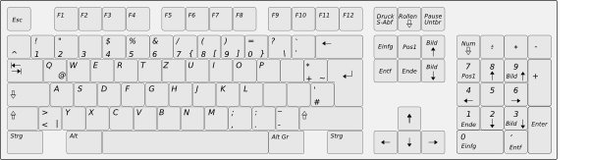



### 2.1.2 – Joystick:

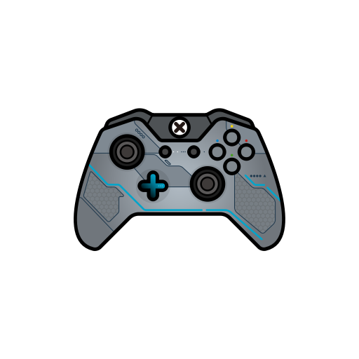

**Y**

**X**

**A**

**B**

## 2.2 – Important Visuals:

|  |  |
| --- | --- |
|  | Main playable character, A.K.A Engineer |
|  | Secondary playable character, A.K.A Sphere, the engineer best creation |
|  | C.A.R07, the vehicle used to move through the planet |
|  | P319-A.I, Engineer A.I helping system |
|  | BoxSwitch: as they are very heavy, only the engineer can pick up and transport them. |
|  | Floor switch: which are meant to have a boxswitch installed on it. |
|  | Wall switch: if they are red, characters have to interact with them so something can happen. |

# Section 3: About the development process

UNDER CONSTRUCTION

# Section 4: References

* Engineer Character Design:

by Papa_Dragon, <http://www.blendswap.com/blends/view/75153>.

* Sphere Character Design:

By 3DHaupt, https://www.blendswap.com/blend/21770

* Car Vehicle Design:

By Mikel007, <http://www.blendswap.com/blends/view/77885>

* Keyboard, mouse and joystick icons:

SihanLiu, <https://www.iconfinder.com/icons/1536922/controller_elite_gamer_xbox_one_icon>

* In-Game Fonts:

Earth 2072 by Lukas Krakora, <http://www.typewriterfonts.net>

* First level environmental assets:

3D Scifi Starter Kit, <https://assetstore.unity.com/packages/3d/environments/3d-scifi-kit-starter-kit-92152>

Sci-Fi Modular Pack, <https://assetstore.unity.com/packages/3d/environments/sci-fi/sci-fi-modular-pack-free-39538>

3D Free modular kit, <https://assetstore.unity.com/packages/3d/environments/3d-free-modular-kit-85732>

Modular Sci-Fi Corridor, <https://assetstore.unity.com/packages/3d/environments/sci-fi/modular-sci-fi-corridor-142811>

Sci-Fi Styled Modular Pack, <https://assetstore.unity.com/packages/3d/environments/sci-fi/sci-fi-styled-modular-pack-82913>

* In-Game UI:

SlimUI, <https://assetstore.unity.com/packages/tools/gui/slimui-tech-menu-133049>

* Engineer Robot Background:

by Papa_Dragon, <http://www.blendswap.com/blends/view/75153>.