**Manual**

*I.* *Introduction*

This is a 2D continuous shooting game. Try to avoid the enemies and their attack. You can also attack the enemies and different enemies take different amount of damages.

*II. Infinity Mode (Demo)*

2.1 Intro:

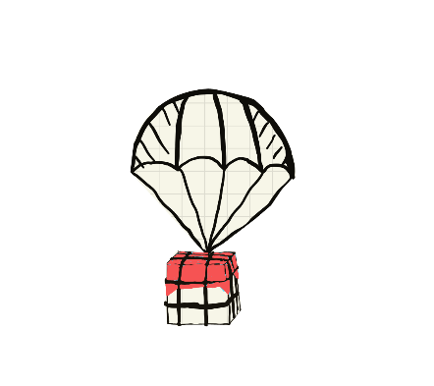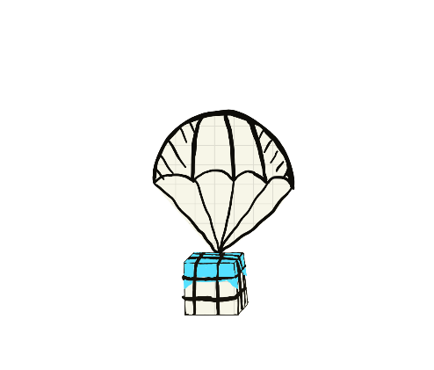This mode is for the Demo. Try to get more points which you need to kill enemies and Bosses as more as possible, also, to collect the blue box to gain more bullets. And the red box to gain a shell. (Boxes have points too)

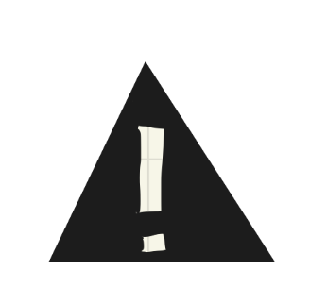Attention: Beware of the comet!

2.2 Controls:

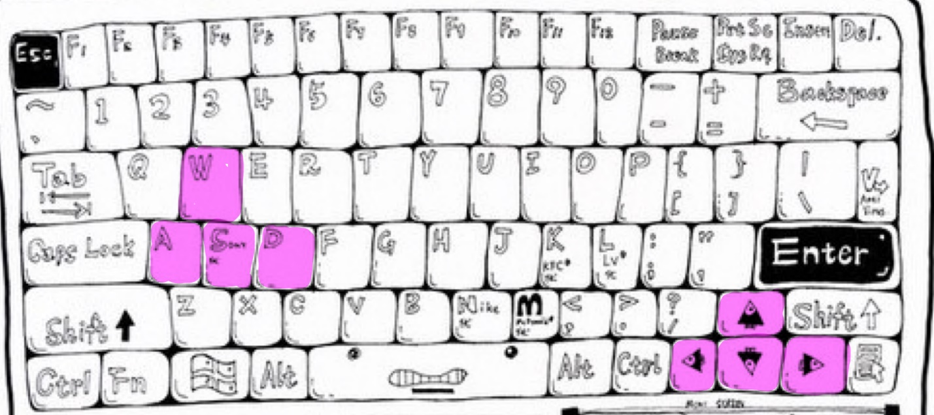W, A, S, D **OR** Up, Down, Left, Right arrow to move

*III. Game Mode (Final)*

3.1 Intro:

This mode is for the Final.

* We received a SOS message from the earth. The earth has been infected by virus H20H20 and a cure from space station Alpha is needed.
* We located three coordinates of space station Alpha, we need to check all three coordinates.
* The great villain Nemesis believes that this disaster is a punishment from god, human is meant to die because of hurting the environment. Thus, Nemesis sends out an army to stop our mission.

We need to hurry and send back the cure! Beware of Nemesis’ army.

3.2 Controls:

W, A, S, D **OR** Up, Down, Left, Right arrow to move

Button G, H, J, K to use your skills

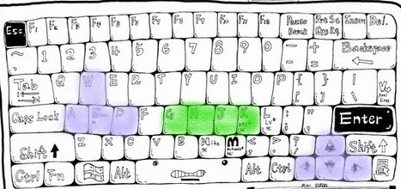

*IV. Enemies*

4.1 Kamikaze Suicide Squad (Nemesis’ Junior unit)



Hit the player by suicide way

4.2 Dagger (Nemesis’ Intermediate Force)

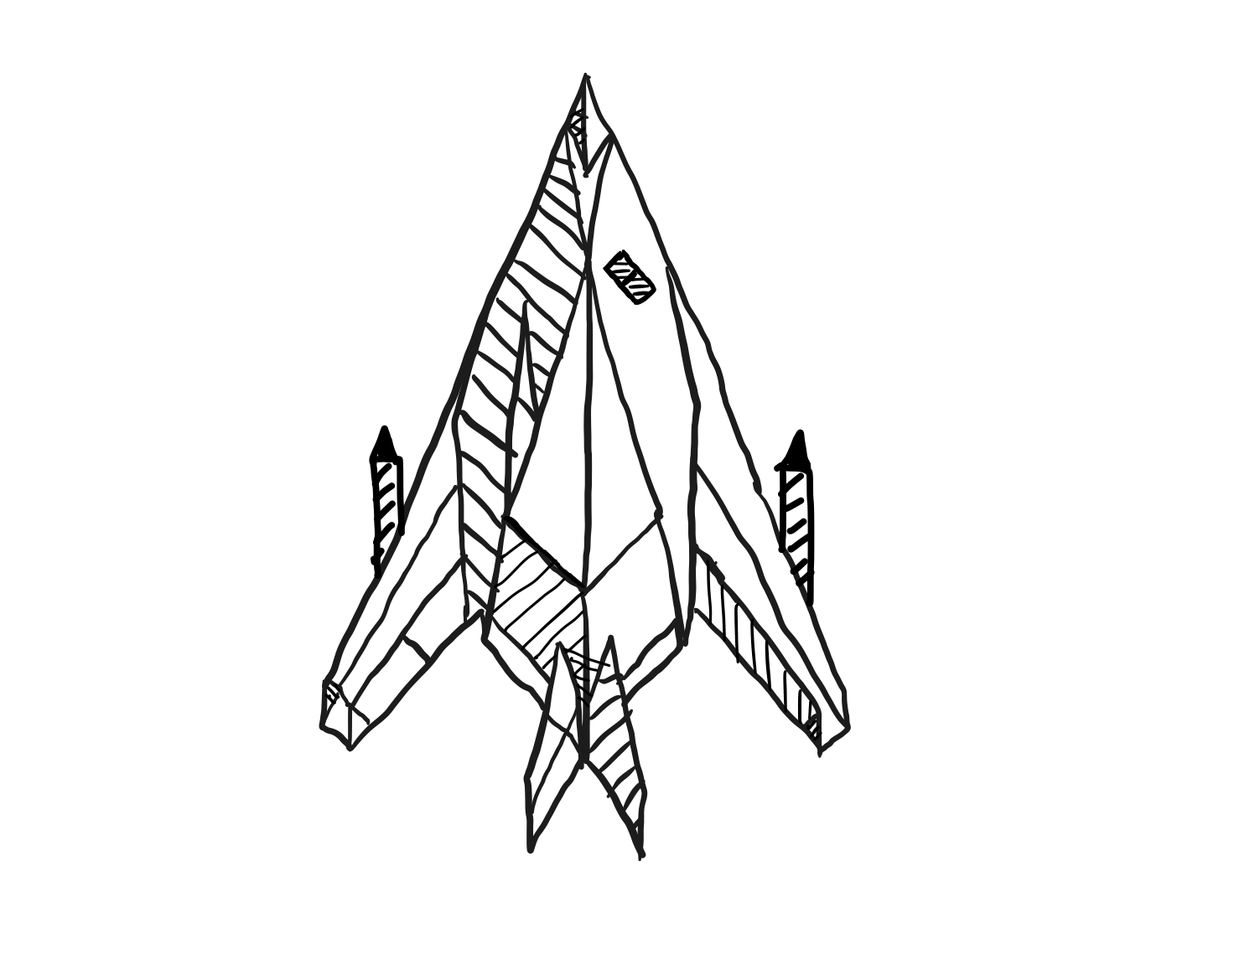

Fire cannonball to destroy player

*V. Bosses*

5.1 Big Bear (Nemesis’ Senior troops)

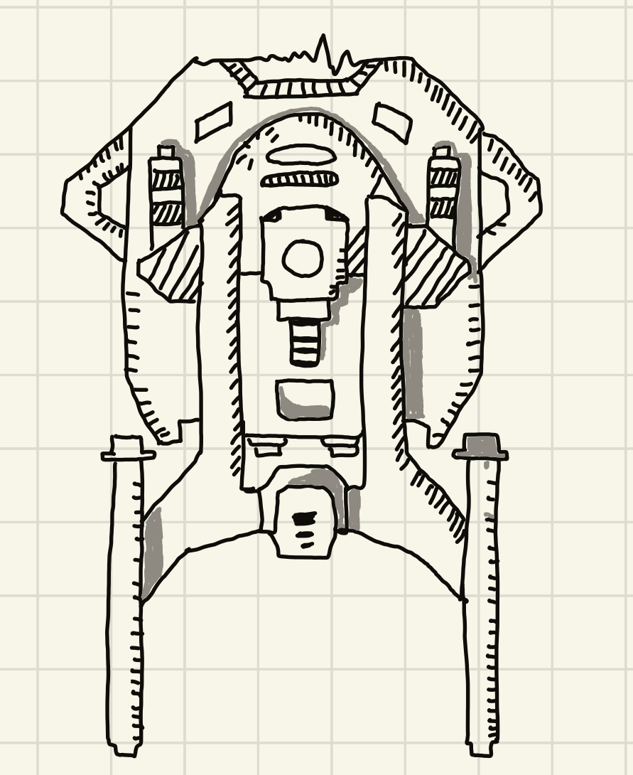

Nemesis's mysterious experimental product with limited information

5.2 Invincible Crab (Nemesis’ Senior troops)

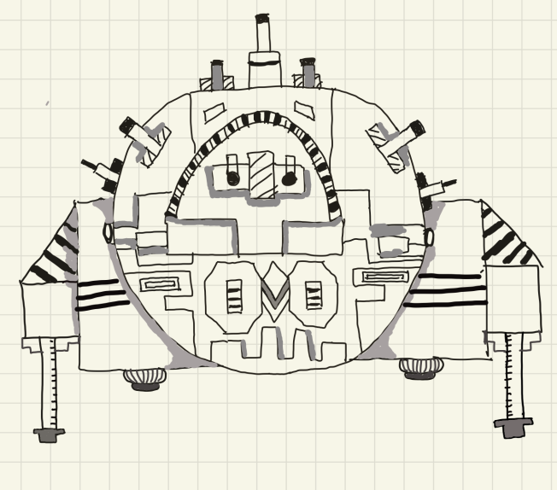 Mass production of Nemesis against the Earth's defensive forces

*VI. Sources(links that can be clicked on the very Bottom)*

Keyboard picture:

<https://m.duitang.com/blog/?id=824022174&belong_album=86097583>

Create a Space Shooter Game:

<https://www.youtube.com/watch?v=XCOTK-a-1cc>

2D Space Shooter Tutorial Extra:

<https://www.youtube.com/watch?v=nGTCnm23iys&list=PLRN2Qvxmju0Mf1GB1hXsT-x1GQJQ0pwE0&index=11>

High Score Table with Saving and Loading:

<https://www.youtube.com/watch?v=iAbaqGYdnyI&t=72s>

Asset Store:

**Fungus (be used for story flowchart)**

https://assetstore.unity.com/packages/templates/systems/fungus-34184

Tutorial:

<https://www.youtube.com/watch?v=F1vmEtQ7k6M&list=PLiMlyObJfJmUohJ_M2pJhtrNKuNECo2Uk>