**5. PLC Defined/Specified:**

PLC selected:

* 5069-L306ERMS2
* 18-32V DC
* https://configurator.rockwellautomation.com/#configurator/5069-L306ERMS2/summary

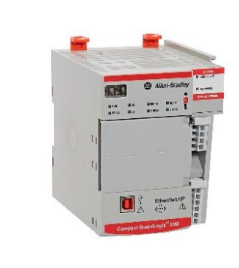

Input Module selected:

* 5069-IB16F
* 12-24V DC
* https://configurator.rockwellautomation.com/#/configurator/5069-IB16F/summary

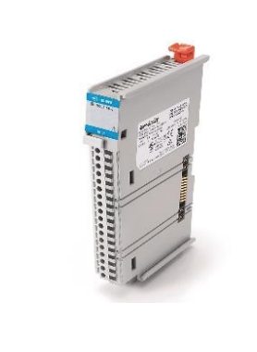

Output Module selected:

* 5069-OB16
* 12-24V DC
* https://configurator.rockwellautomation.com/#/configurator/5069-OB16/summary

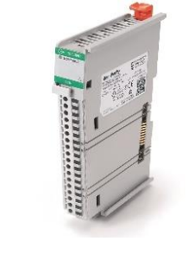

Power Supply selected:

* 1756-PB50
* 12-32 V dc
* https://configurator.rockwellautomation.com/#/configurator/1756-PB50/summary

