Authorized Web Security Simulation
  - Site Cloning, Browser Hooking, and Credential-Harvester Awareness
ETHICAL HACKING | CONTROLLED LAB | EVIDENCE BASED

A controlled web-security exercise examining how cloned content, browser-hook frameworks, and credential-harvester workflows can be assembled in an isolated training environment. The report pairs original execution evidence with defensive analysis and safe publication boundaries.
Authorization and safety boundary: This report documents an instructor-provided, isolated training exercise. No real users, public targets, production systems, or real credentials were used. Commands are presented with placeholders for portfolio safety. Original screenshots are retained as execution evidence and may show transient private lab addresses.
ASSESSMENT TYPE | Authorized training-lab exercise
OBJECTIVE | Demonstrate the mechanics and risk of deceptive web content without collecting real credentials, targeting an uncontrolled system, or exposing the lab service to the public Internet.
ENVIRONMENT | Isolated Kali Linux and local Apache training environment; transient lab data only.
EVIDENCE | 38 original screenshots retained unchanged and presented in execution order.

Professional Skills Demonstrated
- Apache virtual-host configuration
- Controlled site mirroring
- Browser-hook framework awareness
- Social-engineering risk analysis
- Evidence-based technical documentation
- Defensive control mapping

Assessment Workflow and Evidence

1. Establish the Isolated Web Host
Objective: Create a local-only hostname and prepare a clean Apache workspace.
The exercise begins with local name resolution and host preparation. Keeping the destination inside the lab prevents the cloned content from becoming an uncontrolled public service.

Lab Commands
LAB_HOST=cloned.test
sudo nano /etc/hosts
sudo apache2ctl configtest
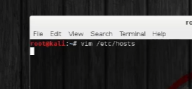
Evidence 01 - Local host mapping and initial web-server preparation. Original lab screenshot retained unchanged.
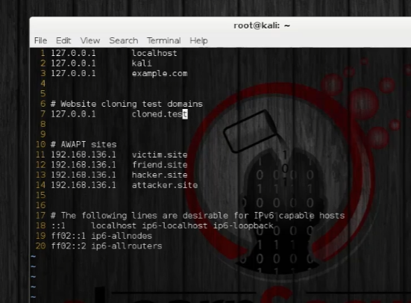
Evidence 02 - Local host mapping and initial web-server preparation. Original lab screenshot retained unchanged.
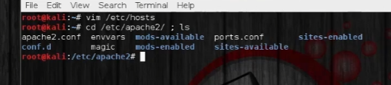
Evidence 03 - Local host mapping and initial web-server preparation. Original lab screenshot retained unchanged.
Analyst observation: A controlled namespace and explicit configuration test provide a clear safety boundary before content is served.

2. Configure and Validate Apache
Objective: Create a dedicated virtual host, enable it, and verify a harmless test page.
Apache configuration was reviewed before and after the virtual-host change. A simple local page confirmed that the document root and access directives worked before any mirrored content was introduced.

Lab Commands
sudo a2ensite cloned-test.conf
sudo apache2ctl configtest
sudo systemctl reload apache2
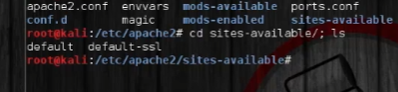
Evidence 04 - Apache virtual-host configuration and harmless content validation. Original lab screenshot retained unchanged.
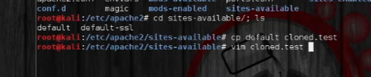
Evidence 05 - Apache virtual-host configuration and harmless content validation. Original lab screenshot retained unchanged.
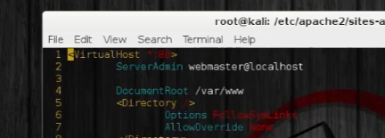
Evidence 06 - Apache virtual-host configuration and harmless content validation. Original lab screenshot retained unchanged.
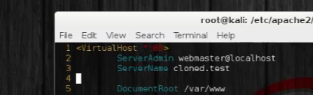
Evidence 07 - Apache virtual-host configuration and harmless content validation. Original lab screenshot retained unchanged.
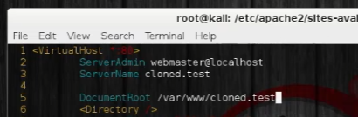
Evidence 08 - Apache virtual-host configuration and harmless content validation. Original lab screenshot retained unchanged.
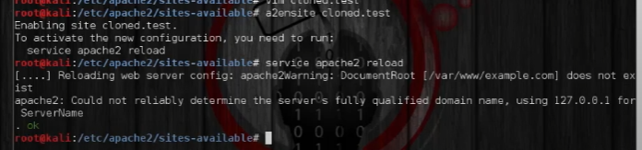
Evidence 09 - Apache virtual-host configuration and harmless content validation. Original lab screenshot retained unchanged.
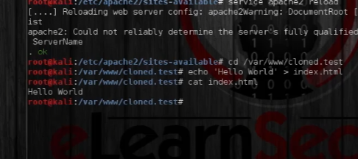
Evidence 10 - Apache virtual-host configuration and harmless content validation. Original lab screenshot retained unchanged.
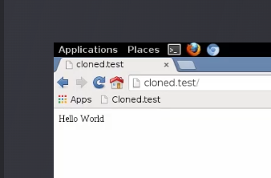
Evidence 11 - Apache virtual-host configuration and harmless content validation. Original lab screenshot retained unchanged.
Analyst observation: Staging with a benign page separates infrastructure troubleshooting from later security-tool behavior.

3. Mirror Test Content
Objective: Observe how automated mirroring reproduces page assets and rewrites local links.
A training page was mirrored into the local document root. The purpose was to understand why visual similarity alone can make a deceptive page convincing and why trusted branding cannot substitute for origin verification.

Lab Commands
wget --mirror --convert-links --page-requisites http://lab-target.invalid/
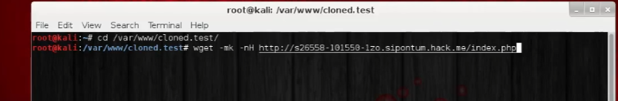
Evidence 12 - Controlled content mirroring and local file inspection. Original lab screenshot retained unchanged.
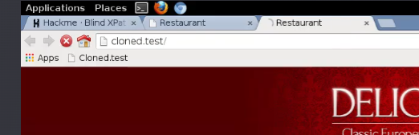
Evidence 13 - Controlled content mirroring and local file inspection. Original lab screenshot retained unchanged.
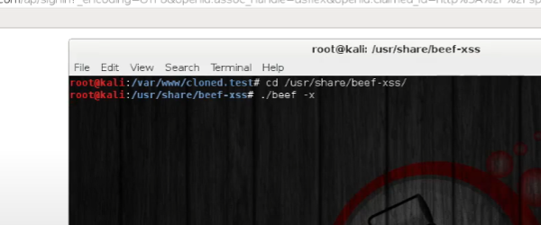
Evidence 14 - Controlled content mirroring and local file inspection. Original lab screenshot retained unchanged.
Analyst observation: The mirror reproduced presentation assets, demonstrating why users must verify the domain, certificate, and expected authentication flow.

4. Examine Browser-Hook Behavior
Objective: Review local browser-hook enrollment and API-driven visibility in a closed environment.
The browser-hook framework was operated only against the lab page. The screenshots show local framework state and a REST-oriented workflow; no public browser or real user was enrolled.

Lab Commands
sudo beef-xss
# Use only the local lab console and transient lab token
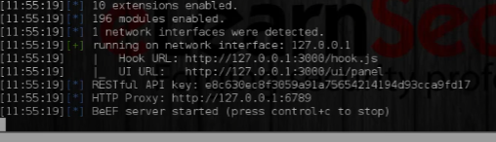
Evidence 15 - Local browser-hook framework and controlled API workflow. Original lab screenshot retained unchanged.
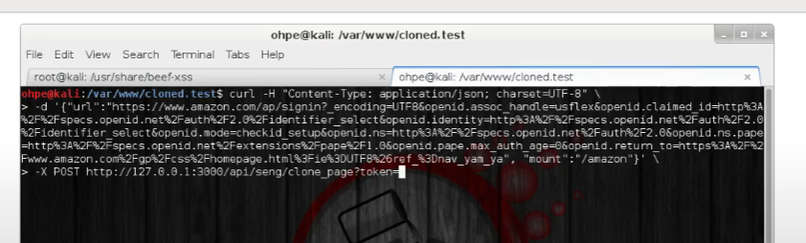
Evidence 16 - Local browser-hook framework and controlled API workflow. Original lab screenshot retained unchanged.
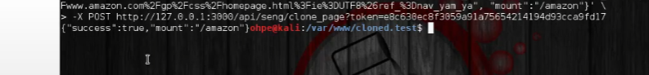
Evidence 17 - Local browser-hook framework and controlled API workflow. Original lab screenshot retained unchanged.
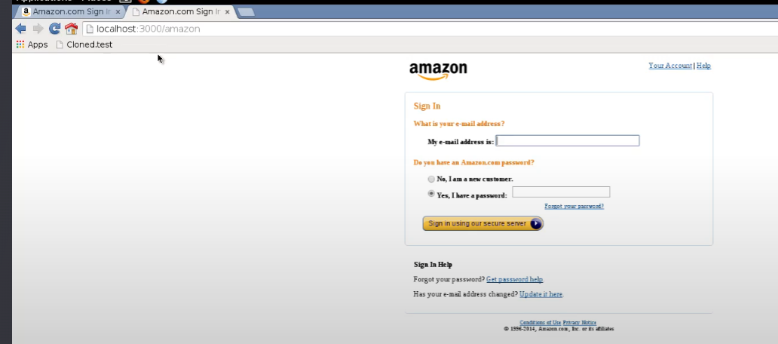
Evidence 18 - Local browser-hook framework and controlled API workflow. Original lab screenshot retained unchanged.
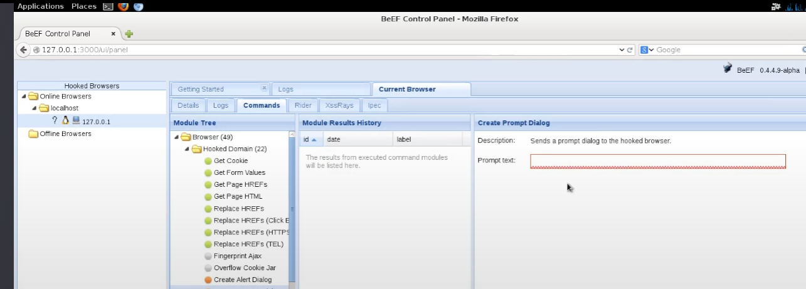
Evidence 19 - Local browser-hook framework and controlled API workflow. Original lab screenshot retained unchanged.
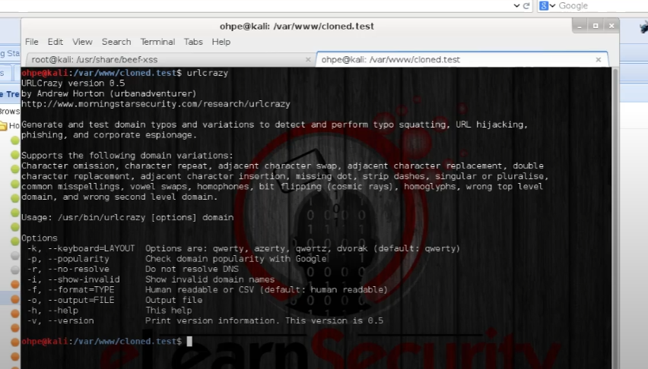
Evidence 20 - Local browser-hook framework and controlled API workflow. Original lab screenshot retained unchanged.
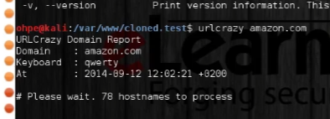
Evidence 21 - Local browser-hook framework and controlled API workflow. Original lab screenshot retained unchanged.
Evidence 22 - Local browser-hook framework and controlled API workflow. Original lab screenshot retained unchanged.
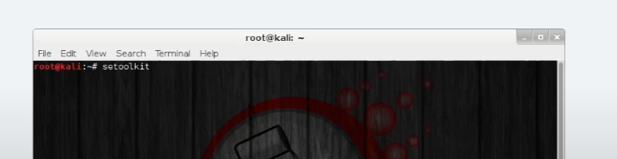
Evidence 23 - Local browser-hook framework and controlled API workflow. Original lab screenshot retained unchanged.
Analyst observation: Client-side hooks can expose browser metadata and enable scripted actions, making content-security policy, endpoint protection, and user awareness important layers.

5. Simulate a Credential-Harvester Workflow
Objective: Document how a cloned login flow can redirect and record test input without using real credentials.
The final stage uses a local social-engineering toolkit workflow and disposable test values. The report preserves the original evidence while intentionally omitting real targets, credentials, and public deployment instructions.

Lab Commands
sudo setoolkit
# Select only the authorized local training workflow
# Use disposable test data; never enter a real password
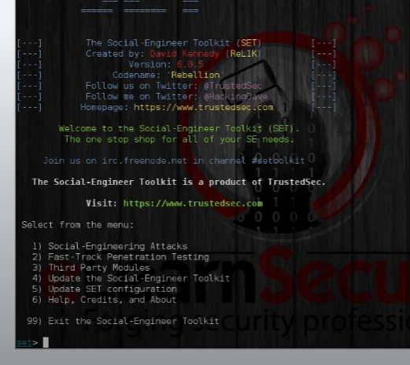
Evidence 24 - Controlled clone, local redirect, and test-input verification. Original lab screenshot retained unchanged.
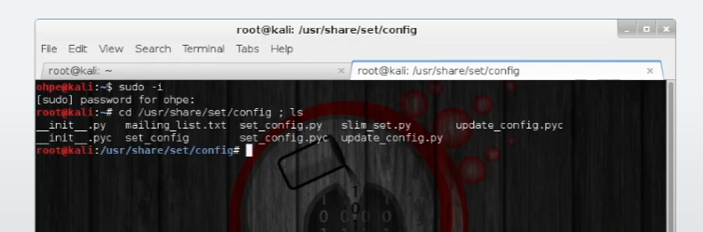
Evidence 25 - Controlled clone, local redirect, and test-input verification. Original lab screenshot retained unchanged.
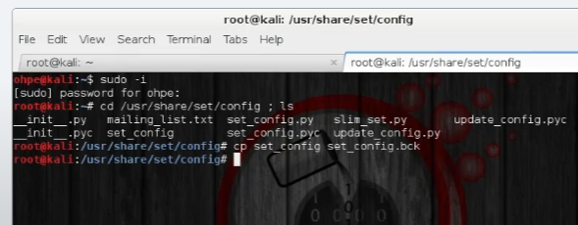
Evidence 26 - Controlled clone, local redirect, and test-input verification. Original lab screenshot retained unchanged.
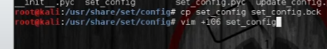
Evidence 27 - Controlled clone, local redirect, and test-input verification. Original lab screenshot retained unchanged.
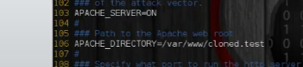
Evidence 28 - Controlled clone, local redirect, and test-input verification. Original lab screenshot retained unchanged.
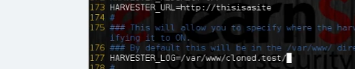
Evidence 29 - Controlled clone, local redirect, and test-input verification. Original lab screenshot retained unchanged.
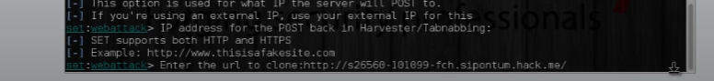
Evidence 30 - Controlled clone, local redirect, and test-input verification. Original lab screenshot retained unchanged.
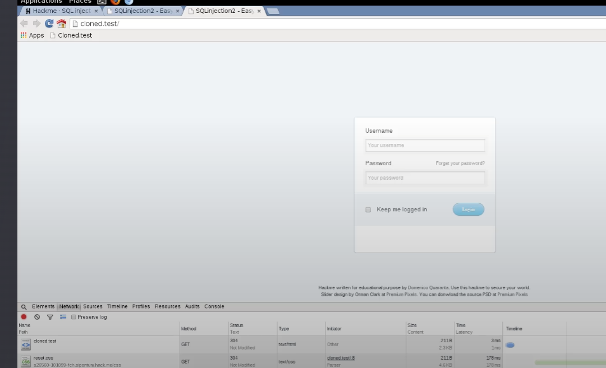
Evidence 31 - Controlled clone, local redirect, and test-input verification. Original lab screenshot retained unchanged.
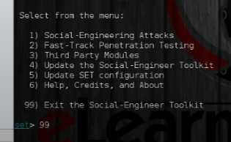
Evidence 32 - Controlled clone, local redirect, and test-input verification. Original lab screenshot retained unchanged.
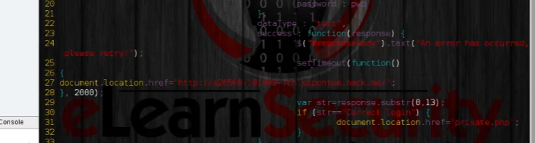
Evidence 33 - Controlled clone, local redirect, and test-input verification. Original lab screenshot retained unchanged.
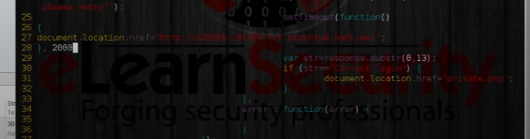
Evidence 34 - Controlled clone, local redirect, and test-input verification. Original lab screenshot retained unchanged.
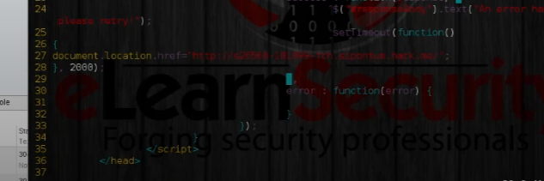
Evidence 35 - Controlled clone, local redirect, and test-input verification. Original lab screenshot retained unchanged.
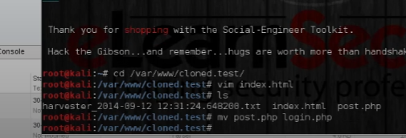
Evidence 36 - Controlled clone, local redirect, and test-input verification. Original lab screenshot retained unchanged.
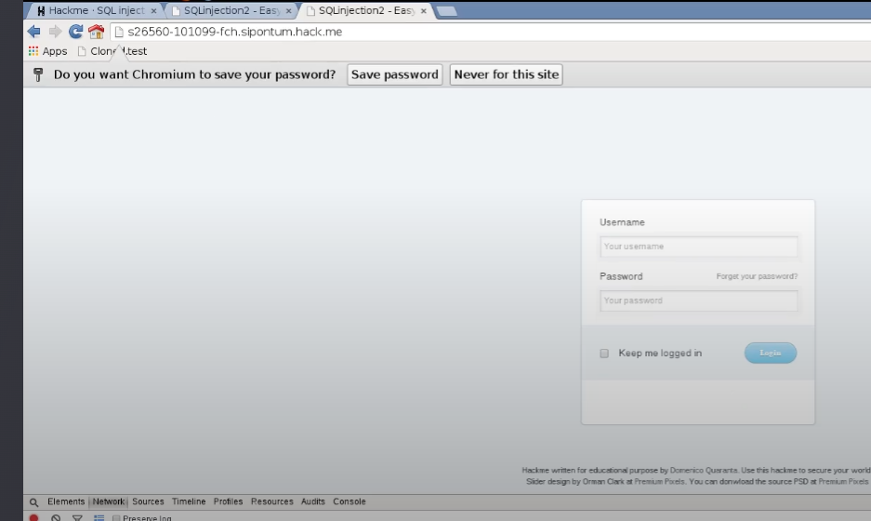
Evidence 37 - Controlled clone, local redirect, and test-input verification. Original lab screenshot retained unchanged.
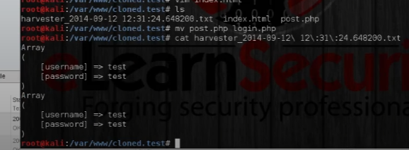
Evidence 38 - Controlled clone, local redirect, and test-input verification. Original lab screenshot retained unchanged.
Analyst observation: The exercise demonstrates the impact of a convincing login clone and reinforces phishing-resistant MFA, password-manager domain matching, and rapid takedown procedures.

Findings and Risk
Severity | Finding | Evidence-based impact
HIGH | Visual trust can be reproduced | A mirrored page can preserve enough branding and layout to mislead a user who does not verify the origin.
HIGH | Credentials remain the primary objective | A deceptive login flow can capture test input unless authentication is phishing resistant.
MEDIUM | Client-side hooks expand exposure | A browser hook can expose metadata and permit scripted actions within the browser context.
MEDIUM | Local misconfiguration increases risk | An exposed lab service or permissive virtual host could unintentionally make training content reachable outside the intended environment.

Defensive Recommendations
- Use phishing-resistant MFA such as passkeys or hardware-backed FIDO2 authentication.
- Train users to verify the complete origin and use password-manager domain matching instead of visual branding.
- Apply content-security policy, secure cookies, modern browser controls, and endpoint telemetry.
- Monitor newly registered lookalike domains, certificate transparency logs, and brand-impersonation reports.
- Keep all social-engineering simulations scoped, approved, logged, isolated, and supplied with disposable test identities.
- Remove cloned content, captured test values, and framework tokens immediately after the exercise.

Reflection and Next Step
The strongest lesson was that a technically simple clone can still create a persuasive user experience. The next step is to document detection telemetry from a controlled exercise, including DNS, proxy, browser, mail, and endpoint signals, without publishing operational tokens or collected credentials.
Evidence note: The screenshots are original lab captures retained unchanged. The surrounding narrative has been rewritten for clarity, public safety, and recruiter review. Training-provider names, marks, and course materials remain the property of their respective owners; this portfolio is not an endorsement or affiliation claim.

