Linux Service Discovery and Enumeration
  - Nmap, Netcat, Banner Analysis, and Web-Service Review
ETHICAL HACKING | CONTROLLED LAB | EVIDENCE BASED

An authorized Linux enumeration exercise that resolves a lab target, inventories TCP services, investigates ambiguous ports, confirms an intentionally exposed bind shell, and reviews a vulnerable web surface.
Authorization and safety boundary: This report documents an instructor-provided, isolated training exercise. No real users, public targets, production systems, or real credentials were used. Commands are presented with placeholders for portfolio safety. Original screenshots are retained as execution evidence and may show transient private lab addresses.
ASSESSMENT TYPE | Authorized training-lab exercise
OBJECTIVE | Build a defensible service inventory and identify exposures requiring deeper validation or immediate containment.
ENVIRONMENT | Instructor-provided Kali Linux and intentionally vulnerable Linux target on an isolated RFC1918 network.
EVIDENCE | 5 original screenshots retained unchanged and presented in execution order.

Professional Skills Demonstrated
- Target validation
- Nmap service detection
- Netcat banner analysis
- Unexpected service investigation
- Web enumeration
- Risk-based remediation

Assessment Workflow and Evidence

1. Resolve and Confirm the Target
Objective: Identify the lab-only target before scanning.
The local hosts file was reviewed to confirm the instructor-provided target mapping. Commands in this public report use TARGET_IP because the screenshot address was transient and specific to the lab session.

Lab Commands
cat /etc/hosts
ping -c 2 demo.ine.local
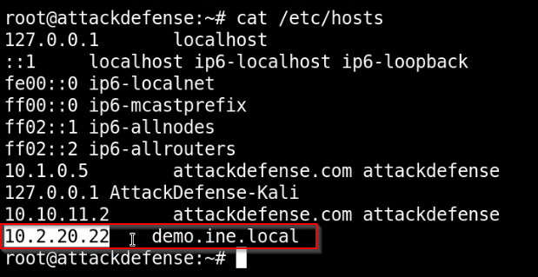
Evidence 01 - Lab target resolution using the local hosts file. Original lab screenshot retained unchanged.
Analyst observation: Target confirmation reduces the risk of scanning the wrong system and establishes a reproducible starting point.

2. Build the Service Inventory
Objective: Identify listening TCP services and their reported versions.
A service-detection scan across the first 10,000 TCP ports produced a broad inventory. The result was used for prioritization rather than treated as proof of vulnerability.

Lab Commands
nmap -sV -p1-10000 TARGET_IP -oA evidence/linux-service-inventory
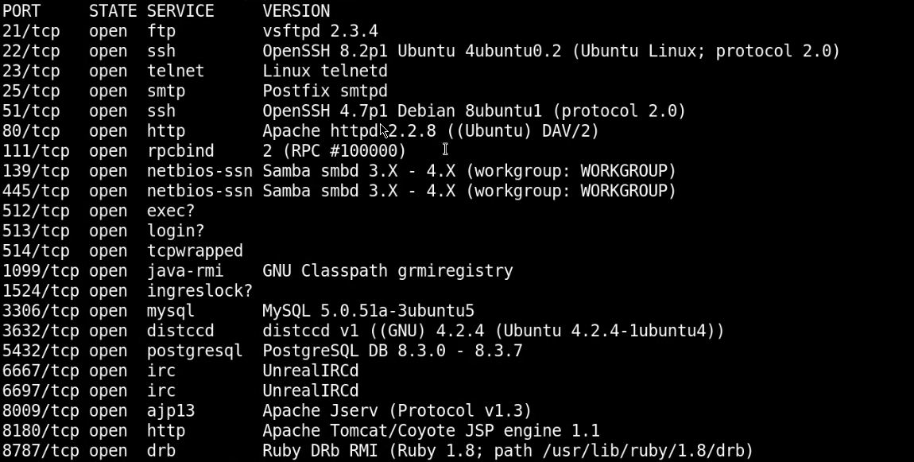
Evidence 02 - Nmap service and version inventory. Original lab screenshot retained unchanged.
Analyst observation: The scan exposed several legacy services and two ports requiring manual validation.

3. Validate Ambiguous Ports
Objective: Use a simple TCP client to observe application behavior on ports without reliable banners.
Netcat produced no useful banner on one service, while the second connection returned an interactive shell. This was an intentionally vulnerable lab condition and was not used to modify the host.

Lab Commands
nc -nv TARGET_IP 512
nc -nv TARGET_IP 1524
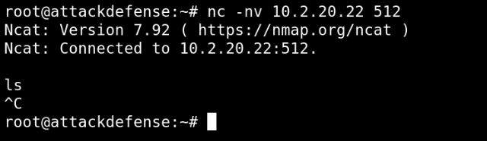
Evidence 03 - Manual connection tests for ambiguous TCP services. Original lab screenshot retained unchanged.
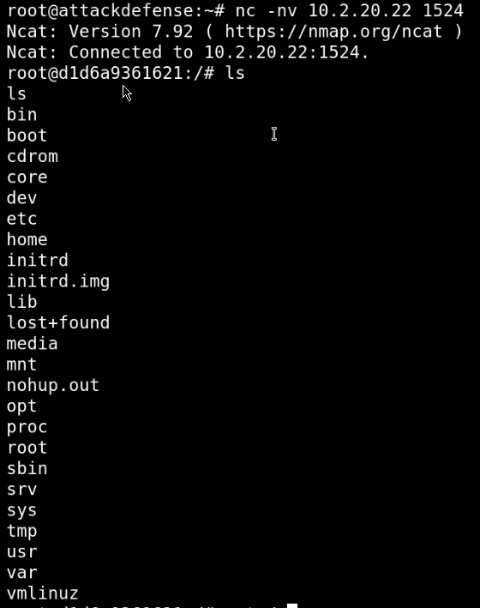
Evidence 04 - Manual connection tests for ambiguous TCP services. Original lab screenshot retained unchanged.
Analyst observation: A listening port with no banner still requires investigation; an unauthenticated bind shell is a critical remote-access exposure.

4. Review the Web Surface
Objective: Inspect the HTTP landing page and visible application paths.
The web page exposed multiple intentionally vulnerable applications and a WebDAV path. The observation created a prioritized follow-up list without expanding the public report into additional exploitation steps.

Lab Commands
curl -I http://TARGET_IP/
nmap -sV -p80 --script http-title,http-methods TARGET_IP
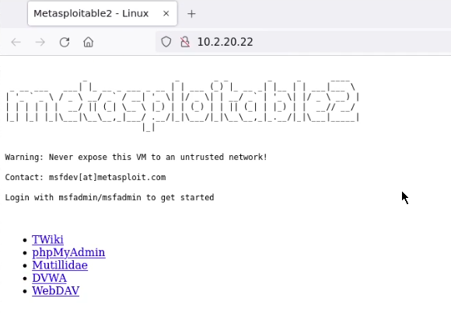
Evidence 05 - Vulnerable training web surface and exposed application paths. Original lab screenshot retained unchanged.
Analyst observation: Visible test applications and WebDAV increase attack surface and should be removed, isolated, or explicitly required and hardened.

Findings and Risk
Severity | Finding | Evidence-based impact
CRITICAL | Unauthenticated bind shell | A remote client obtained an interactive shell through an exposed TCP service in the intentionally vulnerable lab.
HIGH | Legacy and unnecessary services | The scan identified multiple old services that expand exposure and complicate monitoring.
HIGH | Vulnerable web applications | The HTTP service advertised deliberately vulnerable applications and a potentially misconfigured WebDAV path.
MEDIUM | Incomplete service identification | A port without a banner requires process, socket, and packet-level correlation before classification.

Defensive Recommendations
- Remove bind shells, remote debug listeners, and every service without a documented business requirement.
- Restrict management access with host firewalls, network ACLs, and a dedicated administrative segment.
- Patch or replace legacy daemons and disable insecure protocols.
- Disable WebDAV unless required; otherwise enforce authentication, least privilege, and limited methods.
- Correlate scan results with host commands such as ss, lsof, systemctl, package inventory, and process ownership.
- Create detections for new listeners, unusual parent processes, and inbound connections to nonstandard ports.

Reflection and Next Step
The exercise reinforced that enumeration is evidence collection, not automatic vulnerability proof. The bind-shell result was decisive because service behavior was directly observed, while other ports still required host or protocol evidence before drawing conclusions.
Evidence note: The screenshots are original lab captures retained unchanged. The surrounding narrative has been rewritten for clarity, public safety, and recruiter review. Training-provider names, marks, and course materials remain the property of their respective owners; this portfolio is not an endorsement or affiliation claim.

